## 1 INTRODUCTION

Will be able to create new users and change the passwords. He can add or update the employee information in the company. He can and view the information of transport categories and also available routes. Depending on the users’ demands, new route and also new pick up points can be added to the database. It is every company’s need to see the welfare of its employees by providing transportation for the employees to attend their duties successfully. This is the reason many MNC companies maintain their own fleet and sometimes takes the help of third party transport systems also. When several employees wish to utilize the bus services provide by the company, naturally the company employees need a system to allot the buses and oversee the transportation. Corporate company’s Vehicle Management is a software that quenches this need.

**OVERVIEW**

Vehicle Management system is software which is Helpful for bus operators, who wants to operate many bus trips in a day. Vehicle Management system is a windows application written for 32-bit windows operating system which focused in the area of adding , editing and deleting the passengers, staff and the bus routes. In this software a person can be register as a user and he can manage the bus routes and the staff, passengers? Details .? He can add a user can also add the details of the staff and their duty time in the system .

**PURPOSE**

A vehicle management system is a software system — or platform — that serves to manage commercial fleets of vehicles, such as cars, vans or trucks — or even heavy equipment — to ensure they're utilized safely, efficiently and professionally, while making sure they're well maintained and high-performing.

**2 Problem Definition & Design Thinking**

* 1. **Empathy Map**

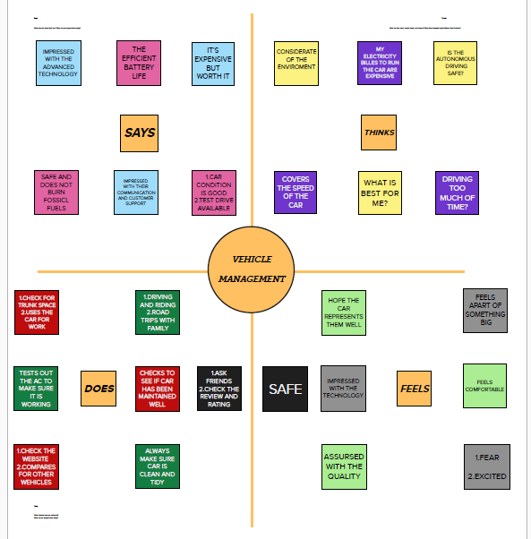

* 1. **Ideation & Brainstorming Map**

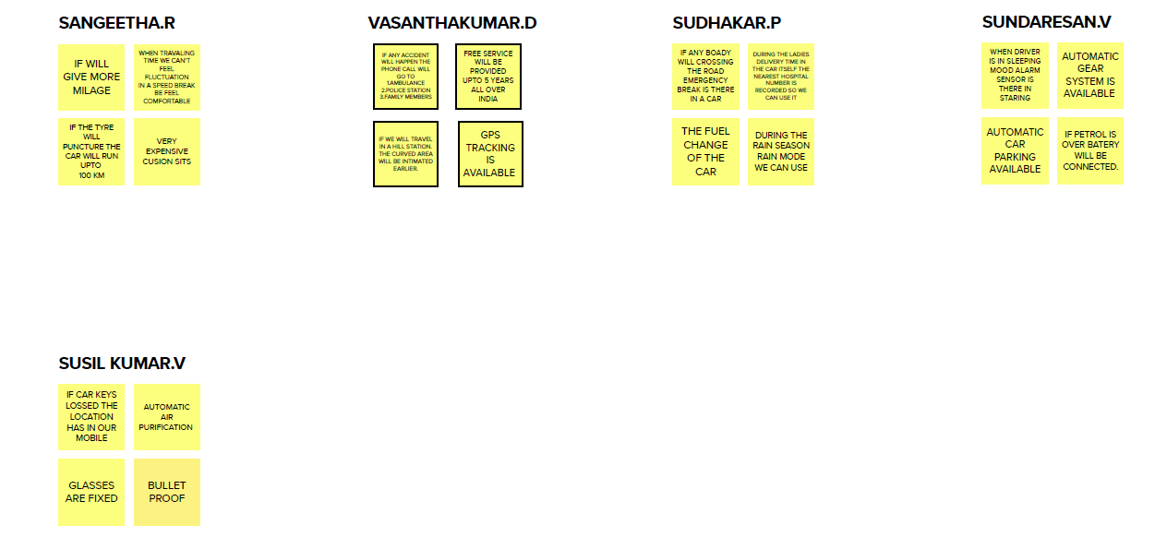

**3. RESULT**

* 1. Data Model:

|  |  |
| --- | --- |
| Field label | Data type |
| Vehicle | Picklist |
|  |  |

|  |  |
| --- | --- |
| **Object name** | **Fields in the Object** |
| obj1 |  |
| obj2 |  |

# Activity & Screenshot

|  |  |
| --- | --- |
| Field label | Data type |
| Driver | Picklist |
|  |  |

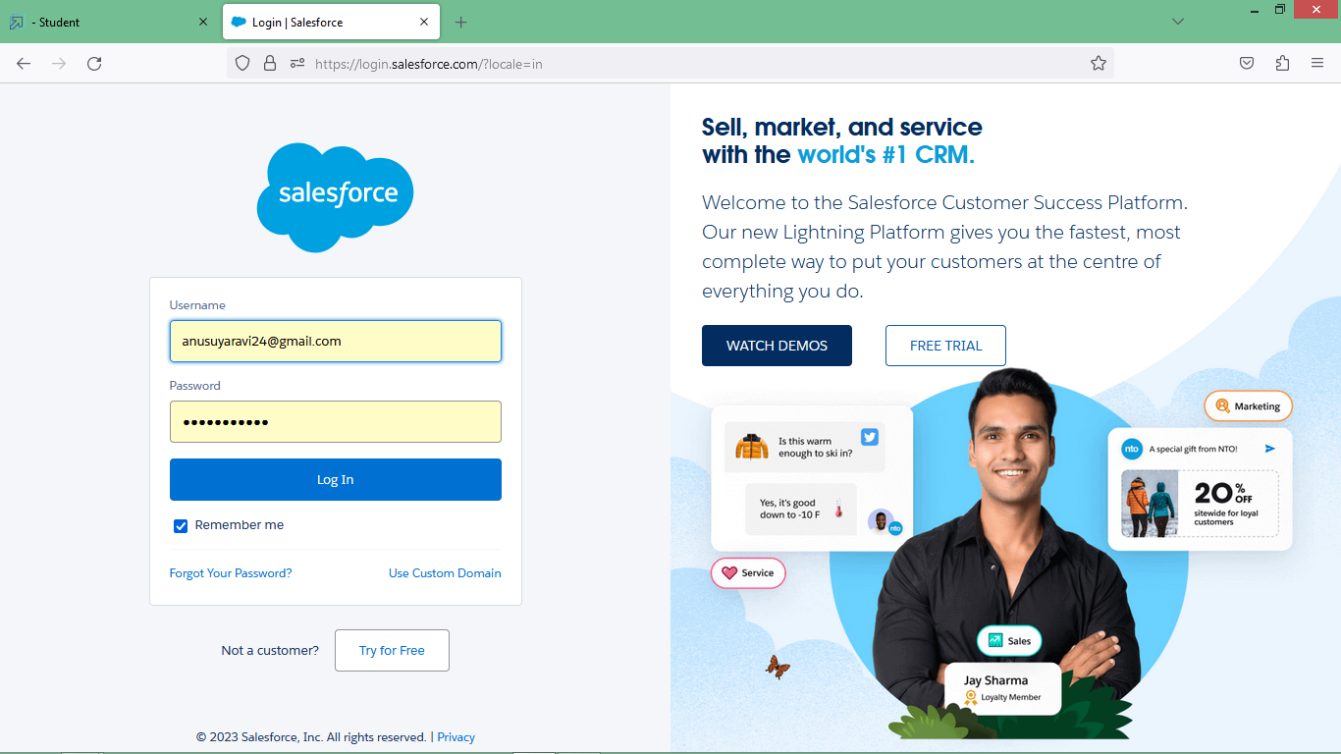

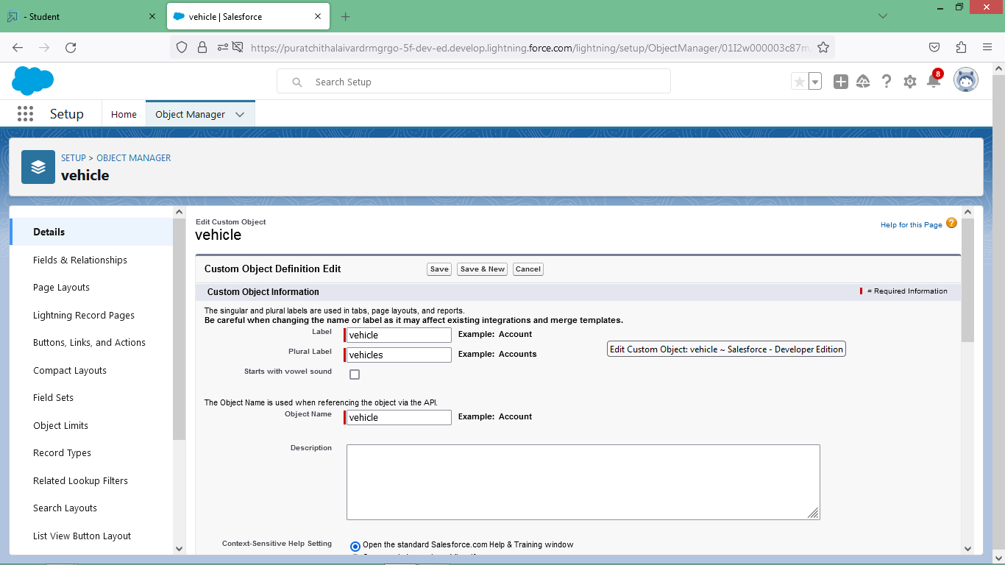

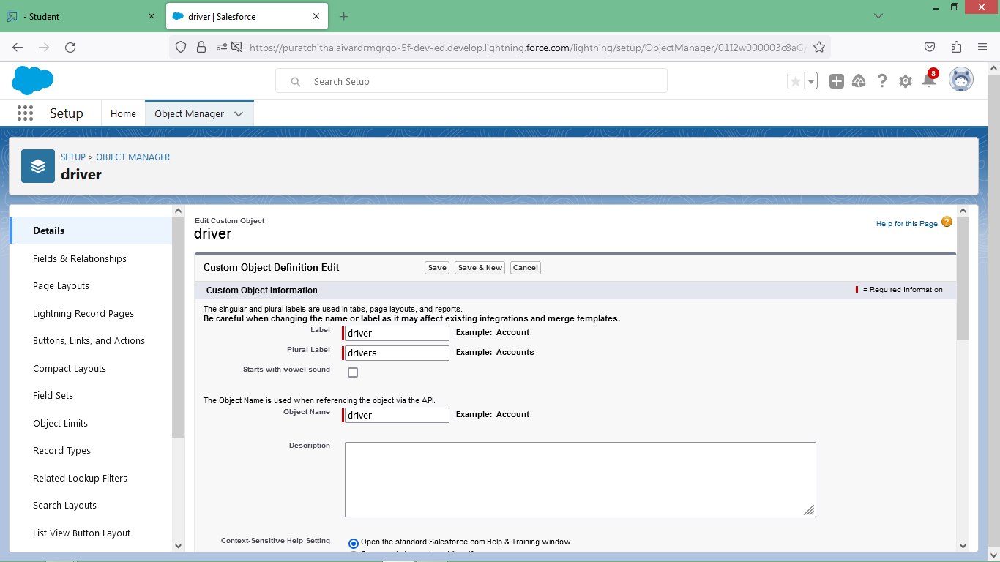

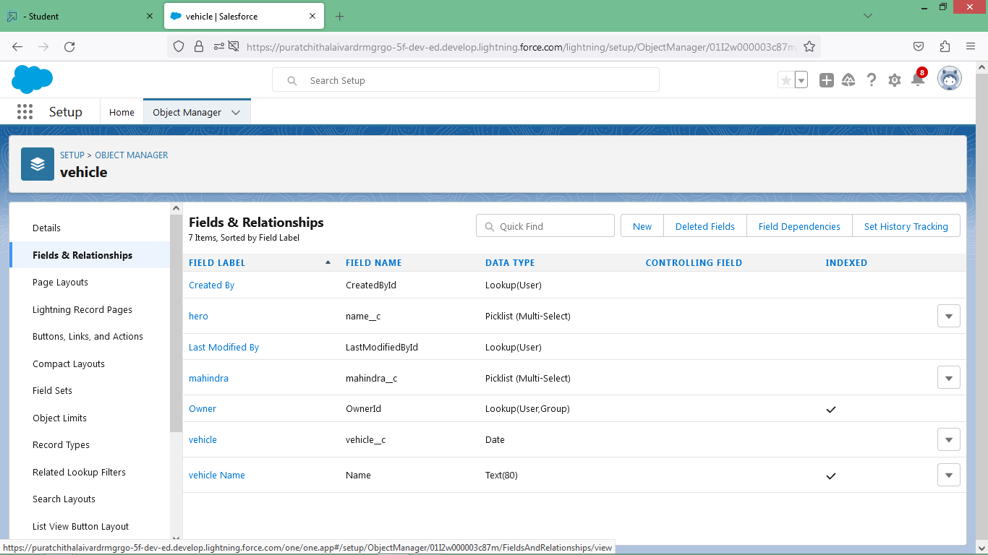

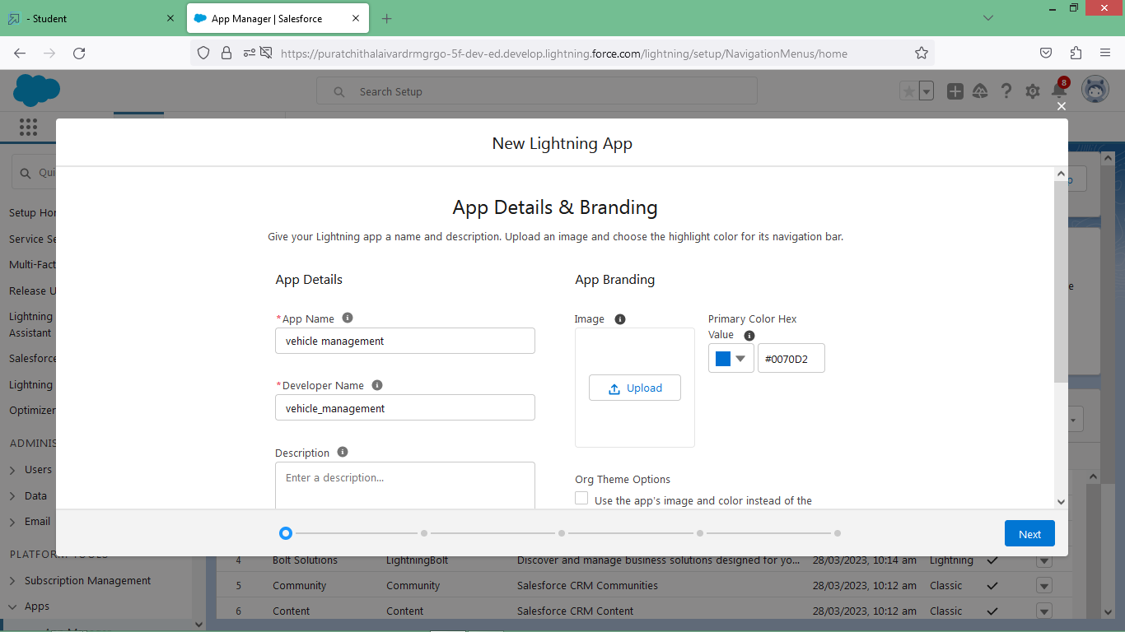

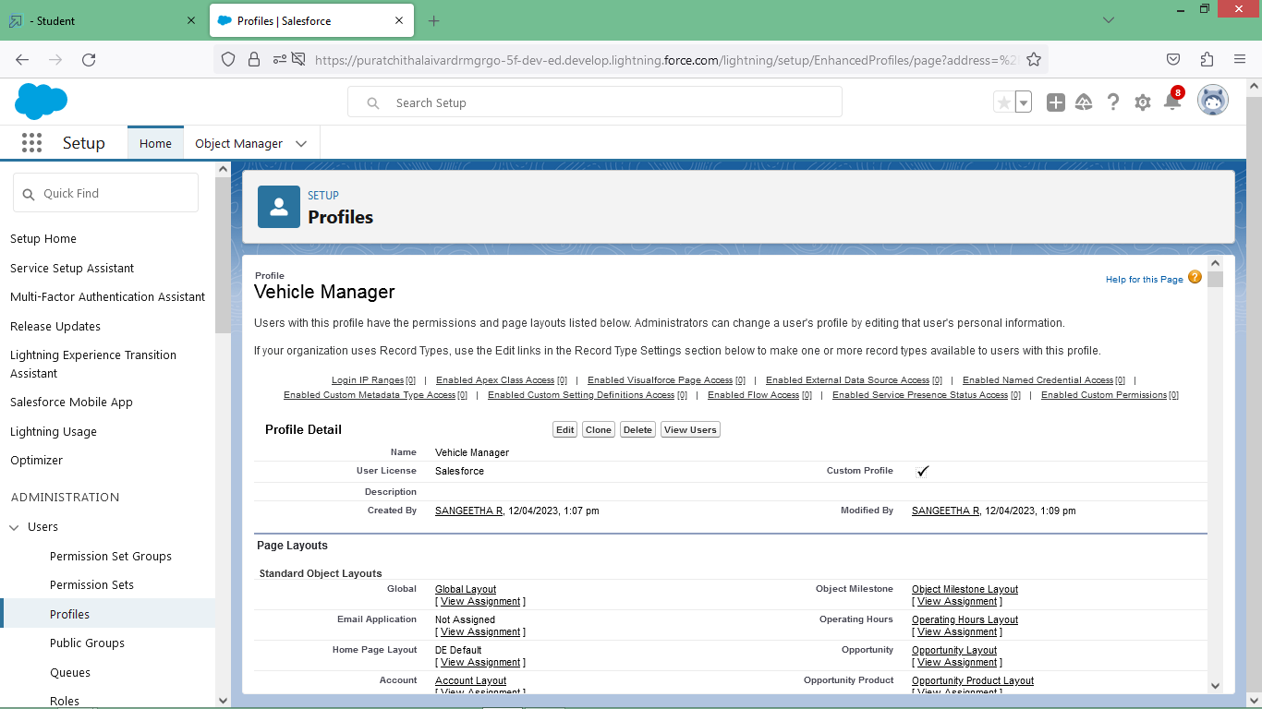

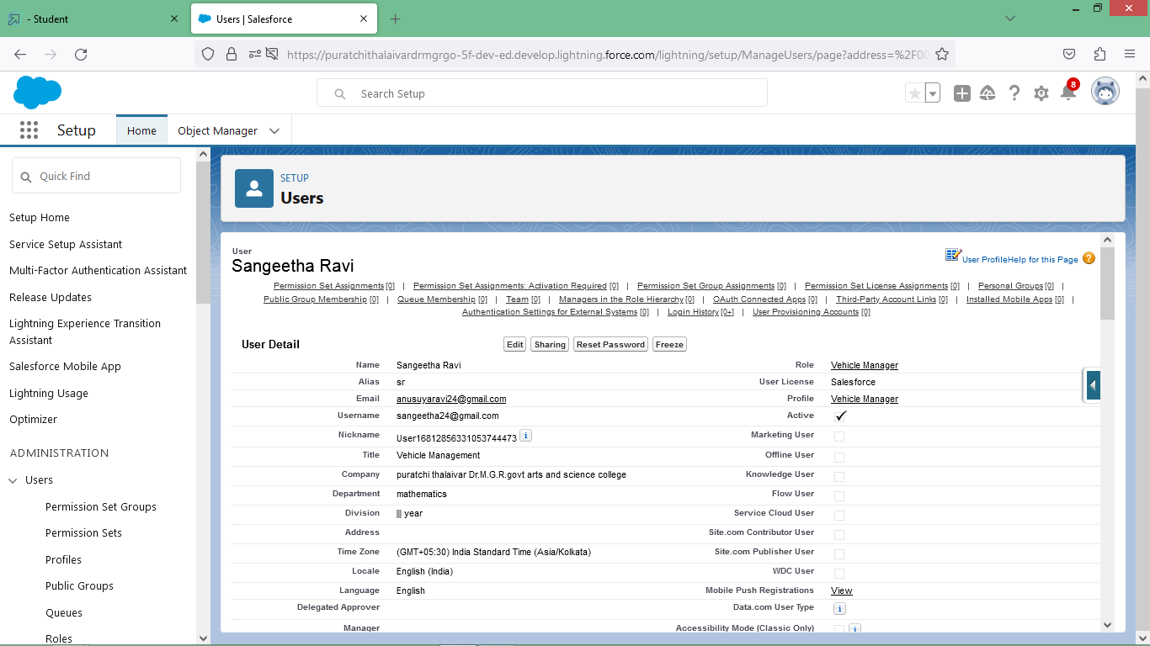

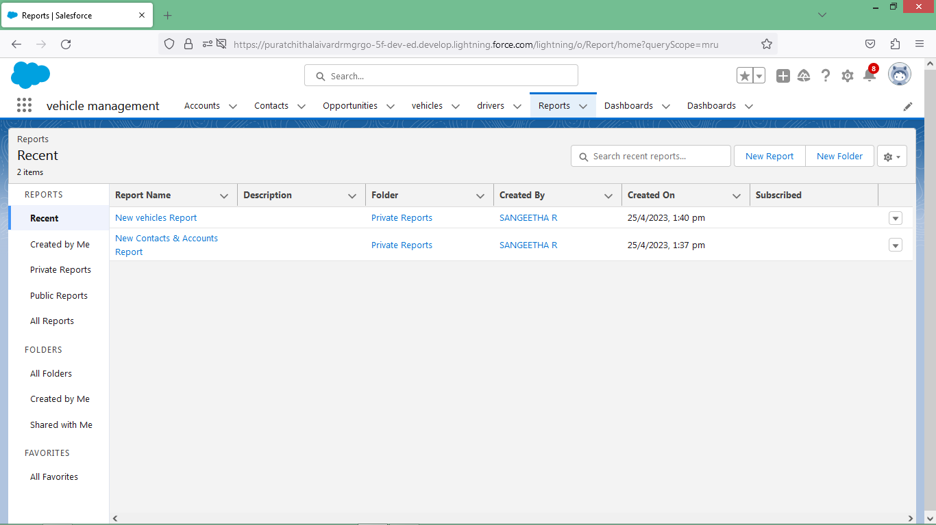

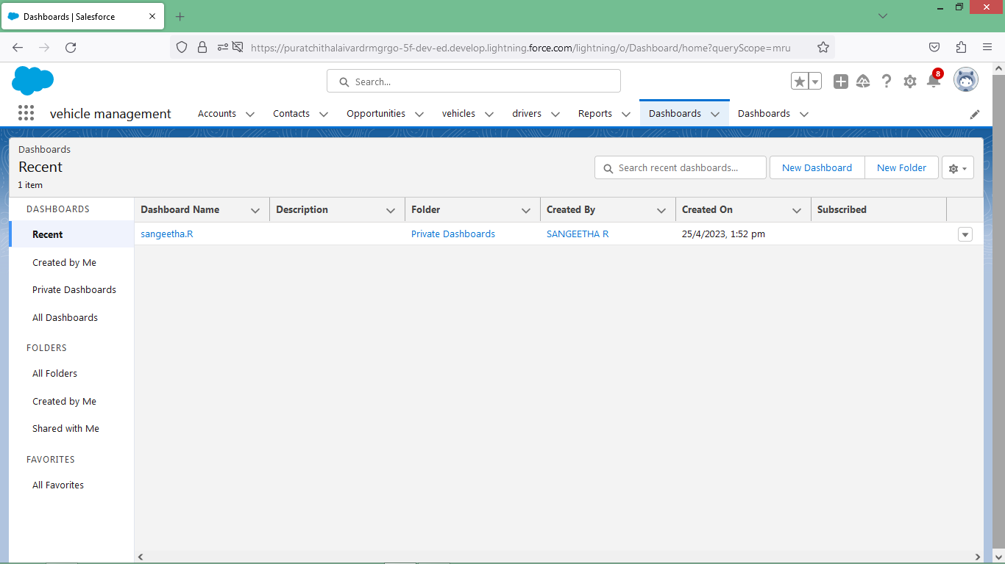

# Trailhead Profile Public URL

## 

## TEAM LEADER -<https://trailblazer.me/id/anusuyaravi24>

# Team Member 1 - <https://trailblazer.me/id/vasad9>

# Team Member 2- <https://trailblazer.me/id/sudhp21>

# Team Member 3- <https://trailblazer.me/id/sundv8>

# Team Member 4- <https://trailblazer.me/id/susil23>

## 

**ADVANTAGES**

Depending on the type of fleet being managed, a vehicle management system can reap a few or more business benefits. Notwithstanding that it largely depends on the quality of management conducted by the fleet owner, fleet manager or fleet operator, even mere few of these benefits can make a real difference in the fleet's performance efficiency, with substantial impact on ROI. That is to say, it may make the difference between a fleet of assets and a fleet of liabilities.

**Improved Record Keeping**: A vehicle management system keeps the record of every important function & daily activities such as vehicle type, vehicle fitness, document validity date, insurance policy, etc.

**Reducing Fuel Corruption and Costs**: Vehicle management system tracks all vehicle performance, employee performance, Inventory expense, Maintainers & maintenance expenses, etc. from A to Z.

**Safety and Breakdown Recovery**: It is the safest storehouse of all important data & recovery opportunities of any remote information to take managerial decisions became due to the vehicle management systems.

**Managing All Records of Company at Glance**: Here is the system for bringing your information under a unique server Manage companies all operations from one place & bring the whole enterprise at the fingers end.

**Tracking Inventory Easily:**Vehicle management has an integrated system to track & manage all-important assets & ensure the best profitability.

**DISADVANTAGES**

**Learning Curve**: As with all software systems, fleet management software also comes with a certain learning curve. Some systems can be so complicated that without aid from the software provider, you might not unlock the true potential of the tool at hand.

**Extra Cost**: Sure, you are bound to gain a lot from using a fleet management software system. The profits you'll make due to the software aid will eventually make up for the initial subscription cost. However, if you are a small business owner, the initial cost might seem like too much.

**Infrastructure Needs**: You'll face issues using fleet management software systems if you don't have proper network infrastructure. Without a stable Internet connection at all times, you will be missing out on the 'real-time' aspect of these systems. However, you can hardly do anything effectively without proper network infrastructure anyway.

# APPLICATIONS

The Vehicle Management System (VMS) is an application for the Automotive industry. It supports, in the area of Sales & Services, the business processes that you require as vehicle importer when dealing with your original equipment manufacturers (OEMs) and your dealers in new and used vehicle sales .

# CONCLUSION

Our project is only a humble venture to satisfy the needs to manage their project work. Several user friendly coding have also adopted. This package shall prove to be a powerful package in sat stying all the requirements of the school. The objective of software planning is to provide a frame work that enables the manger to make reasonable estimates made within a limited time frame at the beginning of the software project and should be updated regularly as the project progresses.

A description of the background and context of the project and its relation to work already done in the area.

Made statement of the aims and objectives of the project

The description of Purpose, Scope, and applicability.

We define the problem on which we are working in the project.

We describe the requirement Specifications of the system and the actions that can be done on these things

We understand the problem domain and produce a model of the system, which describes operations that can be performed on the system.

We included features and operations in detail, including screen layouts

We designed user interface and security issues related to system.

Finally the system is implemented and tested according to test cases.

**FUTURE SCOPE**

In a nutshell, it can be summarized that the future scope of the project circles around maintaining information regarding:

We can add printer in future.

We can give more advance software for Vehicle Management System including more facilities.

We will host the platform on online servers to make it accessible worldwide

Integrate multiple load balancers to distribute the loads of the system

Create the master and slave database structure to reduce the overload of the database queries

Implement the backup mechanism for taking backup of codebase and database on regular basis on different servers

The above mentioned points are the enhancements which can be done to increase the applicability and usage of this project. Here we can maintain the records of Vehicle and Driver. Also, as it can be seen that now-a-days the players are versatile. Le. so there is a scope for introducing a method to maintain the Vehicle Management System. Enhancements can be done to maintain all the Vehicle, Driver. Insurance, Maintanance, Fuel.

We have left all the options open so that if there is any other future requirement in the system by the user for the enhancement of the system then it is possible to implement them.In the last we would like to thanks all the persons involved in the development of the system directly or indirectly. We hope that the project will serve its purpose for which it is develop there by underlining success of process.