INDEX.JSP

<%@ page language=*"java"* contentType=*"text/html; charset=ISO-8859-1"*

pageEncoding=*"ISO-8859-1"*%>

<!DOCTYPE html PUBLIC "-//W3C//DTD HTML 4.01 Transitional//EN" "http://www.w3.org/TR/html4/loose.dtd">

<html>

<head>

<meta http-equiv=*"Content-Type"* content=*"text/html; charset=ISO-8859-1"*>

<title>ONLINE PIZZA ORDERING</title>

</head>

<link rel=*"stylesheet"* href=*"bootstrap/css/bootstrap.min.css"* type=*"text/css"* />

<style>

**body** {

background: *transparent url('pizza_large.jpg') no-repeat center center*;

background-size: *cover*;

}

*.main-content* {

width: *512px*;

margin: *150px auto*;

padding: *20px 0*;

}

**label** {

cursor: *pointer*;

}

</style>

<body>

<form class=*"main-content"*>

<div class=*"row"*>

<div class=*"col-xs-2"*>

<a class=*"btn btn-primary"* href=*"login.jsp"* role=*"button"*>Login</a>

</div>

<div class=*"col-xs-2"*>

<a class=*"btn btn-success"* href=*"signup.jsp"* role=*"button"*>Signup</a>

</div>

</div>

</form>

</body>

</html>

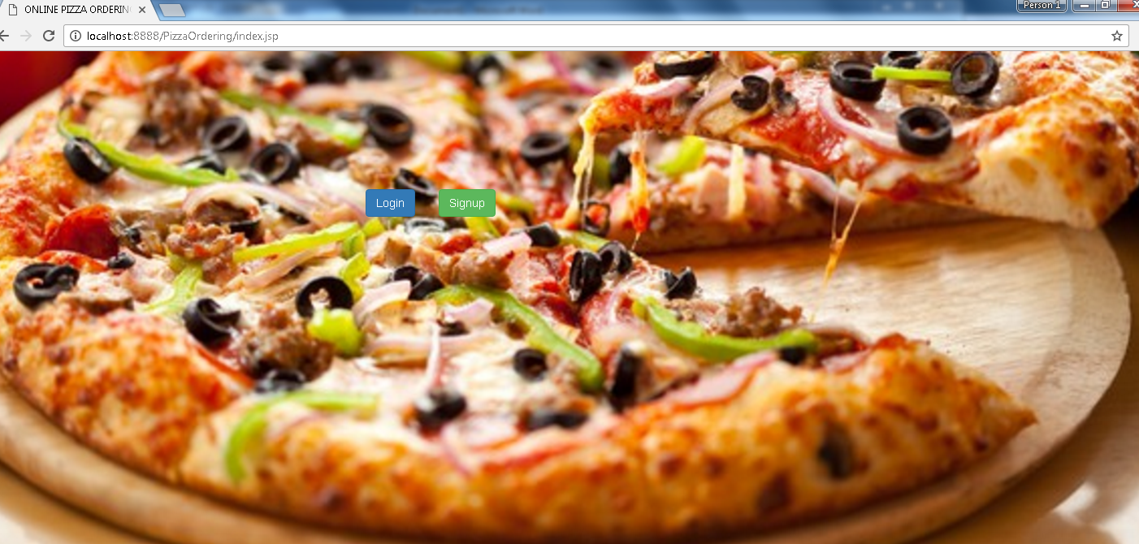

LOGIN.JSP

<%@ page language=*"java"* contentType=*"text/html; charset=ISO-8859-1"*

pageEncoding=*"ISO-8859-1"*%>

<!DOCTYPE html PUBLIC "-//W3C//DTD HTML 4.01 Transitional//EN" "http://www.w3.org/TR/html4/loose.dtd">

<html>

<head>

<meta http-equiv=*"Content-Type"* content=*"text/html; charset=ISO-8859-1"*>

<title>LOGIN PIZZA ORDERING</title>

<style>

**body** {

background: *transparent url('pizza.jpg') no-repeat center center*;

background-size: *cover*;

}

*.main-content* {

width: *512px*;

margin: *150px auto*;

padding: *20px 0*;

}

**label** {

cursor: *pointer*;

}

</style>

<link rel=*"stylesheet"* href=*"bootstrap/css/bootstrap.min.css"* type=*"text/css"* />

</head>

<body>

<form class=*"form-horizontal main-content"* action=*"loginvalidate.jsp"* method=*"post"*>

<div class=*"form-group"*>

<label for=*"auth_user"* class=*"col-sm-4 control-label"*>user name</label>

<div class=*"col-sm-8"*>

<input type=*"text"* class=*"form-control"* name=*"auth_user"* id=*"auth_user"* placeholder=*"Customer Id"* />

</div>

</div>

<div class=*"form-group"*>

<label for=*"auth_key"* class=*"col-sm-4 control-label"*>Password</label>

<div class=*"col-sm-8"*>

<input type=*"password"* class=*"form-control"* name=*"password"* id=*"password"* placeholder=*"Password"* id=*"auth_key"* />

</div>

</div>

<div class=*"form-group"*>

<div class=*"col-sm-offset-4 col-sm-2"*>

<div class=*"radio"*>

<label>

<input type=*"radio"* name=*"user_type"* value=*"corporate"* /> Admin

</label>

</div>

</div>

<div class=*"col-sm-offset-2 col-sm-2"*>

<div class=*"radio"*>

<label>

<input type=*"radio"* name=*"user_type"* value=*"retail"* /> User

</label>

</div>

</div>

</div>

<div class=*"form-group"*>

<div class=*"col-sm-offset-6 col-sm-2"*>

<button type=*"submit"* class=*"btn btn-primary"*>Sign in</button>

</div>

</div>

</form>

</body>

</html>

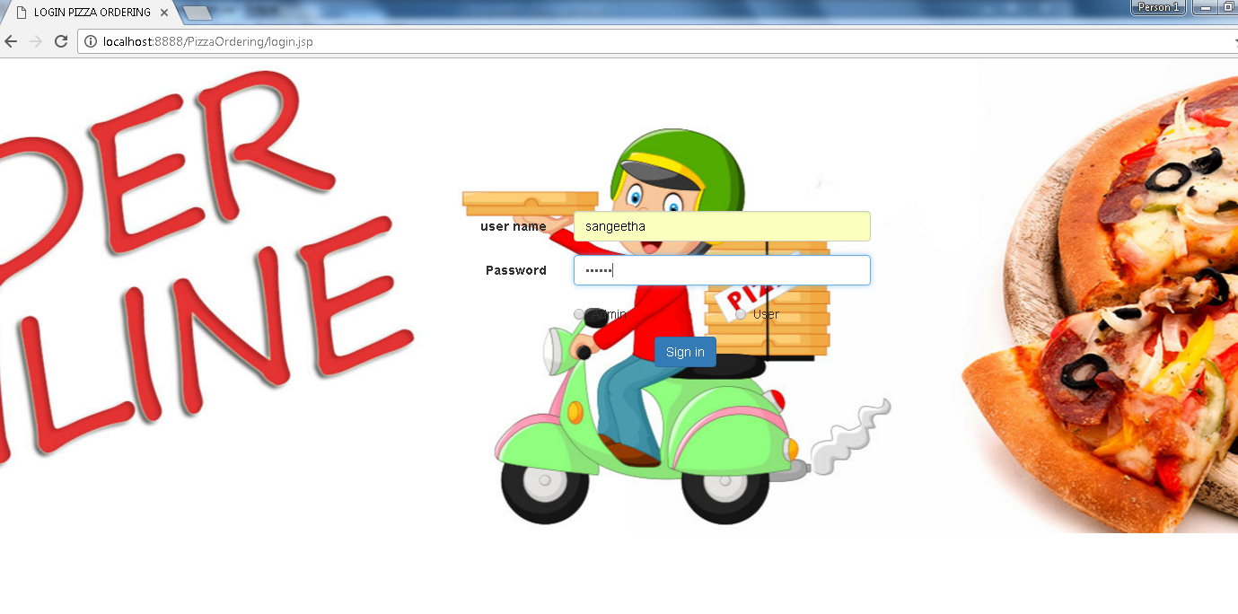

LOGIN VALIDATION.JSP

<%@ page language=*"java"* contentType=*"text/html; charset=ISO-8859-1"*

pageEncoding=*"ISO-8859-1"*%>

<%@ page import=*"java.sql.PreparedStatement, java.sql.ResultSet, com.pizza.util.Database ,com.pizza.util.Cookies"* %>

<!DOCTYPE html PUBLIC "-//W3C//DTD HTML 4.01 Transitional//EN" "http://www.w3.org/TR/html4/loose.dtd">

<html>

<head>

<meta http-equiv=*"Content-Type"* content=*"text/html; charset=ISO-8859-1"*>

<title>Login Validation</title>

</head>

<body>

<%

String user = request.getParameter("auth_user");

String key = request.getParameter("password");

Database db = **new** Database();

PreparedStatement ps = db.getPS("SELECT * FROM user_TBL WHERE username=? AND PASSWORD=? ");

ps.setString(1, user);

ps.setString(2, key);

ResultSet rs = ps.executeQuery();

**if**(rs.next()) {

out.println("Login Success");

Cookies.set(response,"auth_user",user);

out.println("<meta http-equiv='refresh' content='5,url=view.jsp'/>");

} **else** {

out.println("Failed");

out.println("<meta http-equiv='refresh' content='5,url=login.jsp'/>");

}

db.close();

%>

</body>

</html>

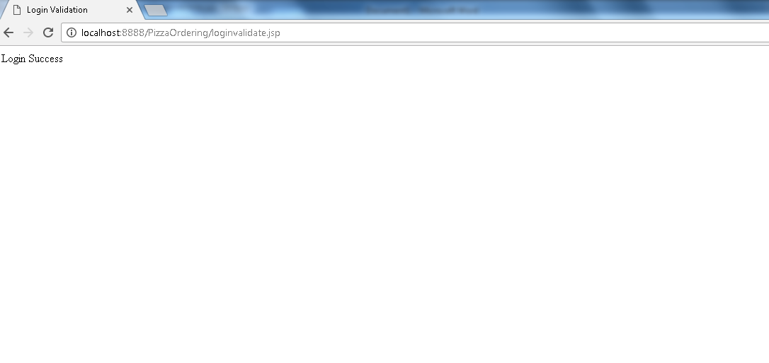

SIGNUP .JSP

<%@ page language=*"java"* contentType=*"text/html; charset=ISO-8859-1"*

pageEncoding=*"ISO-8859-1"*%>

<!DOCTYPE html PUBLIC "-//W3C//DTD HTML 4.01 Transitional//EN" "http://www.w3.org/TR/html4/loose.dtd">

<html>

<head>

<meta http-equiv=*"Content-Type"* content=*"text/html; charset=ISO-8859-1"*>

<title>ADD ACCOUNT</title>

<script type=*"text/javascript"*>

</script>

<style type=*"text/css"*>

**body** {

background: *transparent url('pizza.jpg') no-repeat center center*;

background-size: *cover*;

}

*.main-content* {

width: *512px*;

margin: *150px auto*;

}

**label** {

cursor: *pointer*;

}

**body** {

color: *blue*;

}

</style>

<link rel=*"stylesheet"* href=*"bootstrap/css/bootstrap.min.css"* type=*"text/css"* />

<link rel=*"stylesheet"* href=*"bootstrap/css/bootstrap-theme.min.css"* type=*"text/css"* />

</head>

<body>

<div class=*"main-content"*>

<form class=*"form-horizontal"* method=*"post"* action=*"update.jsp"* >

<div class=*"form-group"*>

<label for=*"name"* class=*"col-sm-4 control-label"*>User name</label>

<div class=*"col-sm-8"*>

<input type=*"text"* class=*"form-control"* id=*"auth_user"* name=*"auth_user"* placeholder=*"username"*>

</div>

</div>

<div class=*"form-group"*>

<label for=*"auth_dob"* class=*"col-sm-4 control-label"*>Password</label>

<div class=*"col-sm-8"*>

<input type=*"password"* class=*"form-control"* id=*"password"* name=*"password"* placeholder=*"password"*>

</div>

</div>

<div class=*"form-group"*>

<div class=*"col-sm-offset-4 col-sm-2"*>

<div class=*"radio"*>

<label>

<input type=*"radio"* name=*"user_type"* value=*"corporate"* /> Admin

</label>

</div>

</div>

<div class=*"col-sm-offset-2 col-sm-2"*>

<div class=*"radio"*>

<label>

<input type=*"radio"* name=*"user_type"* value=*"retail"* /> User

</label>

</div>

</div>

</div>

<div class=*"form-group"*>

<label for=*"auth_phone"* class=*"col-sm-4 control-label"*>Full name </label>

<div class=*"col-sm-8"*>

<input type=*"text"* class=*"form-control"* id=*"fullname"* name=*"fullname"* placeholder=*"full name"*>

</div>

</div>

<div class=*"form-group"*>

<label for=*"auth_email"* class=*"col-sm-4 control-label"*>Phone Number</label>

<div class=*"col-sm-8"*>

<input type=*"text"* class=*"form-control"* id=*"phoneNo"* name=*"phoneNo"* placeholder=*"phoneNo"*>

</div>

</div>

<div class=*"form-group"*>

<label for=*"auth_proof"* class=*"col-sm-4 control-label"*>Email</label>

<div class=*"col-sm-8"*>

<input type=*"text"* class=*"form-control"* id=*"email"* name=*"email"* placeholder=*"email"*>

</div>

</div>

<fieldset>

<legend>Communication Address</legend>

<div class=*"form-group"*>

<label for=*"door"* class=*"col-sm-4 control-label"*>DoorNo</label>

<div class=*"col-sm-8"*>

<input type=*"text"* class=*"form-control"* id=*"door"* name=*"door"* placeholder=*"Door No."*>

</div>

</div>

<div class=*"form-group"*>

<label for=*"street"* class=*"col-sm-4 control-label"*>StreetName</label>

<div class=*"col-sm-8"*>

<input type=*"text"* class=*"form-control"* id=*"street"* name=*"street"* placeholder=*"Street Name"*>

</div>

</div>

<div class=*"form-group"*>

<label for=*"location"* class=*"col-sm-4 control-label"*>Location</label>

<div class=*"col-sm-8"*>

<input type=*"text"* class=*"form-control"* id=*"location"* name=*"location"* placeholder=*"Location"*>

</div>

</div>

<div class=*"form-group"*>

<label for=*"city"* class=*"col-sm-4 control-label"*>City</label>

<div class=*"col-sm-8"*>

<input type=*"text"* class=*"form-control"* id=*"city"* name=*"city"* placeholder=*"City"*>

</div>

</div>

<div class=*"form-group"*>

<label for=*"pincode"* class=*"col-sm-4 control-label"*>PinCode</label>

<div class=*"col-sm-8"*>

<input type=*"text"* class=*"form-control"* id=*"pincode"* name=*"pincode"* placeholder=*"Pin code"*>

</div>

</div>

</fieldset>

<div class=*"form-group"*>

<div class=*"col-sm-offset-4 col-sm-8"*>

<button type=*"submit"* class=*"btn btn-primary col-sm-6"*>Submit Details</button>

</div>

</div>

</form>

</div>

</body>

</html>

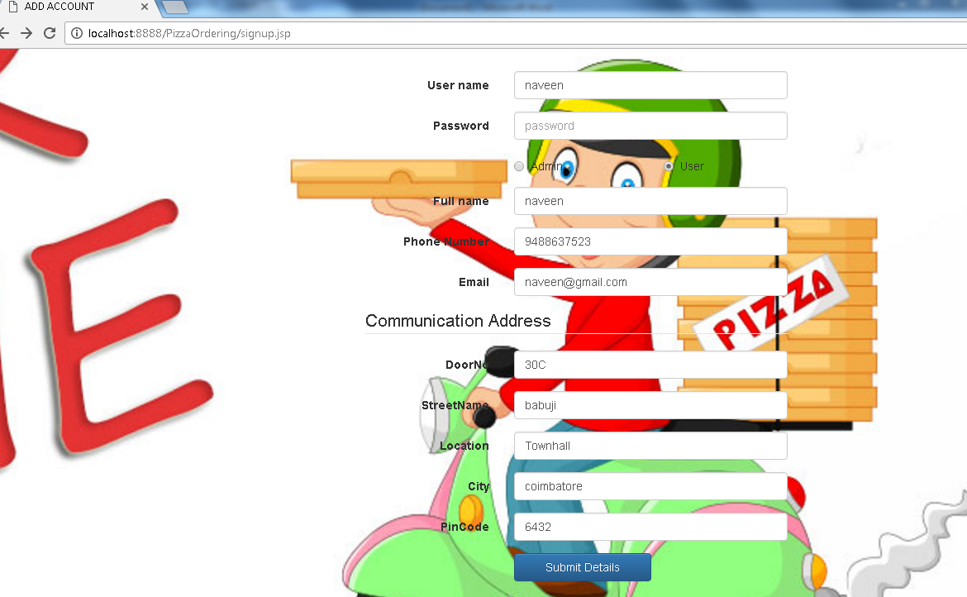

UPDATE.JSP

<%@ page language=*"java"* contentType=*"text/html; charset=ISO-8859-1"*

pageEncoding=*"ISO-8859-1"*%>

<%@ page import=*"java.sql.PreparedStatement, java.sql.ResultSet, com.pizza.util.Database ,com.pizza.util.Cookies"* %>

<!DOCTYPE html PUBLIC "-//W3C//DTD HTML 4.01 Transitional//EN" "http://www.w3.org/TR/html4/loose.dtd">

<html>

<head>

<meta http-equiv=*"Content-Type"* content=*"text/html; charset=ISO-8859-1"*>

<title>Insert title here</title>

</head>

<body>

</body>

</html>

<%

String username = request.getParameter("auth_user");

String password = request.getParameter("password");

String user_type= request.getParameter("user_type");

String fullname = request.getParameter("fullname");

String phoneNo = request.getParameter("phoneNo");

String email = request.getParameter("email");

String door= request.getParameter("door");

String street = request.getParameter("street");

String location= request.getParameter("location");

String city = request.getParameter("city");

String pincode = request.getParameter("pincode");

Database db = **new** Database();

PreparedStatement ps = db.getPS("insert into user_tbl values(?,?,?,?,?,?)");

ps.setString(1,username);

ps.setString(2,password);

ps.setString(3,user_type);

ps.setString(4,fullname);

ps.setString(5,phoneNo);

ps.setString(6,email);

ps.executeUpdate();

ps = db.getPS("insert into address_tbl values(?,?,?,?,?,?)");

ps.setString(1,username);

ps.setString(2,door);

ps.setString(3,street);

ps.setString(4,location);

ps.setString(5,city);

ps.setInt(6,Integer.parseInt(pincode));

ps.executeUpdate();

response.sendRedirect("login.jsp");

%>

VIEW.JSP

<%@ page language=*"java"* contentType=*"text/html; charset=ISO-8859-1"*

pageEncoding=*"ISO-8859-1"*%>

<%@ page import=*"java.sql.PreparedStatement, java.sql.ResultSet, com.pizza.util.Database ,com.pizza.util.Cookies,com.pizza.dao.*"* %>

<%@page import=*"java.util.List,java.util.LinkedList"* %>

<!DOCTYPE html PUBLIC "-//W3C//DTD HTML 4.01 Transitional//EN" "http://www.w3.org/TR/html4/loose.dtd">

<html>

<head>

<meta http-equiv=*"Content-Type"* content=*"text/html; charset=ISO-8859-1"*>

<title>VIEW PIZZA DETAILS</title>

<style>

**body** {

background: *transparent url('view1.jpg') no-repeat center center*;

background-size: *cover*;

}

*.main-content* {

width: *512px*;

margin: *150px auto*;

padding: *20px 0*;

}

**label** {

cursor: *pointer*;

}

</style>

<link rel=*"stylesheet"* href=*"bootstrap/css/bootstrap.min.css"* type=*"text/css"* />

</head>

<body>

&nbsp;

<p align=*"right"*>

<a class=*"btn btn-info"* href=*"logout.jsp"* role=*"button"*>Log Out</a>

</p>

<form class=*"form-inline main-content"* action=*"searchpizza.jsp"* method=*"post"*>

<div class=*"form-group"*>

<label for=*"Search"*></label>

<input type=*"search"* class=*"form-control"* id=*"search"* name=*"search"* placeholder=*"search"*>

<button type=*"submit"* class=*"btn btn-default btn-lg"*>

<span class=*"glyphicon glyphicon-search"* aria-hidden=*"true"*></span>

</button>

</div>

<div class=*"row"*> <p> </p></div>

<div class=*"row"*>

<div class=*"col-xs-2"*>

<a class=*"btn btn-default"* href=*"addnewpizza.jsp"* role=*"button"*>Add New</a>

</div>

</div>

</form>

</body>

</html>

<%

Database db = **new** Database();

PreparedStatement ps = db.getPS("select * from pizza_tbl");

ResultSet rs = ps.executeQuery();

String identity="";

String name="";

String toppings="";

String size="";

**double** price=0;

List<Pizza> ll = **new** LinkedList<Pizza>();

**while**(rs.next()) {

identity = rs.getString(1);

name=rs.getString(2);

toppings=rs.getString(3);

size= rs.getString(4);

price=rs.getDouble(5);

ll.add(**new** Pizza(identity,name,toppings,size,price));

}

%>

<%

out.println("<table class=\"table table-boarded\" >");

%>

<html>

<tr>

<td> <b>iIDENTITY </b> </td>

<td> <b>NAME</b> </td>

<td><b>TOPPINGS</b> </td>

<td> <b>SIZE </b></td>

<td> <b>PRICE</b> </td>

<td> <b>EDIT </b></td>

<td> <b>DELETE </b></td>

</tr>

<tr>

</html>

<%

**for**(Pizza each:ll)

{

out.println("<tr><td>"+each.getIdentity()+"</td><td>"+each.getName()+"</td><td>"+each.getToppings()+"</td><td>"+each.getSize()+"</td><td>"+each.getPrice()+"</td><td>");

out.println("<td> <form action=\"editpizza.jsp\" method=\"get\" ><input type=\"hidden\" name=\"id\" value="+each.getIdentity() +" /> <input type=\"submit\" value=\"Edit\" class=\"btn btn-info btn-xs\" />");

out.println(" </form> </td>");

out.println("<td> <form action=\"deletepizza.jsp\" method=\"get\" ><input type=\"hidden\" name=\"id\" value="+each.getIdentity() +" /> <input type=\"submit\" value=\"Delete\" class=\"btn btn-info-danger btn-xs\" />");

out.println(" </form> </td></tr>");

}

%>

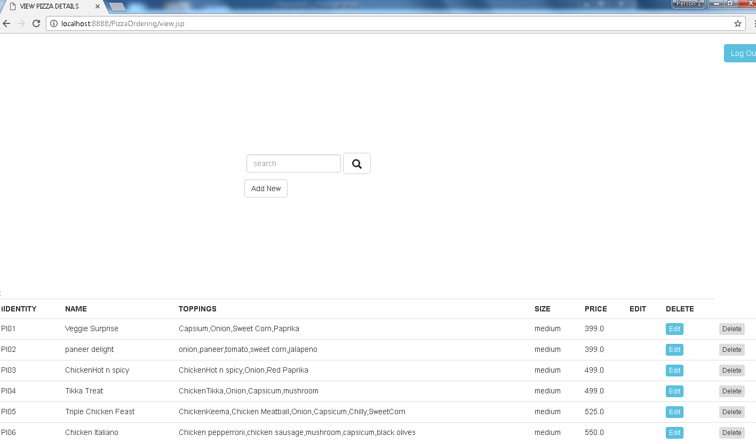

SEARCH PIZZA.JSP

<%@ page language=*"java"* contentType=*"text/html; charset=ISO-8859-1"*

pageEncoding=*"ISO-8859-1"*%>

<%@ page import=*"java.sql.PreparedStatement, java.sql.ResultSet, com.pizza.util.Database, com.pizza.util.Cookies, java.sql.Statement, java.sql.Connection,java.util.LinkedList,java.util.List,com.pizza.dao.*"* %>

<%

String search = request.getParameter("search");

Database db = **new** Database();

PreparedStatement ps = db.getPS("select * from pizza_tbl where identity like ? or name like ? or topping like ? or pizza_size like ? or price like ?");

ps.setString(1, "%"+search+"%");

ps.setString(2, "%"+search+"%");

ps.setString(3, "%"+search+"%");

ps.setString(4, "%"+search+"%");

ps.setString(5, "%"+search+"%");

ResultSet rs = ps.executeQuery();

String identity="";

String name="";

String toppings="";

String size="";

**double** price=0;

List<Pizza> ll = **new** LinkedList<Pizza>();

**while**(rs.next()) {

identity = rs.getString(1);

name=rs.getString(2);

toppings=rs.getString(3);

size=rs.getString(4);

price=rs.getDouble(5);

ll.add(**new** Pizza(identity,name,toppings,size,price));

}%>

<!DOCTYPE html PUBLIC "-//W3C//DTD HTML 4.01 Transitional//EN" "http://www.w3.org/TR/html4/loose.dtd">

<html>

<head>

<style type=*"text/css"*>

**body** {

background: *transparent url('search.jpg') no-repeat center center*;

background-size: *cover*;

}

*.main-content* {

width: *512px*;

margin: *150px auto*;

}

</style>

<meta http-equiv=*"Content-Type"* content=*"text/html; charset=ISO-8859-1"*>

<title>Search</title>

<link rel=*"stylesheet"* href=*"bootstrap/css/bootstrap.min.css"* type=*"text/css"* />

<link rel=*"stylesheet"* href=*"bootstrap/css/bootstrap-theme.min.css"* type=*"text/css"* />

</head>

<body>

<form class=*"form-inline main-content"* action=*"searchpizza.jsp"* method=*"post"*>

<div class=*"form-group"*>

<label for=*"search"* ">Search</label>

<input type=*"text"* class=*"form-control"* id=*"search"* name=*"search"* placeholder=*"Search"* value=*"*<% out.println(search);%>*"*>

</div>

<button type=*"submit"* class=*"btn btn-default"*>

<span class=*"glyphicon glyphicon-search"* aria-hidden=*"true"*></span>

</button>

</form>

</body>

</html>

<%

out.println("<table class=\"table table-bordered\" >");

%>

<html>

<tr>

<td> <b>IDENTITY </b> </td>

<td> <b>NAME</b> </td>

<td><b>TOPPINGS</b> </td>

<td> <b>SIZE</b></td>

<td> <b>PRICE</b> </td>

</tr>

<tr>

</html>

<%

**for**(Pizza each:ll) {

out.println("<tr><td>"+each.getIdentity()+"</td><td>"+each.getName()+"</td><td>"+each.getToppings()+"</td><td>"+each.getSize()+"</td><td>"+each.getPrice()+"</td><td>");

}

out.println("</table>");

%>

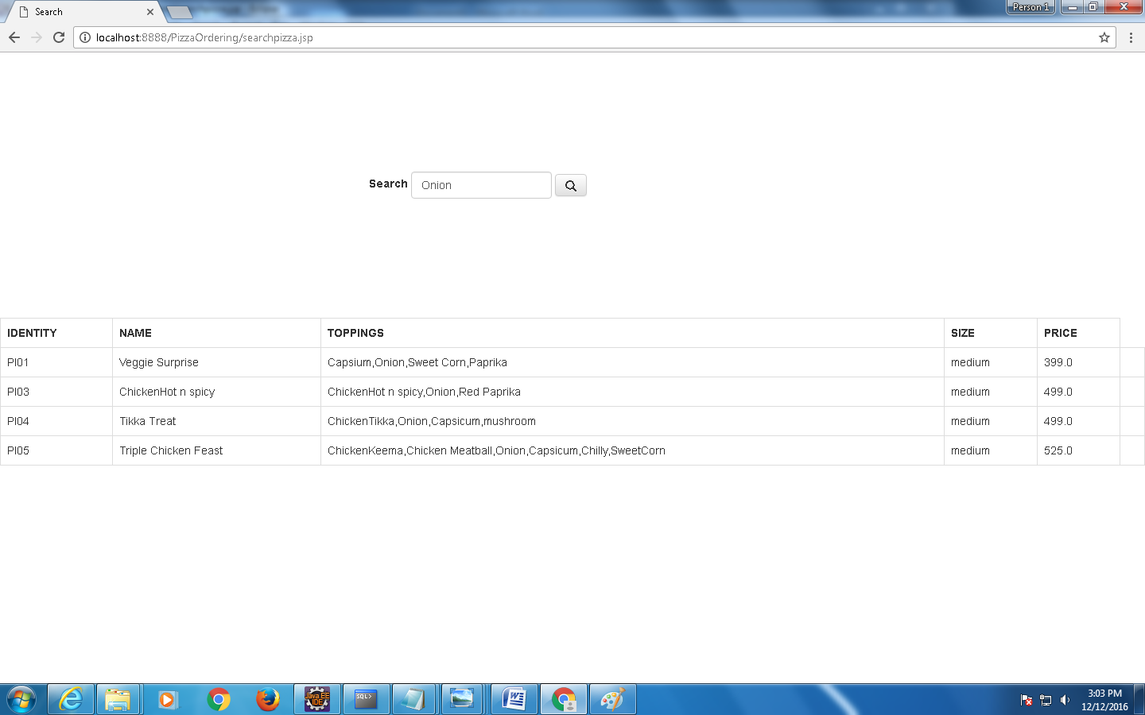

ADDNEW PIZZA.JSP

<%@ page language=*"java"* contentType=*"text/html; charset=ISO-8859-1"*

pageEncoding=*"ISO-8859-1"*%>

<!DOCTYPE html PUBLIC "-//W3C//DTD HTML 4.01 Transitional//EN" "http://www.w3.org/TR/html4/loose.dtd">

<html>

<head>

<meta http-equiv=*"Content-Type"* content=*"text/html; charset=ISO-8859-1"*>

<title>Add New Product</title>

<script type=*"text/javascript"*>

</script>

<style type=*"text/css"*>

**body** {

background: *transparent url('view.jpg') no-repeat center center*;

background-size: *cover*;

}

*.main-content* {

width: *512px*;

margin: *150px auto*;

}

**label** {

cursor: *pointer*;

}

</style>

<link rel=*"stylesheet"* href=*"bootstrap/css/bootstrap.min.css"* type=*"text/css"* />

<link rel=*"stylesheet"* href=*"bootstrap/css/bootstrap-theme.min.css"* type=*"text/css"* />

</head>

<body>

<div class=*"main-content"*>

<form class=*"form-horizontal"* method=*"post"* action=*"updatepizza.jsp"* >

<div class=*"form-group"*>

<label for=*"identity"* class=*"col-sm-4 control-label"*>Pizza Identity</label>

<div class=*"col-sm-8"*>

<input type=*"text"* class=*"form-control"* id=*"identity"* name=*"identity"* placeholder=*"identity"*>

</div>

</div>

<div class=*"form-group"*>

<label for=*"name"* class=*"col-sm-4 control-label"*>Pizza NAME</label>

<div class=*"col-sm-8"*>

<input type=*"text"* class=*"form-control"* id=*"name"* name=*"name"* placeholder=*"name"*>

</div>

</div>

<div class=*"form-group"*>

<label for=*"toppings"* class=*"col-sm-4 control-label"*>Toppings </label>

<div class=*"col-sm-8"*>

<input type=*"text"* class=*"form-control"* id=*"toppings"* name=*"toppings"* placeholder=*"add toppings"*>

</div>

</div>

<div class=*"form-group"*>

<label for=*"size"* class=*"col-sm-4 control-label"*>Size</label>

<div class=*"col-sm-8"*>

<input type=*"text"* class=*"form-control"* id=*"size"* name=*"size"* placeholder=*"size"*>

</div>

</div>

<div class=*"form-group"*>

<label for=*"auth_proof"* class=*"col-sm-4 control-label"*>Price</label>

<div class=*"col-sm-8"*>

<input type=*"text"* class=*"form-control"* id=*"price"* name=*"price"* placeholder=*"price"*>

</div>

</div>

<div class=*"form-group"*>

<div class=*"col-sm-offset-4 col-sm-8"*>

<button type=*"submit"* class=*"btn btn-primary col-sm-6"*>Submit Details</button>

</div>

</div>

</form>

</div>

</body>

</html>

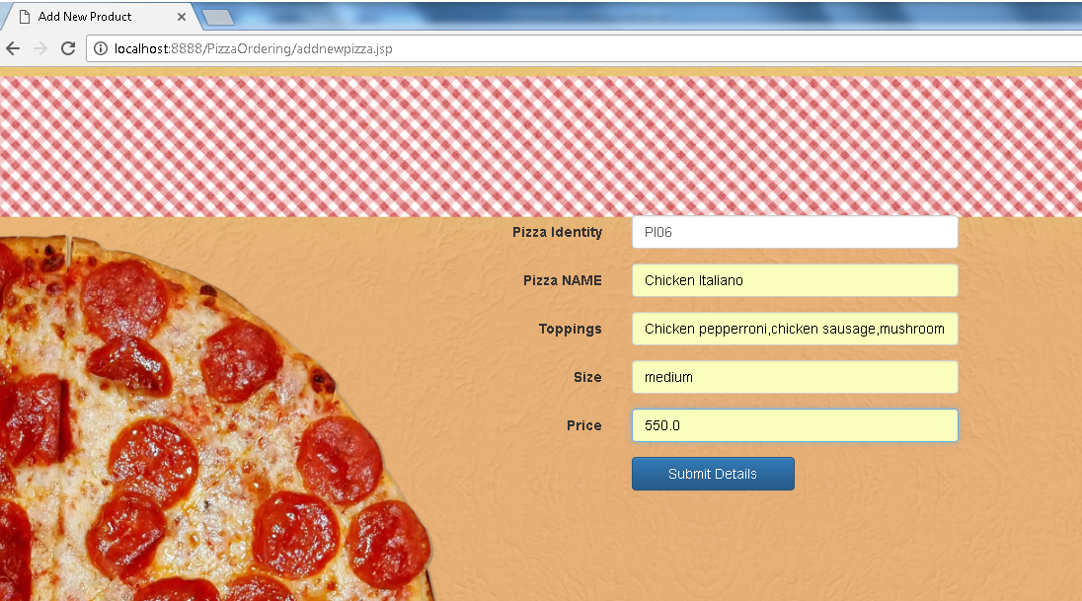

UPDATE NEW PIZZA.JSP

<%@ page language=*"java"* contentType=*"text/html; charset=ISO-8859-1"*

pageEncoding=*"ISO-8859-1"*%>

<%@ page import=*"java.sql.PreparedStatement, java.sql.ResultSet, com.pizza.util.Database ,com.pizza.util.Cookies"* %>

<!DOCTYPE html PUBLIC "-//W3C//DTD HTML 4.01 Transitional//EN" "http://www.w3.org/TR/html4/loose.dtd">

<html>

<head>

<meta http-equiv=*"Content-Type"* content=*"text/html; charset=ISO-8859-1"*>

<title>Insert title here</title>

</head>

<body>

</body>

</html>

<%

String identity = request.getParameter("identity");

String name = request.getParameter("name");

String toppings = request.getParameter("toppings");

String size = request.getParameter("size");

String price = request.getParameter("price");

Database db = **new** Database();

PreparedStatement ps = db.getPS("insert into pizza_tbl values(?,?,?,?,?)");

ps.setString(1,identity);

ps.setString(2,name);

ps.setString(3,toppings);

ps.setString(4,size);

ps.setDouble(5,Double.parseDouble(price));

ps.executeUpdate();

response.sendRedirect("view.jsp");

%>

EDITPIZZA.JSP

<%@ page language=*"java"* contentType=*"text/html; charset=ISO-8859-1"*

pageEncoding=*"ISO-8859-1"*%>

<%@ page import=*"java.sql.PreparedStatement, java.sql.ResultSet, com.pizza.util.Database ,com.pizza.util.Cookies,com.pizza.dao.*"* %>

<%@page import=*"java.util.List,java.util.LinkedList"* %>

<%

String id=request.getParameter("id");

Database db = **new** Database();

PreparedStatement ps = db.getPS("select * from pizza_tbl");

ResultSet rs = ps.executeQuery();

String identity="";

String name="";

String toppings="";

String size="";

**double** price=0;

List<Pizza> ll = **new** LinkedList<Pizza>();

**while**(rs.next()) {

identity = rs.getString(1);

name=rs.getString(2);

toppings=rs.getString(3);

size= rs.getString(4);

price=rs.getDouble(5);

ll.add(**new** Pizza(identity,name,toppings,size,price));

}

%>

<!DOCTYPE html PUBLIC "-//W3C//DTD HTML 4.01 Transitional//EN" "http://www.w3.org/TR/html4/loose.dtd">

<html>

<head>

<meta http-equiv=*"Content-Type"* content=*"text/html; charset=ISO-8859-1"*>

<link rel=*"stylesheet"* href=*"bootstrap/css/bootstrap.min.css"* type=*"text/css"*/>

<title>Edit</title>

</head>

<body>

<br>

<form class=*"form-horizontal"* action=*"updateeditpizza.jsp"* method=*"post"*>

<div class=*"form-group"*>

<label for=*"identity"* class=*"col-sm-4 control-label"*></label>

<div class=*"col-sm-2"*>

<input type=*"text"* id=*"identity"* name=*"identity"* class=*"form-control"* placeholder=*"identity"* value=*"*<%out.println(id);%>*"*readonly>

</div>

</div>

<div class=*"form-group"*>

<label for=*"name"* class=*"col-sm-4 control-label"*>Pizza Name</label>

<div class=*"col-sm-2"*>

<input type=*"text"* class=*"form-control"* id=*"name"* name=*"name"* placeholder=*"Name"* value=*"*<%out.println(name);%>*"* >

</div>

</div>

<div class=*"form-group"*>

<label for=*"toppings"* class=*"col-sm-4 control-label"*>Pizza Toppings</label>

<div class=*"col-sm-2"*>

<input type=*"text"* class=*"form-control"* id=*"toppings"* name=*"toppings"* placeholder=*"Toppings"* value=*"*<%out.println(toppings);%>*"*>

</div>

</div>

<div class=*"form-group"*>

<label for=*"size"* class=*"col-sm-4 control-label"*>Pizza Size</label>

<div class=*"col-sm-2"*>

<input type=*"text"* class=*"form-control"* id=*"size"* name=*"size"* placeholder=*"Size"*value=*"*<%out.println(size);%>*"* >

</div>

</div>

<div class=*"form-group"*>

<label for=*"price"* class=*"col-sm-4 control-label"*>Pizza Price</label>

<div class=*"col-sm-2"*>

<input type=*"text"* class=*"form-control"* id=*"price"* name=*"price"* placeholder=*"Price"* value=*"*<%out.println(price);%>*"*>

</div>

</div>

<div class=*"form-group"*>

<div class=*"col-sm-offset-4 col-sm-10"*>

<button type=*"submit"* class=*"btn btn-default"*>Submit</button>

</div>

</div>

</body>

</html>

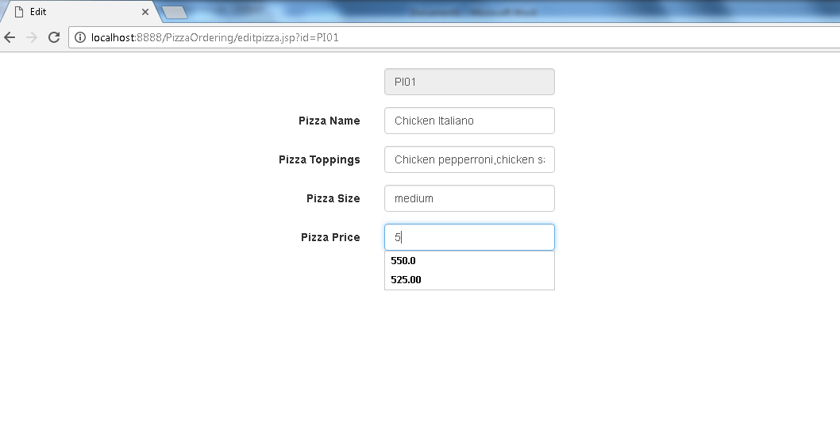

UPDATE EDIT PIZZA.JSP

<%@ page language=*"java"* contentType=*"text/html; charset=ISO-8859-1"*

pageEncoding=*"ISO-8859-1"*%>

<%@ page import=*"java.sql.PreparedStatement, java.sql.ResultSet, com.pizza.util.Database ,com.pizza.util.Cookies"* %>

<!DOCTYPE html PUBLIC "-//W3C//DTD HTML 4.01 Transitional//EN" "http://www.w3.org/TR/html4/loose.dtd">

<html>

<head>

<meta http-equiv=*"Content-Type"* content=*"text/html; charset=ISO-8859-1"*>

<title>Insert title here</title>

</head>

<body>

<%

String identity = request.getParameter("identity");

String name = request.getParameter("name");

String toppings = request.getParameter("toppings");

String size = request.getParameter("size");

String price = request.getParameter("price");

Database db = **new** Database();

PreparedStatement ps = db.getPS("update pizza_tbl set name=?,topping=?,pizza_size=?,price=? where identity=?");

ps.setString(1,name);

ps.setString(2,toppings);

ps.setString(3,size);

ps.setString(4,price);

ps.setString(5,identity);

ps.executeUpdate();

out.println("<meta http-equiv='refresh' content='0,url=view.jsp'/>");

%>

</body>

</html>

DELETE PIZZA.JSP

<%@ page language=*"java"* contentType=*"text/html; charset=ISO-8859-1"*

pageEncoding=*"ISO-8859-1"*%>

<%@ page import=*"java.sql.PreparedStatement, java.sql.ResultSet, com.pizza.util.Database ,com.pizza.util.Cookies"* %>

<!DOCTYPE html PUBLIC "-//W3C//DTD HTML 4.01 Transitional//EN" "http://www.w3.org/TR/html4/loose.dtd">

<html>

<head>

<meta http-equiv=*"Content-Type"* content=*"text/html; charset=ISO-8859-1"*>

<title>Insert title here</title>

</head>

<body>

</body>

</html>

<%

String identity=request.getParameter("id");

Database db = **new** Database();

PreparedStatement ps = db.getPS("delete from pizza_tbl where identity=?");

ps.setString(1,identity);

ps.executeUpdate();

out.println("<meta http-equiv='refresh' content='5,url=view.jsp'/>");

%>

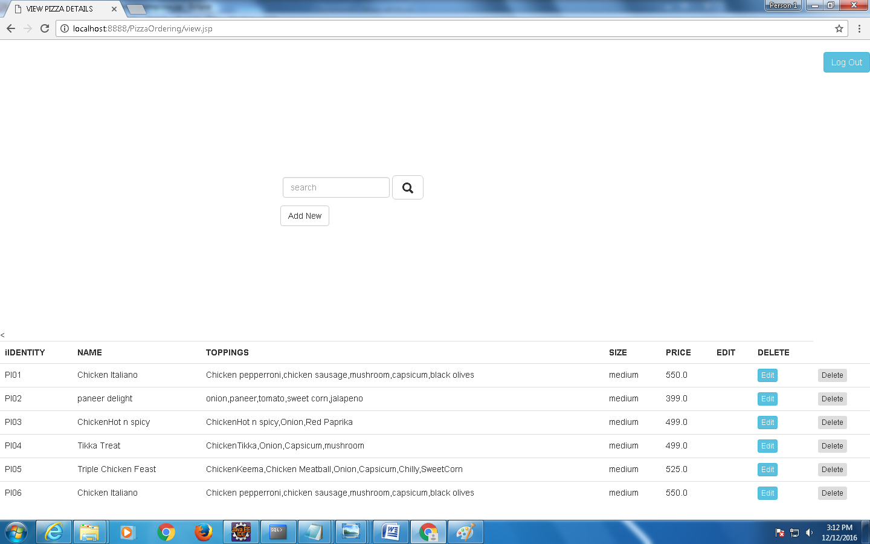

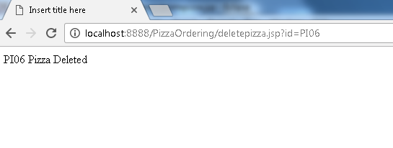

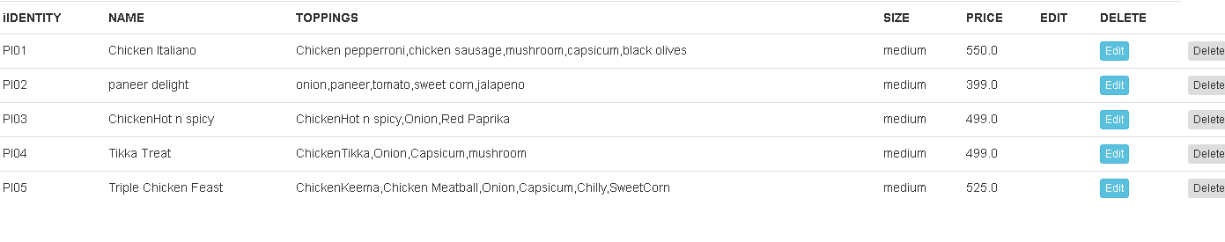

LOGOUT.JSP

<%@ page language=*"java"* contentType=*"text/html; charset=ISO-8859-1"*

pageEncoding=*"ISO-8859-1"*%>

<!DOCTYPE html PUBLIC "-//W3C//DTD HTML 4.01 Transitional//EN"

"http://www.w3.org/TR/html4/loose.dtd">

<html>

<head>

<meta http-equiv=*"Content-Type"* content=*"text/html; charset=ISO-8859-1"*>

<title>Insert title here</title>

</head>

<body>

<%

Cookie cks[] = request.getCookies();

**boolean** status = **false**;

**for**(**int** i = 0; i < cks.length; i++) {

**if**(cks[i].getName().equals("auth_user")) {

cks[i].setMaxAge(0);

response.addCookie(cks[i]);

status = **true**;

}

}

**if**(!status) {

out.println("Not Logged in");

} **else** {

out.println("<p> Log out success. <a href='index.jsp'>Login Again</a></p>");

}

%>

</body>

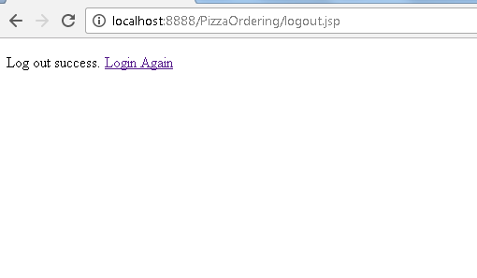

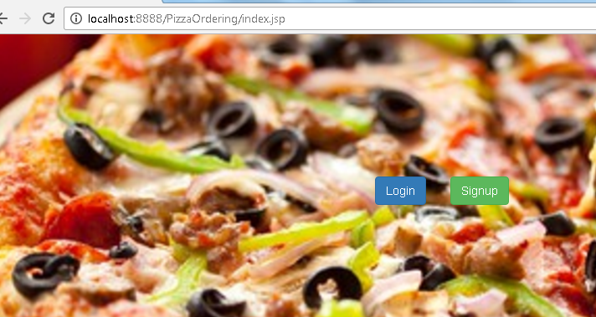

PROJECT LIBRARIES:

PIZZA .JAVA

**package** com.pizza.dao;

**public** **class** Pizza {

**private** String identity;

**private** String name;

**private** String toppings;

**private** String size;

**private** **double** price;

**public** Pizza(String identity, String name, String toppings, String size, **double** price) {

**super**();

**this**.identity = identity;

**this**.name = name;

**this**.toppings = toppings;

**this**.size = size;

**this**.price = price;

}

**public** String getIdentity() {

**return** identity;

}

**public** String getName() {

**return** name;

}

**public** **void** setName(String name) {

**this**.name = name;

}

**public** String getToppings() {

**return** toppings;

}

**public** **void** setToppings(String toppings) {

**this**.toppings = toppings;

}

**public** String getSize() {

**return** size;

}

**public** **void** setSize(String size) {

**this**.size = size;

}

**public** **double** getPrice() {

**return** price;

}

**public** **void** setPrice(**double** price) {

**this**.price = price;

}

}

ADDRESS.JAVA

**package** com.pizza.dao;

**public** **class** Address {

**private** String doorNo;

**private** String streetName;

**private** String location;

**private** String city;

**private** **int** pincode;

**public** Address(String doorNo, String streetName, String location, String city, **int** pincode) {

**super**();

**this**.doorNo = doorNo;

**this**.streetName = streetName;

**this**.location = location;

**this**.city = city;

**this**.pincode = pincode;

}

**public** String getDoorNo() {

**return** doorNo;

}

**public** **void** setDoorNo(String doorNo) {

**this**.doorNo = doorNo;

}

**public** String getStreetName() {

**return** streetName;

}

**public** **void** setStreetName(String streetName) {

**this**.streetName = streetName;

}

**public** String getLocation() {

**return** location;

}

**public** **void** setLocation(String location) {

**this**.location = location;

}

**public** String getCity() {

**return** city;

}

**public** **void** setCity(String city) {

**this**.city = city;

}

**public** **int** getPincode() {

**return** pincode;

}

**public** **void** setPincode(**int** pincode) {

**this**.pincode = pincode;

}

}

USER.JAVA

**package** com.pizza.dao;

**public** **class** User {

**private** String username;

**private** String password;

**private** String userType;

**private** String fullname;

**private** String phoneNo;

**private** String email;

**private** Address address;

**public** User(String username, String password, String userType, String fullname, String phoneNo, String email,

Address address) {

**super**();

**this**.username = username;

**this**.password = password;

**this**.userType = userType;

**this**.fullname = fullname;

**this**.phoneNo = phoneNo;

**this**.email = email;

**this**.address = address;

}

**public** String getUsername() {

**return** username;

}

**public** **void** setUsername(String username) {

**this**.username = username;

}

**public** String getPassword() {

**return** password;

}

**public** **void** setPassword(String password) {

**this**.password = password;

}

**public** String getUserType() {

**return** userType;

}

**public** **void** setUserType(String userType) {

**this**.userType = userType;

}

**public** String getFullname() {

**return** fullname;

}

**public** **void** setFullname(String fullname) {

**this**.fullname = fullname;

}

**public** String getPhoneNo() {

**return** phoneNo;

}

**public** **void** setPhoneNo(String phoneNo) {

**this**.phoneNo = phoneNo;

}

**public** String getEmail() {

**return** email;

}

**public** **void** setEmail(String email) {

**this**.email = email;

}

**public** Address getAddress() {

**return** address;

}

**public** **void** setAddress(Address address) {

**this**.address = address;

}

}

DATABASE.JAVA

**package** com.pizza.util;

**import** java.sql.Connection;

**import** java.sql.DriverManager;

**import** java.sql.PreparedStatement;

**public** **class** Database {

**private** Connection connection;

**private** PreparedStatement ps;

**public** **void** close() {

**try** {

**if**(ps != **null**) {

ps.close();

}

**if**(connection != **null**) {

connection.close();

}

} **catch**(Exception e) {}

}

**public** PreparedStatement getPS(String query) {

**try** {

Class.*forName*("oracle.jdbc.driver.OracleDriver");

connection = DriverManager.*getConnection*("jdbc:oracle:thin:@localhost:1521:xe", "system", "oracle");

ps = connection.prepareStatement(query);

**return** ps;

} **catch**(Exception e) {

System.***out***.println(e);

**return** **null**;

}

}

}

COOKIES.JAVA

**package** com.pizza.util;

**import** javax.servlet.http.Cookie;

**import** javax.servlet.http.HttpServletRequest;

**import** javax.servlet.http.HttpServletResponse;

**public** **class** Cookies {

**public** **static** String get(HttpServletRequest request, String name) {

String value = **null**;

Cookie cks[] = request.getCookies();

**for**(**int** i = 0; i < cks.length; i++) {

**if**(cks[i].getName().equals(name)) {

value = cks[i].getValue();

**break**;

}

}

**return** value;

}

**public** **static** **void** set(HttpServletResponse response, String name) {

Cookie ck = **new** Cookie(name, "");

ck.setMaxAge(0);

response.addCookie(ck);

}

**public** **static** **void** set(HttpServletResponse response, String name, String value) {

Cookie ck = **new** Cookie(name, value);

ck.setMaxAge(24 * 60 * 60);

response.addCookie(ck);

}

**public** **static** **void** set(HttpServletResponse response, String name, String value, **int** age) {

Cookie ck = **new** Cookie(name, value);

ck.setMaxAge(age);

response.addCookie(ck);

}

}