Bachelor's thesis

Information Technology

Networking

2013

Hari Krishna Mahat

DESIGNING A LOGICAL DATA
MODEL FOR A SALES AND

INVENTORY MANAGEMENT SYSTEM



BACHELOR´S THESIS | ABSTRACT

TURKU UNIVERSITY OF APPLIED SCIENCES

Degree programme | Information technology

December 2013| 39

Instructor: Yngvar Wikstrom M.Eng

Author: Hari Krishna Mahat

DESIGNING A LOGICAL DATA MODEL FOR A
SALES AND INVENTORY MANAGEMENT SYSTEM

The aim of this thesis was to design a Sales and Inventory Management System (SIM), that is, a database describing the customer orders and products distributed by the company.

The SIM system shall help in the management of product sales and processing, inventory management process and operation outside the book-keeping system already in use. The SIM system shall be based on a Database Management System. The purpose of the SIM database system is to maintain the data that is used and generated from the warehouse staff and sales staff. Then the data stored will be used to facilitate smooth running of sales operation and stock management. The sole aim and objective of this thesis was to create a logical data model independent of Relational Database Management System for Sales and Inventory Management System.

All the data generated during the business process was studied to design a very well functioning database that will comfort the growth of company. Sales staff and warehouse staff were interviewed, in total 11, on their needs and requirements. These needs and requirements were given high importance throughout the design process. A system independent logical database design was produced from this project work.

The data dictionary, ER diagrams, conceptual data model, high level data transaction details, data flow diagrams and logical data model are the outcome of this project work.

KEYWORDS:

(Data model, database, entity-relation, requirements analysis)

TURKU UNIERSITY OF APPLIED SCIENCE, BACHELOR’S THESIS | Hari Krishna Mahat

FOREWORD

Sales and Inventory Management System design is a design process of a database system for a company named RB and Sons Private Limited. RB and Sons is a distributor company which has acquired contracts from three different manufacturers to solely distribute their products in the Kathmandu region, Nepal.

RB and Sons is currently using the traditional paper and pen format to maintain the inventory and to serve their customers. All the billings and stocking are done by writing reports and producing bills in paper format. This way of keeping records is becoming challenging as the business is growing as they are acquiring more contracts from more manufacturers and more customers to serve, hence causing more work load on inventory management and sales operations.

With more products in line for sales and marketing, the work for sales staff is also increasing exponentially. RB and Sons is currently employing 7 employees in sales, 2 in delivery, the owner as the CEO and 1 accountant. In total for the time being, RB and Sons employs 11 members of staff.

I would like to thank and express my appreciation to my supervisor Mr. Yngvar Wikstrom for being a great advisor and a mentor. All his advices, support and encouragement during my thesis have been a source of inspiration to me.

I would also like to thank RB and Sons family, for their trust and support on me during my thesis. Their views, ideas, and suggestion help me very much during many phases of design process. I am very grateful towards every member of RB and Sons, and looking forward to work with them also in application development process.

05-12-2013, Turku

Hari Krishna Mahat

TURKU UNIERSITY OF APPLIED SCIENCE, BACHELOR’S THESIS | Hari Krishna Mahat

CONTENT

1. INTRODUCTION 1

- SALES AND INVENTORY MANAGEMENT DATABASE DESIGN PROCESS 2

2.1 | Objective of the SIM system |  | 2
2.2 |  | Sales and Inventory Management Database Design phase | 2
2.3 |  | Logical Database Design | 3
2.4 |  | Physical Database Design | 3
3. |  | REQUIREMENT COLLECTION AND ANALYSIS | 4
3.1 |  | Requirements collections | 4
3.1.1 |  | Examining Documentation | 4
3.1.2 |  | Interviewing and Questionnaires | 5
3.2 |  | Database Requirements | 7
3.2.1 |  | Initial Database Size | 7
3.2.2 |  | Database Growth | 7
3.2.3 |  | Searches and inquiry | 7
3.2.4 |  | Networking and shared access requirements | 8
3.2.5 |  | Security | 8
3.3 |  | Functional Requirements | 8
3.3.1 |  | Administration Functional Requirements | 8
3.3.2 |  | Sale Manager Functional Requirements | 9
3.3.3 |  | Inventory Manager Function Requirements | 9
3.3.4 |  | Salesmen Functional requirements | 9
3.4 |  | Users’ transaction requirements | 10
3.4.1 |  | Data entry | 10
3.4.2 |  | Data update/deletion | 10
3.4.3 |  | Data query | 10
4 |  | FUNCTIONAL ANALYSIS | 12
4.1 |  | Input | 12
4.2 |  | Process | 12
4.3 |  | Output | 13
5 |  | CONCEPTUAL DATABASE DESIGN | 14
5.1 |  | Definition | 14
5.2 |  | Conceptual Database Design Methodology | 14
5.2.1 |  | Identifying entity types | 15
5.2.2 |  | Identifying relationship types | 16
5.2.3 |  | Determining attribute domains | 20
5.2.4 |  | Determining candidate, primary, and alternate keys | 21
5.2.5 |  | Redundancy check for the conceptual model | 22
5.2.6 |  | Conceptual model validation with users’ transaction | 23
5.2.7 |  | Reviewing the conceptual data model with users | 24

6 | LOGICAL DATABASE DESIGN |  | 25
6.1 | Definition |  | 25
6.2 | Logical database design methodology |  | 25
6.2.1 | Deriving relations for the logical data model |  | 25
6.2.2 | Validating relations using normalization |  | 29
6.2.3 | Validating relations against user transactions |  | 30
6.2.4 | Checking integrity constraints |  | 30
6.2.5 | Reviewing logical data model | with user | 32
7 | DESIGNING SECURITY MECHANISM |  | 34
7.1 | Database secutiy threats |  | 34
7.2 | Computer-based controls |  | 35
7.2.1 | Authentication and authorization |  | 37
7.2.2 | Access controls |  | 38
7.2.3 | Views |  | 38
7.2.4 | Encryption |  | 38
7.2.5 | Whitelist and blacklist |  | 39
8 | OVERVIEW OF THE PROJECT WORK |  | 40
8.1 | Problems faced |  | Error! Bookmark not defined.
8.2 | Preparation and collecting specifications |  | 40
9 | SUMMARY | ERROR! BOOKMARK NOT DEFINED.

REFERENCES

FIGURES

Figure 1. A simplified diagram to illustrate the main phases of database design

(Elmasri Navathe, 2011, p.201). |  | 3
Figure 3. | Sales view | 16
Figure 4. Warehouse view |  | 17
Figure 5. staff users’ view. |  | 17
Figure 6. | Domain pool for ID attributes possible value | 21
Figure 7. | UML diagram with entities and primary keys | 22

Figure 8. Using pathways to validate conceptual model meets user transaction

requirements. | 23

Figure 9. UML data model showing all attributes at this stage of development phase. 26

Figure 10. | UML diagram representing pk fk mechanism for relationships | 29
Figure 11. | Users Real world data flow diagram (DFD) | 32

Figure 12. Modified using Entity-Relation (ER) method for global data model (Elmasri &

Navathe, 2011,ch. 3) | 33
Figure 13. Users' system environment | 36
TABLES
Table 1. Description of entities to form data dictionary (Connolly, 2005, p.444) | 15
Table 2. Documentation of attributes and entities (Connolly, 2005, p.450) | 19
Table 3. Associating entities with candidate keys, primary key and alternate keys | 21
Table 4. Referential integrity constraints | 31
Table 5. Threat documentation (Connolly, 2005, p.544) | 35
Table 6. Login rule | 37
Table 7. Blacklist and whitelist prototype table | 39

NOTATION

ak Alternate Key

CEO Chief Executive Officer

DBDL Database Design Language

DBMS Database Management System

ER Entity-Relationship

ERD Entity-Relationship Diagram

EERD Enhanced Entity-Relationship Diagram

fk Foreign Key

IT Information Technology

pk Primary key

RDBMS Relational Database Management System

SIM Sales and inventory management system

sk Secondary Key

UML Unified Modelling Language
1

1. INTRODUCTION

A distributor company, which is using paper pen format to keep their records till the day wishes to use computer technology to keep track of all its transactions and day to day operation to achieve its business goal. The company acquires products from the manufacturers and distributes them to the retail shop in the area. The business is basically buying and selling different kinds of consumer goods.

The goal of the company is to make warehouse staffs work effectively efficient by using computer technology. Warehouse staffs were having problems all the time to keep track of the goods coming in and going out of the warehouse. The sales staffs are using papers for the orders they receive from the retailers. The problem with paper orders is that, they are all the time misplaced. On times when several sales persons need to see the same record, records being in paper format cause problems. These problems have increased the need for computer technology.

The company at the moment is fully dependent on its staff skills of recording information using the paper and pen. This dependency of owner among the workers is wasting money and time. The designed system will be used to maintain the data that is used and generated to support the distribution operations of the company. Data stored in the system will be shared among the staff of the company to facilitate the cooperation and sharing of information between sales and warehouse staff.

This thesis includes only the conceptual design of the computer system and not a complete implementation of the designed data model. The designed logical data model will be forwarded to the database programmer who will convert the logical data model into a fully working database with a user friendly interface. However thesis includes brief planning of database security and user authentication.

TURKU UNIVERSITY OF APPLIED SCIENCES, BACHELOR’S THESIS | Hari Krishna Mahat

2

- Sales and Inventory Management Database Design Process

The aim of database design is to produce an integrated database which is accurate and secure. The objective is to achieve the business goal of the company in a more efficient way than in the current system. The process aims to design and develop an integrated database system which will support the application system effectively and efficiently.

2.1 Objective of the SIM system

The company wanted to resolve all the current problems introducing a computer-based solution. A Sales and Inventory Management System was considered as the viable solution for the problems. Using the currently available SIM software would require technical staff to handle the software. SIM software available in the market today is expensive for the company to afford and maintain. In addition to the expenses of the SIM software, hiring a new IT member of staff to maintain the software would be more costly. Most of the SIM software available would not exactly meet the company’s needs and requirements. Hence, the company decided to develop its own SIM system, naming it SIM plus which would meet all the needs and requirements of the company.

SIM plus would be developed studying the company’s requirements. Staff would be familiar about the system from the beginning of its development phase.

The SIM plus system would serve the data storage needs of the company. The System will keep records of all the transaction made during the business and will provide for future references. The system will be designed and made ready for the implementation, studying the operational environment and needs of the company. The focus of thesis work is identifying user requirements and the development of system independent logical database design which will meet user requirements.

2.2 Sales and Inventory Management Database Design phase

The database design process is divided into different sets of design tasks according to the design process being followed. This thesis’ work shall focus on the logical database design. The physical database design phase shall only be introduced.

TURKU UNIVERSITY OF APPLIED SCIENCES, BACHELOR’S THESIS | Hari Krishna Mahat

3

2.3 Logical Database Design

The focus on logical database design is to find the user requirements, study the existing system finding the problems users are having with the current system and study the company business environment. The outcome is the development of a system-independent description of a database that shall fulfil all the requirements.

2.4 Physical Database Design

The physical database design is the actual implementation of the database into the system. The physical database design depends on the Relational Database Management System (DBMS) selected by the user or designer. It depends on the hardware and software environment.

The graphical representation of the database design approach that is followed for this purpose is shown below:-
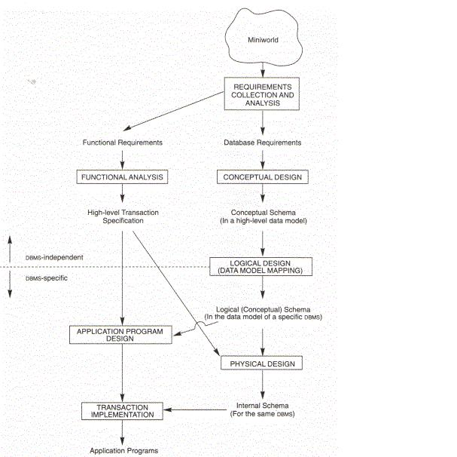

Figure 1. A simplified diagram to illustrate the main phases of database designs (Elmasri Navathe, 2011, p.201).

TURKU UNIVERSITY OF APPLIED SCIENCES, BACHELOR’S THESIS | Hari Krishna Mahat

4

3. Requirement collection and Analysis

Knowing the requirements and needs of clients is vital to the success of a project. Hence we will be following some approaches to finding facts. The following are some of the most widely used fact-finding techniques used to find facts about the needs and requirements of the company:-

– Examining documentation

– Interviewing

– Observing the enterprise in operation

– Research

– Questionnaires.

The purpose of using this fact-finding technique is to find out

– the aims and objectives of SIM plus from users point of view

– the different users’ view

– the system requirements and performances as well as security requirements

– The functional features company wishes to have in the system.

- Requirements collections

In this step, the methods used to collect the enterprise data requirements have been described.

- Examining Documentation

All the documents from the past operations of company were examined and studied. The following were the documents that were studied during the process:-

- Incoming order records

- Clients records

- Clients’ complaint records

- Inventory records

- Manufacturers records

- Products list

- Invoices

- Staff records.

TURKU UNIVERSITY OF APPLIED SCIENCES, BACHELOR’S THESIS | Hari Krishna Mahat

5

From the study of the company’s documentation, all the possible data and data types were recorded.

- Interviewing and Questionnaires

The CEO and all staff members currently employed in the company were interviewed. The purpose of the interviews was to gather further information on the problems the staff are facing and their possible solution from the new system that is to be developed. The interviews were conducted as a structured interview. All the interviewees were asked both open-ended as well as closed-ended questions. The following were the questions asked during the interview.

Questions for the CEO

- What is your business about?

We are a distributor company. We receive goods from different manufacturers and supply them to retailers.

- Why do you feel that you need computer technology?

Currently we are keeping records in paper sheets. The problems with paper sheets are they get misplaced and records gets lost most of the time, to find one particular record we have to go through piles of documentation. We thought computer technology will help us to overcome this problem we are facing with paper records.

- Why don’t you choose existing Sales and Inventory System?

They are quite expensive to buy and maintain, needs to have one more IT staffs, which in our current situation seems more costly. Moreover, existing system does not exactly meet our needs despite of investing lots of money; they will still require further development and changes to meet our needs.

- How do you think, development of new system will solve your problem?

This system will be developed according to our business environment. We can always put our thoughts and ideas in its development. We will familiar with it since the day of its development. We can develop it considering our future growth and requirements.

TURKU UNIVERSITY OF APPLIED SCIENCES, BACHELOR’S THESIS | Hari Krishna Mahat

6

Questions for the warehouse manager

- What is your job description?

Being a warehouse manager, my job mostly involves managing records of incoming and outgoing products from the warehouse. Observe the stock in warehouse, make reports and manage warehouse staff.

- What kinds of task do you perform in daily basis?

Most part of my job includes managing records and keeping track of goods available in the warehouse and generate reports. I also have to notify the CEO when there is a change in the profit margin offered to us by the manufacturer. Labelling of products and organizing products in warehouse.

- What kind of data do you work with?

I keep records of products from different manufacturers coming in warehouse. I keep records of orders sent to my sales personnel and dispatch the orders. I send re-ordering of products to our suppliers and manufacturers.

- What do your need to make your work easier and faster?

A system where I can easily record all the products with proper descriptions. A system which enables to keep track of all products quantity in warehouse and alarms when stock is less than a certain amount. A system which generates incoming and outgoing products report graphically.

Questions for the sales manager

- What is your job description?

I manage the entire sales personnel for the company. I deploy our sales personnel to their local area to collect the orders from our client retailers. I collect all the sales orders and forward them to warehouse for the delivery. I keep records of all clients and possible clients in our business region and get us new clients. I make reports about the most ordered goods in certain time.

- What kind of task do you perform in daily basis?

I deal with sales orders and our sales personnel. I deploy our sales personnel on a certain region based on weekly routines. I make calls and receive calls from clients and possible clients.

TURKU UNIVERSITY OF APPLIED SCIENCES, BACHELOR’S THESIS | Hari Krishna Mahat

7

- What kind of data do you work with?

I work with sales orders which include products, quantity, amount, tax. I deal with clients’ inquiries about certain product details. I make frequent inquiries about the stock quantity for products in the warehouse.

Using these fact finding techniques as described by Connolly in his book: A Practical Approach to Design, Implementation and Management, the requirements of the company were collected and analyzed.

3.2 Database Requirements

- Initial Database Size

Currently the company employs in total eleven staffs, five sales staffs, two warehouse staffs a C.E.O and two delivery staff and an accountant. The company is working as a distributor for three different manufacturers. The number of products each manufacturer supplies are different from each other. All the products the company distributes shall be stored in the database of the SIM plus system.

- Database Growth

In future the company expects to acquire more distribution contract from other manufacturers and suppliers. Increases in the types of products from the manufacturers will result in increased data in the database. The company wishes to grow more acquiring distributorships from other manufacturers in the future. When company receives more manufacturers’ goods to distribute, the data that company shall handle will increase exponentially.

- Searches and inquiry

Most of the searches are made by the sales manager and sales staff. The frequency of queries will be high during the first business hour by the sales staff. The inquiry shall be less after the first business hour and will be high again during the mid-day. Warehouse staff will most likely check the records every afternoon before the closing so the chunks of data will be searched during that time.

TURKU UNIVERSITY OF APPLIED SCIENCES, BACHELOR’S THESIS | Hari Krishna Mahat

8

- Networking and shared access requirements

Every sales and warehouse member of staff will have their own workstations. Each workstation will be connected to the local server where the system database will reside. Each system user will access the system from the interface program installed in the local workstation. The system server will be connected only to the local intranet. The system can only be accessed from the local intra network.

- Security

The system will be password-protected. Each user will be assigned system access privileges appropriate to the particular user view. Staff members shall see only the data necessary to perform their job. The system will be disconnected from World Wide Web to prevent all possible hacking and cracking from the Internet. The system should only be accessed from local workstations.

3.3 Functional Requirements

After the staff interviews and the study carried of the documents, the functional requirements of the company were identified. The functional requirements of the system vary for each user group. Hence the functional requirements of the system are categorized for each user. The following are the functional requirements of the system.

- Administration Functional Requirements

The CEO acts as the system administrator.

– System login function, with password change functionality after login

– Create new user of the system with staff details, limit their privileges according to their job description

– Add new item and category into system product list

– Edit and update product prices

– Remove item and category from inventory with precautions message

– Delete and update system users

TURKU UNIVERSITY OF APPLIED SCIENCES, BACHELOR’S THESIS | Hari Krishna Mahat

9

- Sale Manager Functional Requirements

– System login function through the user interface and change password after first login.

– View inventory status

– Products search function by product code or by product name or by product category

– Check bills generated for the day

– Check money transaction for the day

– Check the bills cancelled

– Check returned products

– Generate sales-trend graph.

- Inventory Manager Function Requirements

– System login function through user interface and change password after first login

– Add product details and prices into the system

– Check the inventory status, minimum and maximum stock point and order point

– Update the inventory according to the sales done in previous day

– Create inventory reports of items category-wise, price-wise

– Generate inventory-trend graphs.

- Salesmen Functional requirements

– System login function and change password function

– View the inventory status

– Product search function by product name or product code or product category

– Create purchase order entering purchase details

– Cancel the bills in case of error in entering the details

– Enter the product details for the returned order.

TURKU UNIVERSITY OF APPLIED SCIENCES, BACHELOR’S THESIS | Hari Krishna Mahat

10

3.4 Users’ transaction requirements

The operations operated over the database objects are transaction. The minimum required user transactions are described in this section which should be implemented during physical database design process. The transaction requirements for the company were discovered during the company’s document analysis and fact collecting techniques used to collect user’s views and ideas about the system.

- Data entry

Enter the detail of suppliers

Enter the details of products

Enter product category details

Enter new and existing staff’s details

Enter role details of each staff

Enter customer details.

Enter order, order details.

Enter dispatched order details.

Enter payments details.

3.4.2 Data update/deletion

Update/delete staff details.

Update/delete product details.

Update/delete product category details.

Update/delete order, order details.

Update/delete customer details.

Update/delete supplier details.

Update/delete payment details.

3.4.3 Data query

List the details of staffs.

List details of each staff roles.

List details of suppliers.

List details of each product.

List products in stock.

TURKU UNIVERSITY OF APPLIED SCIENCES, BACHELOR’S THESIS | Hari Krishna Mahat

11

List products reaching minimum stock level.

List products hitting re-order level.

List products by category

List available category details.

List customer details.

List all incoming order details

List all dispatched order

List payment details for recent orders

List orders with credit payments and customer details

List total number of order.

List orders with full payments (balance 0).

In this chapter, the required users’ transactions are described. The reports that need to be generated using the systems are described in this chapter. The design of the reports shall be designed by the physical designer meeting the needs of the company’s current report formats.

TURKU UNIVERSITY OF APPLIED SCIENCES, BACHELOR’S THESIS | Hari Krishna Mahat

12

4 Functional Analysis

In this step of design process, the brief analysis of all the function that user wishes to have in the system is described.

4.1 Input

The data that shall be fed into the system will be inserted by the user of the system. The data each user feeds to the system is different. The following are the types of data that will be fed to the system:

– Username, password and new changed password

– New user details

– Product details and category

– Incoming product details

– Order details

– Cancelled bills

– Return products details

– Search parameter (product name, product category, product ID )

- Process

After the data is fed to the system, the system will process data to generate output. The processes that should be processed by the system are as follows:

– Authentication of existing username and password

– Save any changes to database (add, delete, update products/categories)

– Carry the search within database

– Generate bill for the sales item

– Cancel the bills generated in case of error

– Produce invoice for the purchase order

– Produce bills or reports for return purchase

– Validate the inventory stocks

– Generate reports on minimum stock point maximum stock point and order point

TURKU UNIVERSITY OF APPLIED SCIENCES, BACHELOR’S THESIS | Hari Krishna Mahat

13

4.2 Output

The system processes the data that is fed into the system. The system shall produce different kinds of reports as the outputs. The following are the outputs the system shall produce:

– Product lists

– Maximum stock point, minimum stock point, order point

– Detailed reports on purchase and sales

– Reports on dispatched orders

– Reports on due payment from clients over certain period of time

– Inventory trends and graphs

– User information and clients information

– Product details on execution of search query

TURKU UNIVERSITY OF APPLIED SCIENCES, BACHELOR’S THESIS | Hari Krishna Mahat

14

5 Conceptual Database Design

In this step of project, the conceptual database methodology IS used for database design during the database development lifecycle for a relational database is described.

5.1 Definition

Conceptual database design: The process of constructing a model of data used in an enterprise, independent of all physical consideration. (Connolly, 2005, p.439)

In database design process, the first phase of database design after the collection and analysis of user requirements is the conceptual database design. The purpose of this design process is the creation of a conceptual data model independent of Database Management System software, application programs, programming language, hardware platforms or any other physical systems. During the process, user specifications and requirements are closely followed.

The conceptual data model is tested and validated with the users’ requirements and specification. A well designed conceptual data model is the key for success of next phase of design process: Logical Database design and whole database system in general.

5.2 Conceptual Database Design Methodology

The idea of using a design methodology is to give structure to the procedures, techniques, tools and documentation to support and facilitate the process of designing. The following are the steps in methodology that are followed during the conceptual database design process for the company.

Using the conceptual database design methodology as described by Connolly in his book: A Practical Approach to Design, Implementation and Management, the conceptual data model shall be designed.

TURKU UNIVERSITY OF APPLIED SCIENCES, BACHELOR’S THESIS | Hari Krishna Mahat

15

- Identifying entity types

The process of identifying entity types involves reorganization of user interested objects. User requirements specification is vital to the success of identification of entities. The company has two types of staff, namely, warehouse staff and sales staff who will use the system the most. Hence the entity is identified classifying the entity type.

a. Identifying warehouse entities

The following are the possible warehouse entities:-Warehouse staff, products, suppliers, orders

b. Identifying sales entities

The following are the possible sales entities:-Sales staff, products, customers, orders, payments

c. Documentation of entity types

Table 1. Description of entities to form data dictionary (Connolly, 2005, p.444)

 | Entity Name |  |  | Description |  |  |  |  |  | Aliases |  |  | Occurrence
 | Staff |  |  | Describes |  | all | the |  |  | Employee |  |  | Warehouse |  |  | and
 |  |  |  | staffs | in | company |  |  |  |  |  |  | sales | mainly |  | two
 |  |  |  | warehouse or sales |  |  |  |  |  |  |  |  | types of staffs
 | Product |  |  | Describes |  | all | the |  |  | Distributing items |  |  | Each | product |  | has
 |  |  |  | items the company |  |  |  |  |  |  |  |  | its own supplier and
 |  |  |  | will be distributing |  |  |  |  |  |  |  |  | is different |  | from
 |  |  |  |  |  |  |  |  |  |  |  |  | other
 | Supplier |  |  | Manufacturer |  |  | or |  |  | Mainly |  |  | Each supplier deals
 |  |  |  | manufacturers’ |  |  |  |  |  | manufacturer |  |  | with its own product
 |  |  |  | agents who supply
 |  |  |  | items |  |  | for
 |  |  |  | distribution
 | Customers |  |  | Retailer shops who |  |  |  |  |  | Retailer shops |  |  | There | are | many
 |  |  |  | orders |  | products |  |  |  |  |  |  | retailer shops |  |  | in
 |  |  |  | from the company |  |  |  |  |  |  |  |  | one local area
 | Orders |  |  | Sent by the retailer |  |  |  |  |  | Customer orders for |  |  | Many | orders | come
 |  |  |  | shop | containing |  |  |  |  | products |  |  | from | customer |  | or
 |  |  |  | items | and |  | their |  |  |  |  |  | customers
 |  |  |  | quantity |  | they | has
 |  |  |  | demand for
 | Payments |  |  | Payments |  |  | are |  |  | Customer |  |  | Payments |  |  | are
 |  |  |  | made by customers |  |  |  |  |  | payments partial or |  |  | either partial or full
 |  |  |  | for | the | goods |  |  |  | full
 |  |  |  | ordered

TURKU UNIVERSITY OF APPLIED SCIENCES, BACHELOR’S THESIS | Hari Krishna Mahat

16

- Identifying relationship types

As the two types of entities have been identified, there are two possible views of the system database, namely, the warehouse view and sales view. Therefore, the relationship between the attributes will be different in each view.

- Company has sales and warehouse staff

- Sales manager manages sales staff

- Sales staff get Orders

- Orders has Orders number and Ordering cutomerNo, Customer name

- Order details contains products

- Products has product ID, product name, product price

- Product belongs to categories

- Categories has category id category id

- Each Category product has suppliers

- Suppliers has supplier ID, supplier name

- Products are stored in warehouse

- Warehouse is managed by warehouse staff

There are two possible conceptual views, which are shown in the UML diagram below in figures 3 and 4
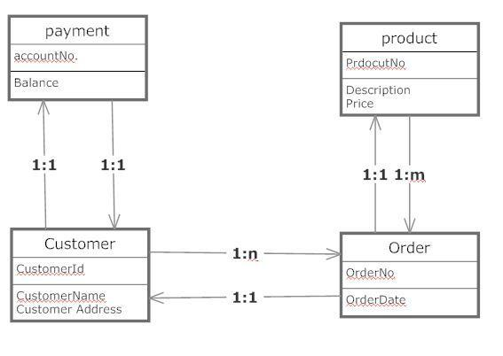

Figure 2. Sales view

TURKU UNIVERSITY OF APPLIED SCIENCES, BACHELOR’S THESIS | Hari Krishna Mahat

17
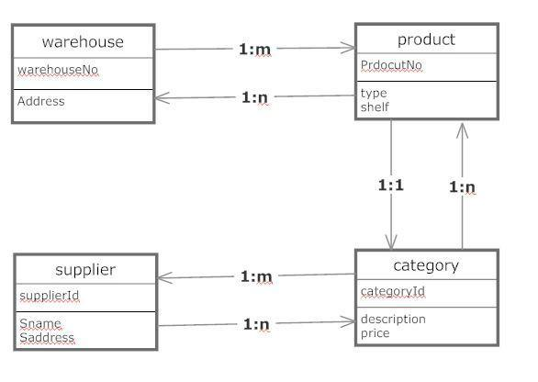

Figure 3. Warehouse view

Documentation of relationship types using partial ER diagram only with entities and their respective primary key.
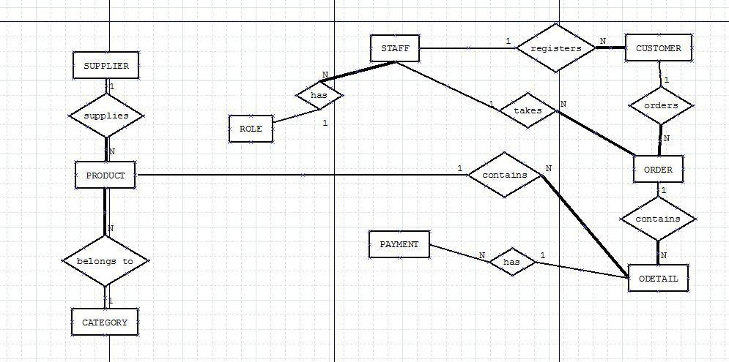

Figure 4. Staff users’ view.

Identification and association of attributes to Entities

In this step of design process, the entities that were discovered in earlier step are assigned with attributes. The possible attributes from the analysis of company’s document and users interviews is documented in this step. The bold names are entities and following that are the attributes. These attributes are only the proto types; on further processes these will be more concrete and well defined.

TURKU UNIVERSITY OF APPLIED SCIENCES, BACHELOR’S THESIS | Hari Krishna Mahat

18

Staff

Staff ID, FirstName, LastName, DateOfBirth, Address, role ID, phone No, username, password

Role

Role ID, roleName, Description

Customer

Customer ID, FirstName, LastName, Address, phone, Email, BusinessRegNo,

Order

OrderID, BillNo, Staff ID, CustomerID, OrderDate, DispatchedDate, PaymentID, ErrorMsg, Deleted, Paid,

OrderDetails

OrderId, BillNo, ProductId, Price, OrdQuantity, DelQuantity, Discount, Total, Size, OrdDate, DispatchDate, OrderDetailID, BillDate

Payment

paymentID, PaymentType, CreditAmount, DebitAmount, Balance, BalanceDate,

Product

ProductID, ProductName, ProductDescription, SupplierID, CategoryID, QuantityPerUnit, UnitPrice, UnitWeight, Size, Discount, UnitsInStock, UnitsonOrder, ReorderLevel, ProductAvailable, CurrentOrder, Note

Category

CategoryID, CategoryName, Description,

Supplier

SupplierID, CompanyName, ContactFname, ContactLname, ContactTitle, Address, Phone, Fax, Email, PaymentMethods, DiscountType

Documentation of Attributes and Entities

The following table 2 is the documentation of above discussed entities and their respective attributes

TURKU UNIVERSITY OF APPLIED SCIENCES, BACHELOR’S THESIS | Hari Krishna Mahat

19

Table 2. Documentation of attributes and entities (Connolly, 2005, p.450)

Entity | Attributes | Description | Data Type & Length | Null
Staff | Staff ID | Uniquely identifies a member staff | 5 varchar | No
 | Name
 | FName | First Name of Staff | 15 varchar | No
 | LName | Last Name of Staff | 15 varchar | No
 | DOB | Date of Birth of Staff | Date | No
 | Address | Home Address or contact address | 30 varchar | No
 | SEX | Gender Male M or Femal F | 1 char {M/F} | No
 | PhoneNo | Contact Phone Number | 10 Digit number | No
 | roleID | Job Title ID, Foreign Key | 5 var char, F-key | N0
 | username | Unique to user, for login function | 15 var char
 | password | Unique, encrypted, | 8 to 15 var char


 | Role |  |  | roleID | Uniquely identifies a staff role |  | 5 var char | No
 |  |  |  | roleName | Job title of the staff |  | 15 var char | No
 |  |  |  | Descr | Description of role |  | 30 var char | No

 | CID | Uniquely identifies customer | 5 var char | No
Customer | BRegNo | Customer PAN resgister Number | 10 digit | No
 | Name
 | Fname | Firsta name of customer | 15 var char | No
 | Lname | Last name of customer | 15 var char | No
 | Address | Address of customer retail shop | 30 var char | No
 | Phone | Contact phone of customer | 10 digit | No
 | Email | Email address of customer | 15 var cha | Yes
 | Staff ID | Staff who registers customer | 5 varchar | No

Order |  |  |  | OrderID |  |  | Uniquely identifies each order |  |  |  | 10 digit number |  |  | No
 |  |  |  | Staff ID |  |  | Identifies the sales staff |  |  |  | 5 var char |  |  | No
 |  |  |  | CID |  |  | Customer id who orders |  |  |  | 5 var char |  |  | No
 |  |  |  | ODate |  |  | Incoming order date |  |  |  | Date |  |  | No
 |  |  |  | ErroMsg |  |  | Error message if happens |  |  |  | 30 var char |  |  | Yes
 |     ODetail | OrderID |  |  | Identifies order that came in |  |  | 10 digit number |  |  |  | No
 |  | BillNo |  |  | Identifies the bill generated |  |  | 10 digit number |  |  |  | No
 |  | ODetailID |  |  | Identifies id for order details |  |  | 5 var char |  |  |  | No
 |  | ProductID |  |  | Identifies each product |  |  | 10 var char |  |  |  | No
 |  | USP |  |  | Unit price of each product unit |  |  | 5 digit |  |  |  | No
 |  | Size |  |  | Size of product |  |  | S, M, L |  |  |  | No
 |  | OrdQuant |  |  | Quantity of product ordered |  |  | 6 digit |  |  |  | No
 |  | DelQuant |  |  | Quantity of product delivered |  |  | 6 digit number |  |  |  | Yes
 |  | Discount |  |  | Discounts involved |  |  | 3 digit number |  |  |  | No
 |  | Total |  |  | Total amount of bill |  |  | 7 digit number |  |  |  | No
 |  | DelDate |  |  | Order dispatch date |  |  | Date |  |  |  | No
 |  | OrdDate |  |  | Date when order came |  |  | Date

 | Payment |  |  | BillNo | Identifies payment bill number |  | 10 digit number | No
 |  |  |  | Pay Type | Payment type, cash or bank |  | 10 var char | No
 |  |  |  | CrAmount | Credited amount |  | 7 digit number | Yes
 |  |  |  | CrDate | Credit date |  | Date | Yes
 |  |  |  | DrAmount | Debited amount |  | 7 digit number | Yes
 |  |  |  | DrDate | Debit date |  | Date | Yes
 |  |  |  | Balance | Total balance (derived) |  | 7 digit number | No

TURKU UNIVERSITY OF APPLIED SCIENCES, BACHELOR’S THESIS | Hari Krishna Mahat

20


Product | ProductID | Uniquely identifies product | 10 var char | No
 | PName | Product Name | 15 var char | No
 | PDescr | Product Description | 50 var char | No
 | CatID | Identifies product category | 5 var char | No
 | supplierID | Identifies product supplier | 5 var char | No
 | QPerUnit | Product quantity per unit | 4 digit number | No
 | Uprice | Product unit price | 4 digit number | No
 | USP | Unit Selling price | 4 digit number | No
 | Uweight | Product unit weight | 4 digit number | No
 | Usize | Product unit size, S, M, L | 1 var char (S,M,L) | No
 | Discount | Discount offered by supplier | 3 digit number | Yes
 | UInStock | Product units in stock | Number | No
 | UInOrder | units in order from supplier | Number | No
 | ReOrLevel | Product margin for re-ordering | Number | No
 | Note | Some note for product | 50 var char | Yes
Category | CatID | identifies product category | 5 var char | No
 | CatName | name of the category | 15 var char | No
 | Desc | category description | 50 var char | No
Supplier | SupplierID | Uniquely identifies each supplier | 5 var char | No
 | ComName | Supplier company name | 15 var char | No
 | ConfName | Contact person first name | 15 var char | No
 | ConlName | Contact person last name | 15 var char | No
 | ConTitle | Cont person job title | 10 var char | No
 | Address | Address of supplier | 30 var char | No
 | Phone | Suppliers’ phone number | 10 digit number | No
 | Fax | Fax number | Number | Yes
 | Email | Email address | 30 varchar | Yes
 | PayMeth | Payment methods | Var char | No
 | DisType | Discount type | 3 digit number | Yes



Some derived attributes and their derivation

In Payment, Balance is to be derived from

Payment . Balance = ODetail . Total – Payment . DrAmount

Payment. Cr.Amount= ODetail. Total – Payment. DrAmount

- Determining attribute domains

A domain is a poll of values from which one or more attributes receive their values.

In the database, all the ID attributes are 5 variable characters which shall have their values in the form of: 2 characters (first and last name initials) + 3 digits (000-999).

TURKU UNIVERSITY OF APPLIED SCIENCES, BACHELOR’S THESIS | Hari Krishna Mahat

21
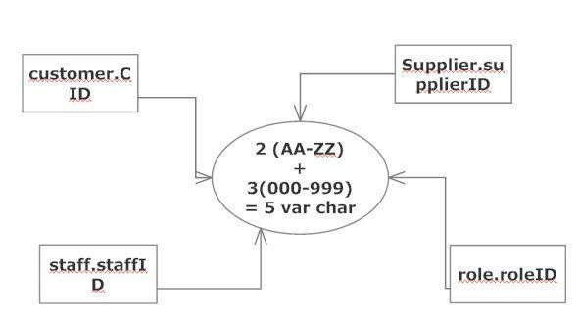

Figure 5. Domain pool for ID attributes possible value

- Determining candidate, primary, and alternate keys

Those attributes which can uniquely identify entire entity are the candidate keys. One of these attributes shall be the primary key and the other keys are alternate keys.

Table 3. Associating entities with candidate keys, primary key and alternate keys

Entity | Candidate keys |  | Primary key | Alternate keys
Staff | staffID, DOB name |  | staffID | DOB
 | , phone
Role | roleID |  | roleID
Customer | CID, | BRegNo, | CID | BRegNo
 | phone
Order | OrderID |  | OrderID
ODetail | ODetailID, |  | ODetailID | OrderID+ProductID
 | OrderID+ProductID
Payment | billNo |  | billNo
Product | ProductID, |  | ProductID | productName
 | productName
Category | CatID, CatName |  | catID | CatName
Supplier | supplierID, |  | supplierID | comName
 | comName

We using enhanced entity relationship modelling to show entity and primary keys

TURKU UNIVERSITY OF APPLIED SCIENCES, BACHELOR’S THESIS | Hari Krishna Mahat

22
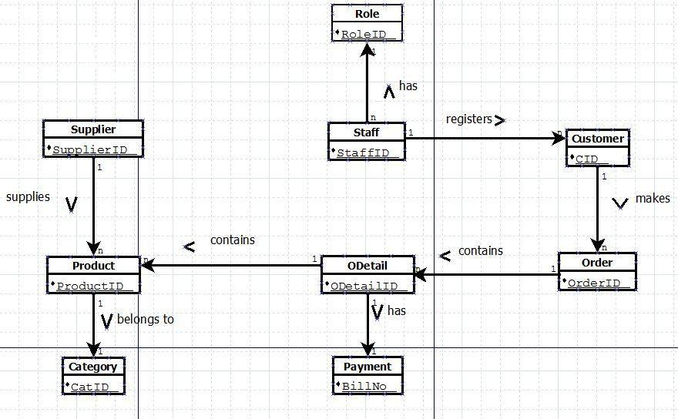

Figure 6. UML diagram with entities and primary keys

- Redundancy check for the conceptual model

The system will be inefficient if there are redundant data. The process of redundancy check helps in eliminating any duplicate data if there exists any. The conceptual data model is subjected to the redundancy check. The process carried involves re-examining all the relationships between the entities. The following were the processes carried for redundancy check:-

- Re-examining one-to-one relationships

- Removing redundant relationships

- Considering time dimensions

After the process, the conceptual model was found free of any redundancy.

TURKU UNIVERSITY OF APPLIED SCIENCES, BACHELOR’S THESIS | Hari Krishna Mahat

23

- Conceptual model validation with users’ transaction

At this stage, the conceptual data model that represents the enterprise’s data requirements is achieved. The purpose of validation is to ensure the data model supports the required transactions of the enterprise.

An attempt to carry out enterprise transactions manually using the data model is performed. The aim is to observe if the transaction succeeds or fails. If the transaction is successful, there is no problem with the data model, otherwise the conceptual model needs to be reviewed and redesigned to meet the enterprise transaction requirements. The following are the approaches carried out to ensure that the conceptual data model meets the transaction requirements:-

- Describing transactions

- Using transaction pathways

The UML diagram 8 is used to describe the conceptual model validation process with users’ transaction.
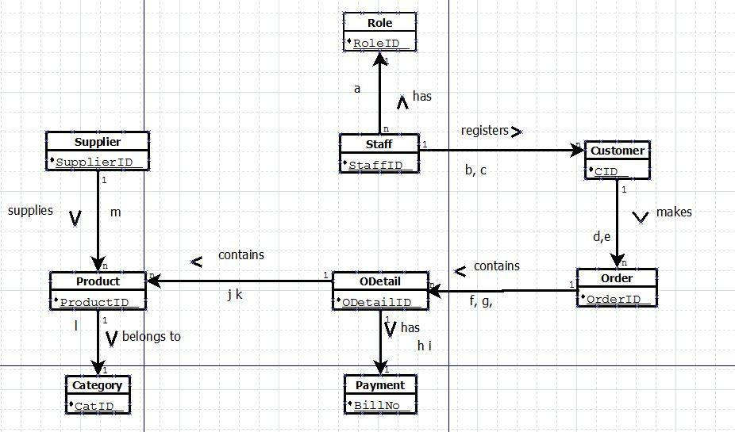

Figure 7. Using pathways to validate conceptual model meets user transaction requirements.

TURKU UNIVERSITY OF APPLIED SCIENCES, BACHELOR’S THESIS | Hari Krishna Mahat

24

The UML diagram in Figure 8 was used to validate the transaction process. The description of each transaction process is as follows:

  - Enter/update/delete staff detail and roles.

  - Enter/update/delete customer details.

  - List staff/customer details and who register which customer.

  - List which customer ordered what products, current orders.

  - Enter/update/delete order.

  - List products in order by order number of each customer.

  - Enter/update/delete order details

  - List credit, debit, balance amounts for each order/bill.

  - Enter/update debit/credit amount for each order/bill.

  - List products in each order.

  - Update/delete products from order (if out of stock).

  - List/update/delete/ products from category or category.

  - List/update/delete supplier details.

- Reviewing the conceptual data model with users

The conceptual data model has been verified with enterprise data requirements and transaction requirements. The data model is reviewed along with the user and user is happy with the positive signs of development process of a well designed database, ready to implement. The next step of the design process is to produce a logical database design from this data model.

TURKU UNIVERSITY OF APPLIED SCIENCES, BACHELOR’S THESIS | Hari Krishna Mahat

25

6 Logical Database Design

In this phase of project, the conceptual data model produced in last step is translated into logical data model. The process of translation was conducted following certain process which is described in this chapter

6.1 Definition

Logical database design: The process of constructing a model of the data used in an enterprise based on a specific data model, but independent of a particular DBMS and other physical considerations. (Connolly, 2005, p.439)

The objective of logical database design is to convert the conceptual data model into a logical data model. The logical data model is then validated to check structural correctness and support for the required enterprise transactions. A single logical data model that is correct, unambiguous and comprehensive representation of enterprise data requirements is achieved on the completion of logical database design methodology.

6.2 Logical database design methodology

The purpose of using a design methodology is to give structure to the procedures, techniques, tools and documentation to support and facilitate the process of designing. The following are the steps in methodology that are followed during the logical database design process for the company.

- Deriving relations for the logical data model

The relationship between entities and attributes are derived during this step. The compositions of each relation are described using Database Definition Language (DBDL). The name of each relation is specified using DBDL followed by list of attributes enclosed in brackets. The primary key (pk), alternate key (ak), secondary key (sk) and foreign keys (fk) of the relations are identified.

The relationship between the entities is represented using the primary key/ foreign key mechanism. The ‘parent’ and ‘child’ entity are identified to place the foreign key attribute(s). The parent entity posts its primary key as foreign key into the relation that represents child entity. All the primary keys in the ER diagram are represented by

TURKU UNIVERSITY OF APPLIED SCIENCES, BACHELOR’S THESIS | Hari Krishna Mahat

26

being underlined. The relations and attributes of all entity are shown in the diagram 9 below:
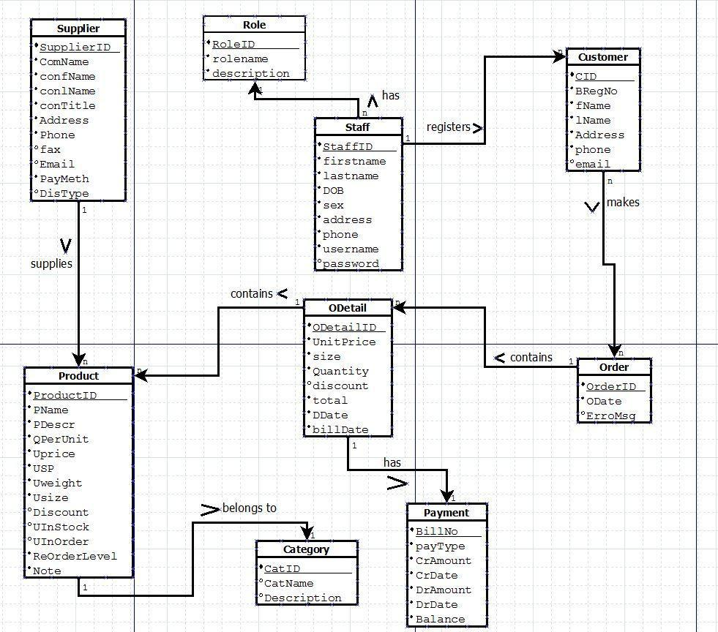

Figure 8. UML data model showing all attributes at this stage of development phase.

TURKU UNIVERSITY OF APPLIED SCIENCES, BACHELOR’S THESIS | Hari Krishna Mahat

27

Relations in Database Definition Language (DBDL)

- Staff has role

Staff (Staff ID, firstname, lastname, DOB, Sex, address, phone, username,

 | password, Role ID)
 | Primary Key | Staff ID
 | Alternate Key | username
 | Foreign Key | Role ID refrences Role (Role ID)
 | Role (Role ID, rolename, description)
 | Primary Key | Role ID
b. | Staff registers customers
 | Customer (CID, BRegNo, fname, lname, address, phone, email, staffID)
 | Primay Key | CID
 | Alternate Key | BRegNo
 | Foreign Key | staffID references Staff (staffID)
c. | Customer makes order
 | Order (OderID, OrderDate, ErroMsg, staffID, CID)
 | Primary Key | OrderID
 | Foreign Key | staffID references Staff (Staff ID)
 | Foreign key | CID references Customer (CID)

- Order has Order details

ODetail (OdetailID, unitprice, size, Quantity, discount, total, DDate, billDate,

BillNo, OrderID, ProductID)

Primary Key OdetailID

Foreign Key BillNo references Payment (BillNo)

Foreign Key OrderID references Order (OrderID)

Foreign Key ProductID references Product (prodcutID)

Payment (BillNo, payType, CrAmount, CrDate, DrAmount, DrDate, Balance)

Primary Key BillNo

Product (ProdcutID, PName PDescr QperUnit, Uprice, USP, Uweight, Usize, Discount, UInstock, UInOrder, ReorderLevel, Note, SupplierID, CatID)

Primary Key ProductID

Foreign Key SupplierID references Supplier (SupplierID)

Foreign Key CatID references Category (CatID)

TURKU UNIVERSITY OF APPLIED SCIENCES, BACHELOR’S THESIS | Hari Krishna Mahat

28

- Product belongs to category

Product (ProdcutID, PName PDescr QperUnit, Uprice, USP, Uweight, Usize,

Discount, UInstock, UInOrder, ReorderLevel, Note, SupplierID, CatID)

Primary Key ProductID

Foreign Key SupplierID references Supplier (SupplierID)

Foreign Key CatID references Category (CatID)

Category (CatID, catName, Description)

Primary Key catID

- Supplier supplies product

Supplier (SupplierID, comName, confName, conLname, conTitle, Address,

Phone, fax, Email, PayMeth, DiscType)

Primary Key supplierID

Product (ProdcutID, PName PDescr QperUnit, Uprice, USP, Uweight, Usize, Discount, UInstock, UInOrder, ReorderLevel, Note, SupplierID, CatID)

Primary Key ProductID

Foreign Key SupplierID references Supplier (SupplierID)

Foreign Key CatID references Category (CatID)

The following UML diagram in Figure 10 represents the relationship using the primary key and foreign key attributes mechanism. The primary key is underlined and foreign key is indicated by (fk) at the end of attributes in the table.

TURKU UNIVERSITY OF APPLIED SCIENCES, BACHELOR’S THESIS | Hari Krishna Mahat

29
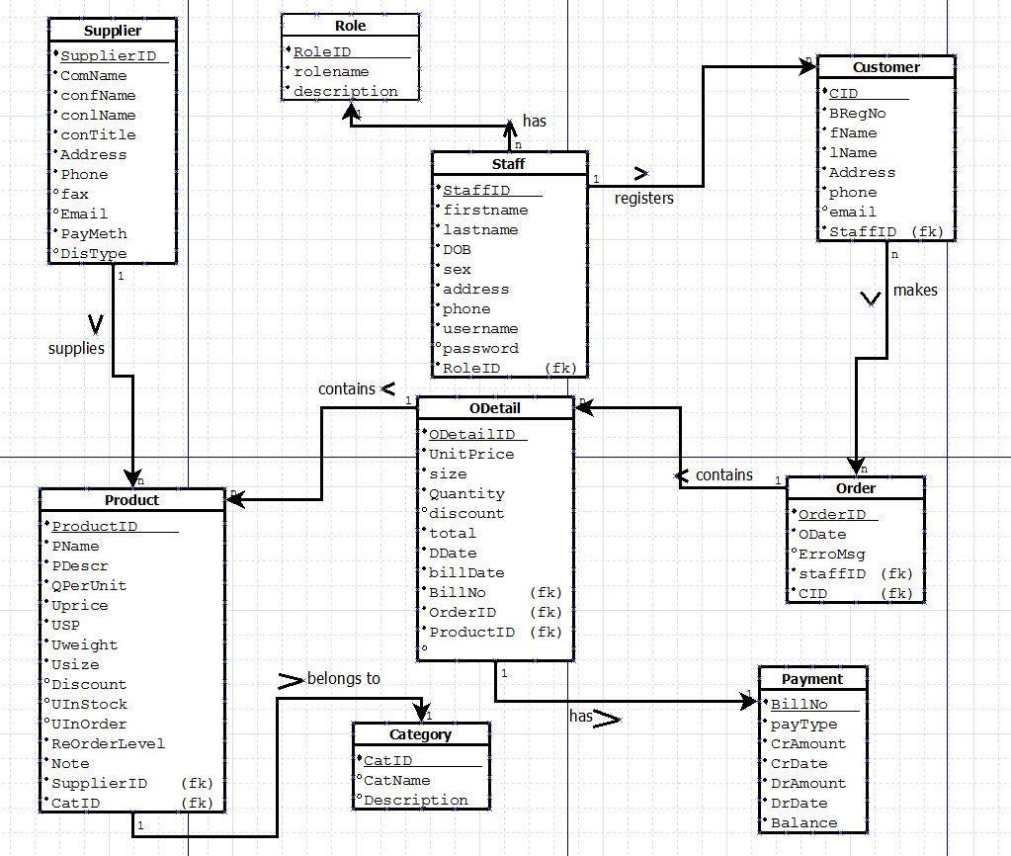

Figure 9. UML diagram representing pk fk mechanism for relationships

- Validating relations using normalization

The objective of using the normalization technique is to minimize the number of attributes in entities supporting data requirements of enterprise. This process helps in reducing of data redundancy and solving update anomalies. Some of the redundancies are, nevertheless, essential to form joints in relationship between entities.

The process of normalization of DATA follows different normalization steps, namely First Normal Form (1NF), Second Normal Form (2NF), Third Normal Form (3NF), Fourth Normal Form (4NF), and Fifth Normal Form (5NF). However, for our purpose we are following only up to 3NF as recommended in general. The relations that we are deriving from the conceptual data model, however, might already be in 3NF form. The conceptual model is yet validated using the normalization technique. The relations that are not in 3NF are identified and corrected.

TURKU UNIVERSITY OF APPLIED SCIENCES, BACHELOR’S THESIS | Hari Krishna Mahat

30

- Validating relations against user transactions

The purpose of this step is to ensure that the logical data model supports the required transactions. Although the transaction requirements were validated already during the conceptual data model design process, the logical data model is also validated against the users’ transactions requirements.

The primary key/foreign key links from the ER diagram, relations, and data dictionary are used for validation. The process was performed manually as before. All the required transactions were performed successfully validating the logical data model to be correct.

- Checking integrity constraints

The constraints in a database are defined to protect the database from being incomplete, inaccurate, or inconsistent are known as integrity constraints. Integrity constraints are mostly controlled by DBMS. The project work is concerned only with high-level design, defining required integrity constraints irrespective of how this might be achieved. It is said (Connolly, 2004) that a logical data model that defines and includes all required integrity constraints is a ‘true’ representation of enterprise data requirements. In this process, the following types of integrity constraints are considered:-

– Required data

The attributes that must not be null shall be assigned a value. Some defaults values are defined to the attributes that requires.

– Attribute domain constraints

The domain pool is the group of attribute values from which the value may be acquired. For gender/sex attribute, the domain pool has only two values ‘M’ or ‘F’

– Multiplicity

– Entity integrity

The primary key that uniquely represents entity shall not be null or duplicated.

– Referential integrity

Attributes which are involved in relationship shall not be null, in case of deletion of attributes value in parent entity, default values are defined.

– General constraints

TURKU UNIVERSITY OF APPLIED SCIENCES, BACHELOR’S THESIS | Hari Krishna Mahat

31

The attributes: total, balance, CrAmount, DrAmount from ODetail and payment shall always have default value as 0.00. The attribute ReorderLevel is defined to have a certain number as default value like 100 Units.

The table 4 shows referential integrity constraints for the relation in the staff user view of enterprise database:

Table 4. Referential integrity constraints

Staff (Staff ID, firstname, lastname, DOB, Sex, address, phone, username,

password, Role ID)
Primary Key Staff ID

Alternate Key username
Foreign Key Role ID references Role (Role ID

ON UPDATE CASCADE ON DELETE SET DEFAULT (SALESMEN ROLE) Role (Role ID, rolename, description)
Primary Key Role ID

ON UPDATE CASCADE ON DELETE NO ACTION
Customer (CID, BRegNo, fname, lname, address, phone, email, staffID)
Primary Key CID -> ON UPDATE CASCADE ON DELETE NO ACTION
Alternate Key BRegNo

Foreign Key staffID references Staff (staffID)

ON UPDATE CASCADE ON DELETE SET TO DEFAULT (SALES MANAGER) Order (OderID, OrderDate, ErroMsg, staffID, CID)
Primary Key OrderID -> ON UPDATE CASCADE ON DELETE NO

ACTION /CHECK
Foreign Key staffID references Staff (Staff ID) ON UPDATE CASCADE

ON DELETE SET TO DEFAULT (SALES MANAGER ID)
Foreign key CID references Customer (CID) ON UPDAGE CASCADE

ON DELETE NO ACTION

ODetail (OdetailID, unitprice, size, Quantity, discount, total, DDate, billDate, BillNo, OrderID, ProductID)
Primary Key OdetailID ON UPDATE CASCADE ON DELETE NO

ACTION
Foreign Key BillNo references Payment (BillNo) ON UPDATE/DELETE

NO ACTION
Foreign Key OrderID references Order (OrderID) ON UPDATE/DELETE

NO ACTION
Foreign Key ProductID references Product (prodcutID) ON UPDATE

CASCADE ON DELETE NO ACTION

Payment (BillNo, payType, CrAmount, CrDate, DrAmount, DrDate, Balance) Primary Key BillNo ON UPDATE/DELETE NO ACTION/CHECK

Product (ProdcutID, PName PDescr QperUnit, Uprice, USP, Uweight, Usize, Discount, UInstock, UInOrder, ReorderLevel, Note, SupplierID, CatID)
Primary Key ProductID ON UPDATE/DELETE CASCADE

Foreign Key SupplierID references Supplier (SupplierID) ON

UPDATE/DELETE CASCADE
Foreign Key CatID references Category (CatID) ON UPDATE/DELETE

CASCADE

TURKU UNIVERSITY OF APPLIED SCIENCES, BACHELOR’S THESIS | Hari Krishna Mahat

32


Category (CatID, catName, Description)
Primary Key catID ON UPDATE/DELETE CASCADE

Supplier (SupplierID, comName, confName, conLname, conTitle, Address, Phone, fax, Email, PayMeth, DiscType)
Primary Key supplierID ON UPDATE/DELETE CASCADE

- Reviewing logical data model with user

The logical data model achieved at this stage is reviewed with users to ensure that the model is the true representation of the enterprise data requirements. The relationship between the logical data model and the data flow diagram is reviewed. The data flow diagram shows the real time data that flows in enterprise that is being saved in database and logical data model shows the structure of the stored data of the enterprise.
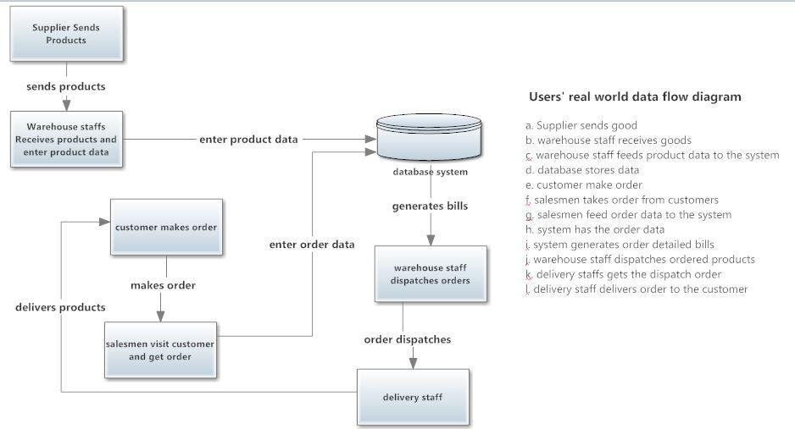

Figure 10. User’s Real world data flow diagram (DFD)

TURKU UNIVERSITY OF APPLIED SCIENCES, BACHELOR’S THESIS | Hari Krishna Mahat

33

The relationship between the logical data model and the data flow was used to check consistency and completeness of each other. It was ensured that the data stored represents the whole number of entity types and the attributes on the data flow belong to the entity type.
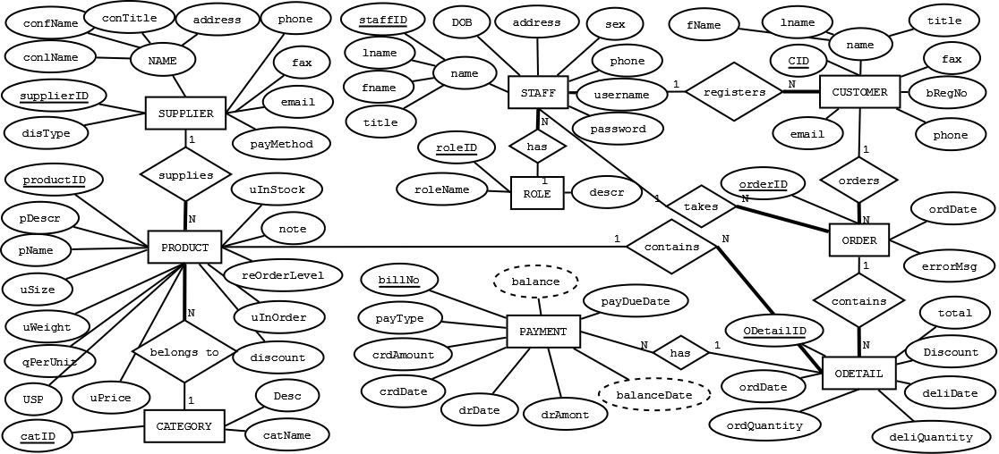

Figure 11. Modified using Chen’s Entity-Relation (ER) method for global data model (Elmasri & Navathe, 2011, ch. 3)

TURKU UNIVERSITY OF APPLIED SCIENCES, BACHELOR’S THESIS | Hari Krishna Mahat

34

7 Designing Security Mechanism

The database stores enterprise resources and data that should be properly secured using proper controls. The objective of this step is to design security mechanism that meets the security requirements documented during the requirements collection and analysis stage of database system development lifecycle. The DBMSs provides different kind of security controls, so it also depends on the selection of RDBMS, however in this step we design general security mechanism that should be followed during the physical implementation of database design.

There are two types of database security generally provided by DMBSs:

– system security;

– data security;

The use and access of database at the system level protected by usernames and password is defined by system security mechanism.

The use and access of database objects such as relations and views and users privileges to carry out operations on these objects is defined by data security mechanism.

7.1 Database secutiy threats

The effective implementation of security requires identification of security breach and threats. The following are the identified threats:

- theft and fraud;

- loss of confidentiality;

- loss of privacy;

- loss of availability;

The documentation of possible known threats is documented in the table below. The 5 table consist of all the known threats.

TURKU UNIVERSITY OF APPLIED SCIENCES, BACHELOR’S THESIS | Hari Krishna Mahat

35

Table 5. Threat documentation (Connolly, 2005, p.544)

Threat | Theft and | Loss of | Loss of | Loss | of | Loss of
 | Fraud | confidenti | privacy | integrity |  | availabilit
 |  | ality |  |  |  | y
Access imposing other person | √ | √ | √
Unauthorized amendment or copying of | √ |  |  | √ |  | √
data
Program alteration (trap door) | √ |  |  | √ |  | √
Inadequate policies and procedures that | √ | √ | √
allow a mix of confidential and normal
output
Wire trapping | √ | √ | √
Illegal entry by hacker | √ | √ | √
Blackmail | √ | √ | √
Data, program, equipment theft | √ | √ | √
Inadequate staff training |  | √ | √ | √ |  | √
Viewing and disclosing unauthorized | √ | √ | √
data
Physical change to equipment |  |  |  | √ |  | √
Connection problems |  |  |  | √ |  | √
Virus attack |  |  |  | √ |  | √
Data corruption due to power loss or |  |  |  | √ |  | √
surge

7.2 Computer-based controls

It is important to know the system environment to find the possible threats and danger to the database. The following figure shows the current working system environment of the enterprise along with the possible future environment:

TURKU UNIVERSITY OF APPLIED SCIENCES, BACHELOR’S THESIS | Hari Krishna Mahat

36
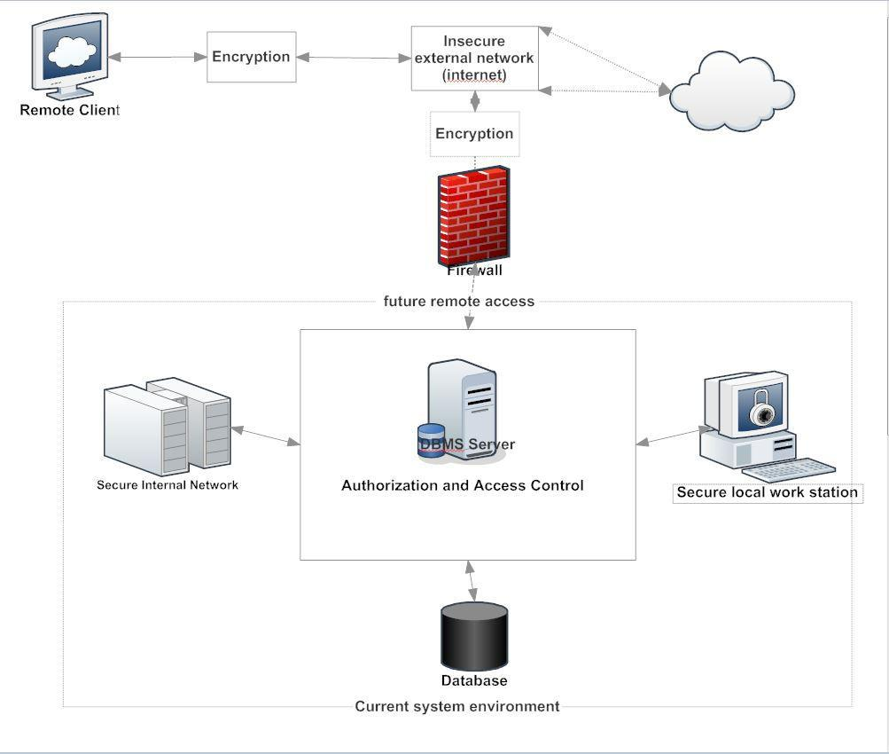

Figure 12. Users' system environment

The range of computer-based controls that are provided in a DBMS is only as good as that of the operating system owing to their close system. The figure 13 represents a multi-user computer system environment of the company. Here the designee of computer-based security system that will be implemented in user’s system environment is described.

TURKU UNIVERSITY OF APPLIED SCIENCES, BACHELOR’S THESIS | Hari Krishna Mahat

37

- Authentication and authorization

The mechanism to check whether a user is the person who he or she claims to be is known as user authentication. The system admin is responsible for allowing staff to have access to the system. The staff is identified with a unique identifier, and with each identifier is a password chosen by the user. The identifier will authenticate the staff to user the computer system. The DBMS login identifier and workstation identifier must be same, but this also depends on the DBMS company decides to use.

The process of granting certain rights and privilege to the user that enables them to have legitimate access to a system or system’s object is authorization. The authorization controls are built into the software and it governs what users can access and how they can access. The process of authorization involves authentication of user and their privileges on database table, view, procedure, trigger or any other object that is created within the system. The following table 6 shows the authentication and authorization log file system

Table 6. | Login rule
User account |  | Loginfailure | Password |  | Max. | login | Max. | login
 |  | counter | expire |  | failure |  | failure action
CEO/administrator |  | Count | Password |  | 3 attempts |  | lock account
 |  | unsuccessful | expired | every
 |  | login attempts | 60 days
Sales | manager | Count | Password |  | 5 attempts |  | lock account
Warehouse |  | unsuccessful | expire | every
manager |  | login attempts | 90 days
Warehousestaff
Sales staff

The locked accounts shall only be unlocked by the CEO/administrator or the Database Administrator (DBA).

TURKU UNIVERSITY OF APPLIED SCIENCES, BACHELOR’S THESIS | Hari Krishna Mahat

38

- Access controls

The access controls for a database system is based on granting and revoking user privileges. A privilege allows user to create, read, modify, and write some database objects such as relation, view, table or index or to run certain DBMS utilities.

The user should get only the privileges they need to perform their task. Granting excessive user privileges are always a security issues. The privilege that is granted to the user depends on their roles and job description. There are four types of user in the company and their privilege is different from each other.

The selected DBMS keeps track of privileges that are granted to users and can be revoked when needed ensuring users still can access database objects he or she needs to complete their task. The two types of access controls available in most of the commercial DMBS are:

– Discretionary Access Control (DAC)

– Mandatory Access Control (MAC)

- Views

The view mechanism provides user to access objects and utilities from the DBMS hiding backbone structure of the database. A view is a virtual dynamic result created from one or more relational operations operating on the base relations to produce another relation.

The views that shall be created will be accessed and viewed only through the interface program that will be designed. The user interface designed shall not have any inputs for Structured Query Language (SQL). The interface should define every view in the interface through menus and should be restricted according to the user privileges.

- Encryption

The encoding of data by a special algorithm that makes the data unreadable by any program without a special decryption key is known as encryption. Though the data at the moment will be transmitted over the secure local network, but in future, it might be essential to transmit data over insecure network. To transmit data securely over insecure network, the use of cryptosystem is important. The cryptosystem should include:

TURKU UNIVERSITY OF APPLIED SCIENCES, BACHELOR’S THESIS | Hari Krishna Mahat

39

– An encryption key to encrypt the data;

– An encryption algorithm, that uses encryption key to transform plaintext to cipher text;

– A decryption key to decrypt the cipher text;

– A decryption algorithm, that uses decryption key to decrypt cipher text to plaintext

The data that shall be stored into the database system will be encrypted using Data Encryption Standard (DES) algorithm. The encryption and decryption key provided by DES is always kept secret.

- Whitelist and blacklist

The objective of whitelist and blacklist is to register those that are being provided certain privilege, service, mobility, access or recognition. Those which are on the list will be accepted or denied according on which list they belong.

Those which are in the whitelist shall be accepted and those on the blacklist will be denied. All the possible sql injection parameters shall be listed in blacklist. The table 7 below shows blacklist and whitelist created during security design phase:

Table 7. Blacklist and whitelist prototype table

Blacklist |  | Whitelist
Sql injection characters like:- |  | input only Aa-Zz and 0-9 in put field or
“)”, “;“, and ”EXEC” |  | combination
Special characters | except in password | Local network: MAC filter (only company’s
Special characters | except in password | computer)
field and email address |  | computer)
Combination like, | CategoryID=1 or | applications on | companies computer
Combination like, | CategoryID=1 or | shall be listed
1=1
Escape characters in the form filed

The process of defining black list and whitelist also depends on the DBMS system implemented. Some of the DMBS might already do have inbuilt black and white list.

TURKU UNIVERSITY OF APPLIED SCIENCES, BACHELOR’S THESIS | Hari Krishna Mahat

40

8 Overview of the project work

The aim of this project work was to produce a clear and good conceptual and logical data model. The objective of the project was to produce a database design based on the company’s working environment. The data requirements of company were studied using the documents produced in their day-to-day business life.

8.1 Problems faced

During the project work, the most hectic problems were to study piles of documents stored in paper format. Documents were not stored in any kind of orders, neither chronological nor alphabetical. Most of the time was consumed in understanding the business and types and amounts of data generated every day.

The other problem faced was conducting staff interviews. The questions to be asked needed to be structured according to the job description. Every question answered by different staff member was different according to their own problems and issues and their way of solving them. Summarizing those answers identifying entities and relations was not easy, either.

8.2 Preparation and collecting specifications

During the project work, lots of studies were needed to complete the task, to structure the designing methods, from those studies and my earlier studies in the subject matter, and now applying them in real work gave me more knowledge in database designing. Getting knowledge is no project outcome, but is accepted (same content)

The challenges I faced during the project work have increased my confidence on tackling challenges that I may face during my work life in the same field. The time management was one of the greatest challenges during the project work. The time that I had for the project was very. Managing the time for studies, planning the project work, and starting to do the work was very challenging. Although I believe I have finished my project work on time, I still have the feeling that I could have done it better and sooner if I would have had all the time that I thought I would need.

The process of communication with the company for which I was doing my project work has helped me develop good communication skills. Studying the business documents, interviewing the company staff, and observing the company day-to-day operations has made my business understanding very good. It was a privilege to be able to see inside

TURKU UNIVERSITY OF APPLIED SCIENCES, BACHELOR’S THESIS | Hari Krishna Mahat

41

of a distribution company and how all its mechanism works. It was a good experience in the field of database designing.

TURKU UNIVERSITY OF APPLIED SCIENCES, BACHELOR’S THESIS | Hari Krishna Mahat

42

9 Summary

The logical data model that has been produced during the project is fully capable of defining the data requirements of the enterprise. During the project work, all the data requirements, functional requirements, and transaction requirements were closely observed and described in this document. The document produced now is ready for the physical implementation of the SIM database system.

During the project work, the data dictionary, ER diagrams, conceptual data model, high level transaction details, data flow diagrams and logical data model were produced, which are starting point for the physical database design and implementation.

The document produced from enterprise requirements collection and analysis is very useful and important for the application development.

After the enterprise chooses platforms and required hardware components and software, the project goes to the next level as illustrated in Figure 1 where the application designer will design the application and physical database and will be implemented as a Sales and Inventory Management (SIM) System.

TURKU UNIVERSITY OF APPLIED SCIENCES, BACHELOR’S THESIS | Hari Krishna Mahat

43

REFERENCES

Connolly, T. (2004). Database Systems: A Practical Approach to Design, Implementation and Management (4th Edition). 4 Editions. Addison Wesley

Weldon, J. (1981), Database Administration, New York and London: Plenum Press

Norman, M. (2003). Database Design Manual: using MySQL for Windows (Springer Professional Computing). 4th Edition. London: Springer-Verlag.

Elmasri, R. and Navathe, S. (2011), Fundamentals of Database System. 6th Edition, USA: Pearson Education Limited

Database Analysis. 2013. Database Analysis. [ONLINE] Available at:http://db.grussell.org/section004.html. [Accessed 17 October 2013].

Course: Systems Engineering. 2013. Course: Systems Engineering. [ONLINE] Available at: http://ocw.metu.edu.tr/course/view.php?id=22.. [Accessed 7 October 2013].

Database System Concepts. 2013. Database System Concepts. [ONLINE] Available at: http://cnx.org/content/m28150/latest/.. [Accessed 17 November 2013]

TURKU UNIVERSITY OF APPLIED SCIENCES, BACHELOR’S THESIS | Hari Krishna Mahat

