Monolithic :

A monolithic application is like a big, all-in-one package where all the different parts of the software are tightly connected and run together as a single unit.

Microservice:

* Microservices is a software or application development process. And this process emphasizes on single-purpose modules with specific interfaces and operations.
* Building Micro + Service

(A small independently deployed REST API)

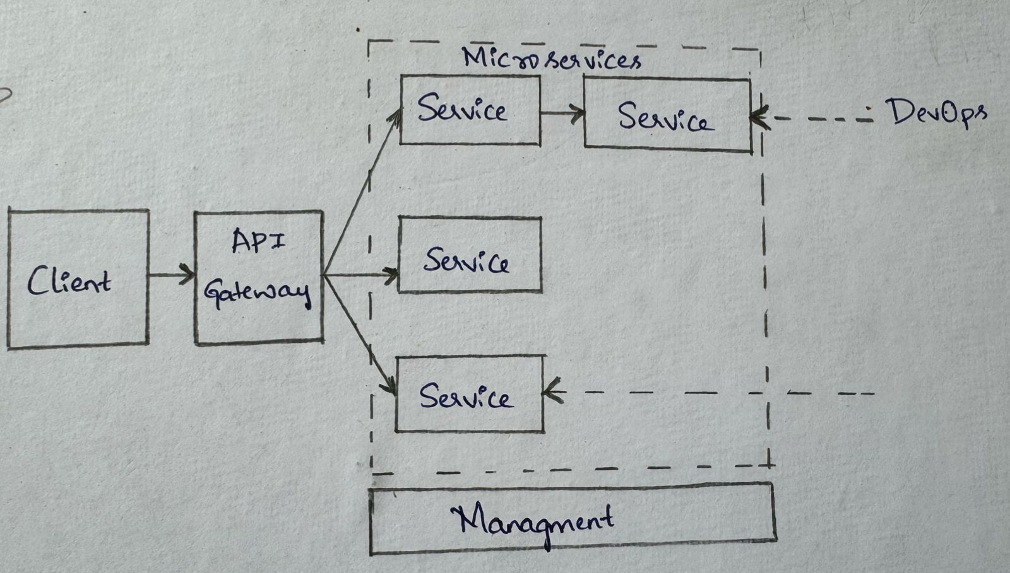

**API Gateway**. The API gateway is the entry point for clients. Instead of calling services directly, clients call the API gateway, which forwards the call to the appropriate services on the back end.

**MicroServices** :can be deployed independently.

**Management-** This component is responsible for placing services on nodes, identifying failures, rebalancing services across nodes.

**Advantages:**

Microservices architecture is an approach to system design that breaks complex systems into more minor, more manageable services. Using microservices frameworks results in more scalable, flexible, and easier-to-maintain systems.

Applications built using this architecture consist of small, independently deployable services that communicate with each other through APIs. By breaking down complex systems into more minor services, microservices architecture provides improved scalability, flexibility, and maintenance simplicity.

Advantages of microservices architecture

* Accelerate scalability
* Improve fault isolation
* Enhance team productivity
* Quicker deployment time
* Increase cost-efficiency

This guide explains the advantages and disadvantages of microservices and how to manage and streamline microservices to simplify scalable app development. Microservices architecture is vital for DevOps because it promotes faster development cycles, reduces risk, and improves scalability and resilience.