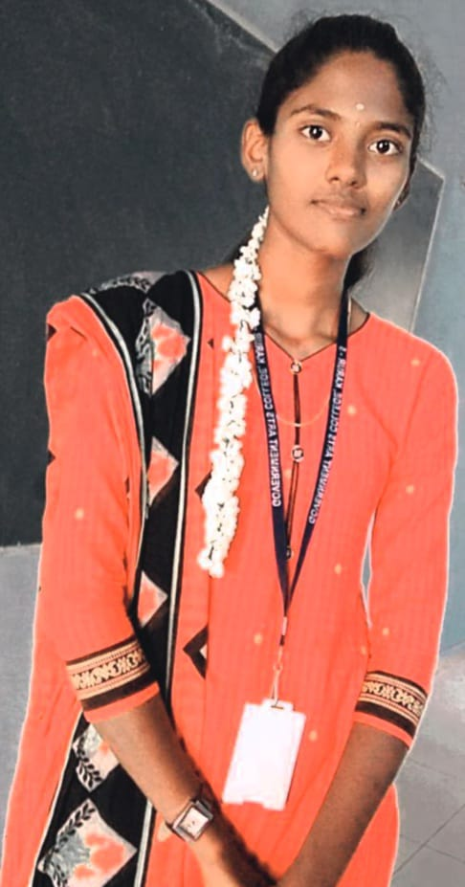

# Contact

**Email [id:](mailto:sangeetha2003cs@gmail.com)**[sangeetha2003cs@gmail.com](mailto:sangeetha2003cs@gmail.com) **Mobile no :**8110909683

# Skills

**Programming Languages : Python, Java, C++ Frontend : HTML5, CSS3, JavaScript, React Backend : Node.js**

# Language

English Tamil

# Hobbies

Playing chess Running

GeeksforGeeks

passion on Web Developer

# Summary

To secure a challenging position in a reputable organization to expand my learning knowledge and skill

# Xyz webdev pvt ltd - junior web developer

August 2021 to December 2021

Actively engaged in web creative design and development.

Designing project & planning Working on designing

**Education**

**University/college Passing year percentage/cgpa**

|  |  |  |
| --- | --- | --- |
| xyz | 2020 | 8.9 |
| pqr | 2018 | 89% |

# Project1

This project is based on html & used React