**CRIMOPEDIA (Online Crime Reporting System)**

**ABSTRACT**

CRIMOPEDIA (Online Crime Reporting System) is a web-based application developed using PHP and MySQL. The aim of the project is that people can report crime online. Presently there is no online web application available to report crime online. In order to report any complaints associated with crime, people have to contact closest police station. Our system makes crime reporting and follow-up easier. Counselling is required for some individuals on the basis of each case. Thus, counselling is requested by police officers for those who need counselling. Counsellors in the respective section can see the counselling request and take further action. If you need legal advice, you can request it through this system. Every request is evaluated and help is provided.

System Users

1. Admin
2. Police Station
3. Public Users
4. Lawyer
5. Counselling

Admin

1. Add/Update/Display/Delete Police Officer (Police Station)
2. Add/Update/Display/Delete lawyers
3. Add/Update/Display/Delete Counsellor(counselling)
4. Add/Update/Display/Delete Citizen (User)
5. Update/Display/Delete Complaint
6. View/Delete Complaints Status
7. View Feedback

Police Officer

1. View Complaint
2. Update Complaint Status

User

1. Register
2. Login
3. Add Complaint
4. View Complaint Status
5. Find Police Station
6. Find Lawyer
7. View laws
8. Take appointment for counselling

Lawyer

1. Register
2. Login
3. Add laws
4. Find user request
5. Proceed with the case if interested

Counselling

1. Register
2. Login
3. Add counselling Time
4. Find user request
5. Respond to the request

TABLES

tbl_**lawyers**

|  |  |  |  |  |
| --- | --- | --- | --- | --- |
| **No:** | **Field Name** | **Data Type** | **Key constraints** | **Field Description** |
| 1 | aid | Int (10) | Primary key | Primary key used to identify uniquely |
| 2 | name | Varchar (30) | Not null | Name of the lawyer |
| 3 | L_Phone number | Varchar (20) | Not null | Lawyer contact number |
| 4 | L_email | Varchar (30) | Not null | Lawyer email id |
| 5 | Office_address | Varchar (30) | Not null | Office location or name |
| 6 | city | Varchar (30) | Not null | Place of the lawyer |
| 7 | state | Varchar (30) | Not null | Type of court |
| 8 | district | Varchar (30) | Not null | Select district |
| 9 | Experience | Int (10) | Not null | Work experiences in year |
| 10 | logid | Int (10) | Foreign key | Login id of lawyer |
| 11 | Practice_area | Varchar (10) | Not null | type of lawyer |
| 12 | court | Varchar (10) | Not null | Describe supreme or high court. |

Tlb_counselling

|  |  |  |  |  |
| --- | --- | --- | --- | --- |
| No: | Field | Datatype | Key_constraints | Description |
| 1 | Couselling_id | Varchar (10) | Primary key | Id (primary key) |
| 2 | Counsellor name | Varchar (100) | Not null | Name of the counsellor |
| 3 | Counsellor_housename | Varchar (100) | Not null | Address line1 |
| 4 | Counsellor_place | Varchar (100) | Not null | Place of the counsellor |
| 5 | Qualification_details | Varchar (200) | Not null | Qualification  details of counsellor |
| 6 | Specialization | Varchar (200) | Not null | Specialisation field |
| 7 | Exp | Varchar (200) | Not null | Working experience in year |

Tlb_Payment

|  |  |  |  |  |
| --- | --- | --- | --- | --- |
| No | Field | Datatype | Key Constraints | Description |
| 1 | Payment_id | Int (200) | Primary | Primary for the payment |
| 2 | Date | date | Not null | Date describes the payment is done |
| 3 | Payment | Int (20) | Not null | Payment amount |

Tbl login

|  |  |  |  |  |
| --- | --- | --- | --- | --- |
| S.  No: | Field | Datatype | Key Constraints | Description |
| 1 | Loginid | Int (10) | Primary key | Login id of users |
| 2 | Username | Varchar (20) | Not null | Username of login person |
| 3 | Password | Varchar (20) | Not null | Password of the user |
| 4 | Role | Varchar (20) | Not null | Role of the user login |

Diagram

Activity diagram

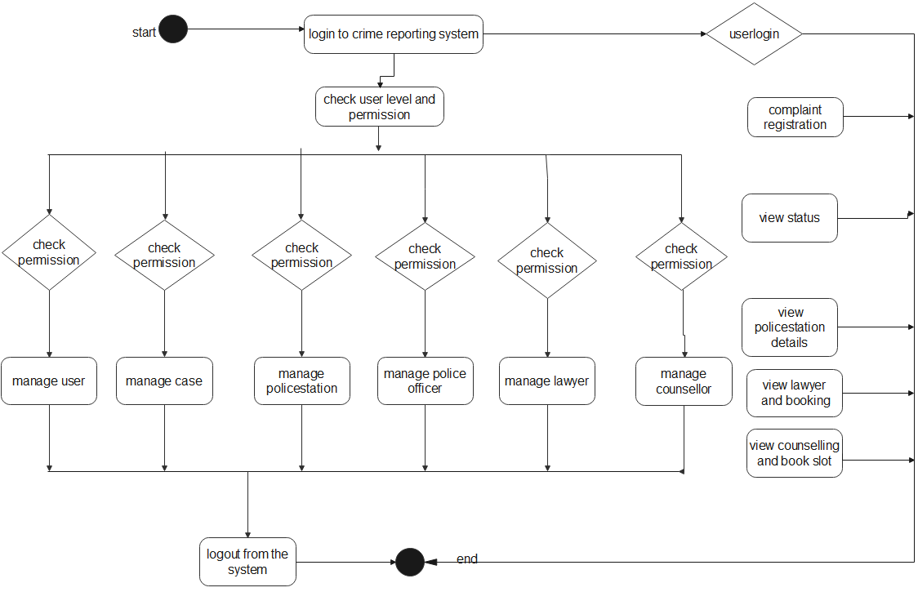

Class diagram

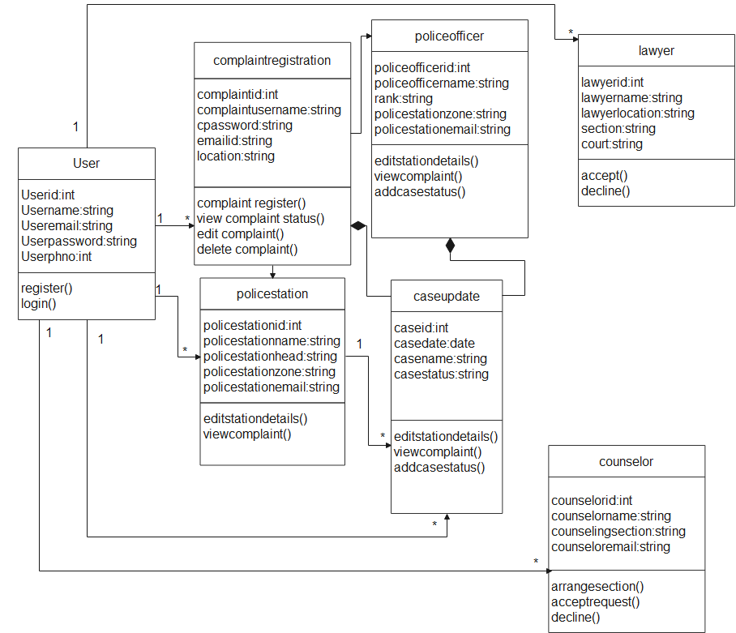

Component diagram

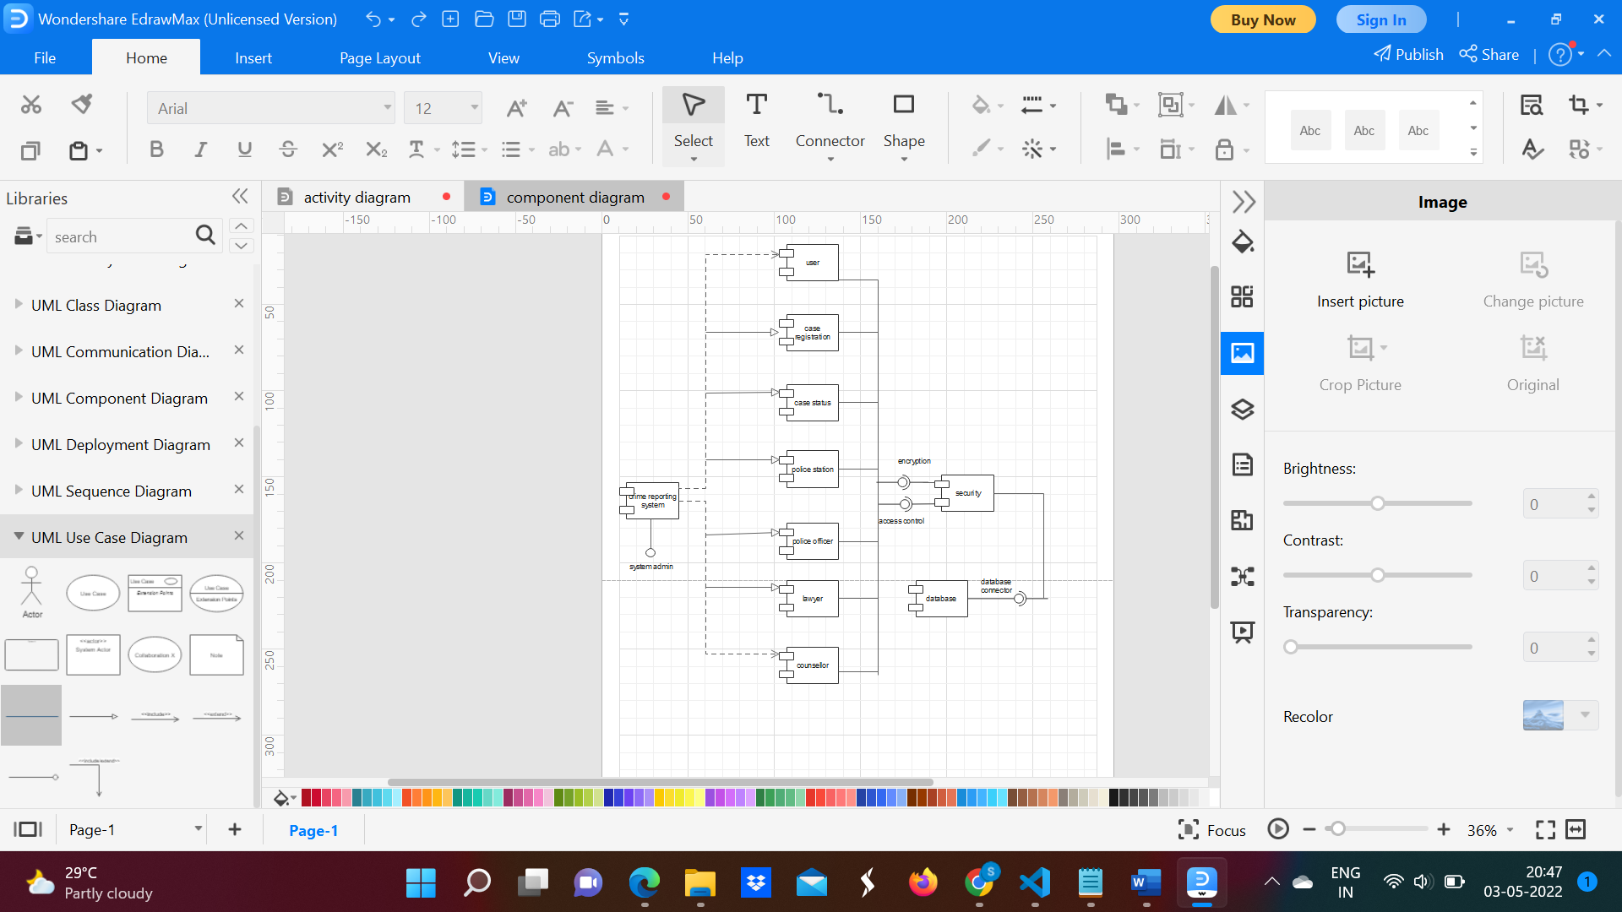

Object diagram

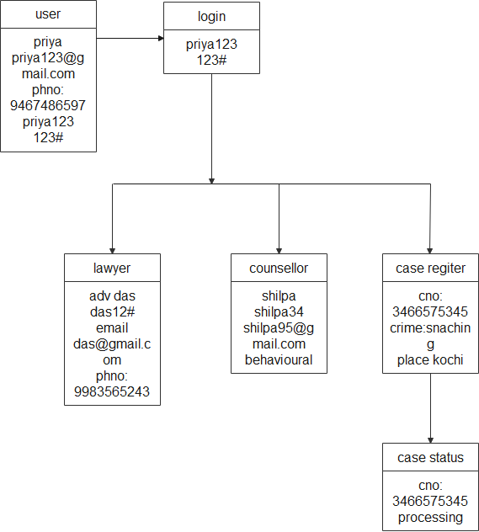

Sequence diagram

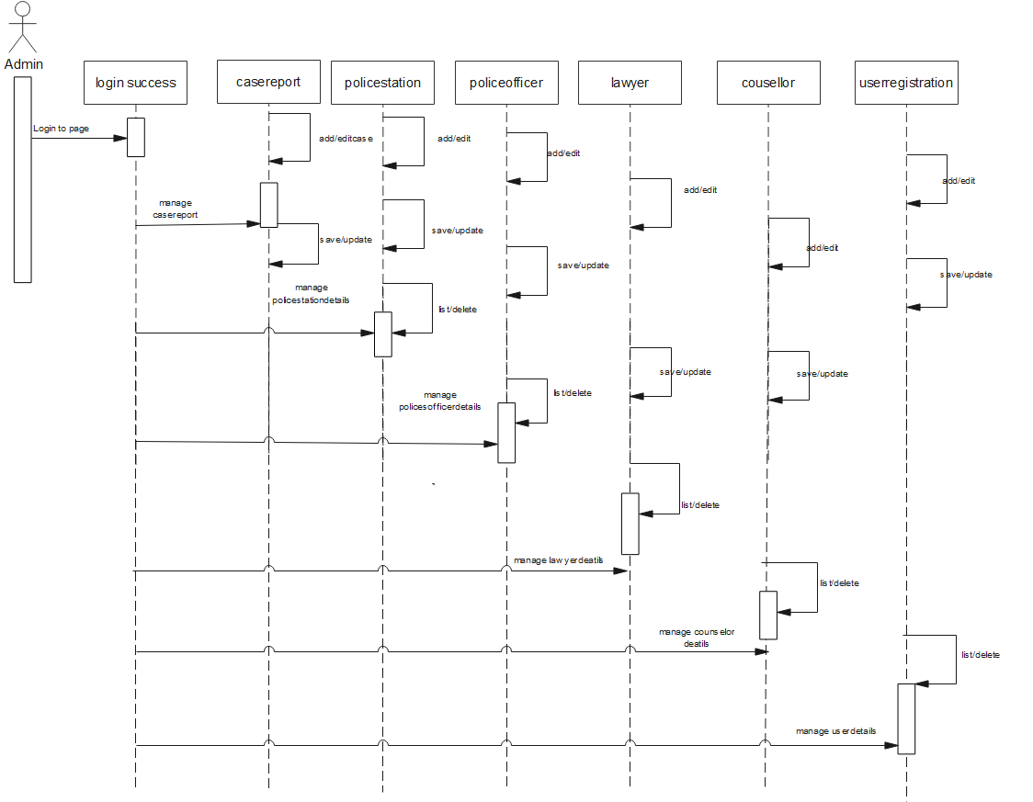

State machine diagram

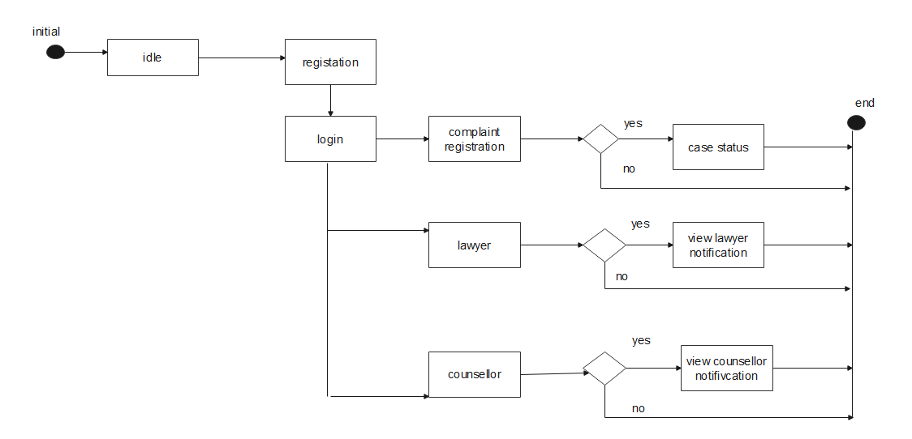

Usecase diagram

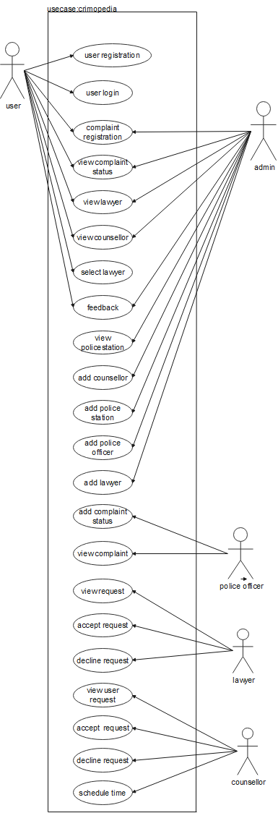

Deployment diagram

