Running AI Privately: Benchmarking Small Language Models for Offline and Privacy-Sensitive Deployment
Specification and Design Proposal
Statement of Ethical Compliance
Data Category: A0 (No personal data collected or processed). This project does not involve human participants, personal data, or sensitive information. All benchmark data is self-generated by the researcher. The project will be conducted in accordance with the University of Liverpool ethical guidelines.
Project Description
Financial institutions such as banks, investment firms, and trading companies handle some of the most sensitive data in existence, and are subject to strict privacy regulations including the UK General Data Protection Regulation (GDPR) and Financial Conduct Authority (FCA) guidelines. When employees use popular AI tools such as ChatGPT, every query is transmitted to external servers owned by third-party companies. For a regulated financial institution, this means sensitive data leaves the organisation's control the moment it is typed into the tool, creating both a regulatory and a reputational risk. As a result, many financial institutions are effectively unable to adopt modern AI tools, not because the technology lacks value, but because the way it is currently deployed is fundamentally incompatible with their data protection obligations.
This project addresses that problem by investigating Small Language Models (SLMs) — compact AI models capable enough to be genuinely useful but small enough to run entirely on a standard laptop with no internet connection. Recent advances from organisations such as Meta, Mistral AI, and Microsoft have produced SLMs that are openly available and increasingly capable for professional use. The project will build a working application allowing finance professionals to query one of three locally running models — Mistral 7B, Llama 3.2, and Phi-3 Mini — with no data leaving their device, alongside a cloud-based model accessed via API as a performance baseline. A structured benchmark will compare all four models on response speed, answer quality, and memory usage across finance-specific test questions. The resulting recommendation framework gives financial organisations practical, evidence-based guidance for adopting AI without compromising regulatory compliance or client confidentiality.
Aims and Requirements
i) Aims:
- To build a working offline AI assistant for financial services operating entirely on local hardware with no internet connection or external data transmission.
- To develop an interactive web-based interface allowing finance professionals to query the three local models and a cloud-based baseline, demonstrating the practical difference between offline and online AI deployment.
- To benchmark three small language models — Mistral 7B, Llama 3.2, and Phi-3 Mini — alongside a cloud-based model accessed via API, measuring response speed, answer quality, and memory usage across finance-specific test questions.
- To produce evidence-based recommendations on which model best suits speed-critical, accuracy-critical, and resource-constrained financial deployment scenarios.
- To contribute to the growing body of knowledge on privacy-preserving AI deployment in regulated industries.
ii) Requirements:
Essential:
- The system must run all three local models completely offline, requiring no internet connection after initial download.
- A cloud-based model must be integrated via API as a fourth option, serving as a performance and quality baseline.
- The application must provide a web-based chat interface allowing users to query any of the four models.
- Users must be able to switch between all four models without restarting the application.
- The interface must clearly distinguish local models from the cloud model so users know whether their query is processed locally or transmitted externally.
- Each response must display the model used, response time, and RAM usage.
- A finance-specific system prompt must configure model behaviour as a professional financial assistant.
- A benchmark script must automatically run all questions through all four models and save the results to a CSV file.
- The dashboard must display at least four comparative charts covering response time, quality score, cost per query, and the speed-quality tradeoff.
- All code must be version controlled and publicly accessible via GitHub.
Desirable:
- Conversation history should persist within a session for natural follow-up questions.
- Benchmark results should be filterable by question category.
- A privacy indicator should confirm local processing, with a clear warning when the cloud model is selected.
- A downloadable summary of benchmark findings should be available.
- Estimated cost per query should display in real time when the cloud model is selected.
Key Literature and Background Reading
Foundations of Large Language Models
The theoretical foundation underlying all modern language models is the transformer architecture, introduced by Vaswani et al. (2017). This paper established the self-attention mechanism enabling unprecedented language processing capability, and all three local models used in this project are built directly upon it.
Small Language Models and the Three Models Used
Mistral 7B was introduced by Jiang et al. (2023), who demonstrated that a carefully designed seven billion parameter model could outperform larger models through architectural innovations including sliding window attention, justifying its inclusion as the balanced, general-purpose model in this comparison. The Llama 3.2 family was released by Meta AI (2024) as an openly available series emphasising accessibility and performance on consumer hardware, a release widely credited with enabling the growth of local AI deployment tools such as Ollama. Phi-3 Mini was introduced by Abdin et al. (2024) from Microsoft Research, who showed that training on carefully curated data could produce a 3.8 billion parameter model performing comparably to much larger ones — a model explicitly designed for resource-constrained local hardware, directly aligned with this project's deployment context.
Small Language Models as the Future of Agentic AI
Belcak et al. (2025) argue that small language models are sufficiently powerful, inherently more suitable, and necessarily more economical for many invocations in agentic systems, positioning them as the future of agentic AI. This supports the idea behind the project: that local SLMs are not just a workaround for privacy requirements, but can actually be a better technical and cost-effective option for real-world use in areas like financial services.
Model Compression and Quantisation
Running large language models on resource-constrained hardware is made possible through quantisation, which reduces the numerical precision of model weights to decrease memory and computational requirements, often with limited impact on performance depending on the specific method and configuration used (Dettmers et al., 2022). This makes low-bit inference feasible in practical deployment scenarios, although performance trade-offs may vary depending on the model and quantisation approach. Building on this, the llama.cpp framework (Gerganov, 2023) provides support for the GGUF model format and efficient CPU-based inference, including low-bit quantisation schemes such as 4-bit and 5-bit configurations. Ollama is built on top of llama.cpp and utilises GGUF-quantised versions of the selected models used in this project. As a result, quantisation is an important factor when interpreting performance differences observed in the benchmark.
Privacy and Regulatory Context for AI in Financial Services
The privacy motivation for this project is grounded in real regulatory requirements rather than theoretical concerns. The UK GDPR requires organisations processing personal data to identify a lawful basis for processing and sharing data, while organisations using third-party processors must establish appropriate data processing arrangements (Information Commissioner’s Office, 2021). The Financial Conduct Authority (2023) highlights the increasing adoption of artificial intelligence and machine learning in financial services and emphasises that firms must maintain appropriate governance, risk management, and accountability for AI-driven systems, including when third-party technologies are used. This implies that the use of external cloud-based AI systems may introduce additional governance and data control considerations, motivating the exploration of local or offline AI alternatives where sensitive data remains under organisational control.
Benchmarking and Evaluation Methodology
The evaluation methodology draws on established benchmarking frameworks. Liang et al. (2022) introduced HELM, a multi-dimensional evaluation framework for language models covering accuracy, robustness, fairness, and efficiency, demonstrating that single-metric evaluation is insufficient. This supports this project’s benchmarking approach based on speed, quality, and resource usage. Srivastava et al. (2022) similarly demonstrated that meaningful comparison requires diverse task categories rather than homogeneous question sets, justifying the decision to spread benchmark questions across four categories: factual knowledge, regulatory compliance, financial reasoning, and plain language explanation.
Summary
Together, this literature establishes the technical foundations of the models compared, justifies the privacy-first motivation for local deployment in financial services, grounds the benchmark design methodologically, and situates this project within an emerging consensus that small language models are a genuinely superior choice for many professional deployment scenarios. The specific gap this project addresses — an empirical comparison of these models on finance-specific tasks on consumer hardware with a cloud baseline — is not covered by any reviewed paper, confirming the originality of the contribution.
Development and Implementation Summary
The project will be developed using Python 3.13, selected for its established role in AI and data science development, comprehensive library support, and suitability for clear, reproducible implementations. Development will take place on a Windows laptop using Visual Studio Code.
Ollama will serve as the runtime environment for the three local models, handling model loading, inference, and response serving through a simple command-line interface and Python API. The three models — Mistral 7B, Llama 3.2, and Phi-3 Mini — are downloaded once and run with no internet connection required. The primary reason for choosing Ollama is its clean Python integration, active developer community, and reduced implementation complexity compared with alternative local AI frameworks.
A cloud-based model will be integrated via a third-party API as a fourth option within the same backend, ensuring the benchmark is conducted under consistent conditions across all four models. When selected, the question is transmitted externally and the response is processed and recorded using identical methodology to the local models.
FastAPI will be used for the backend, exposing a single endpoint that receives a question and model selection, applies a finance-specific system prompt, routes the request to either Ollama or the cloud API, measures response time and memory usage, and returns the result. FastAPI provides automatic documentation, built-in validation through Pydantic, and strong performance, and is deployed locally using Uvicorn.
Streamlit will be used for the interface, consisting of two tabs: a live chat tab where users select a model and submit questions, and a results tab displaying benchmark comparisons as interactive Plotly charts. Streamlit allows rapid development of data-focused interfaces entirely within Python.
The benchmark system loops through all four models and test questions automatically, recording responses, response time, and RAM usage to a CSV file using Pandas. Each answer is then manually scored from one to five using a predefined rubric, and the completed CSV generates the comparison charts via Plotly Express.
Development will follow an iterative workflow — backend and local model integration, followed by cloud API integration, the interface, the benchmark system, and finally analysis and visualisation — with each component tested individually before integration, and all code committed to GitHub throughout.
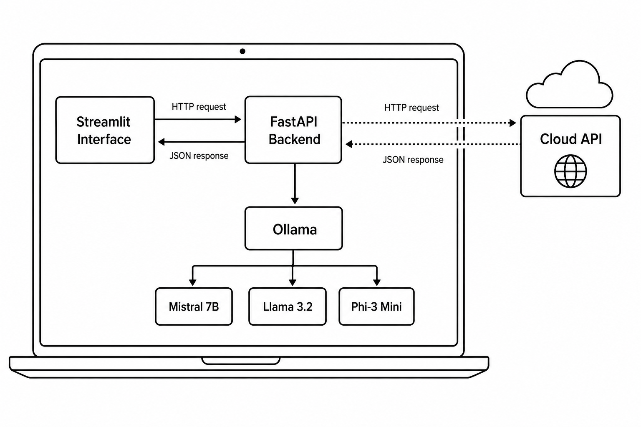
Figure illustrates how the system components connect. The Streamlit interface sends the user's question and selected model to the FastAPI backend via an HTTP request. FastAPI then routes the request either to Ollama, which runs the three local models directly on the same machine, or to the cloud API, which processes the request on an external server before returning a response. This architecture keeps the local and cloud pathways structurally identical from the interface's perspective, while making clear — both in the diagram and in practice — that only the cloud pathway involves data leaving the device.
Data Sources
This project does not use any external datasets, real financial data, or personal data of any kind. This reflects the privacy-first nature of the project itself — a system built to protect financial data should not rely on sensitive data to evaluate itself.
The only data used is a set of finance-specific benchmark questions, created by the researcher and structured across four categories: factual financial knowledge, regulatory and compliance knowledge, financial reasoning, and plain language explanation. During the cloud baseline comparison, these same questions will be transmitted to a third-party API; as they contain no personal or confidential information, this raises no data protection concerns and reinforces the project's core argument that real financial data could not be handled this way.
The responses from all four models, along with performance metrics and manually assigned quality scores, will be recorded in a CSV file and committed to the project's GitHub repository. As no external data is consumed, there are no data sharing or licensing requirements beyond the API provider's standard terms of service, and the project will be conducted in accordance with University of Liverpool data management guidelines.
Testing and Evaluation
Testing and evaluation will be conducted at two levels: technical testing, confirming that each component functions correctly in isolation and as an integrated whole, and evaluation testing, assessing whether the system meets its research objectives and produces meaningful results.
Technical Testing
Testing will follow a component-by-component approach. The FastAPI backend will be tested through its automatically generated documentation interface, confirming valid responses with correct timing and RAM data across all models, correct cloud API functionality, and appropriate handling of invalid requests. The Streamlit interface will be tested by selecting each model and submitting a range of questions, verifying that results match those obtained directly from the backend. The benchmark script will first be run on a reduced sample to verify logic and CSV output before the full run, followed by end-to-end integration testing of the complete system.
Offline vs Online Comparative Evaluation
A central feature of the evaluation is a direct comparison between the three local models and the cloud-based model, addressing the most practically relevant question for financial organisations: how does local AI compare to a commercial cloud alternative? The same benchmark questions will be submitted to all four models, with response time, quality, and cost per query recorded using identical methodology. As the questions contain no sensitive information, their transmission to the cloud API raises no data protection concerns, while reinforcing the project's central argument that real financial data could not be handled this way — making local deployment the only viable option for genuine use cases. Results will be visualised alongside the local models, allowing evidence-based conclusions about how closely local models match cloud quality while offering zero cost, complete privacy, and no internet dependency.
Manual Quality Evaluation
Each answer will be scored from one to five using a predefined rubric — five for a complete and accurate answer, three for partially correct or incomplete, and one for incorrect or irrelevant — finalised before scoring begins and applied in a single sitting to maintain consistency, acknowledging that manual scoring introduces some subjectivity. Quantitative metrics will include average response time, p50 and p95 latency calculated using NumPy, average RAM usage, cost per query, and quality score per model and category, visualised through bar charts, a cost comparison chart, and a speed-quality scatter chart. The evaluation concludes with deployment recommendations addressing speed-critical, accuracy-critical, and resource-constrained scenarios, grounded in comparison against the cloud baseline to ensure practical actionability.
Project Ethics and Human Participants
This project does not involve any human participants. No users will be recruited, no surveys or interviews conducted, and no observations of human behaviour carried out. The entire project is completed by the researcher using self-generated questions and AI-generated responses.
The data category for this project is A0, confirming that no personal data is collected, processed, or stored at any point. The only data generated is the benchmark questions, the model responses, and the performance metrics recorded during benchmarking, none of which contain personal or identifiable information.
The three local models — Mistral 7B, Llama 3.2, and Phi-3 Mini — are used under their respective open-source licences (Apache 2.0, Llama 3 Community Licence, and MIT), as are the development tools and frameworks including FastAPI, Streamlit, Ollama, Pandas, and Plotly. The cloud-based model is accessed via its official API in accordance with its terms of service.
No personal or sensitive data is transmitted to the cloud API at any point, as the benchmark questions are entirely researcher-generated. There are no other ethical considerations specific to this project, and any broader considerations relating to AI bias or fairness will be discussed critically in the dissertation. This project will be conducted in full accordance with the University of Liverpool ethical guidelines, with the ethical category confirmed as A0 following discussion with the project supervisor.
BCS Project Criteria
The following explains how this project addresses the six required BCS learning outcomes.
1. Systematic understanding of knowledge and awareness of current research
This project engages with an active area of AI research: the use of small language models (SLMs) for privacy-sensitive applications. The literature review draws on recent work (2022–2025), including Mistral, Llama, Phi-3, quantisation research, FCA regulatory guidance, and emerging perspectives on SLMs in agentic AI systems. The study identifies a clear gap in existing research: no published work compares Mistral 7B, Llama 3.2, and Phi-3 Mini on finance-domain tasks using consumer hardware alongside a cloud baseline. This project addresses that gap through original empirical evaluation grounded in relevant UK financial regulatory context.
2. Comprehensive understanding of applicable techniques
The project applies techniques across software engineering (modular architecture, API design, version control), data science (benchmark design, statistical analysis, and visualisation using Plotly and NumPy), AI/NLP (local model deployment, prompt engineering, and quantisation-aware evaluation), and research methodology (rubric development and structured benchmarking). Together, these demonstrate a broad and integrated technical skill set.
3. Originality in application of knowledge
While the models and tools are existing technologies, their combined use in this specific evaluation framework is original. No existing study benchmarks Mistral 7B, Llama 3.2, and Phi-3 Mini on finance-specific tasks with a structured rubric and a cloud API baseline. The benchmark design adapts established frameworks such as HELM and BIG-bench to a domain-specific context not previously explored.
4. Ability to address complex problems systematically and creatively
The project manages multiple interconnected challenges including model deployment, API integration, and evaluation design through a modular architecture. Key design decisions, such as benchmark size, balance feasibility with analytical depth. Findings are communicated through both a technical dissertation and a non-specialist Streamlit dashboard.
5. Self-direction and autonomy
This work is fully self-directed, from problem identification and literature review to system design and implementation. The project evolved in response to feedback, including the addition of a cloud baseline comparison. The final system reflects independent decision-making and professional-level development practice.
6. Critical self-evaluation
The dissertation critically reflects on limitations such as subjectivity in manual scoring, constraints of single-machine evaluation, and the limited benchmark size. It also evaluates design choices (e.g., use of FastAPI) and outlines future improvements, including automated evaluation and expanded datasets.
UI/UX Mockup
The FinanceAI application will be delivered as a web-based interface built using Streamlit, designed for simplicity and usability so that a finance professional can use it without technical knowledge of the underlying system.
The interface consists of a sidebar and a main content area containing two tabs. The sidebar displays the application name, a privacy indicator confirming local processing, and a model selection dropdown allowing the user to choose between the three local models and the cloud-based baseline, clearly distinguished so the user always knows whether a query is processed locally or transmitted externally.
The first tab, Ask a Question, provides a live chat interface where questions and answers are displayed alongside the model name, response time, and RAM usage, with an external-transmission indicator shown for the cloud model. The second tab, Benchmark Results, displays four Plotly charts comparing the four models on response time, quality score, cost per query, and the overall speed-quality tradeoff, alongside a written summary of key findings and deployment recommendations.
The design favours clarity over visual complexity, using Streamlit's default clean interface with all elements clearly labelled, requiring no training to use.
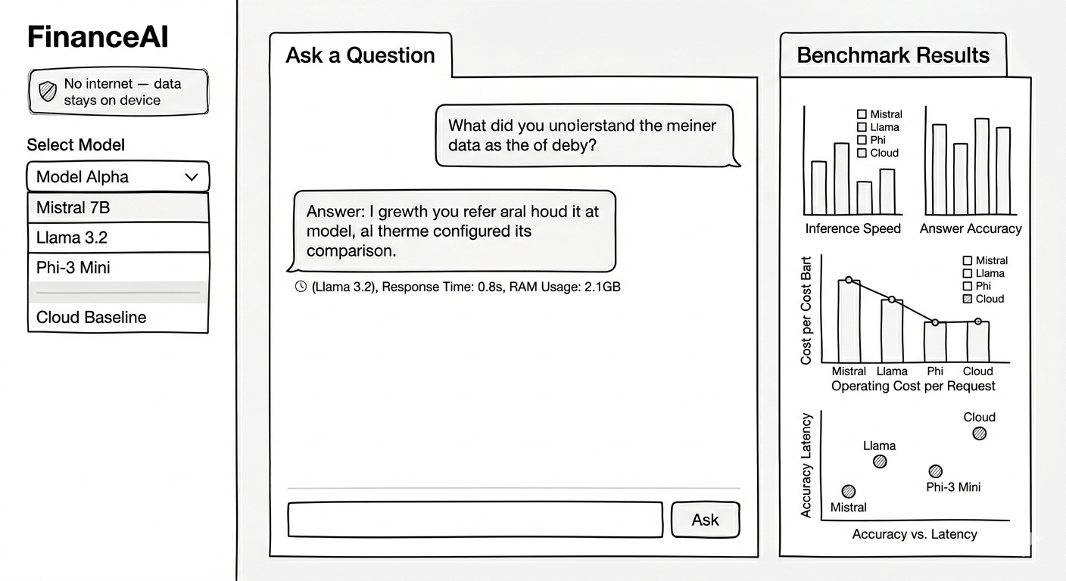
Project Plan (Gantt Chart)
The project runs from 1st June 2026 to 11th September 2026. The chart below shows the planned timeline for each development and writing activity.
Task | June W1 | June W2 | June W3 | June W4 | July W1 | July W2 | July W3 | July W4 | Aug W1 | Aug W2 | Aug W3 | Aug W4 | Sept W1 | Sept W2
Environment setup & model downloads
FastAPI backend development
Streamlit dashboard — live chat
Write benchmark questions
Run full benchmark
Score answer quality manually
Add benchmark charts to dashboard
Data analysis and trade-off writeup
Literature review
Dissertation writing
Testing and evaluation
Final polish and submission

Risk and Contingency
Risk | Contingency plan | Likelihood | Impact
Local models run too slowly on available hardware, making benchmarking impractical | Test all models early in the project; switch to smaller quantised versions via Ollama if needed | Medium | Medium
Running out of time due to dissertation workload | Follow the project plan closely; prioritise essential requirements over desirable ones if time becomes limited | Medium | High
Cloud API costs, rate limits, or downtime disrupt the benchmark | Test the API on a small sample first; set a spending cap; run the local benchmark first so results are not dependent on cloud availability | Low | Medium
Loss of code or benchmark data | Commit code and results to GitHub regularly throughout development | Low | High
Manual quality scoring introduces inconsistency or subjectivity | Define the scoring rubric before scoring begins; score all answers in a single sitting; acknowledge the limitation in the dissertation | Medium | Medium
Benchmark results show little meaningful difference between models | Redesign questions to be more discriminating if needed; note that similar performance is itself a valid and useful finding | Low | Medium

References
Abdin, M., Jacobs, S.A., Awan, A.A., Aneja, J., Awadallah, A., Awadalla, H., Bach, N., Bahree, A., Bakhtiari, A., Behl, H., Benhaim, A., Bilenko, M., Bjorck, J., Bubeck, S., Cai, M., Mendes, C.C.T., Chen, W., Chaudhary, V., Chopra, P. and Del Giorno, A. (2024). Phi-3 Technical Report: A Highly Capable Language Model Locally on Your Phone. [online] arXiv.org. doi: https://doi.org/10.48550/arXiv.2404.14219.
Belcak, P., Heinrich, G., Diao, S., Fu, Y., Dong, X., Muralidharan, S., Lin, Y.C. and Molchanov, P. (2025). Small Language Models are the Future of Agentic AI. [online] arXiv.org. Available at: https://arxiv.org/abs/2506.02153.
Dettmers, T., Lewis, M., Belkada, Y. and Zettlemoyer, L. (2022). LLM.int8(): 8-bit Matrix Multiplication for Transformers at Scale. [online] arXiv.org. doi: https://doi.org/10.48550/arXiv.2208.07339.
Dubey, A., Jauhri, A., Pandey, A., Kadian, A., Al-Dahle, A., Letman, A., Mathur, A., Schelten, A., Yang, A., Fan, A., Goyal, A., Hartshorn, A., Yang, A., Mitra, A., Sravankumar, A., Korenev, A., Hinsvark, A., Rao, A., Zhang, A. and Rodriguez, A. (2024). The Llama 3 Herd of Models. [online] arXiv.org. Available at: https://arxiv.org/abs/2407.21783.
Financial Conduct Authority (2022). FS23/6: Artificial Intelligence and Machine Learning. [online] FCA. Available at: https://www.fca.org.uk/publications/feedback-statements/fs23-6-artifical-intelligence-machine-learning.
Gerganov, G. (2023). llama.cpp. [online] GitHub. Available at: https://github.com/ggerganov/llama.cpp.
ICO (2023). Lawful basis for sharing personal data. [online] ico.org.uk. Available at: https://ico.org.uk/for-organisations/uk-gdpr-guidance-and-resources/data-sharing/data-sharing-a-code-of-practice/lawful-basis-for-sharing-personal-data/.
Jiang, A.Q., Sablayrolles, A., Mensch, A., Bamford, C., Chaplot, D.S., Casas, D. de las, Bressand, F., Lengyel, G., Lample, G., Saulnier, L., Lavaud, L.R., Lachaux, M.-A., Stock, P., Scao, T.L., Lavril, T., Wang, T., Lacroix, T. and Sayed, W.E. (2023). Mistral 7B. [online] arXiv.org. doi: https://doi.org/10.48550/arXiv.2310.06825.
Liang, P., Bommasani, R., Lee, T., Tsipras, D., Soylu, D., Yasunaga, M., Zhang, Y., Narayanan, D., Wu, Y., Kumar, A., Newman, B., Yuan, B., Yan, B., Zhang, C., Cosgrove, C., Manning, C.D., Ré, C., Acosta-Navas, D., Hudson, D.A. and Zelikman, E. (2022). Holistic Evaluation of Language Models. [online] arXiv.org. Available at: https://arxiv.org/abs/2211.09110.
Srivastava, A., Rastogi, A., Rao, A., Shoeb, A.A.M., Abid, A., Fisch, A., Brown, A.R., Santoro, A., Gupta, A., Garriga-Alonso, A., Kluska, A., Lewkowycz, A., Agarwal, A., Power, A., Ray, A., Warstadt, A., Kocurek, A.W., Safaya, A., Tazarv, A. and Xiang, A. (2022). Beyond the Imitation Game: Quantifying and extrapolating the capabilities of language models. arXiv:2206.04615 [cs, stat], [online] 3. Available at: https://arxiv.org/abs/2206.04615.
Vaswani, A., Shazeer, N., Parmar, N., Uszkoreit, J., Jones, L., Gomez, A.N., Kaiser, L. and Polosukhin, I. (2017). Attention Is All You Need. [online] Cornell University. Available at: https://arxiv.org/abs/1706.03762.

