Week 3

Clusters
First understand the data and remove the data we don’t need
Find mean of line and standard deviation and take distance of each data points normalise it
Once we normalise it is easier to understand them
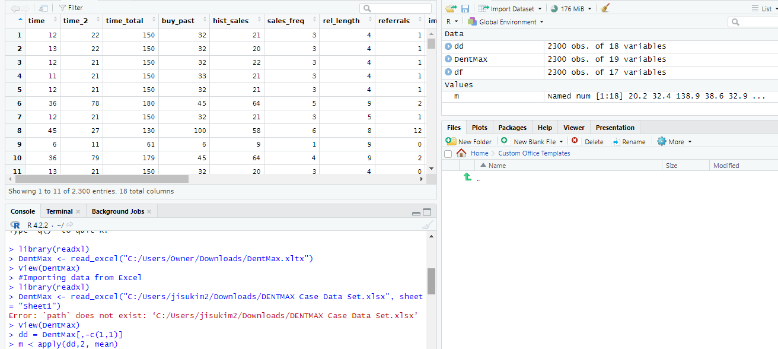
We looked at the number of optimal clusters

Week 4

Regression
- consists of dependant and independent variable
- try to understand of y to x

Linear is starting point of regression

Week 5
Psych-statistic tool

