Sulav Infra Pvt. Ltd.
Portfolio of Completed Projects

1. Periodic Maintenance of Anamnagar-BICC, Boharatar-Banasthali, Bhajangal-Kirtipur-Chobhar, Gokarna-Jorpati-Gothatar & Karkigaun-Mulpani-Gokarna Roads, Kathmandu
Certifying Authority: Department of Roads, Road Division Kathmandu
Contractor / JV: M/S U Infra - S Infra J/V (Uma Infra Builders Pvt. Ltd. 60%, Sulav Infra Pvt. Ltd. 40%)

Project Description & Scope of Work
Periodic maintenance works carried out across five separate Kathmandu road sections under a single Department of Roads contract. The scope covered base course preparation, bituminous penetration macadam, premix and asphalt concrete pavement layers, cement concrete works (M15/M20), stone masonry and plum concrete structures, and thermoplastic road marking, restoring these urban roads to a safe and durable riding condition while fulfilling all health, safety, environmental and social safeguard requirements.

Site Photograph
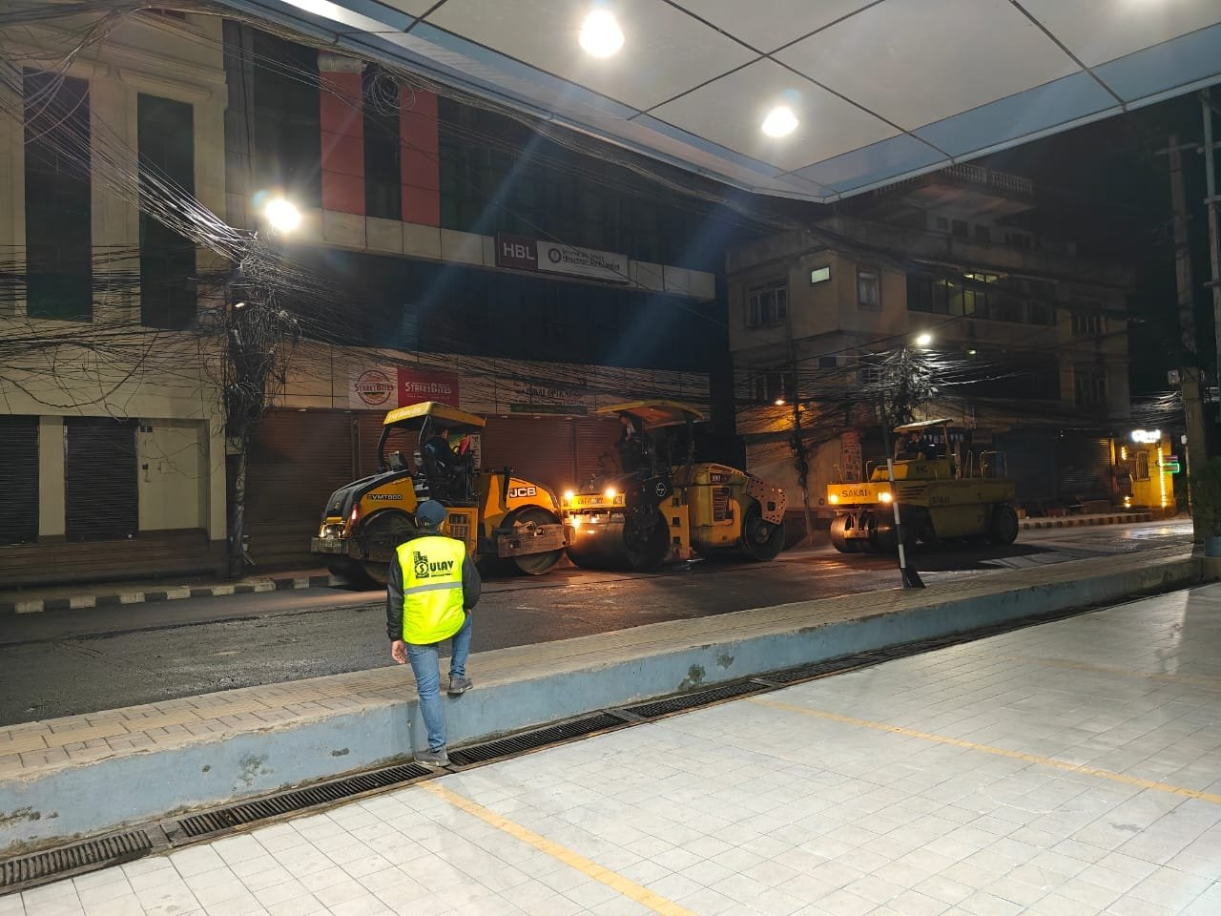
Figure 1: Night-time bituminous paving and rolling works, Kathmandu roads

General Information
Contract Identification No. | SRCTIP-DOR-WPM-RDKTM-NCB-33
Employer | Department of Roads, Road Division Kathmandu
Contract Agreement Date | 2080.08.07
Work Completed Date | 2081.09.08
Original Contract Amount | NRs. 4,10,72,891.59 (Excl. VAT, incl. PS)
Revised Contract Amount | NRs. 4,25,40,479.90 (Excl. VAT, incl. PS)
Final Bill Amount | NRs. 4,22,23,868.70 (Excl. VAT, incl. PS NRs. 615,760.30)
Certificate Date / Ref | 2081.10.15 / Ref. No. 1231-081-82

Major Items of Work Completed
Item of Work | Total Qty | Unit
Base | 241.66 | Cum
Bituminous penetration macadam | 629.47 | Sqm
Premix | 2255.40 | Sqm
Asphalt concrete | 1380.65 | Cum
Cement concrete M15 | 38.89 | Cum
Cement concrete M20 | 9.73 | Cum
Stone masonry | 68.74 | Cum
Plum concrete (60%-40%) | 25.76 | Cum
Thermoplastic road marking painting | 2064.99 | Sqm

2. Rehabilitation / Post-monsoon Works along Mahakali Highway (Phaltude to Sahukhark Section)
Certifying Authority: Department of Roads, Road Division Doti
Contractor / JV: M/S Pagoda-Sulav JV, Kathmandu

Project Description & Scope of Work
Structural rehabilitation and post-monsoon repair works on a critical section of the Mahakali Highway. The joint venture executed extensive stone soling, plain cement concrete, stone masonry and gabion protection works together with large-volume plum concrete placement, and installed road delineator posts to reinforce slope stability and safeguard the highway against future monsoon damage.

Site Photograph
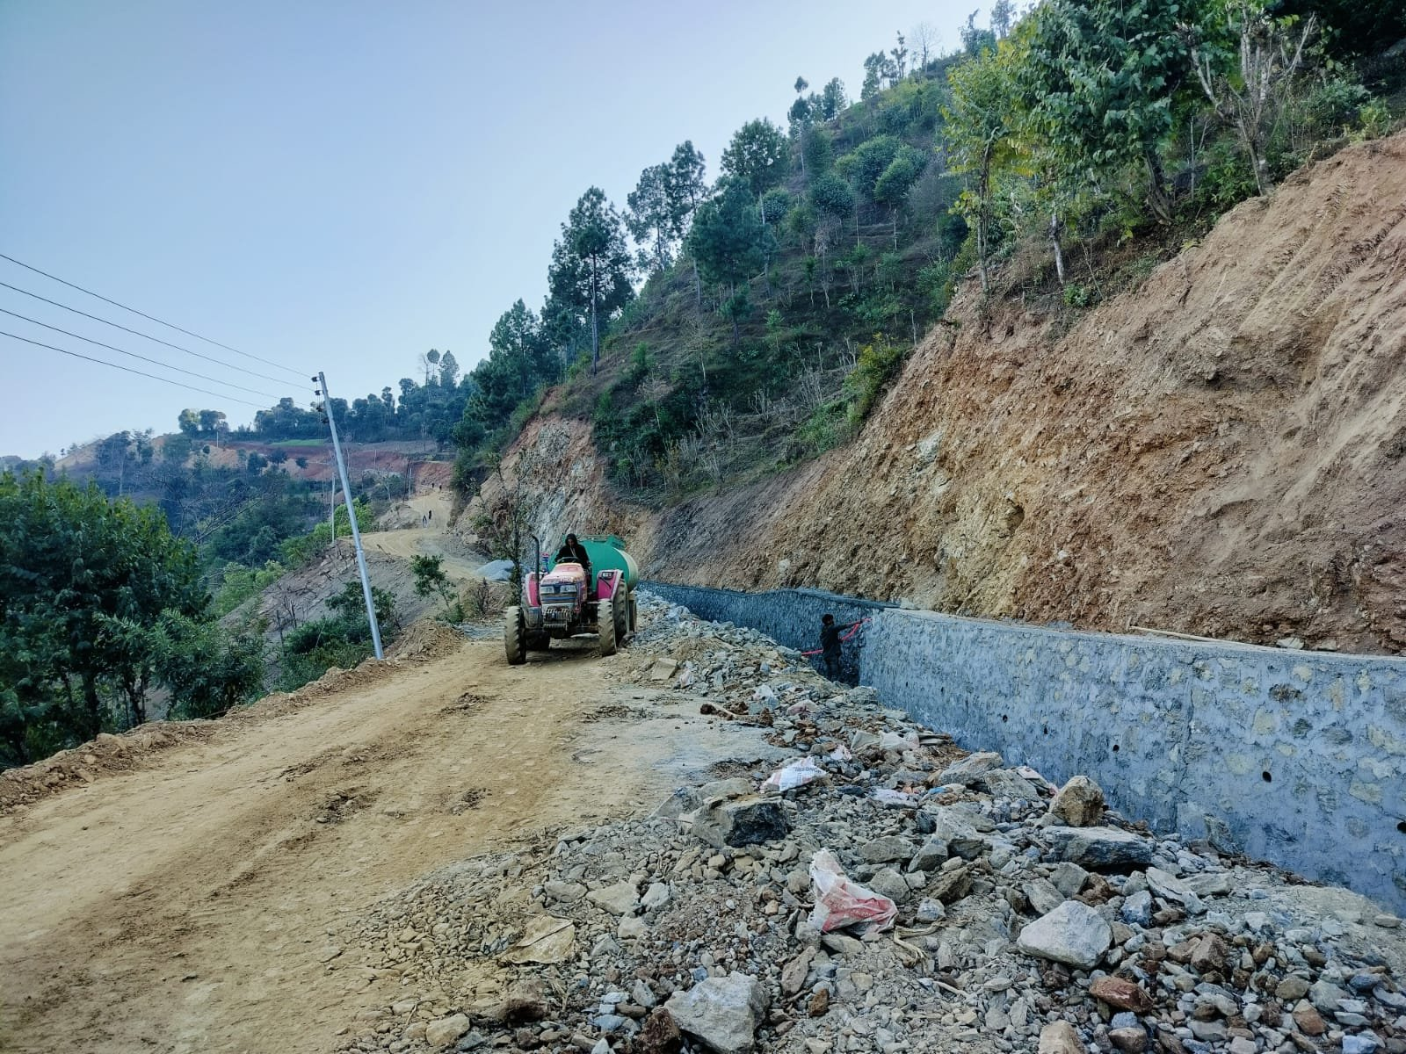
Figure 2: Stone-masonry retaining wall and slope protection, Mahakali Highway

General Information
Contract Identification No. | RDDOT/337310113/2079/80-031(Re)
Type of Work | Structure Works
Date of Agreement | 2080/02/23
Initial Date of Work Completion | 2080/06/30
Final Date of Work Completion | 2080/06/30
Status of the Project | Completed
Total Contract Amount | NRs. 65,970,591.92 (Excl. VAT & PS)
Total Expenditure | NRs. 65,271,238.00 (Excl. VAT & PS)
Certificate Date / Ref | 2080/10/08 / Letter No. 2080/2081, Ref No. 493

Major Items of Work Completed
Item of Work | Quantity | Unit
Stone Soling | 465.79 | Cum
Plain Cement Concrete (PCC, M15) | 51.31 | Cum
Stone Masonry works (CM 1:4) | 1010.68 | Cum
Gabion works | 1586.5 | Cum
Plum Concrete works | 4890.52 | Cum
Road Delineator Post | 300 | nos

3. Construction of Black Top Road at Birendra Aishwarya Marga, Inner Road of Samakhushi Pabitranagar Nawasangam Marg and Hunuman Chowk Marga (KMC-26)
Certifying Authority: Kathmandu Metropolitan City Office, Ward Office No. 26, Lainchaur, Kathmandu
Contractor / JV: Sulav-Indreni JV

Project Description & Scope of Work
Full black-topping of urban roads within Kathmandu Metropolitan City's ward 26, including Birendra Aishwarya Marga and connecting inner roads. Works included sub-base and base course construction, structural M25/M15 concrete, HYSD reinforcement, bituminous penetration macadam and premix carpeting, drainage upgrades with reinforced concrete hume pipes, flagstone and interlock block footpaths, brick masonry, thermoplastic road marking and MS railing works — delivering a complete urban street upgrade.

Site Photograph
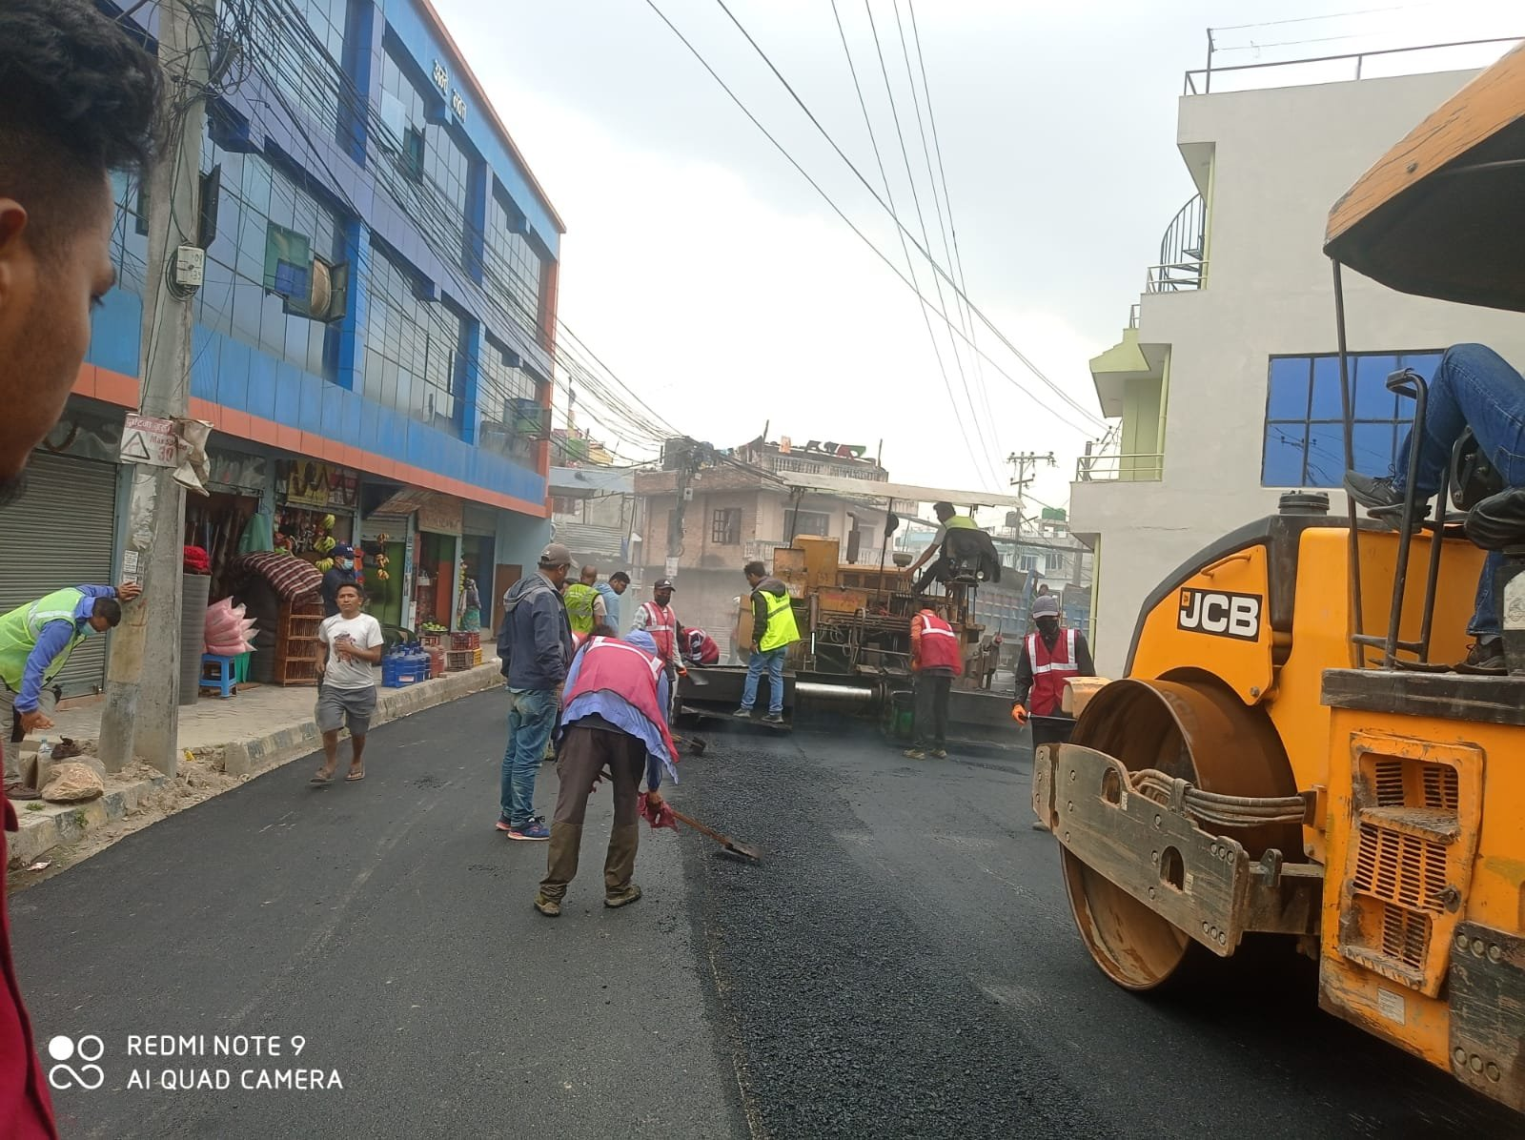
Figure 3: Asphalt paving and compaction, KMC-26 black-top road

General Information
Contract No. | 08-29-080-81-NCBW-KMC
Date of Work Order | 2080-12-27
Date of Completion | 2081-08-19
Agreement Amount (V.O. 01) | NRs. 58,440,063.51 (Incl. VAT & PS)
Final Bill Amount | NRs. 57,741,951.02 (Incl. VAT & PS)
Certificate Date | 2081-09-08

Major Items of Work Completed
Item Description | Quantity | Unit
Sub Base Course | 2,738.28 | Cum
Base Course | 1,825.52 | Cum
M25 Concrete (1:1:2) | 642.18 | Cum
M15 Concrete (1:2:4) | 294.67 | Cum
HYSD Reinforcement Bar | 43.24 | MT
Prime Coat | 7,017.66 | Ltr
Tack Coat | 5,059.12 | Ltr
Bituminous Penetration Macadam (75mm) Semi Grouting | 2,320.81 | Sqm
Premix Carpeting (20 MM) | 2320.81 | Sqm
Asphalt Concrete Works | 311.90 | Cum
50 mm thick Flag Stone | 894.87 | Sqm
60 mm Thick Heavy Duty Interlock Block | 1009.9 | Sqm
450 MM internal dia Hume Pipe NP3 | 137.50 | Rm
150 MM internal dia Hume Pipe NP3 | 362.50 | Rm
Brick Masonry (1:4) | 74.70 | Cum
Road Marking with Hot Applied Thermoplastic | 941.46 | Sqm
MS Angle Plate with Red Oxide Paint | 2,328.00 | Kg

4. Periodic Maintenance of Nagarjun Thulokhola Road Section (NH18) (Chainage 1+725 - 5+765)
Certifying Authority: Department of Roads, Road Division Kathmandu
Contractor / JV: M/s UIBPL-BNSPL-SIPL JV (Uma Infra Builders Pvt. Ltd. 38%, Bardevi Nirman Sewa Pvt. Ltd. 37%, Sulav Infra Pvt. Ltd. 25%)

Project Description & Scope of Work
Periodic maintenance of a 4-kilometre stretch of the Nagarjun Thulokhola Road Section on National Highway 18. The joint venture carried out subbase and base repairs, bituminous penetration macadam, premix patch repair, asphalt concrete overlay, cement concrete and stone masonry works, plum concrete protection, and thermoplastic road marking to restore the highway surface and extend its service life.

Site Photograph
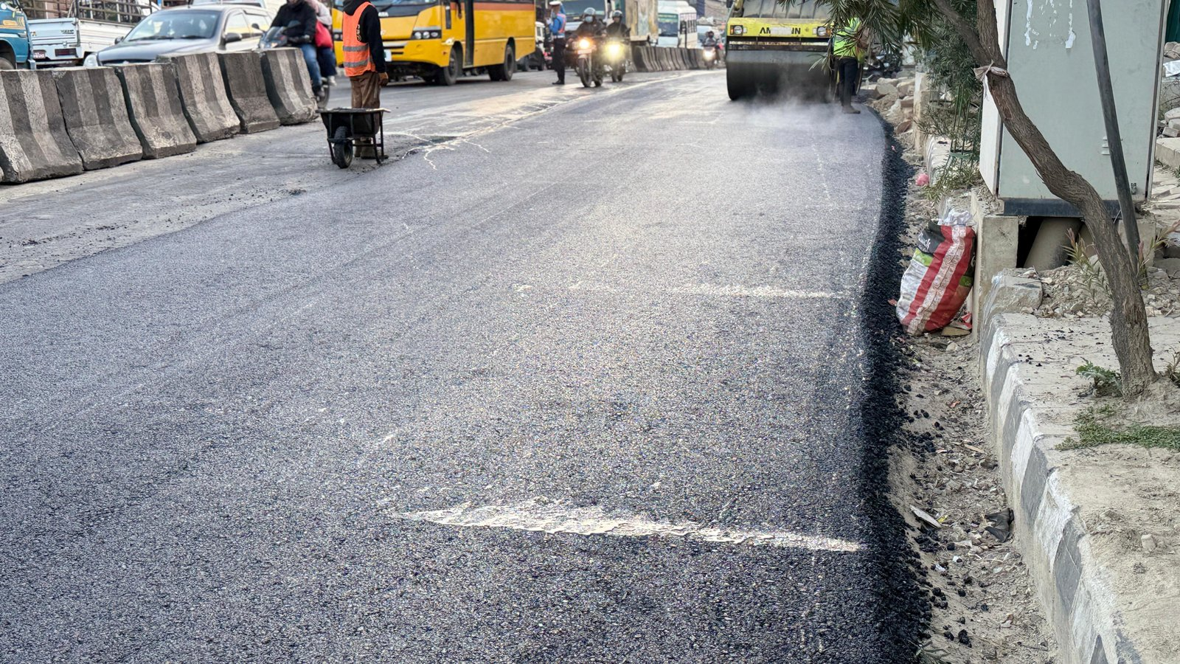
Figure 4: Asphalt overlay and compaction, Nagarjun–Thulokhola Road (NH18)

General Information
Contract No. | RDKTM/337310113/079/80/036
Date of Agreement | 2079.12.10
Date of Work Completed | 2080.06.19
Original Contract Amount | NRs. 52,995,727.38 (Incl. VAT & PS)
Revised Contract Amount | NRs. 54,869,989.33 (Incl. VAT & PS)
Final Bill Amount | NRs. 54,327,552.28 (Incl. VAT & PS)
Certificate Date / Ref | 2080.08.15 / Ref No. 570/080/81

Major Items of Work Completed
Item of Work | Quantity | Unit
Subbase | 20.77 | Cum
Base | 151.35 | Cum
Bituminous penetration macadam | 402.25 | Sqm
Tackcoat | 14324.47 | Ltr
Patch repairing works (Premix) | 2460.07 | Sqm
Asphalt concrete | 1133.00 | Cum
Cement concrete M15 | 29.86 | Cum
Stone masonry | 213.79 | Cum
Plum concrete (60%-40%) | 844.40 | Cum
Thermoplastic road marking painting | 1711.25 | Sqm

5. Maintenance of Lainchaur - Galkopakha - Samakhusi Road
Certifying Authority: Department of Roads, Road Division Kathmandu
Contractor / JV: M/s Sulav/Durpana JV (Sulav Infra Pvt. Ltd. 51%, Durpana Nirman Sewa Pvt. Ltd. 49%)

Project Description & Scope of Work
Maintenance of the Lainchaur-Galkopakha-Samakhusi road corridor within Kathmandu, comprising subbase and base course renewal, bituminous penetration macadam, tack coat application, premix patch repairs, asphalt concrete resurfacing, cement concrete works, drainage improvement with reinforced concrete hume pipe, and thermoplastic road marking to restore a smooth and safe travel surface.

Site Photograph
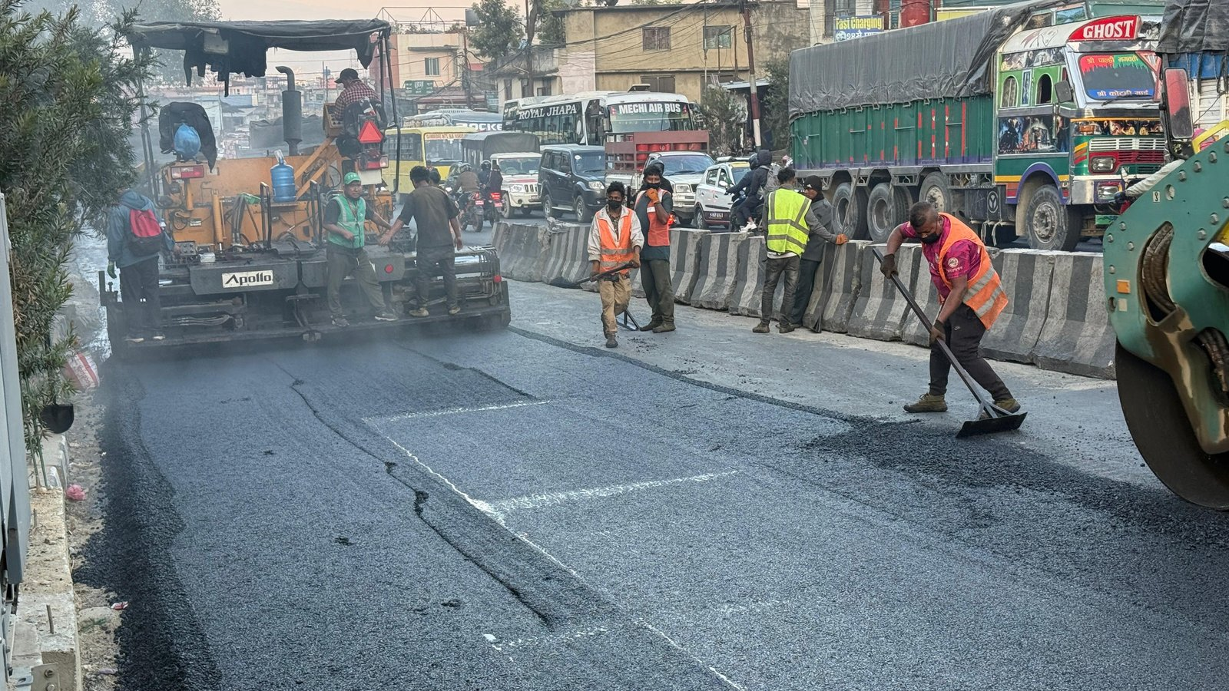
Figure 5: Asphalt paving works, Lainchaur–Galkopakha–Samakhusi Road

General Information
Contract No. | RDKTM/337310113/079/80/050
Date of Agreement | 2079.12.16
Date of Work Completed | 2080.06.29
Original Contract Amount | NRs. 30,566,801.88 (Incl. VAT & PS)
Revised Contract Amount | NRs. 30,565,874.09 (Incl. VAT & PS)
Final Bill Amount | NRs. 30,010,809.30 (Incl. VAT & PS)
Certificate Date / Ref | 2080.09.11 / Ref No. 743/080/81

Major Items of Work Completed
Item of Work | Quantity | Unit
Subbase | 440.41 | Cum
Base | 487.28 | Cum
Bituminous penetration macadam | 2051.84 | Sqm
Tackcoat | 9071.90 | Ltr
Patch repairing works (Premix) | 3994.66 | Sqm
Asphalt concrete | 607.76 | Cum
Cement concrete M15 | 84.10 | Cum
200 mm dia RCC NP3 Hume pipe | 45.00 | Rm
Thermoplastic road marking painting | 1100.54 | Sqm

6. Andheridekhi Masanepati Samma Sadak Staronnati Karya, Sippaghat
Certifying Authority: Urban Development and Building Office, Dhulikhel, Kavrepalanchok
Contractor / JV: M/s Samjhana - Sulav JV, Sathdobato, Lalitpur (Samjhana 51%, Sulav 49%)

Project Description & Scope of Work
Upgrading of the road from Andheridekhi to Masanepati at Sippaghat, Kavrepalanchok, involving stone masonry and stone soling for slope and roadbed stabilisation, plain cement concrete and RCC (M20) structural works, gabion protection, formwork and TMT steel reinforcement — strengthening the road against erosion and improving year-round accessibility.

Site Photograph
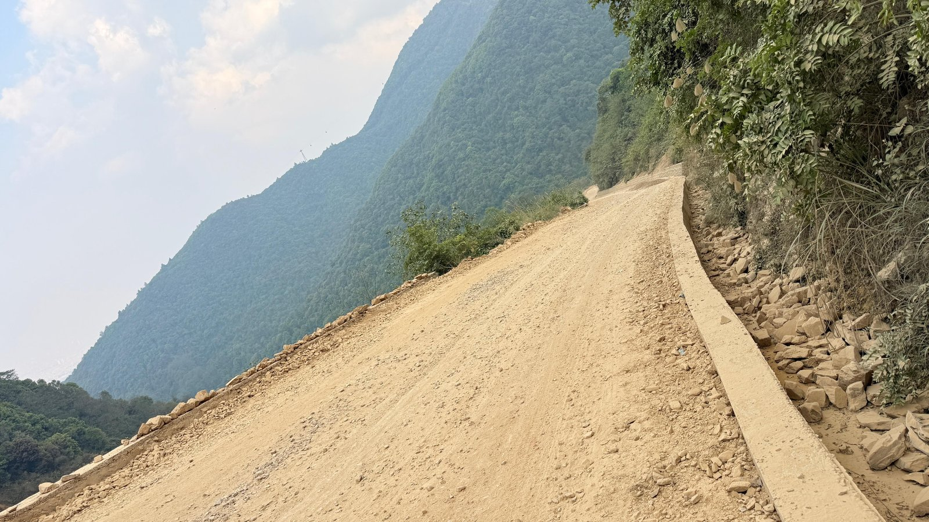
Figure 6: Road formation and lined side-drain, Andheri–Masanepati Road, Sippaghat

General Information
Contract No. | UDBO/NCB/Works/01/1S2E/079/080
Date of Agreement | 2079/12/15
Date of Work Started / Work Order | 2079/12/20
Date of Completion | 2080/10/14
Original Contract Amount (with VAT & PS) | NRs. 25,440,295.87
Payment up to Final Bill | NRs. 25,403,337.19
Certificate Date | 2080/11/15

Major Items of Work Completed
Description of Works | Unit | Total Quantity
Stone masonry | Cu.m | 380.68
Stone soling Work | Cu.m | 899.74
Plain cement concrete (M10) | Cu.m | 36.26
Plain cement concrete (M15) | Cu.m | 124.52
RCC (M20) | Cu.m | 828.45
Gabion Work | Cu.m | 435.50
Form Works | Sq.m | 1446.10
TMT steel reinforcement bar | Ton | 27.92

7. Widening and Rehabilitation Work in Bansgadhi Mainapokhar Road
Certifying Authority: Department of Roads, Road Division Nepalgunj
Contractor / JV: M/S Sulav-Ratala JV

Project Description & Scope of Work
Widening and rehabilitation of the Bansgadhi-Mainapokhar Road in the Terai region, covering subgrade preparation, granular sub-base and crusher-run macadam base construction, prime and tack coat application, asphalt paving, plum concrete works, embankment construction and thermoplastic road marking to create a wider, more durable carriageway.

Site Photograph
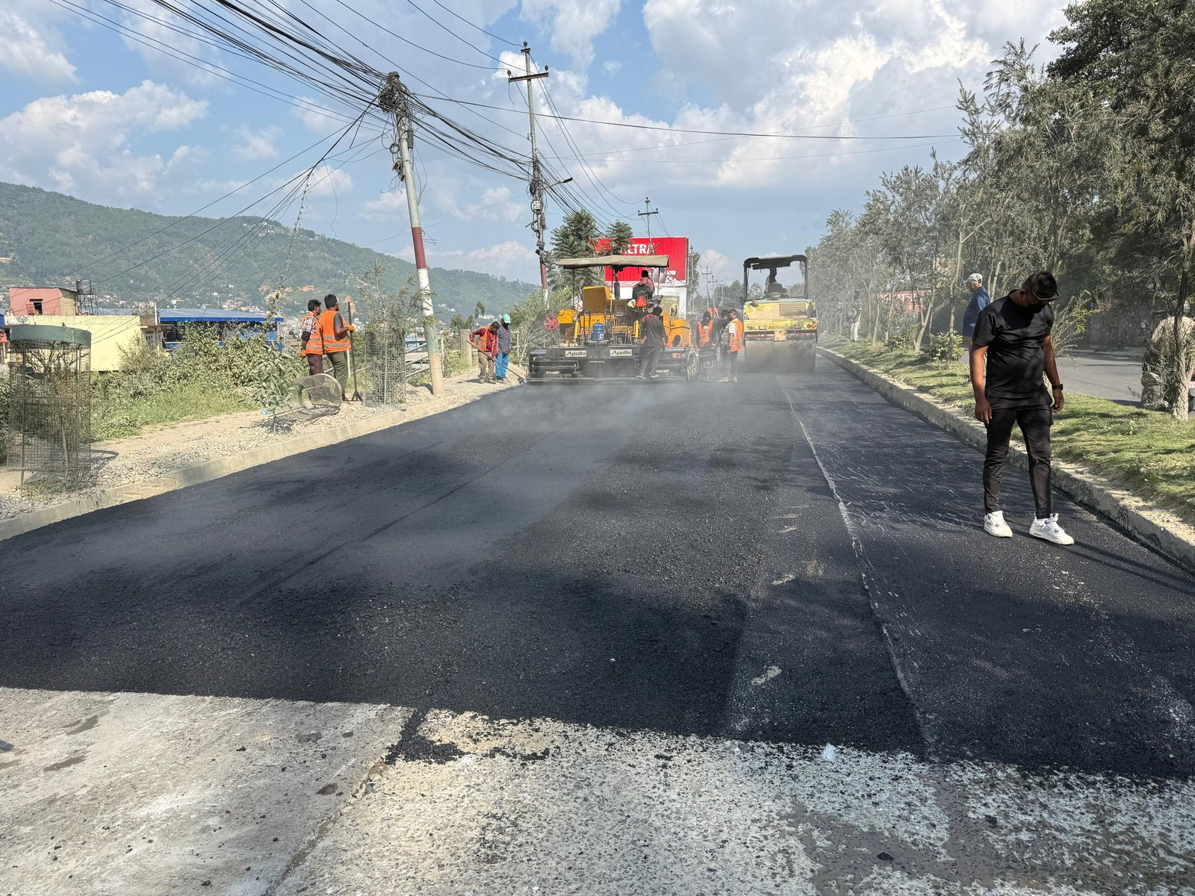
Figure 7: Carriageway paving and widening, Bansgadhi–Mainapokhar Road

General Information
Contract Identification No. | RDNG/337310113/079/080-20
Date of Contract Agreement | 2079/12/10
Intended Date of Completion | 2080/03/15
Date of Completion | 2080/03/15
Original Contract Amount | NRs. 16,992,638.22 (With VAT and PS)
Final Bill Amount | NRs. 16,364,858.54 (With VAT and PS)
Certificate Date | 2080/04/28

Major Items of Work Completed
Description of Works | Unit | Quantity | Remarks
Sub grade work | sqm | 6402.2 | Work Done in F/Y 2079/80
Granular Sub base Work | cum | 1061 | -
Crusher run Macadam Base Work | Cum | 964 | -
Prime coat Work | litr | 6459 | -
Tack coat work | litr | 3875 | -
Asphalt work | cum | 258 | -
Plum concrete | cum | 74.5 | -
Embankment | cum | 1845 | -
Thermoplastic paint | Sqm | 110 | -

8. Upgrading Road from Mahila Bikas Bhawan-Football Ground & Gurungtar-Bhukbhuke Sadak
Certifying Authority: New Town Project Office, Dumre-Bhansar, Tanahun
Contractor / JV: M/S Sulav/Dhami J.V., Kathmandu (Sulav Infra Pvt. Ltd. 55%, Dhami Construction Pvt. Ltd. 45%)

Project Description & Scope of Work
Upgrading of the road from Mahila Bikas Bhawan through the football ground and the Gurungtar-Bhukbhuke Sadak in Tanahun district. Works included stone soling, M15/M20 concrete structures, HYSD bar reinforcement, stone masonry, sub-grade preparation, sub-base and base course construction, prime and tack coats, premix surfacing and sand seal — delivering a new, all-weather rural road link.

Site Photograph
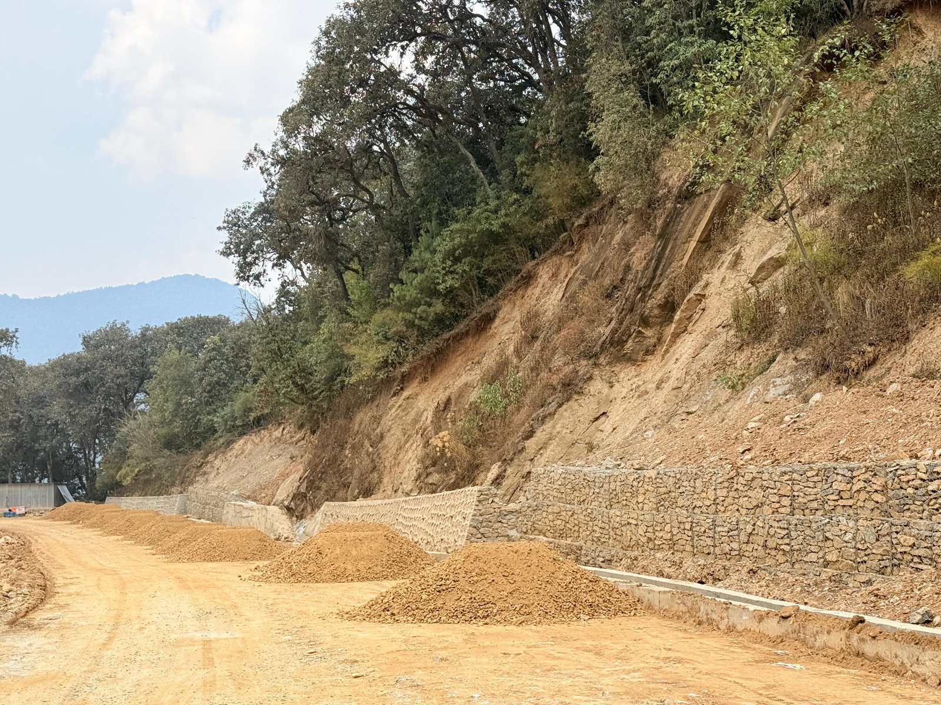
Figure 8: Gabion protection and roadway formation, Gurungtar–Bhukbhuke Road, Tanahun

General Information
Contract No. | NTPO/Dumre-Bhansar/Works/NCB-2077/078-01
Contract Awarded Date | 2077-09-27 B.S.
Work Completed Date | 2078-03-15 B.S.
Contract Amount (with VAT) | NRs. 1,29,00,079.12
Final Bill Amount (with VAT) | NRs. 1,28,79,826.00
Certificate Date / Ref | 2078/03/15 / Letter No. 077/078, Ref 289

Major Items of Work Completed
Item of Work | Quantity
Stone Solling | 396.67 Cu.m
M15 Grade Concrete | 15.89 Cu.m
M20 Grade Concrete | 376.98 Cu.m
Reinforcement (HYSD Bars) | 15.41 MT
Stone Masonry (1:4) | 109.53 Cu.m
Sub-Grade Preparation | 6978.00 Sq.m
Sub-Base | 1042.40 Cu.m
Base | 520.68 Cu.m
Prime Coat | 5037.94 Ltr
Tack Coat | 3409.27 Ltr
Premix | 104.10 Cu.m
Sand Seal | 5207.04 Sq.m

9. Improvement of Approach Road of New Baneshwar Maitighar Thapathali Road (Expansion Roads - Army HQ Bhadrakali, Thapathali Campus, Special Court, Nepal Drugs, Babarmahal)
Certifying Authority: Department of Roads, Road Division Kathmandu
Contractor / JV: M/s Sulav Infra Pvt. Ltd., Balaju-16, Kathmandu

Project Description & Scope of Work
Improvement of approach roads serving New Baneshwar, Maitighar and Thapathali, including the expansion roads leading to the Army Headquarters at Bhadrakali, Thapathali Campus, the Special Court, Nepal Drugs and Babarmahal. The project involved subbase and base course construction, prime and tack coat application, and asphalt concrete paving to improve access and traffic flow around these key government and institutional areas of central Kathmandu.

Site Photograph
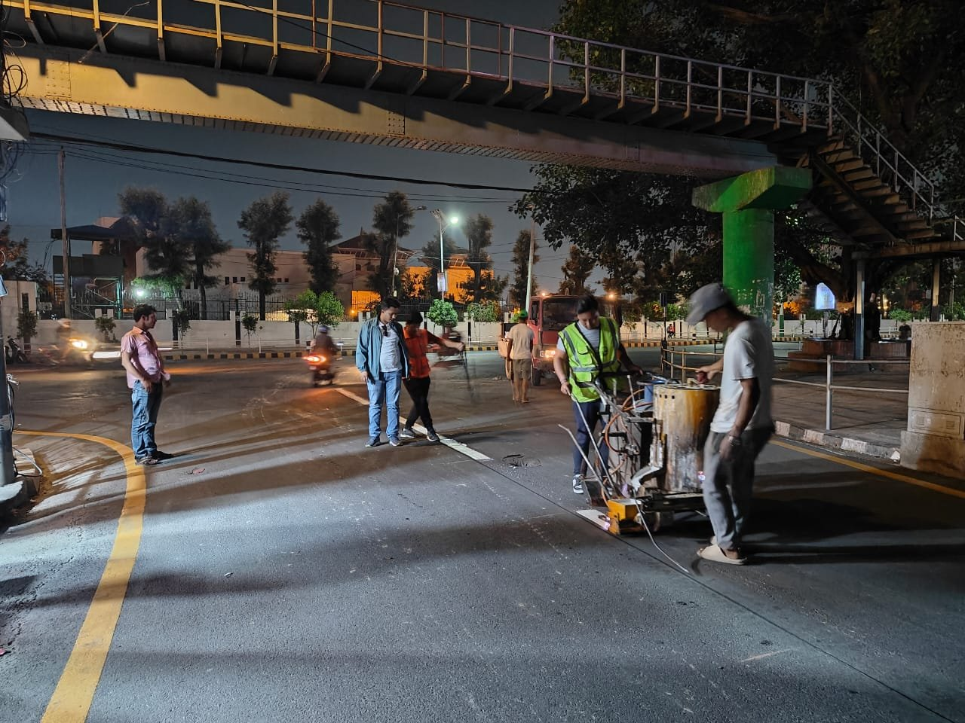
Figure 9: Thermoplastic road-marking works, Baneshwar–Maitighar–Thapathali Road

General Information
Contract No. | RDKTM/337011204/077/78/103
Date of Agreement | 2078.02.09
Date of Work Completed | 2078.12.15
Contract Amount | NRs. 12,869,701.33 (Incl. VAT & PS)
Revised Contract Amount | NRs. 12,719,960.51 (Incl. VAT & PS)
Final Bill Amount | NRs. 12,219,016.51 (Incl. VAT & PS)
Certificate Date / Ref | 2079.04.05 / Ref No. 069/60, Ch. No. 926

Major Items of Work Completed
Item of Work | Quantity | Unit
Subbase | 1,121.47 | Cum
Base | 636.89 | Cum
Prime Coat | 3608.11 | Ltr
Tack Coat | 3259.89 | Ltr
Asphalt concrete | 274.14 | Cum

10. Nawajyoti Margmaa Kaalopatre ra Dhal Nirman at Ward 10, Tokha, Kathmandu
Certifying Authority: Tokha Municipality, Municipal Executive Office
Contractor / JV: Sulav/Dhami JV, Kathmandu

Project Description & Scope of Work
Construction of the Nawajyoti Marg blacktop road and drainage system at Ward 10, Tokha, Kathmandu. Scope included laying of reinforced concrete hume pipes for drainage, brick masonry works, compacted base course preparation, prime and tack coats, premix carpeting, sand seal surfacing and installation of manhole covers — completed within a one-year defect liability period.

Site Photograph
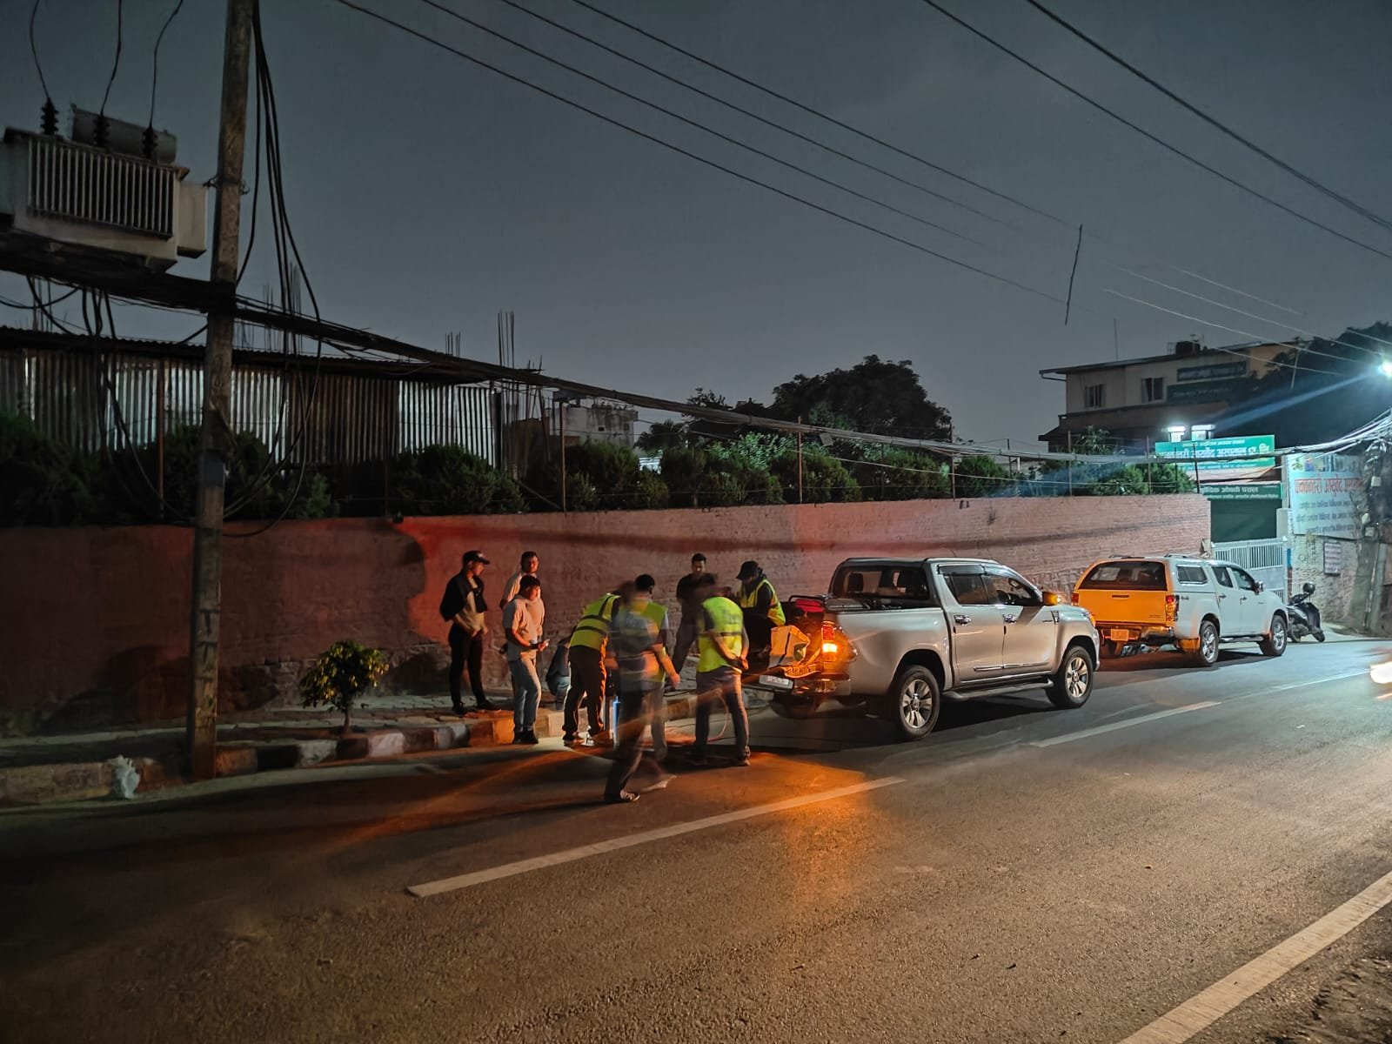
Figure 10: Road and drainage works, Nawajyoti Marg, Tokha

General Information
Contract No. | 13/NCB/TM/W/2077-78
Date of Agreement | Feb 21, 2021
Date of Completion | July 04, 2021
End Date of DLP Period | July 04, 2022
Contract Amount (incl. PS & VAT) | NRs. 22,14,328.80
Final Work Done Amount (incl. PS & VAT) | NRs. 20,95,626.67
Certificate Date / Ref | 2078/04/22 / Ref No. 94

Major Items of Work Completed
Description of Works | Unit | Work Done Quantity
Supplying and laying RCC Hume pipe - NP2 (450 mm dia) | Rm | 138.00
Brick Masonry Works (1:6) | Cum | 33.70
Preparation of 7.5 cm thick compacted base course (8/10 ton roller) | Cum | 14.23
Cleaning and Brooming over base course | Sqm | 1532.72
Prime Coat | Sqm | 1532.72
Tack Coat | Sqm | 1532.72
Premix Carpet (30 mm) | Cum | 45.81
Sand Seal | Sqm | 1532.72
Rounded manhole cover with square frame 24" dia medium class (70kg) | Nos | 14.00

11. Graveling Works at Different Ward of Bharatpur Metropolitan City, Package-2
Certifying Authority: Bharatpur Metropolitan City, Office of Municipal Executive
Contractor / JV: M/S Sulav Infra Pvt. Ltd., Balaju-16, Kathmandu

Project Description & Scope of Work
Graveling works carried out across multiple wards of Bharatpur Metropolitan City under Package-2, supplying and laying over 10,000 cubic metres of sub-base gravel material to improve rural and peri-urban road access throughout the municipality.

Site Photograph
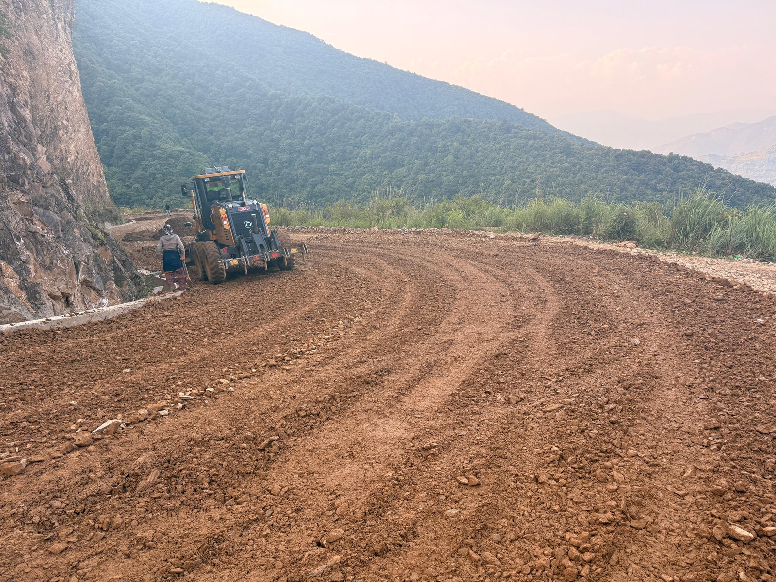
Figure 11: Sub-grade grading and gravelling works, Bharatpur Metropolitan City

General Information
Contract No. | Metro/Bhr/W/NCB/137/077-078
VAT No. | 609845408
Date of Agreement | 2078/04/20
Completion Date | 2078/12/22
Agreement Amount (Incl. VAT) | NRs. 91,75,508.24
Total Amount of Work Done (Incl. VAT) | NRs. 91,71,838.04
Certificate Date / Ref | 2079/02/16 / Ref No. 8680

Major Items of Work Completed
Item of Work | Quantity
Gravelling works (Sub Base Material) | 10,435.82 Cum

12. Sutkeri Dhunga - Rahudanda Motarbato Dalan
Certifying Authority: Galchhi Rural Municipality, Office of Rural Municipal Executive
Contractor / JV: M/S Sulav Infra Pvt. Ltd.

Project Description & Scope of Work
Construction of the Sutkeri Dhunga-Rahudanda motorable road in Galchhi Rural Municipality, comprising machine excavation, stone soling, rigid pavement (RCC) works, steel reinforcement, side drains and cross-drainage structures, and stone masonry — completed ahead of the intended schedule.

Site Photograph
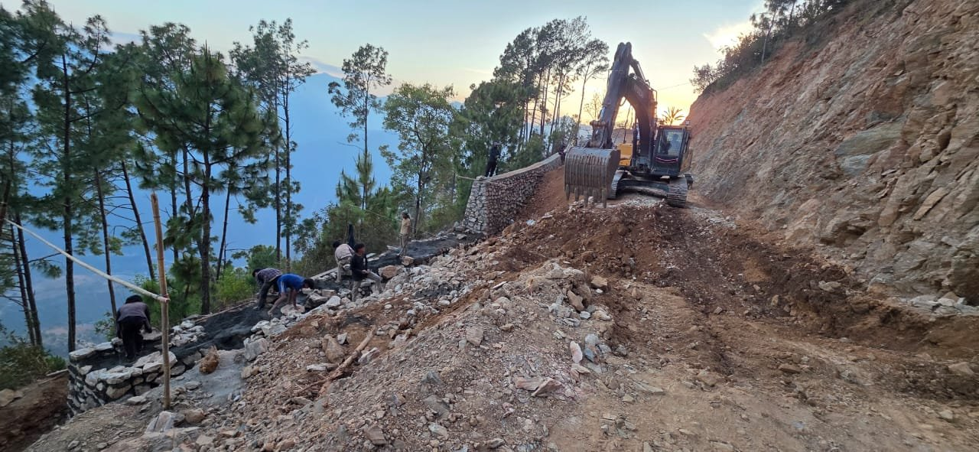
Figure 12: Excavation and stone-masonry works, Sutkeri Dhunga–Rahudanda Road

General Information
Contract ID | GRM/NCB/02/078/079
Date of Agreement | 2078/10/10
Intended Completion Date | 2079/1/30
Completion Date | 2079-01-29
Contract Amount | NRs. 30,56,135.74
Final Bill Amount | NRs. 29,95,814.247
Certificate Date / Ref | 2079/05/10 / Ref No. 399

Major Items of Work Completed
Description | Quantity
Earth Work Excavation Works by Machine means | 261.984 Cum
Stone Soling Works | 193.886 Cum
R.C.C Works (1:2:4) | 212.180 Cum
Steel Reinforcement Works | 8.344 MT
Stone Masonry (1:6) Works | 19.200 Cum

13. Ghimirethumka - Machedi - Palangkharka hudai Ward No. 5 Jodne Bato
Certifying Authority: Galchhi Rural Municipality, Office of Rural Municipal Executive (Baireni, Dhading)
Contractor / JV: M/S Sulav-Dhami JV

Project Description & Scope of Work
Construction of the Ghimirethumka-Machedi-Palangkharka road connecting to Ward 5, including large-scale machine excavation, stone soling, RCC and PCC works, steel reinforcement, stone masonry retaining structures, hume pipe cross-drainage with stone masonry head and toe walls, natural quarry gravelling with rolling, and gabion works — opening up a new rural road link with proper drainage and slope protection.

Site Photograph
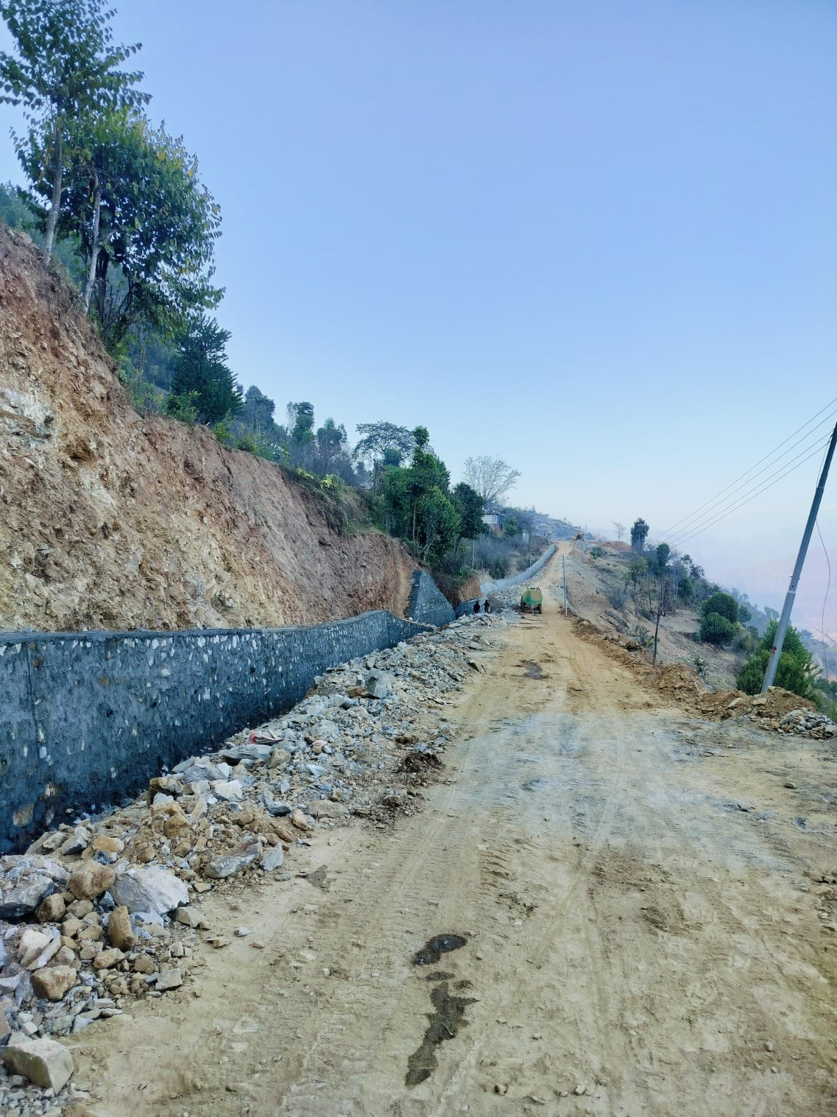
Figure 13: Roadway formation with gabion and masonry protection, Ghimirethumka–Machedi Road

General Information
Contract ID | GRM/NCB/02/078/079
Date of Agreement | 2078/08/23
Intended Completion Date | 2079/2/30
Completion Date | 2079-02-28
Contract Amount (With VAT) | NRs. 95,08,218.98
Final Bill After VO (With VAT) | NRs. 98,41,828.66
Certificate Date / Ref | 2079/05/08 / Ref No. 290

Major Items of Work Completed
Description | Quantity
Earth Work Excavation Works by Machine means | 9,014.53 Cum
Stone Soling Works | 67.19 Cum
R.C.C Works (1:2:4) | 21.00 Cum
P.C.C Works (1:3:6) | 43.36 Cum
Steel Reinforcement Works | 1.20 MT
Stone Masonry (1:6) Works | 405.13 Cum
Supply and laying of 600mm Hume Pipe | 62.50 Rm
Supply and Laying of 900mm Hume Pipe | 32.50 Rm
Natural Quarry Gravelling with Rolling | 2,906.95 Cum
Gabion Works | 368.00 Cum

14. Construction of Road Alignment of Jaldigad Hydropower Project (20.73 MW), Rukum (West)
Certifying Authority: Shangrila Hydropower Pvt. Ltd., Maharajgunj-3, Kathmandu
Contractor / JV: M/s Sulav Infra Pvt. Ltd., Balaju-16, Kathmandu

Project Description & Scope of Work
Construction of the road alignment for the 20.73 MW Jaldigad Hydropower Project in Rukum (West), involving large-volume excavation of boulder-mix soil and hard rock (using breakers), gabion protection works, geotextile filter fabric installation and plum concrete works — providing safe road access to the hydropower project site through challenging mountain terrain.

Site Photograph
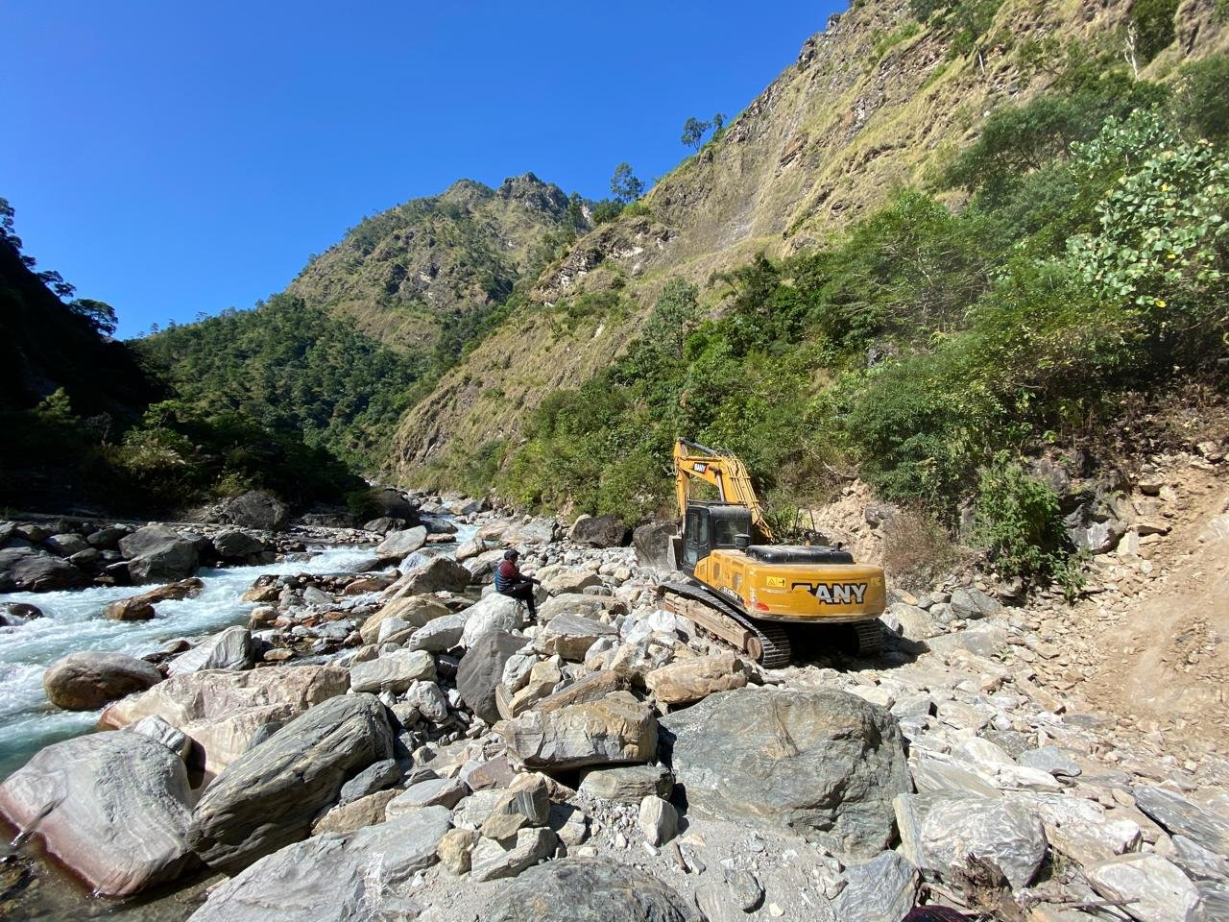
Figure 14: Roadway excavation through river gorge, Jaldigad Hydropower access road

General Information
Contract ID | SHP/JHP/2024/25/Road/Lot No: I
Contract Agreement Date | Bhadra 19, 2081
Date of Completion | Ashad 20, 2082
Actual Date of Completion | Jestha 28, 2082
Original Contract Amount (Incl. VAT) | NPR 11,21,84,479.00
Value of Work Done (Incl. VAT) | NPR 11,11,30,112.45
Certificate Date / Ref | 8 August 2025 / Ref No. 22

Major Items of Work Completed
Description of Work | Quantity
Excavation of Boulder Mix Soil (BMS) | 34,314.38 Cum
Excavation of Hard Rock (Using Breaker) | 1,47,259.70 Cum
Gabion Works | 5,660.00 Cum
Geotextile (Filter Fabrics) | 4,824.64 Sqm
Plum Concrete (M20 concrete 60% + Boulders/Stones 40%) | 2,138.73 Cum

15. Roadway Excavation and Landslide Clearance Works Along the Approach Road, Powerhouse to Headworks, Buddhi Gandaki Hydropower Project (Ch 0+000 to Ch 7+210)
Certifying Authority: Budhigandaki Hydropower Pvt. Ltd., Super Machha Khola Small Hydropower Project
Contractor / JV: M/s Sulav Infra Pvt. Ltd., Balaju-16, Kathmandu

Project Description & Scope of Work
Roadway excavation and landslide clearance along the 7.2 km approach road from the powerhouse to the headworks of the Buddhi Gandaki Hydropower Project in Gorkha district, involving extensive excavation of boulder-mix soil and hard rock using breakers to keep the access road open and safe through an active landslide-prone corridor.

Site Photograph
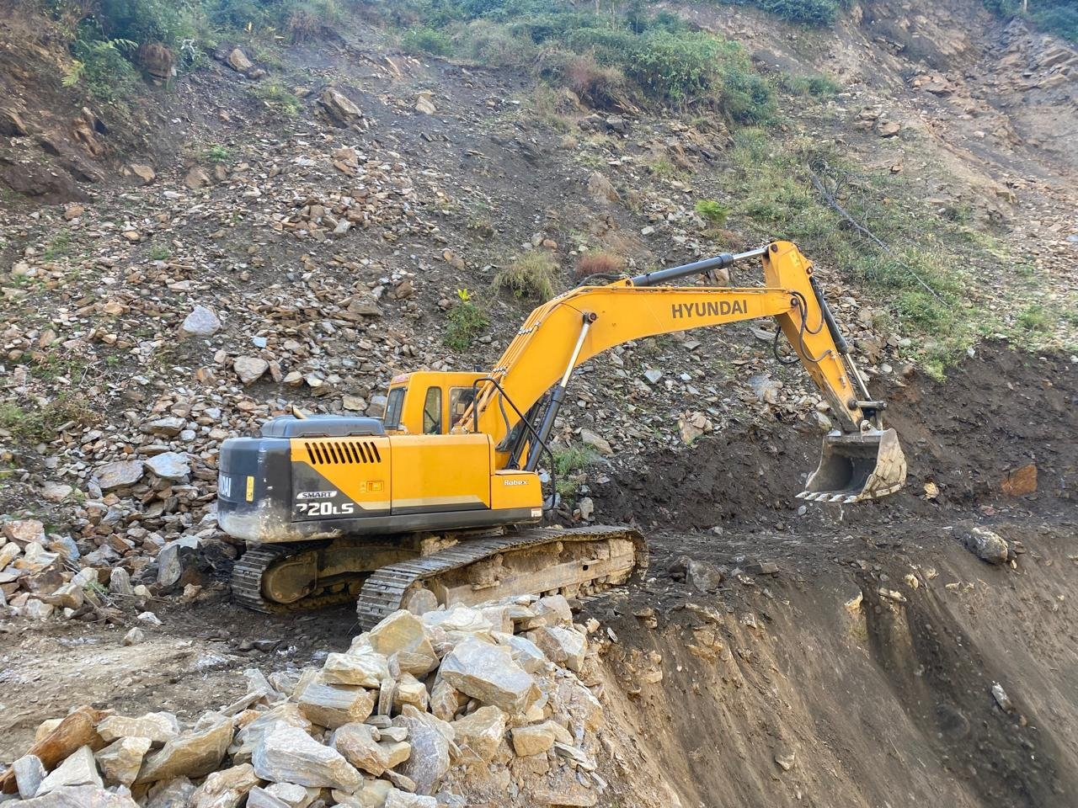
Figure 15: Landslide clearance and roadway excavation, Buddhi Gandaki Hydropower access road

General Information
Contract ID | BHPP/01/WORKS/2080-081
Contract Agreement Date | Magh 10, 2080
Date of Completion (per Contract) | Ashad 25, 2081
Actual Date of Completion | Jestha 15, 2081
Original Contract Amount (Incl. VAT) | NRs. 1,56,89,939.27
Value of Work Done (Incl. VAT) | NRs. 1,49,99,631.71
Certificate Date / Ref | 07 July 2024 / Ref No. 081/82

Major Items of Work Completed
Description of Work | Quantity
Excavation of Boulder Mix Soil (BMS) | 1,13,260.24 Cum
Excavation of Hard Rock (Using Breaker) | 21,657.13 Cum

16. PO12812945 - Construction of Mezzanine Floor in RM Warehouse, Unilever Factory Premises, Hetauda, Makwanpur
Certifying Authority: Unilever Nepal Ltd.
Contractor / JV: M/s Sulav Infra Pvt. Ltd.

Project Description & Scope of Work
Design and construction of a structural steel mezzanine floor within the raw-material warehouse at Unilever Nepal's Hetauda factory. Works comprised fabrication and erection of main and secondary steel beams, columns, chequered plate flooring, MS angles and railing, together with reinforced concrete column foundations — over 108 tonnes of structural steel fabricated and erected to expand the warehouse's usable storage capacity.

Site Photograph
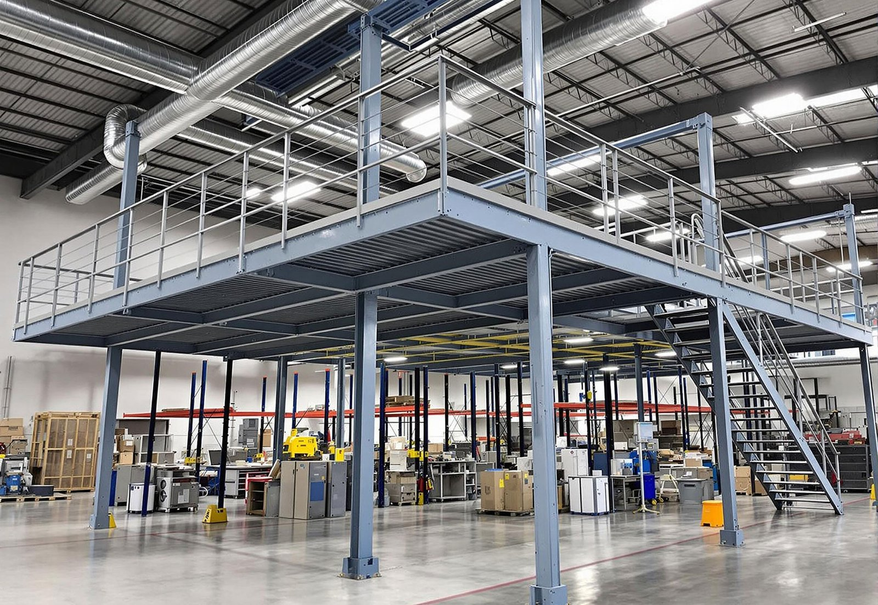
Figure 16: Structural-steel mezzanine floor, Unilever RM Warehouse, Hetauda

General Information
Contract Agreement Date | 21 October, 2021
Actual Date of Completion | 17 March, 2022
Original Contract Amount (Excl. VAT) | NRs. 14,319,397.27
Value of Work Done (Excl. VAT) | NRs. 18,836,766.46
Certificate Date / Ref | 09 January, 2023 / Ref No. 81/2223

Major Items of Work Completed
Item | Quantity | Unit
6mm chequered Plate - Fe 250 | 50,943.27 | Kg
Main Beam (ISMB 300) - Fe 250 | 18,862.66 | Kg
Secondary Beam (ISMB 200) - Fe 250 | 17,165.43 | Kg
ISA 50*50*3 - Fe 250 | 2179.47 | Kg
Column ISMC 300 | 17,722.66 | Kg
Reinforcement | 9,827.61 | Kg
M20 for Column Foundation | 34.79 | Cum
Square Pipe 72*72*3.6 for railing | 1498.43 | Kg
Total MS Fabrication and Erection Quantity | 108,371.92 | kg

17. Construction of 10,000 sqft Warehouse at Unilever Factory Premises, Hetauda, Makwanpur
Certifying Authority: Unilever Nepal Ltd.
Contractor / JV: M/s Sulav Infra Pvt. Ltd.

Project Description & Scope of Work
Construction of a new 10,000 sq. ft. warehouse at Unilever Nepal's Hetauda factory premises, from earthworks and foundations through to structural completion. Scope covered PCC and RCC (M20) works, stone and brick masonry, steel reinforcement, a fabricated steel truss roof structure and roof sheeting works, delivering a complete industrial storage facility.

Site Photograph
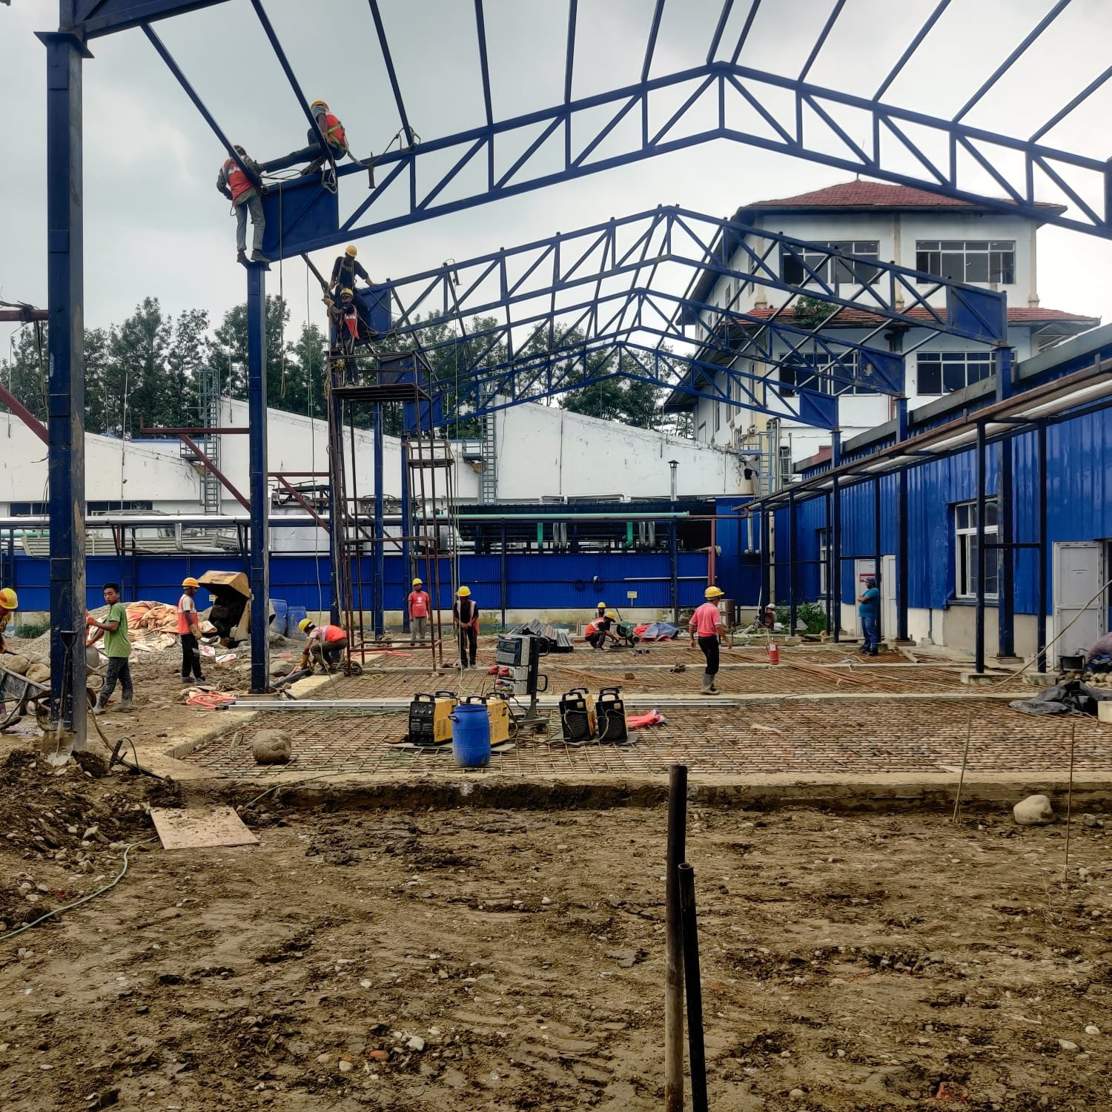
Figure 17: Steel-truss warehouse under construction, Unilever premises, Hetauda

General Information
Contract Agreement Date | 04 April, 2022
Actual Date of Completion | 06 January, 2023
Original Contract Amount (Excl. VAT) | NRs. 25,367,050.69
Value of Work Done (Excl. VAT) | NRs. 34,461,395.69
Certificate Date / Ref | 09 January, 2023 / Ref No. 84/2223

Major Items of Work Completed
Item | Quantity | Unit
Earthworks | 2223.27 | Cum
PCC M15 | 44.39 | Cum
Stone Masonry | 98.33 | Cum
Brick Masonry | 172.31 | Cum
M20 RCC | 223.48 | Cum
Reinforcement | 23,161.47 | Kg
MS Works (Steel Truss) | 97,130.54 | Kg
Sheeting Works | 1304.63 | Sqm

18. Bagmati River Corridor Fencing Works (Thapathali to Dhobikhola Dovan, Tinkune to Sinamangal) KMC-9,10,11,31
Certifying Authority: Kathmandu Metropolitan City, Public Works Department
Contractor / JV: Sulav Infra Pvt. Ltd.

Project Description & Scope of Work
Fencing works along the Bagmati river corridor from Thapathali to Dhobikhola Dovan and from Tinkune to Sinamangal, carried out under Kathmandu Metropolitan City's landscaping and beautification programme. Scope covered earthwork excavation, brick soling, PCC and RRM works, brick masonry, structural steel (MS) work, flagstone laying, pointing, plastering and painting, together with 300mm NP3 RCC hume pipe drainage — delivering a landscaped and secured riverbank corridor along a key stretch of the Bagmati.

Site Photograph
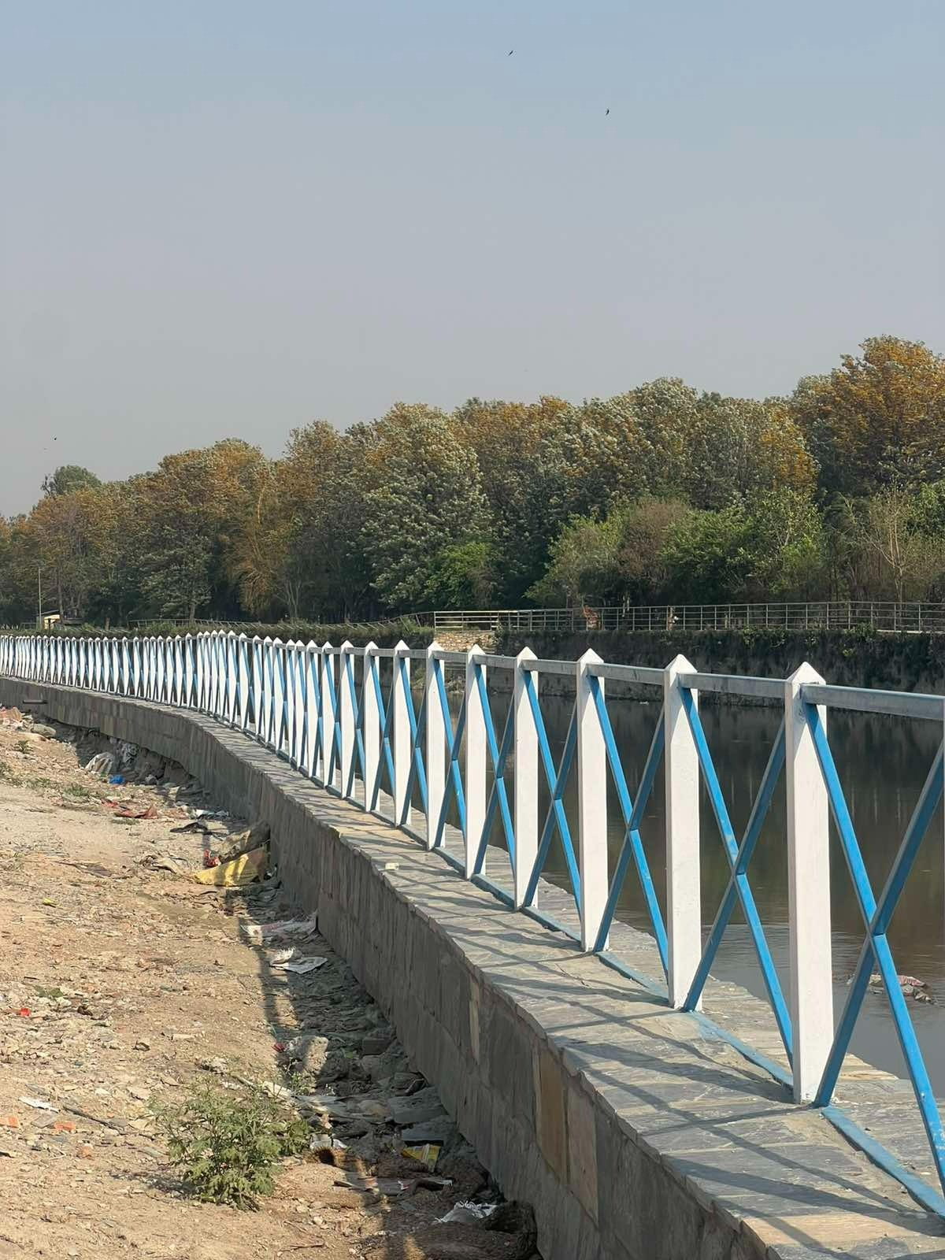
Figure 18: River-corridor fencing and landscaping, Bagmati Corridor (KMC)

General Information
Contract ID | 11-42-NCBW-080-081-PWD-KMC
Employer | Kathmandu Metropolitan City, Public Works Department
Date of Work Order | 2081/02/13
Date of Work Completed | 2082/12/19
Estimated Amount | NRs. 7,97,14,740.25 (Incl. VAT and PS)
Agreement Amount | NRs. 6,20,79,559.46 (Excl. VAT, Incl. PS)
Agreement Amount (After VO) | NRs. 6,18,97,574.81 (Excl. VAT, Incl. PS)
Final Bill Amount | NRs. 5,94,39,851.98 (Excl. VAT, Incl. PS)
Scope of Work | Landscaping and Beautification Works
Certificate Date | June 25, 2026

Major Items of Work Completed
Description of Items | Total Quantity | Unit
Earthwork Excavation | 4379.48 | Cum
Brick Soling | 1292.99 | Sqm
PCC work M10 (1:2:4) | 118.15 | Cum
PCC work M15 (1:3:6) | 54.39 | Cum
Brick Masonry work | 757.41 | Cum
MS work | 60719.56 | KG
Flag Stone laying | 2099.19 | Sqm
RRM work | 2641.33 | Cum
Pointing work | 2066.94 | Sqm
Plaster work | 296.94 | Sqm
Painting work | 4200.30 | Sqm
300mm NP3 RCC hume pipe | 937.50 | Rm

Plant & Equipment
Sulav Infra Pvt. Ltd. mobilizes a diverse fleet of construction plant and equipment across its road, building and hydropower access-road projects. The list below reflects the general categories of equipment typically deployed; the specific completion certificates reviewed did not itemize equipment on a per-project basis (with the exception of an 8/10-ton road roller referenced in the Tokha Municipality project).

Earthmoving & Excavation Equipment
Equipment | Typical Use
Hydraulic Excavator (20-30 Ton) | Bulk excavation, boulder mix soil and hard rock excavation
Rock Breaker / Hydraulic Hammer | Hard rock breaking and landslide clearance
Bulldozer | Site clearance, grading and embankment formation
Backhoe Loader | Trenching, loading and general earthwork
Motor Grader | Sub-grade and road surface levelling

Compaction Equipment
Equipment | Typical Use
Vibratory Road Roller (8-10 Ton) | Base course and sub-base compaction
Plate Compactor | Compaction in confined areas and trenches
Sheep-foot Roller | Embankment and fill compaction

Road Construction & Paving Equipment
Equipment | Typical Use
Bitumen / Tar Boiler & Sprayer | Prime coat and tack coat application
Paver Finisher | Asphalt concrete and premix carpeting
Premix Plant | Production of bituminous premix material
Chip Spreader | Bituminous penetration macadam works
Thermoplastic Road Marking Machine | Hot-applied thermoplastic road marking

Concrete & Batching Equipment
Equipment | Typical Use
Concrete Batching Plant | Production of PCC / RCC concrete
Transit Mixer | Transport of ready-mix concrete
Concrete Mixer (Drum type) | Small-scale on-site concrete mixing
Concrete Vibrator | Compaction of poured concrete
Bar Bending & Cutting Machine | Reinforcement fabrication

Transportation Equipment
Equipment | Typical Use
Tipper / Dump Truck | Haulage of excavated material, gravel and aggregate
Water Tanker | Compaction water supply and dust control
Flatbed Truck | Transport of steel, pipes and construction materials
Pickup / Support Vehicle | Site supervision and material logistics

Steel Fabrication & Erection Equipment
Equipment | Typical Use
Welding Machine | Structural steel fabrication and erection
Cutting / Grinding Machine | Steel plate and section cutting
Mobile Crane | Lifting and erection of structural steel members
Chain Pulley Block / Hoist | Manual lifting of steel components

Survey & General Support Equipment
Equipment | Typical Use
Total Station | Setting out and progress survey
Auto Level | Levelling and grade control
Generator Set | Power supply at remote / hydropower sites
Hand & Power Tools | General construction support

Project Execution Timeline
The chart and table below present the execution period of each project, from agreement/work-order date to completion date, as stated on the respective completion certificates. Most certificates record dates in the Bikram Sambat (B.S.) calendar; these have been converted to approximate Gregorian (A.D.) dates for charting purposes and should be treated as indicative rather than exact.
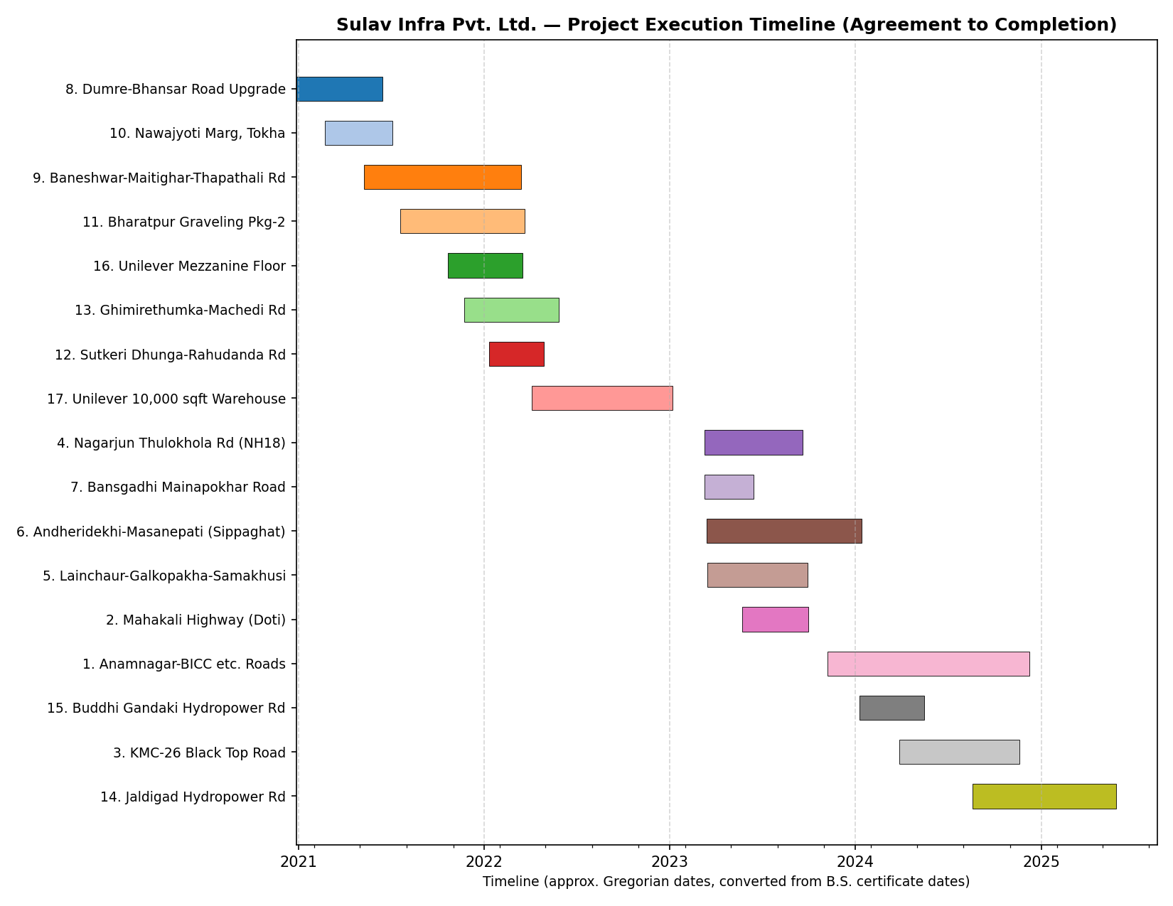

Chronological Project Schedule
S.N. | Project | Cert. Start Date | Cert. End Date | Approx. Start (A.D.) | Approx. End (A.D.) | Duration
1 | Dumre-Bhansar Road Upgrade | 2077-09-27 BS | 2078-03-15 BS | 27 Dec 2020 | 15 Jun 2021 | ~6 months
2 | Nawajyoti Marg, Tokha | Feb 21, 2021 | Jul 04, 2021 | 21 Feb 2021 | 04 Jul 2021 | ~4.5 months
3 | Ghimirethumka-Machedi Rd | 2078/08/23 BS | 2079-02-28 BS | 23 Nov 2021 | 28 May 2022 | ~6 months
4 | Unilever Mezzanine Floor | 21 Oct 2021 | 17 Mar 2022 | 21 Oct 2021 | 17 Mar 2022 | ~5 months
5 | Baneshwar-Maitighar-Thapathali Rd | 2078.02.09 BS | 2078.12.15 BS | 09 May 2021 | 15 Mar 2022 | ~10 months
6 | Bharatpur Graveling Pkg-2 | 2078/04/20 BS | 2078/12/22 BS | 20 Jul 2021 | 22 Mar 2022 | ~8 months
7 | Unilever 10,000 sqft Warehouse | 04 Apr 2022 | 06 Jan 2023 | 04 Apr 2022 | 06 Jan 2023 | ~9 months
8 | Sutkeri Dhunga-Rahudanda Rd | 2078/10/10 BS | 2079-01-29 BS | 10 Jan 2022 | 29 Apr 2022 | ~3.5 months
9 | Lainchaur-Galkopakha-Samakhusi | 2079.12.16 BS | 2080.06.29 BS | 16 Mar 2023 | 29 Sep 2023 | ~6.5 months
10 | Nagarjun Thulokhola Rd (NH18) | 2079.12.10 BS | 2080.06.19 BS | 10 Mar 2023 | 19 Sep 2023 | ~6 months
11 | Bansgadhi Mainapokhar Road | 2079/12/10 BS | 2080/03/15 BS | 10 Mar 2023 | 15 Jun 2023 | ~3 months
12 | Andheridekhi-Masanepati (Sippaghat) | 2079/12/15 BS | 2080/10/14 BS | 15 Mar 2023 | 14 Jan 2024 | ~10 months
13 | Mahakali Highway (Doti) | 2080/02/23 BS | 2080/06/30 BS | 23 May 2023 | 30 Sep 2023 | ~4 months
14 | Anamnagar-BICC etc. Roads | 2080.08.07 BS | 2081.09.08 BS | 07 Nov 2023 | 08 Dec 2024 | ~13 months
15 | Buddhi Gandaki Hydropower Rd | Magh 10, 2080 BS | Jestha 15, 2081 BS (actual) | 10 Jan 2024 | 15 May 2024 | ~4 months
16 | KMC-26 Black Top Road | 2080-12-27 BS | 2081-08-19 BS | 27 Mar 2024 | 19 Nov 2024 | ~8 months
17 | Bagmati River Corridor Fencing (KMC) | 2081/02/13 BS | 2082/12/19 BS | 13 May 2024 | 19 Mar 2026 | ~22 months
18 | Jaldigad Hydropower Rd | Bhadra 19, 2081 BS | Jestha 28, 2082 BS (actual) | 19 Aug 2024 | 28 May 2025 | ~9 months

