Assignment 1

D/L Method
Sangeet M
M.Tech AI, 2021-23
04-04-03-10-51-21-1-19322

Instructions

The project folder contains 2 folders and this file
- The screenshots showing the final values of the variables Z and L, and of the loss variable are stored inside the Output folder
- The code folder has a pre_process_mod.py file which performs the pre-processing of data, and is imported into the main program at the time of execution
- The main.py uses the pre_process function from the pre_process_mod.py program and gets the data cleaned. The analysis is carried out on the new data and the outputs are shown
- the Files folder contains the input csv file

Program
- pre_process:
  - This function takes the full csv file as input
  - the entries with innings as 1 are kept and rest are discarded
  - Then the fields with wrong data, that are of use for the analysis, are cleaned, after confirming the data is completely available. i.e the data are not cut in between the 50 overs, unless the team is fully out
  - Code doing this work is highlighted in the program and can be commented at execution to use the full data
  - the cleaned data is cropped and returned to the caller program (Cropping is selecting the required attributes)

- main.py
  - Calls the pre_process( ) function with the path to the input file and gets the data cleaned
  - the loss_func( ) function is defined which takes parametres and data as inputs and calculates the mean square error on the given parameters
  - The duck_lew_mod( ) function finds the required parameter values Z, using optimize( ) from scipy library
  - The output, parameter values and the graph, are shown using the disp( ) function

Output
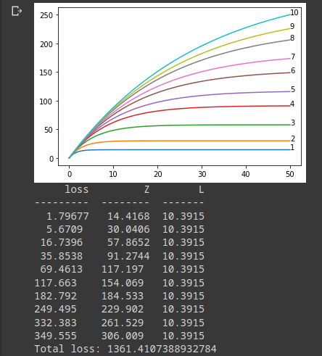
- The output for the analysis done on data without the incomplete entries mentioned in the pre_process part, under the heading: Program

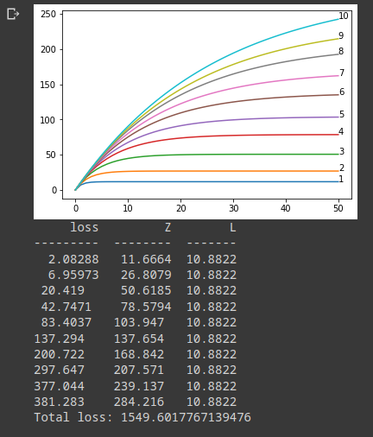
- The ouput from the analysis done on the dataset having the incomplete data (50 overs’ data not present and team is not fully out)

