RealSense Bench Check of best_large_640_100e_77k_fp16.engine on Larger Drone Target
Image-first summary for email. Ground truth comes from mocap. On April 17, 2026, the larger-drone target tracked cleanly through about 3.7 m actual range, but both 4.8 m holds and the 6.0 m hold stayed at 0 detections and 0 world tracks. This does not show a clear improvement over the April 16, 2026 small-drone result; the collapse is still in roughly the same 4-5 m band.
Overview Plot: Tracking Coverage vs Ground-Truth Range
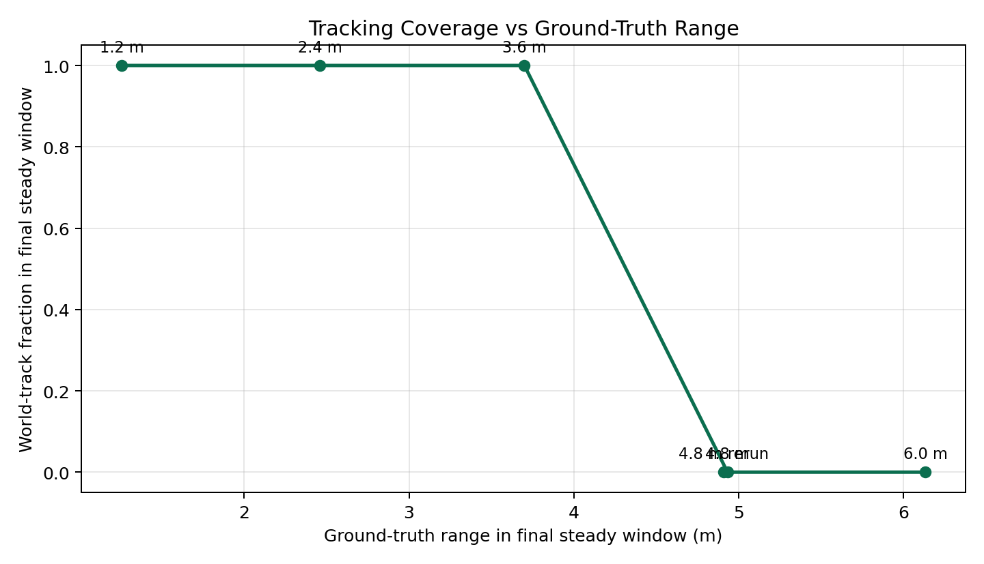
The larger-drone pass still shows a hard range cliff. The last successful steady window was the 3.6 m nominal hold at about 3.70 m actual range. Both 4.8 m windows at about 4.91-4.93 m and the 6.0 m window at about 6.13 m stayed at 0 detections and 0 world tracks.
Overview Plot: Error vs Ground-Truth Range
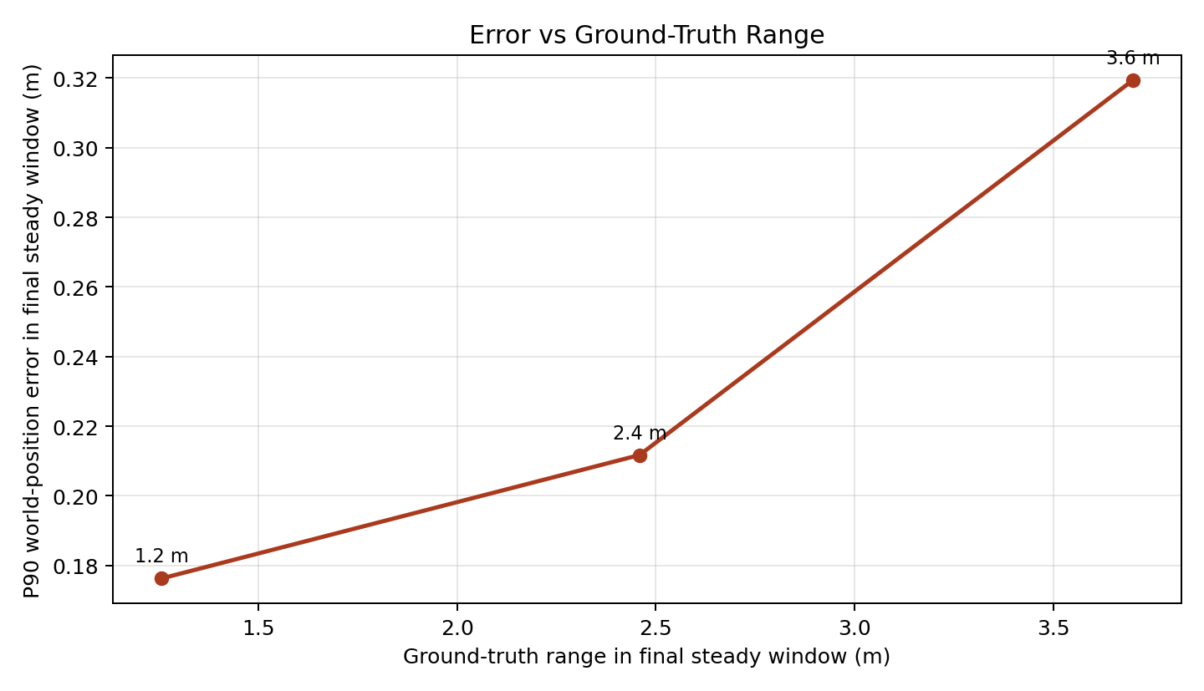
Before detection fully fails, error is already rising. The matched final hold windows give p90 world-position error of about 0.176 m at 1.26 m, 0.212 m at 2.46 m, and 0.319 m at 3.70 m actual range.

1.2 m clean detection
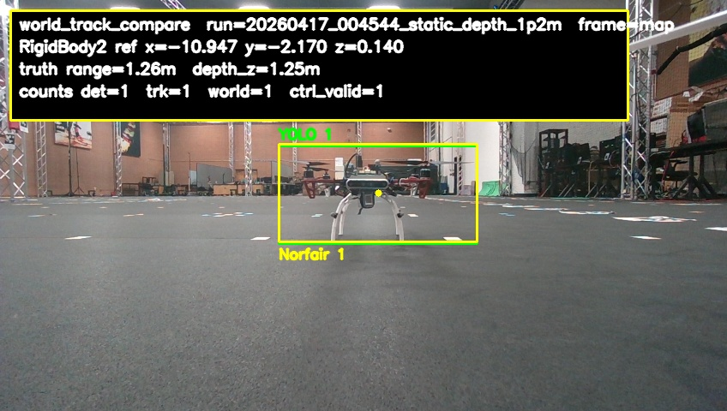
This is the short-range reference case. The detector is healthy here and the track overlay is stable. Ground-truth range: 1.257 m. Ground-truth forward depth: 1.251 m. Detector hit rate in the final steady window: 100.0%. World-track hit rate: 100.0%. Follow-usable hit rate: 100.0%. Mean estimated depth from the tracker: 1.104 m. P90 world-position error: 0.176 m.

2.4 m clean detection
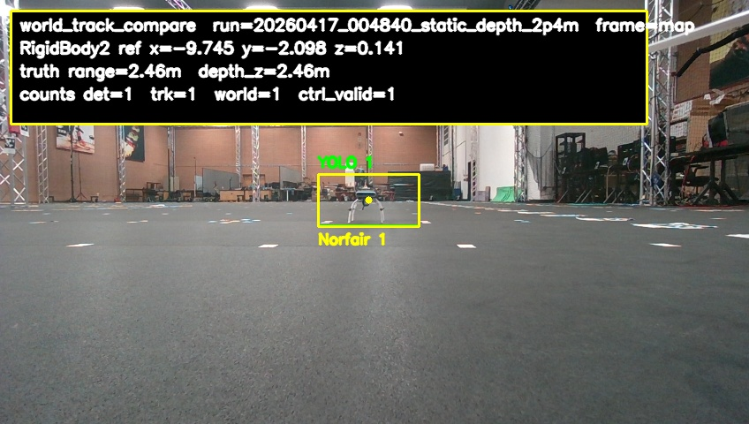
Detection is still solid here, although the overall follow-readiness gate already starts to tighten on lateral error. Ground-truth range: 2.459 m. Ground-truth forward depth: 2.456 m. Detector hit rate in the final steady window: 100.0%. World-track hit rate: 100.0%. Follow-usable hit rate: 100.0%. Mean estimated depth from the tracker: 2.379 m. P90 world-position error: 0.212 m.

3.6 m still detected but weaker
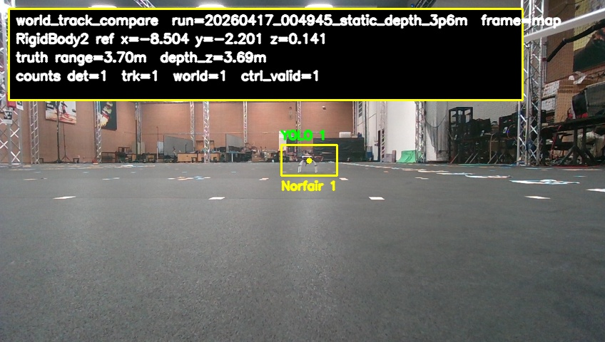
This is the last successful point in this larger-drone pass before the collapse. Ground-truth range: 3.700 m. Ground-truth forward depth: 3.687 m. Detector hit rate in the final steady window: 100.0%. World-track hit rate: 100.0%. Follow-usable hit rate: 100.0%. Mean estimated depth from the tracker: 3.807 m. P90 world-position error: 0.319 m.

4.8 m miss
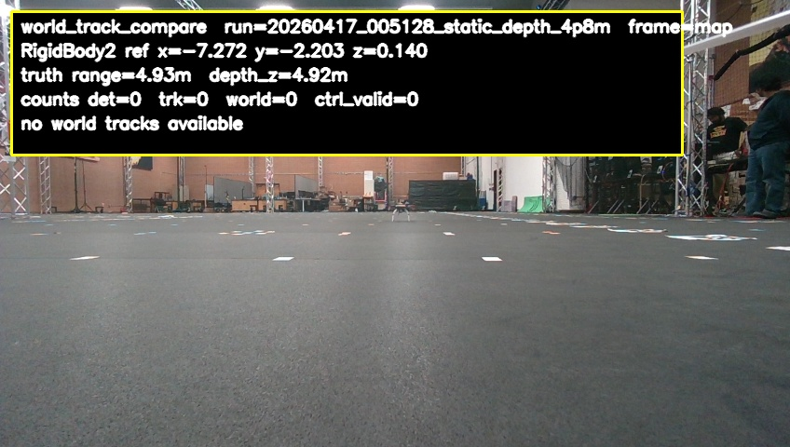
Ground truth is still stable here, but the detector does not fire at all in the final steady hold window. Ground-truth range: 4.932 m. Ground-truth forward depth: 4.916 m. Detector hit rate in the final steady window: 0.0%. World-track hit rate: 0.0%. Follow-usable hit rate: 0.0%. There was no estimated depth and no position error in this window because the detector never produced a valid world track.

4.8 m rerun miss
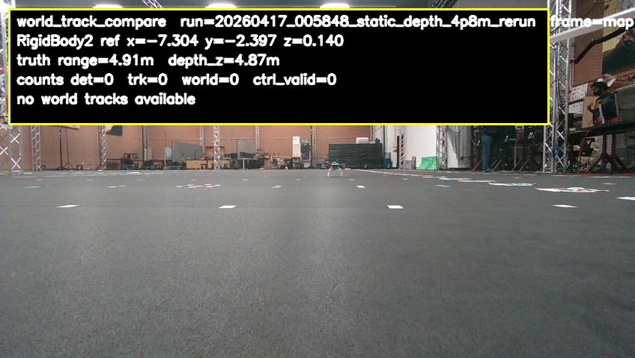
This rerun confirms that the 4.8 m hold is a repeatable miss rather than a one-off. Ground-truth range: 4.907 m. Ground-truth forward depth: 4.871 m. Detector hit rate in the final steady window: 0.0%. World-track hit rate: 0.0%. Follow-usable hit rate: 0.0%. There was no estimated depth and no position error in this window because the detector never produced a valid world track.

6.0 m miss
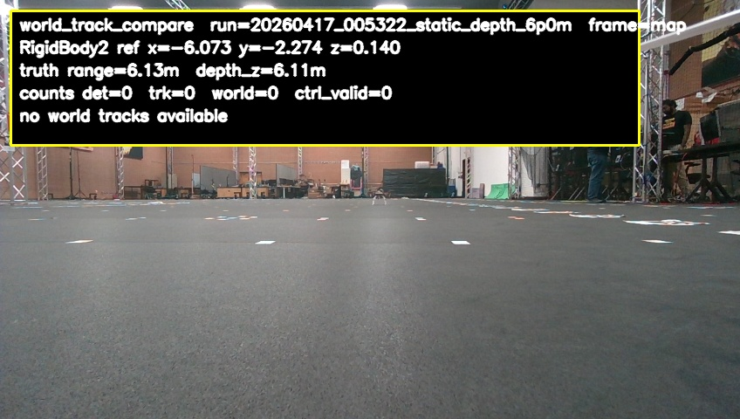
At this range the detector remains fully off even though the target pose is still available from mocap. Ground-truth range: 6.132 m. Ground-truth forward depth: 6.108 m. Detector hit rate in the final steady window: 0.0%. World-track hit rate: 0.0%. Follow-usable hit rate: 0.0%. There was no estimated depth and no position error in this window because the detector never produced a valid world track.
Embedded source images are also in /home/jetson/cdrone_control/email_frames_big_drone

