RealSense Bench Check of best_large_640_100e_77k_fp16.engine
Image-first summary for email. Ground truth came from mocap. The short version is: the engine still detects up to about 4 m in this setup, error grows by 3-4 m, and detection collapses completely by about 5 m. The 6 m reruns with propellers on and with reduced lighting both stayed at 0 detections.
Overview Plot: Tracking Coverage vs Ground-Truth Range
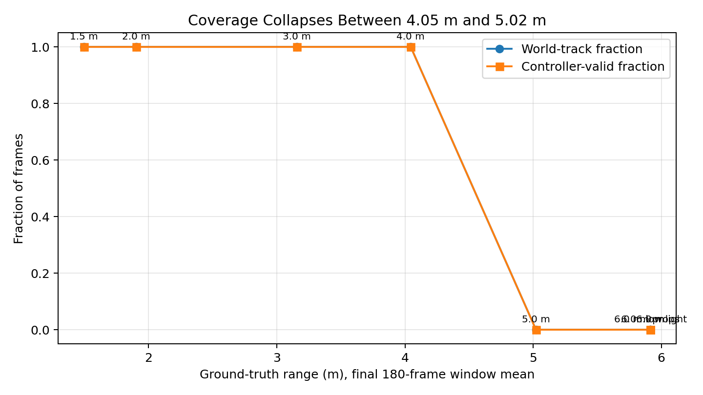
The clean range cliff is between about 4.05 m and 5.02 m. Up to 4.05 m the system still produced world tracks in the final steady hold window. At 5.02 m and beyond, the final steady windows dropped to 0 detections and 0 world tracks.

Before detection fully fails, the position error is already rising. The matched final hold windows give p90 world-position error of about 0.205 m at 1.5 m, 0.188 m at 2.0 m, 0.245 m at 3.16 m, and 0.308 m at 4.05 m.

1.5 m clean detection
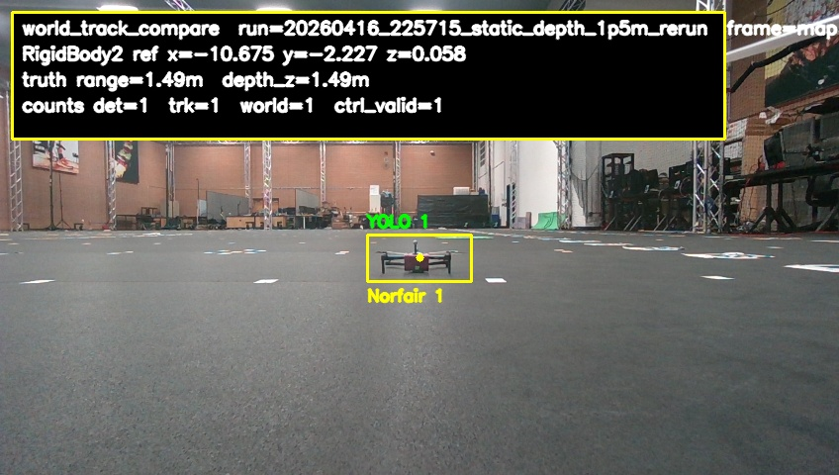
This is the short-range reference case. The detector is healthy here and the track overlay is stable. Ground-truth range: 1.495 m. Ground-truth forward depth: 1.489 m. Detector hit rate in the final steady window: 100.0%. World-track hit rate: 100.0%. Follow-usable hit rate: 100.0%. Mean estimated depth from the tracker: 1.325 m. P90 world-position error: 0.205 m.

2.0 m clean detection
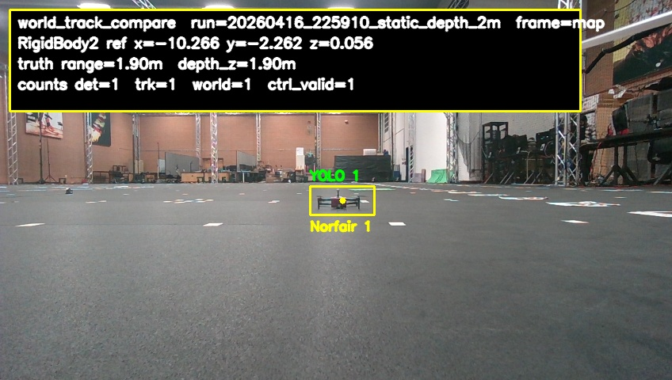
Ground-truth range: 1.904 m. Ground-truth forward depth: 1.896 m. Detector hit rate in the final steady window: 100.0%. World-track hit rate: 100.0%. Follow-usable hit rate: 100.0%. Mean estimated depth from the tracker: 1.768 m. P90 world-position error: 0.188 m.

3.0 m still detected
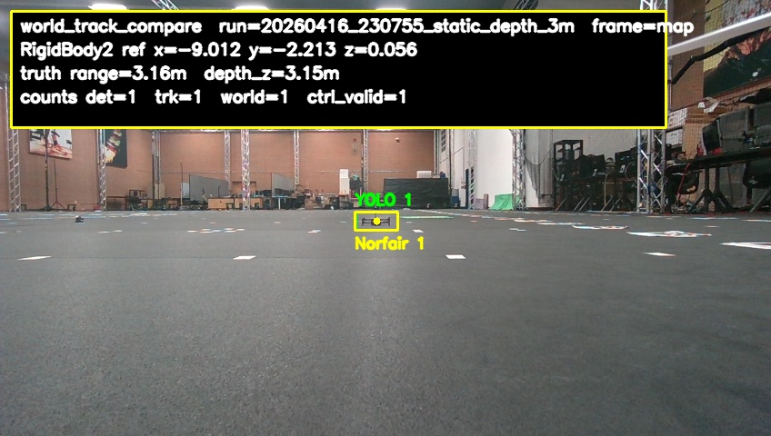
The detector still sees the target consistently, but the world-position error is higher than at short range. Ground-truth range: 3.156 m. Ground-truth forward depth: 3.152 m. Detector hit rate in the final steady window: 100.0%. World-track hit rate: 100.0%. Follow-usable hit rate: 100.0%. Mean estimated depth from the tracker: 3.131 m. P90 world-position error: 0.245 m.

4.0 m still detected but weaker
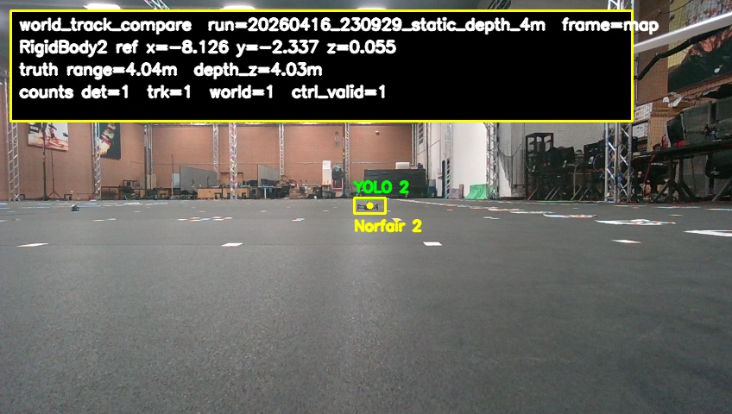
The system is still detecting at this range, but this is the last stable point before the collapse. Ground-truth range: 4.045 m. Ground-truth forward depth: 4.033 m. Detector hit rate in the final steady window: 99.4%. World-track hit rate: 100.0%. Follow-usable hit rate: 100.0%. Mean estimated depth from the tracker: 4.136 m. P90 world-position error: 0.308 m.

5.0 m miss
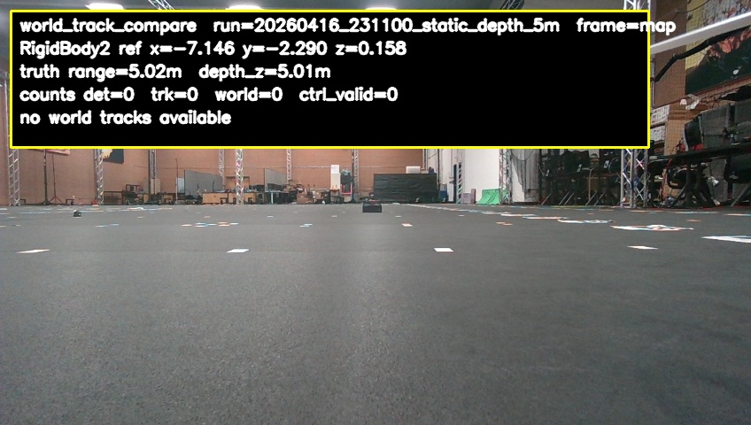
Ground truth is still stable here, but the detector does not fire at all in the final steady hold window. Ground-truth range: 5.022 m. Ground-truth forward depth: 5.013 m. Detector hit rate in the final steady window: 0.0%. World-track hit rate: 0.0%. Follow-usable hit rate: 0.0%. There was no estimated depth and no position error in this window because the detector never produced a track.

6.0 m miss
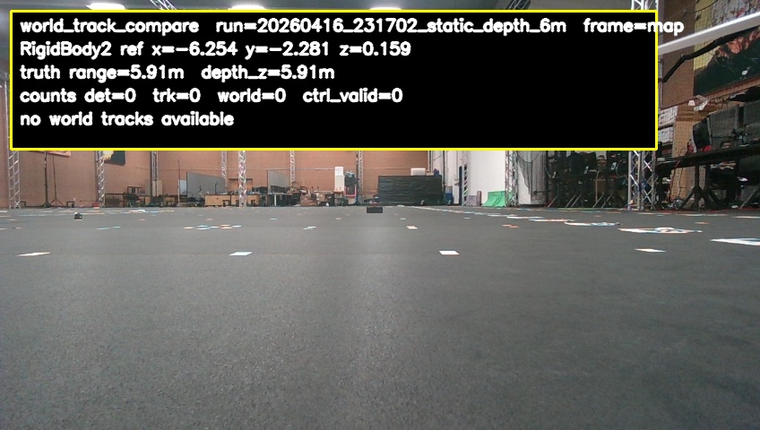
At this range the detector remains fully off even though the target pose is still available from mocap. Ground-truth range: 5.914 m. Ground-truth forward depth: 5.906 m. Detector hit rate in the final steady window: 0.0%. World-track hit rate: 0.0%. Follow-usable hit rate: 0.0%. There was no estimated depth and no position error in this window because the detector never produced a track.

6.0 m props-on miss
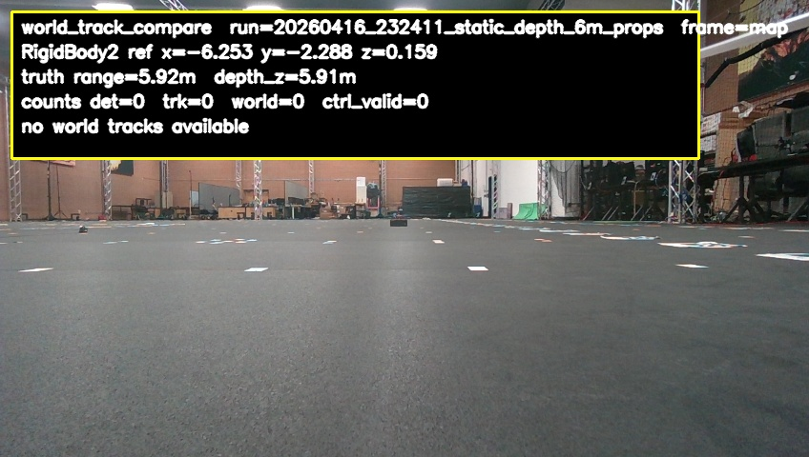
Spinning the propellers did not recover detection. The detector still stayed at zero. Ground-truth range: 5.915 m. Ground-truth forward depth: 5.906 m. Detector hit rate in the final steady window: 0.0%. World-track hit rate: 0.0%. Follow-usable hit rate: 0.0%. There was no estimated depth and no position error in this window because the detector never produced a track.

