RealSense Bench Check of 16_k_and_drone_studio_realsense_images_model.engine
Image-first summary for email. Ground truth came from mocap. In the April 20, 2026 static-depth ladder, this new engine tracked cleanly through 2.4 m, lost follow readiness by 3.6 m, collapsed sharply at 4.8 m, and stayed unreliable at 6.0 m and 7.2 m. The 6.0 m rerun did recover intermittent detections, but coverage and error were still far outside the follow gate.
Overview Plot: Tracking Coverage vs Ground-Truth Range
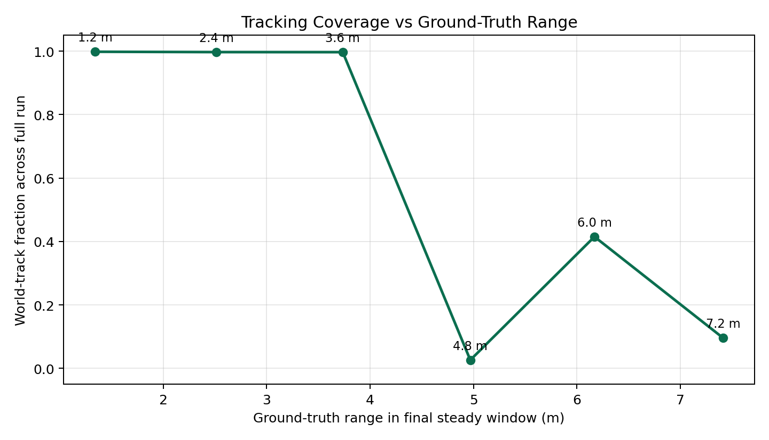
Coverage stays essentially full through 3.6 m, then collapses sharply at 4.8 m. The 6.0 m rerun shows only partial recovery, and 7.2 m is effectively unusable.
Overview Plot: Error vs Ground-Truth Range
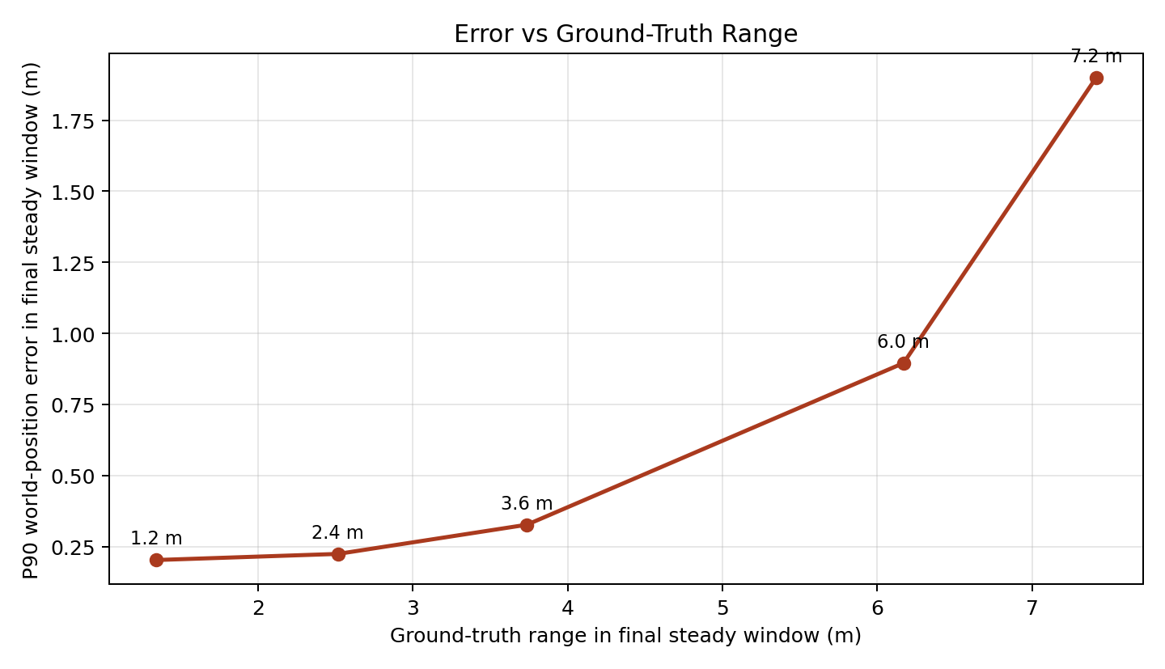
P90 world-position error is acceptable at short range, grows past the follow gate by 3.6 m, and becomes very large once coverage breaks down.

1.2 m clean detection
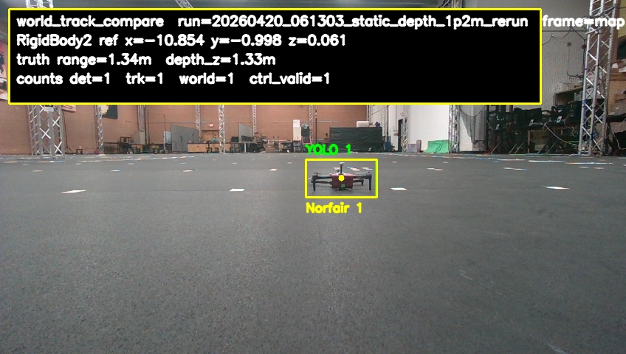
Short-range detection is stable and comfortably inside the follow gate. Ground-truth range: 1.342 m. Ground-truth forward depth: 1.326 m. Detector hit rate across the full run: 100.0%. World-track hit rate across the full run: 99.8%. Follow-usable hit rate across the full run: 99.8%. Mean estimated depth from the tracker: 1.158 m. P90 world-position error: 0.203 m.

2.4 m clean detection
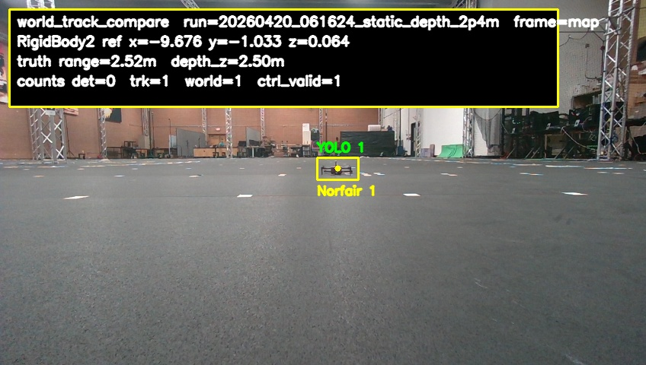
Tracking is still stable here and remains follow-ready. Ground-truth range: 2.516 m. Ground-truth forward depth: 2.503 m. Detector hit rate across the full run: 95.2%. World-track hit rate across the full run: 99.7%. Follow-usable hit rate across the full run: 99.7%. Mean estimated depth from the tracker: 2.416 m. P90 world-position error: 0.224 m.

3.6 m still detected but no longer follow-ready
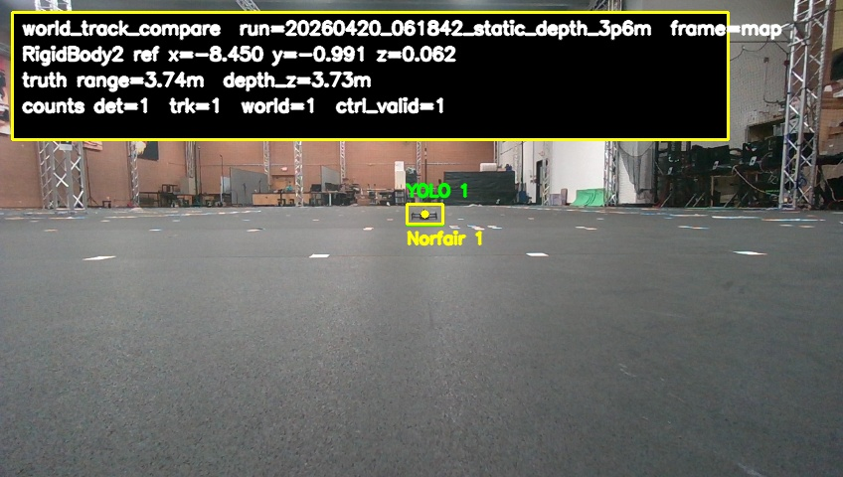
Coverage is still high, but error has grown beyond the follow gate. Ground-truth range: 3.736 m. Ground-truth forward depth: 3.730 m. Detector hit rate across the full run: 100.0%. World-track hit rate across the full run: 99.7%. Follow-usable hit rate across the full run: 99.7%. Mean estimated depth from the tracker: 3.769 m. P90 world-position error: 0.327 m.

4.8 m near-collapse with sparse tracks
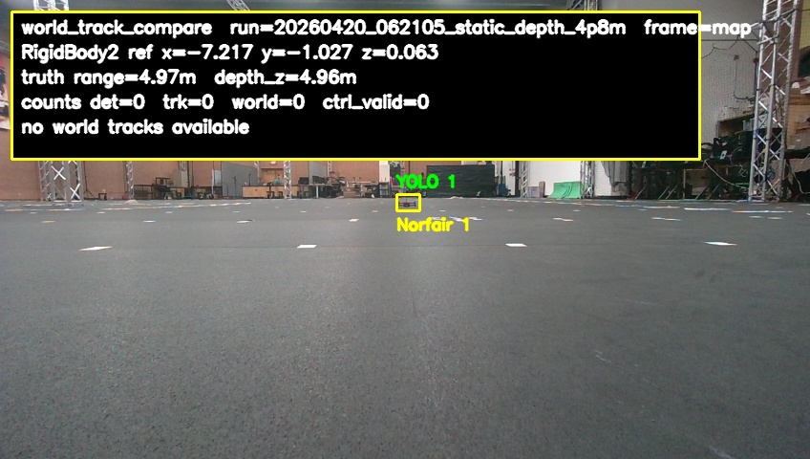
Only brief detections remained at this depth, with world tracks appearing only sporadically. Ground-truth range: 4.969 m. Ground-truth forward depth: 4.962 m. Detector hit rate across the full run: 7.1%. World-track hit rate across the full run: 2.6%. Follow-usable hit rate across the full run: 2.6%. There was no estimated depth and no position error in this window because the detector never produced a valid world track.

6.0 m intermittent detections but unusable
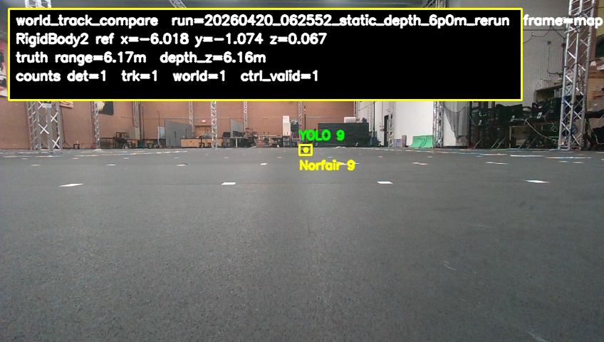
The rerun recovered some detections, but coverage and error stayed far outside the follow gate. Ground-truth range: 6.170 m. Ground-truth forward depth: 6.161 m. Detector hit rate across the full run: 31.3%. World-track hit rate across the full run: 41.5%. Follow-usable hit rate across the full run: 41.5%. Mean estimated depth from the tracker: 6.697 m. P90 world-position error: 0.896 m.

7.2 m mostly failed tracking
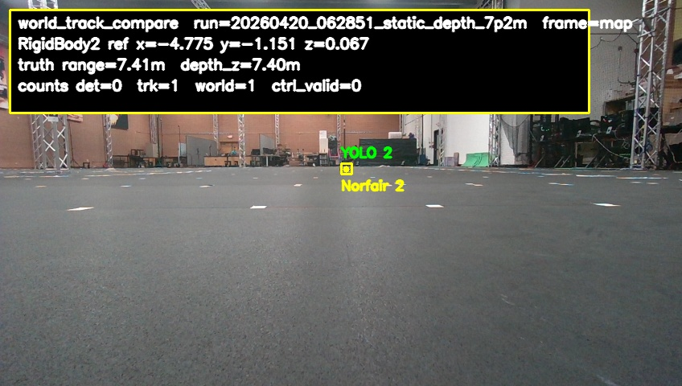
Detections still appear occasionally, but usable tracks are effectively gone. Ground-truth range: 7.414 m. Ground-truth forward depth: 7.401 m. Detector hit rate across the full run: 16.2%. World-track hit rate across the full run: 9.6%. Follow-usable hit rate across the full run: 0.0%. Mean estimated depth from the tracker: 8.755 m. P90 world-position error: 1.900 m.
Embedded source images are also in /home/jetson/cdrone_control/email_frames_2026-04-20

