

**ALAGAPPA COLLEGE OF TECHNOLOGY**

**ANNA UNIVERSITY-600025**

**NM Assignment / Digital Marketing**

|  |  |  |
| --- | --- | --- |
| NAME | REG.NO | Naan Mudhalvan ID |
| SANGEEETHA S | 2020308029 | 5FB4E17BB0E9C86A60343A5FDF014725 |

1. **Create a blog or website using Blogpost Customize the theme design and post new article with 500 words.**

https://weirdfoodtrend.blogspot.com/2023/10/trending-weird-food-culture-at-chennai.html?m=1

**2. Create a New Facebook Business Page and post one social media poster for your brand.**

https://www.facebook.com/profile.php?id=61553004327797

**3. Create and design a social media advertisement poster using canva.**

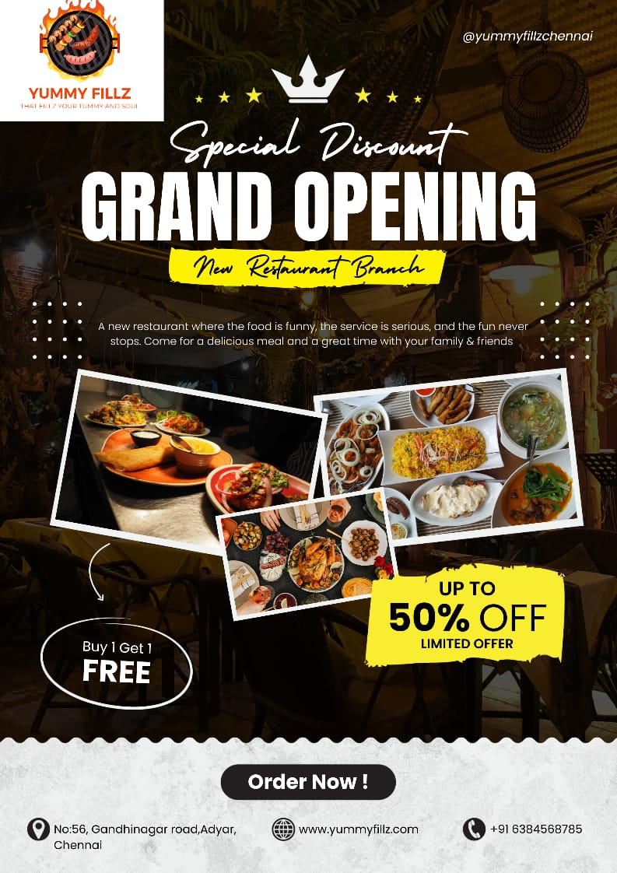

**4. Create email newsletter design using MailChimp or canva tool**.

