The *Exp\_X#* folders contain the network as it develop over time. Simply use ImageJ to create a slow movie or show the frames you like. The “A” are wildtype and “B” are Dpch

|  |  |  |
| --- | --- | --- |
|  | C:\Users\ematt\AppData\Local\Microsoft\Windows\INetCache\Content.Word\Exp1_Fr_3.tiff |  |

The “*Exp\_B2\_DensityAllTimePoints\_50um*” simply take all the time points and place all cell points in a single “map”. I can then plot is it as a density plot. This show that the wt cells positions are not highly conserved within the movie, therefore we have low diffuse values everywhere. On the other hand the Dpch has a few focal spot where cells are constantly concentrated.

C:\Users\ematt\AppData\Local\Microsoft\Windows\INetCache\Content.Word\Exp_A4_DensityAllTimePoints_50um.tiff

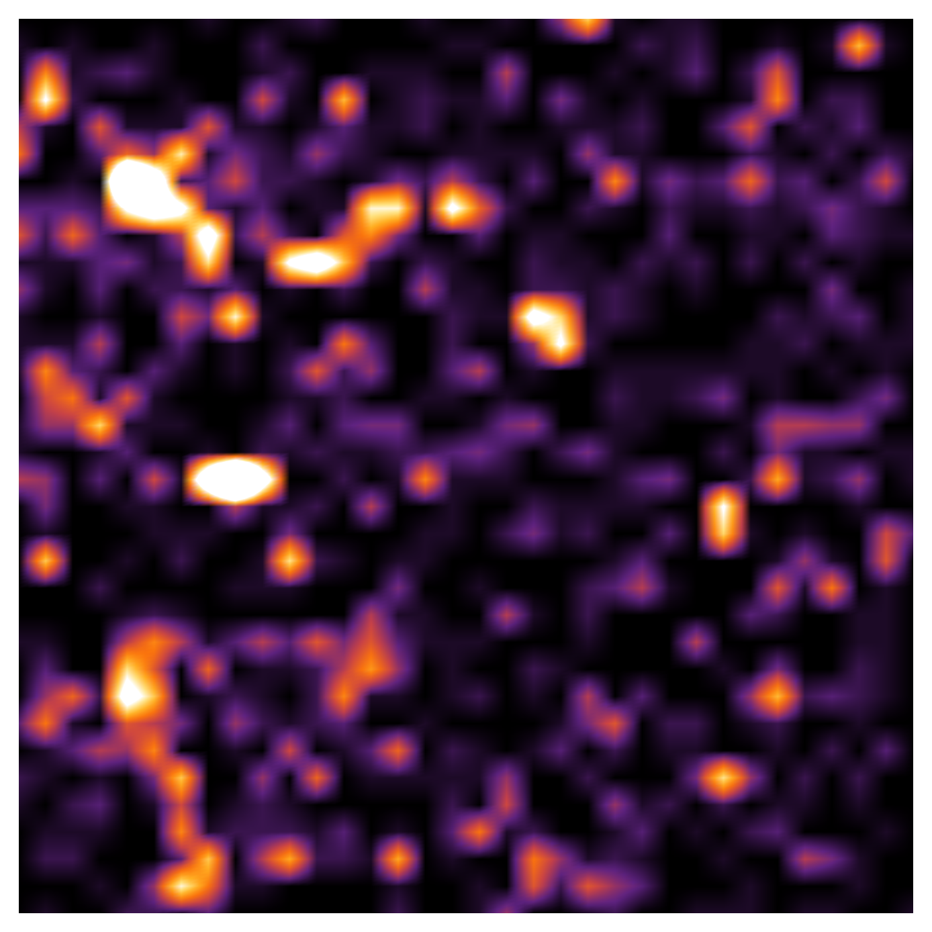

It looks quite cool, like some results of star analysis. The color-scale value (in (num. cells)/(2500 um2)) goes from as follow: 0 at black---violet---red---yellow---white---20

The Line plots show the “distributions of distances in the Delanunay network”, for all frames. The color coding tells you the time: (t=0)---Black---red---yellow---(t=10)

C:\Users\ematt\AppData\Local\Microsoft\Windows\INetCache\Content.Word\A3_NetworkDistanceDistribution.tiff

