Install docker on EC2



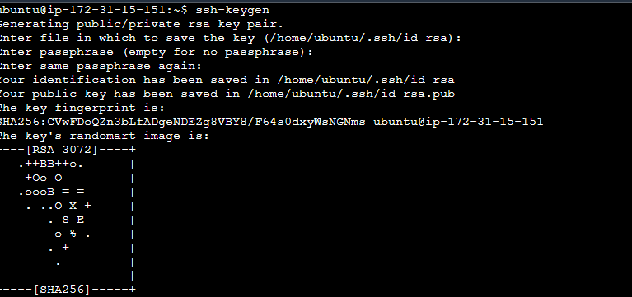

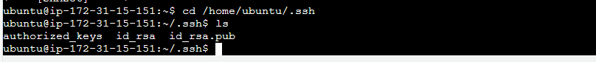

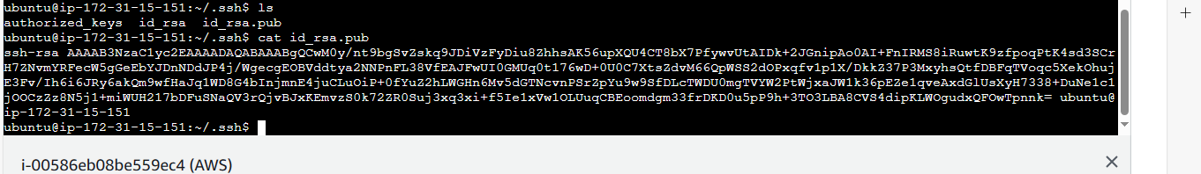



and explore the docker commands (docker images, containers, volumes, network)

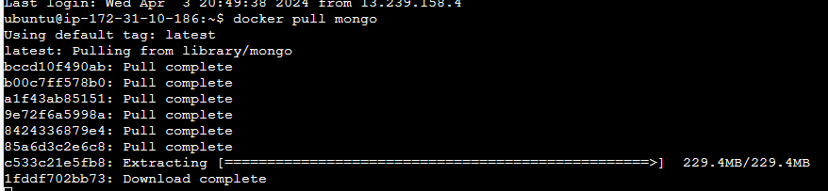

Docker images

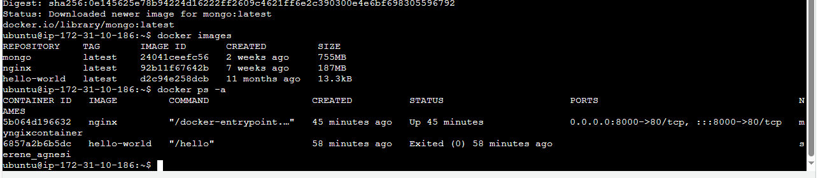

Docker container



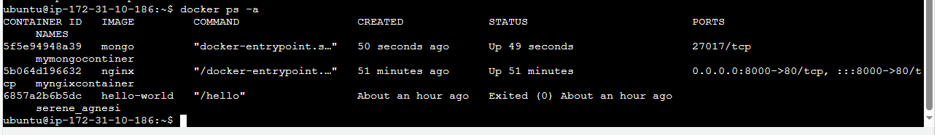

List all containers (including stopped ones):

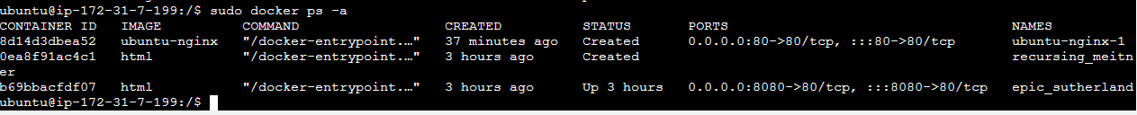

* Remove a container:

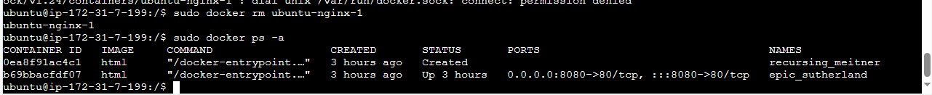

* Remove an image:

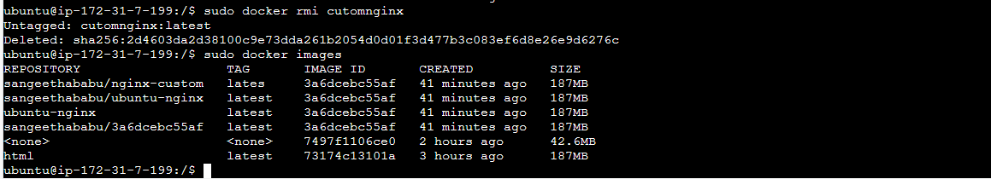

Volumes

Volume

Create a Volume



* List volumes:

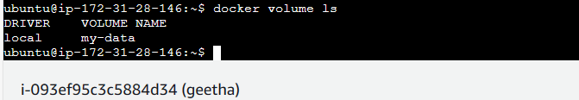

* Remove a volume:



Network

Create a network



List all the network

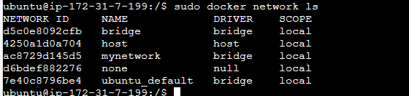

Remove the network

