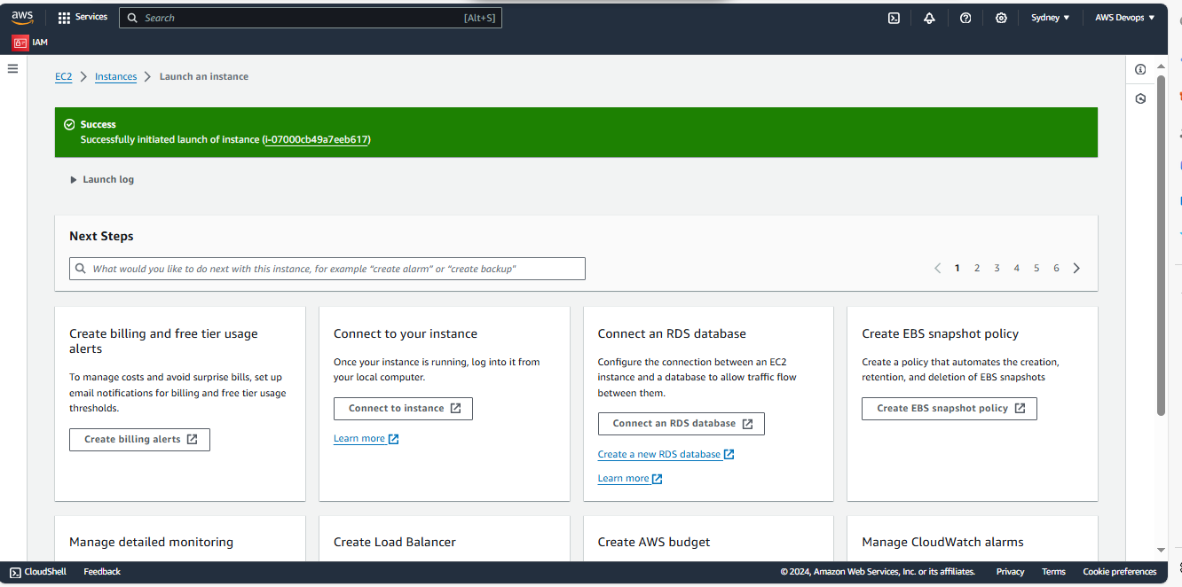





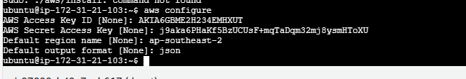



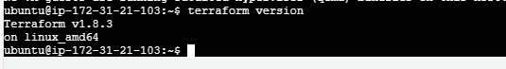

provider "aws" {

region = "us-west-2"

}

# Create first EC2 instance in us-west-2 region

resource "aws_instance" "instance1" {

ami = "ami-01cd4de4363ab6ee8"

instance_type = "t2.micro"

tags = {

Name = "Instance1"

}

user_data = <<-EOF

#!/bin/bash

sudo apt-get update

sudo apt-get install nginx

EOF

}

provider "aws" {

alias = "us_east"

region = "us-east-1"

}

resource "aws_instance" "instance2" {

provider = aws.us_east

ami = "ami-04b70fa74e45c3917"

instance_type = "t2.micro"

tags = {

Name = "Instance2"

}

user_data = <<-EOF

#!/bin/bash

sudo apt-get update

sudo apt-get install nginx

EOF

}

