FUNDAMENTALS OF SOFTWARE DESIGN AND DEVELOPMENT (SYST17796)

PROFESSOR NAME: - FAGUN VANKAWALA

**PROJECT DELIVERABLE 3**

GROUP MEMBERS(Group 7)

Sanghani, Rihil Pareshbhai

Vahanka, Freny Nilesh

Vaghani, Parth Vinodbhai

Patel, Pancham Jigneshkumar

USE CASE DIAGRAM

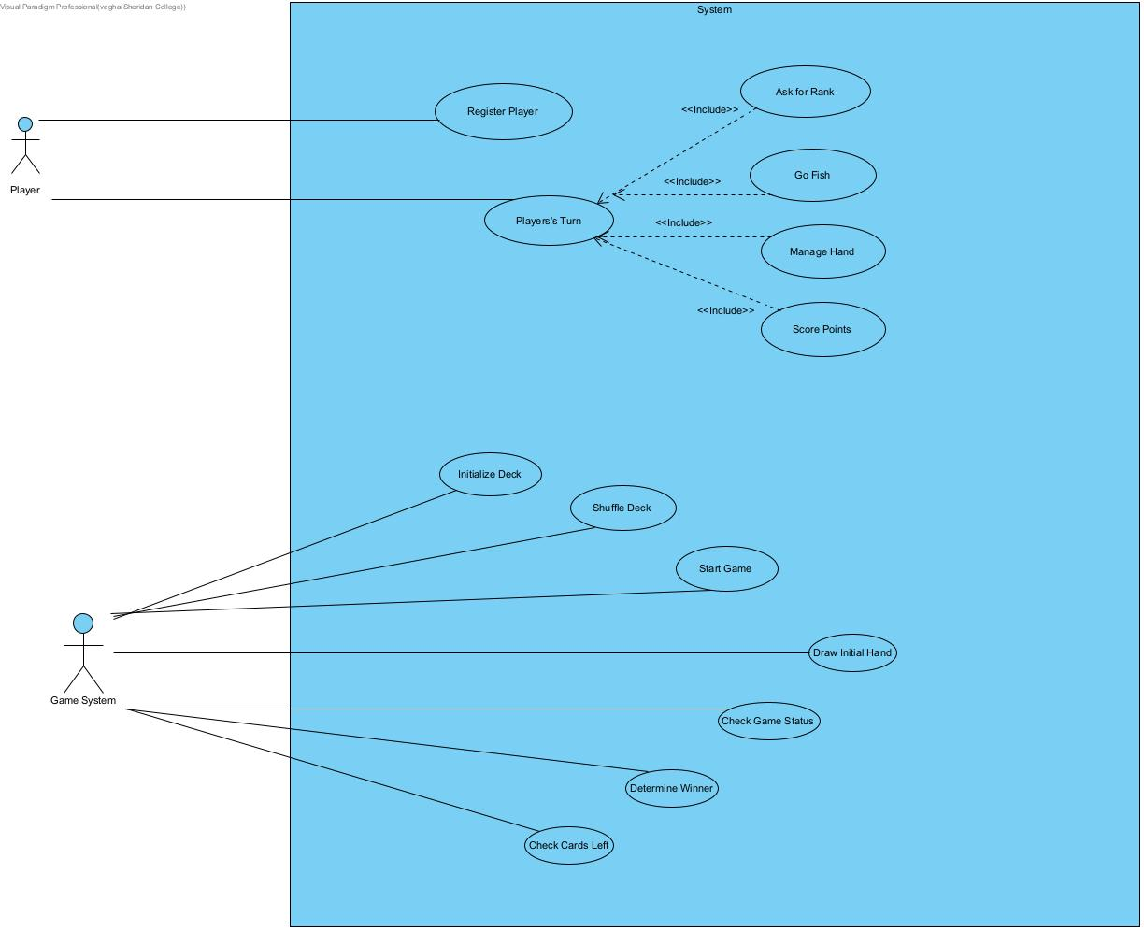

**Actors**

1. **Player**: Represents the participants interacting with the game.
2. **System**: Represents the game system responsible for managing game processes.

**Use Cases**

1. **Initialize Deck**: The system creates a standard deck of 52 cards.
2. **Shuffle Deck**: The system shuffles the deck to randomize the order of cards.
3. **Register Player**: Players register to join the game.
4. **Start Game**: The system initializes and starts the game.
5. **Draw Initial Hand**: Each player draws an initial set of cards.
6. **Player's Turn**: Players take turns during the game.
   * **Ask for Rank**: A player requests a specific rank from another player.
   * **Go Fish**: If the requested rank is not available, the player draws a card from the deck.
   * **Draw Card**: A player draws a card from the deck during their turn.
   * **Score Points**: Players score points by collecting cards of the requested rank.
   * **Manage Hand**: Players add or remove cards from their hand.
7. **Check Game Status**: The system checks if the deck is empty or if the game should end.
8. **Determine Winner**: The system determines and announces the winner.
9. **Check Cards Left**: The system or player checks the number of cards left in the deck.

CLASS DIAGRAM

