This how our back-office looks on DASHBOARD menu

You can use the same kind of visual aspect, but with a different section that I will explain on next page

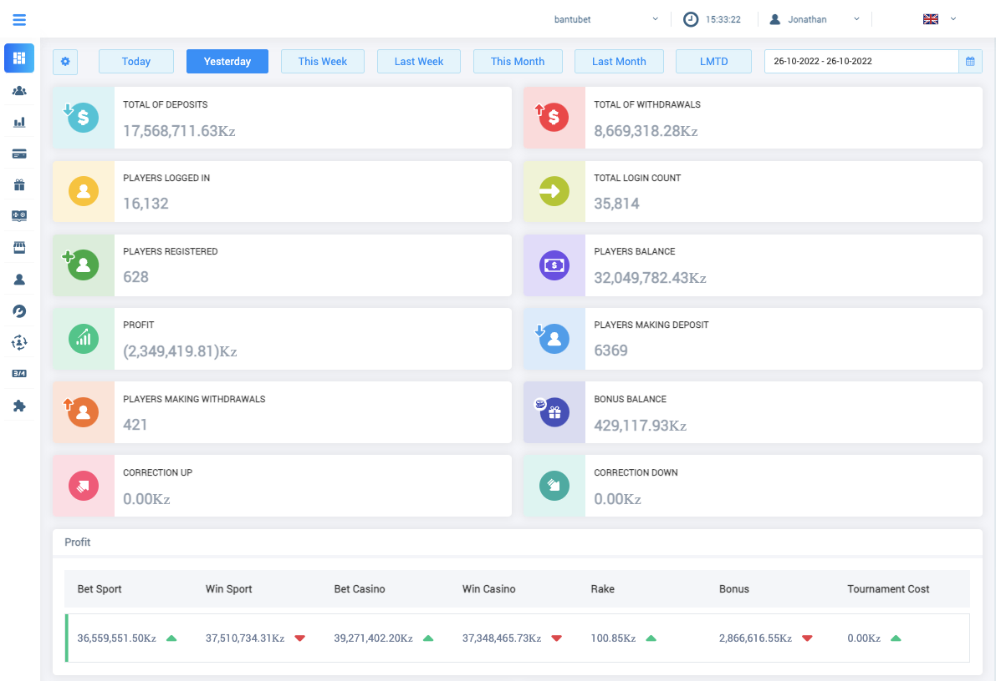

**Timezone**

**Username**: Clicking it should show below options:

1. Logout
2. Settings – to change timezone and currency (screenshots in the 2nd page)

**Language** change dropdown: English and Portuguese (screenshots in the 2nd page)

**Currency** AOA (Angolan Kwanza) and USD

Date Filters (like what is shown on image except in red bracket) on the Dashboard:

* Today
* Yesterday
* This month
* Calendar (to select range, screenshot in 2nd page)

Red boxes: we don’t want to develop

Wherever there are business revenue figures (every report in the back office 2), we want an ability to decide % that we want to show along with date filter that will enable us updating % for past and future transactions, fix ongoing %, fix % for upcoming reports/transactions etc.

Every report page should have an option to download in xlsx, csv and pdf format

Ability to schedule and send report to desired email addresses for every report and dashboard on this Back Office 2. Example: statistic report is supposed to sent to authorities via email every day at certain hour of the day, in the beginning we will be checking the report manually and send it via email but once the process is set, we would want to automate this by scheduling reports to be sent at desired hour of the day/week/month, in a desired format (xlsx, csv and pdf) and to desired recipients.

**User setting:**

* 2 Admin Account
* 3 User accounts (admin should be able to create these)
* Users should have view only access to everything in this project except admin settings
* User should be able to change timezone
* Currency (default language should be Portuguese)
* Language (default currency should be AOA – Angolan Kwanza)

For password reset, they should contact us (admin), we will set their password and then share it with the user

**Domain:** [www.backoffice.bantubet.com](http://www.backoffice.bantubet.com)

**Calendar:** In the calendar, please see if giving options like today, yesterday, this month etc. options can be made available

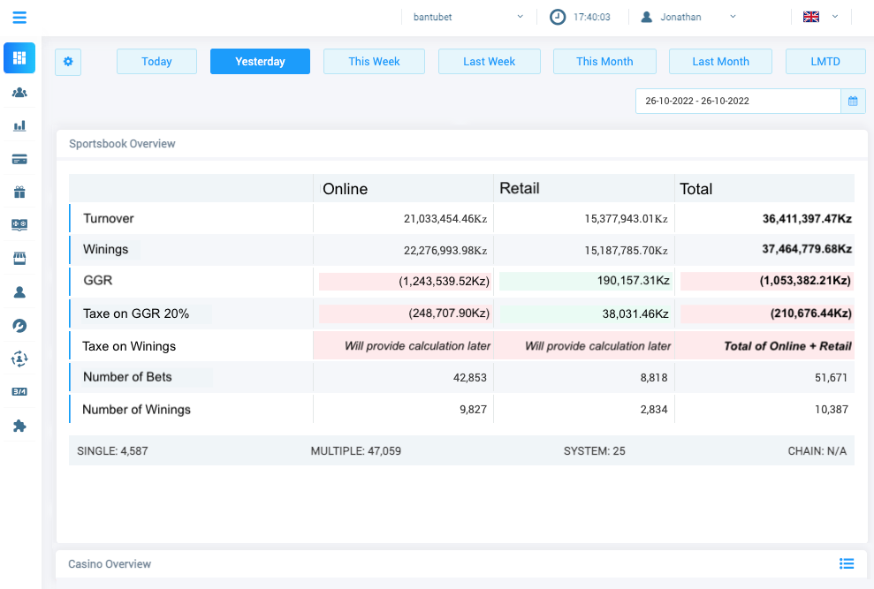

Items to show in this table as exactly shown in the image:

* Turnover
* Winnings
* GGR
* Tax on GGR 20%
* Tax on Winnings
* Number of Bets
* Number of Winnings

**We want settings in admin panel where we can define % for all the figures shown on dashboard:**

1. % for a particular day for each figure shown
2. Calendar to select date range
3. Current % set – today I set 20% but for tomorrow if I have not defined anything, it should assume % from this field until updated later on

**User setting:**

1. User should be able to change timezone
2. Currency
3. Language

For password reset, they should contact us (admin), we will set their password and then share it with the user

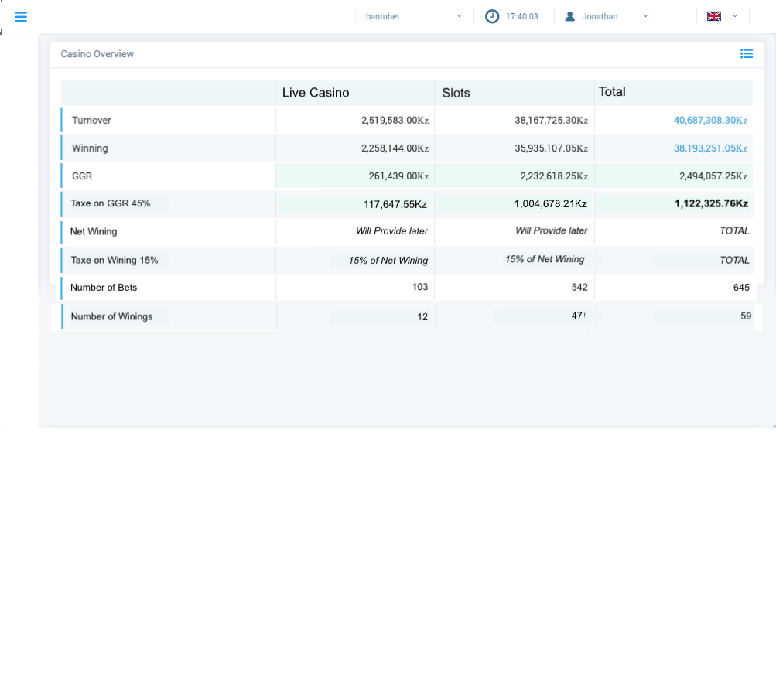

Items to show on this Dashboard:

* Turnover
* Winning
* GGR
* Tax on GGR 45%
* Net Winning
* Tax on Winning 15%
* Number of Bets
* Number of Winnings

**We want settings in admin panel where we can define % for all the figures shown on dashboard:**

1. % for a particular day for each figure shown
2. Calendar to select date range
3. Current % set – today I set 20% but for tomorrow if I have not defined anything, it should assume % from this field until updated later on

On the same Dashboard home page, after the Sportsbook overview, we have the Casino Overview

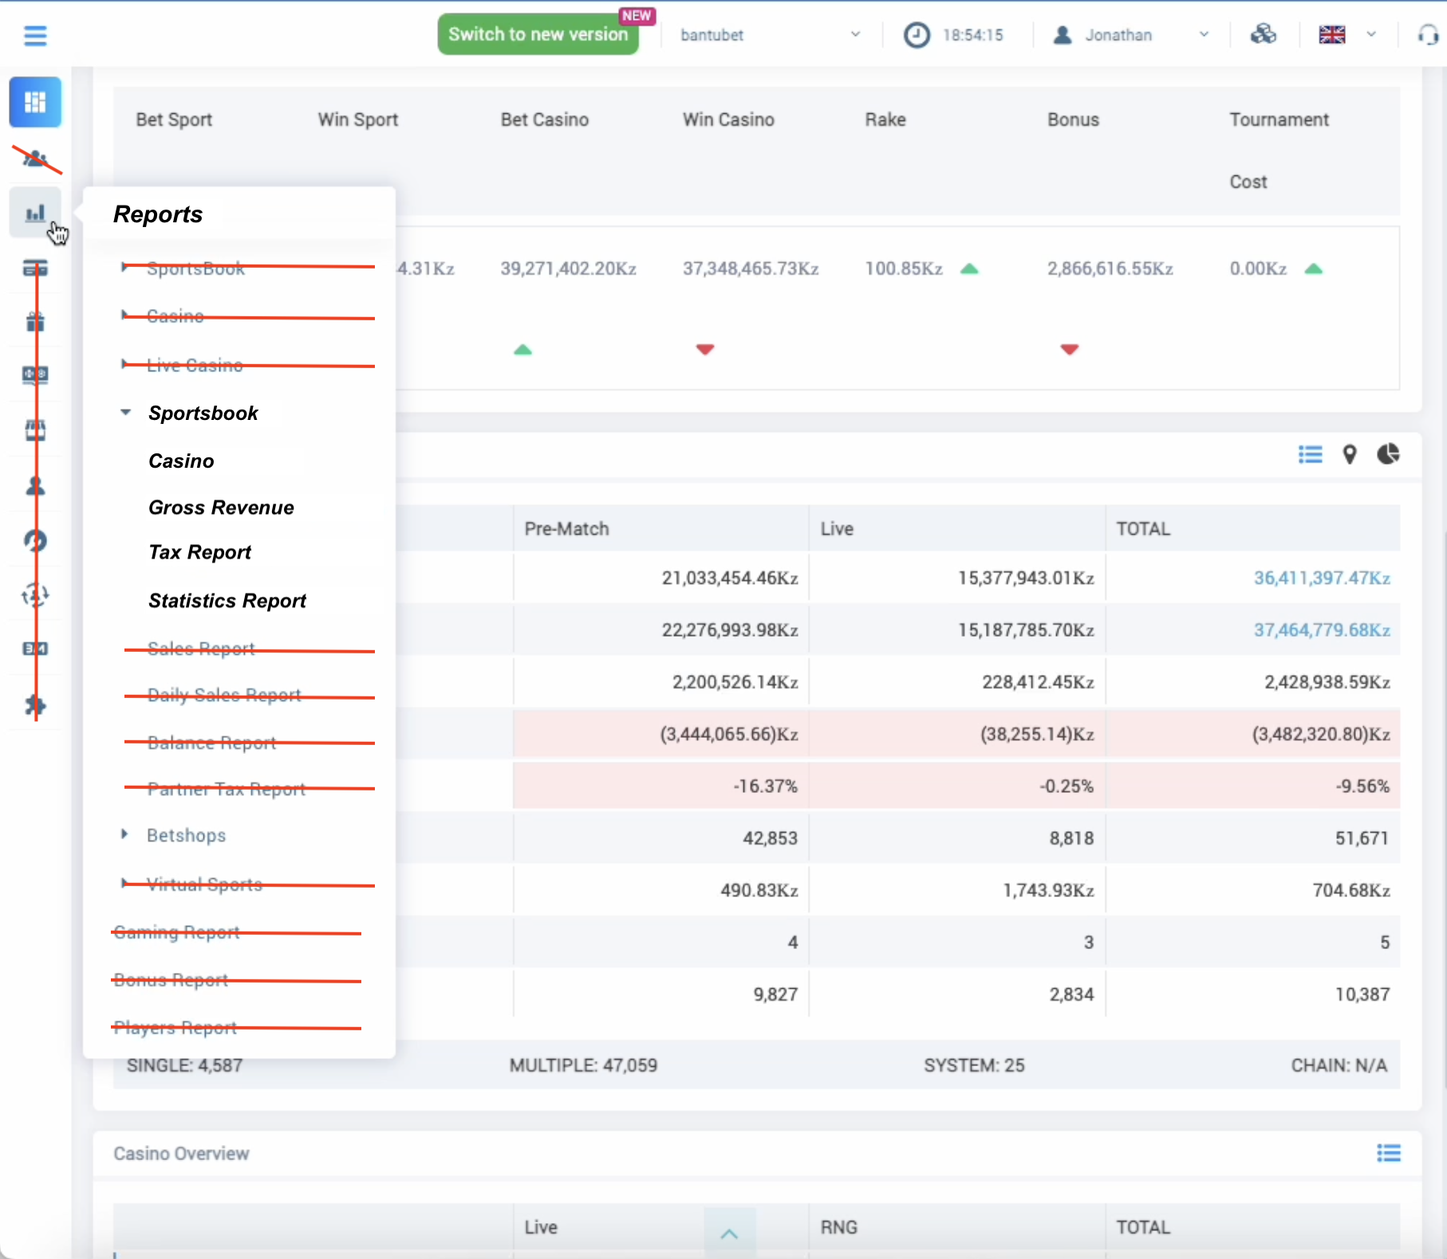

We will need, for the moment 3 menu: Dashboard, Reports and Alerts

**Reports -> Sportsbook**

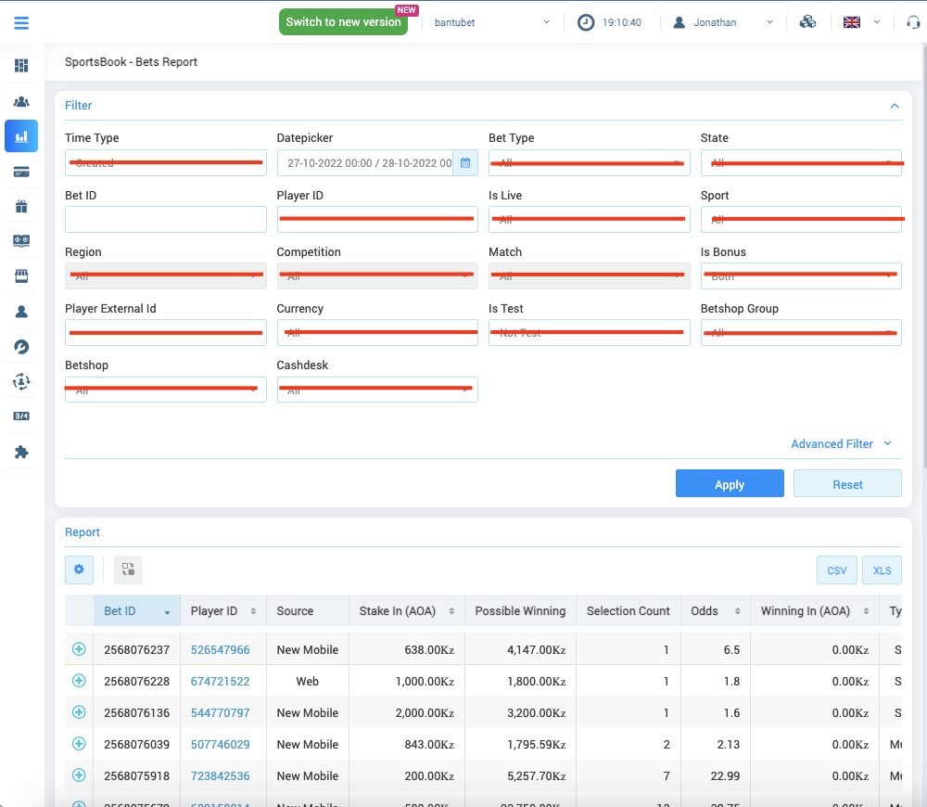

Filters:

- Datepickers (calendar for date range)

- Bet ID (search)

Report:

- Will show only recent 20 bets

- Will not show bets with Stake amount higher than 250.000,00

Columns needed:

* Bet ID
* Player ID (without link)
* Stake
* Possible Wining
* Selection Count
* Odds
* Wining
* Type
* GGR
* State
* Created (date)
* Calculation Date
* Bonus

**Reports -> Casino**

Filters:

- Datepickers (calendar for date range)

- Bet ID (search)

Report:

- Will show only recent 20 bets

- Will not show bets with Stake amount higher than 250.000,00

Columns needed:

* Bet ID
* Player ID (without link)
* Stake
* Possible Wining
* Selection Count
* Odds
* Wining
* Type
* GGR
* State
* Created (date)
* Calculation Date
* Bonus

**Reports -> Tax Report**

Filters:

- Datepickers (calendar for date range)

**We want settings in admin panel where we can define % for all the items shown on the search result:**

* % for a particular day and item
* Calendar to select date range
* In the columns mentioned in image, we don’t want to show entire 100% business, hence % logic

Definition of columns:

* Product:
  + Sportsbook Online
  + Sportsbook Retail
  + Casino
* Bets: total bets placed
* Stake: bet amount (in USD / AKZ as per selection in setting)
* Cancelled stakes: cancelled bet amount
* Net Stakes: total bet amount – cancelled bet amount
* Free bet winnings: won freebet amount
* Winning: money won from betting
* Turnover Tax: amount as per % decided in the settings for dashboard
* GGR: amount as per % decided in the settings for dashboard

**Reports -> Statistic Report**

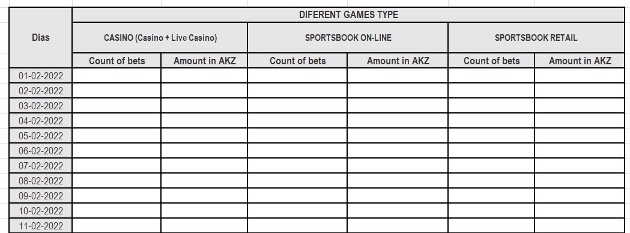

**Filters:**

- Datepicker (calendar for date range)

- Game Type:

* Online Sales Report
* Online Winning Report
* Retail Sales Report
* Retail Winning Report

**We want settings in admin panel where we can define % for all the items shown on the search result:**

* % for a particular day and item
* Calendar to select date range
* In the columns mentioned in images, we don’t want to show entire 100% business, hence % logic

**Definitions for the reports:**

* Online Sales Report:
  + Count of bets = bets sold online
  + Amount in AKZ = amount in Angolan kwanza (if the payment selected is in USD, we show USD here)
* Online Winning Report:
  + Winning Count = numbers of bets that won from online selling
* Retails Sales Report:
  + Count of bets = bets sold at retail shop (betshop, cash desk)
* Retails Winning Report:
  + Winning Count = numbers of bets that won from retail selling

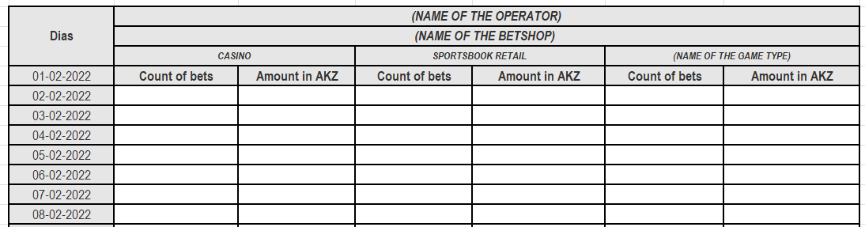



Winning count

Winning count

Winning count

**Dashboard**

|  |  |
| --- | --- |
| **Turnover** | Stake / Wagered Amount  Turnover is the expression used to describe the amount wagered. It is all the money bet before any winnings are paid out or losses incurred. It does not include any additional charges that may also be paid at the point of purchase, such as the selling agents' commission in the case of lotteries. |
| **Winnings** | If the customer wagered $10 on a market with odds 2.5 and if he wins, he will receive $25 (10x2.5) as a winning amount. This $25 is the winning. |
| **GGR** | Gross gaming revenue is a key metric used by gambling and betting companies. It represents the difference between the amount wagered (Turnover) minus the amount won (Winning). |
| **Tax on GGR** | 20% |
| **Tax on Winning** | Need % for Sportsbook and Casino |
| **Single** | Is this the single bet count or amount? |
| **Multiple** | Is this the multiple bet count or amount? |
| **System** | Is this the system bet count or amount? |
| **Chain** |  |

Sportsbook bet report

|  |  |
| --- | --- |
| **Bet ID** |  |
| **Player ID** | Please do not hyperlink this player ID |
| **Stake** |  |
| **Possible Wining** | Odds x Stake / Wagered amount |
| **Selection Count** | Number of selected markets |
| **Odds** |  |
| **Winning** |  |
| **Type** |  |
| **GGR** |  |
| **State** | Status of the bet |
| **Created Date** | Date and time the bet was placed on |
| **Calculation Date** | Pay-out date in case of winning |
| **Bonus** |  |

Casino bet report

|  |  |
| --- | --- |
| **Bet ID** | Related Bet ID |
| **Transaction ID** |  |
| **Created Date** | Date and time the bet was placed on |
| **Player ID** | Please do not hyperlink this player ID |
| **Stake** | Wagered / Stake amount |
| **Winning** | Win Amount |
| **State** | Status of the bet |
| **~~Possible Wining~~** | ~~Odds x Stake / Wagered amount~~ |
| **~~Selection Count~~** | ~~Number of selected markets~~ |
| **~~Odds~~** |  |
| **Game ID** |  |
| **Game** |  |
| **Provider** |  |