* Create an EC2 Instance and Fetch Its Public IP.
* Its Public IP is dynamic in nature and changes when you reboot your system.

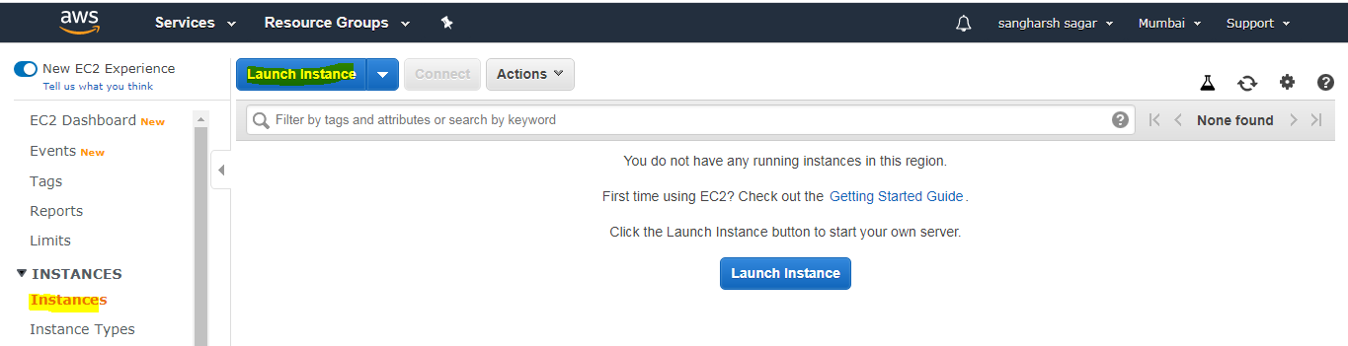

Public IP is : **13.232.113.120**

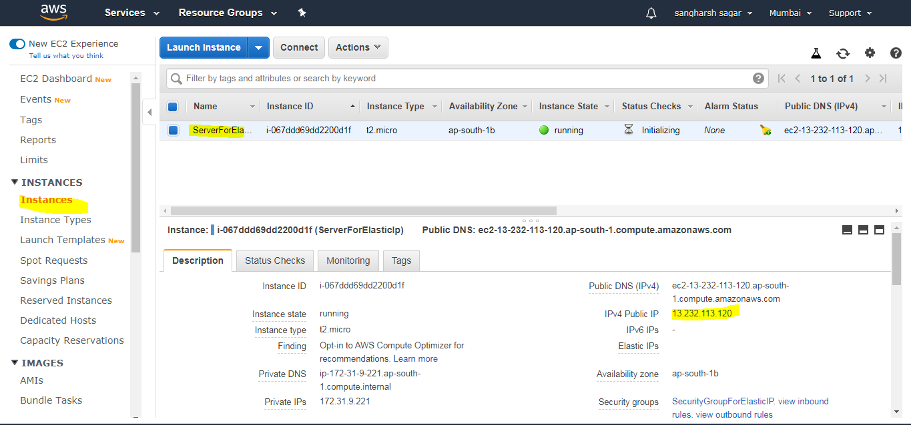

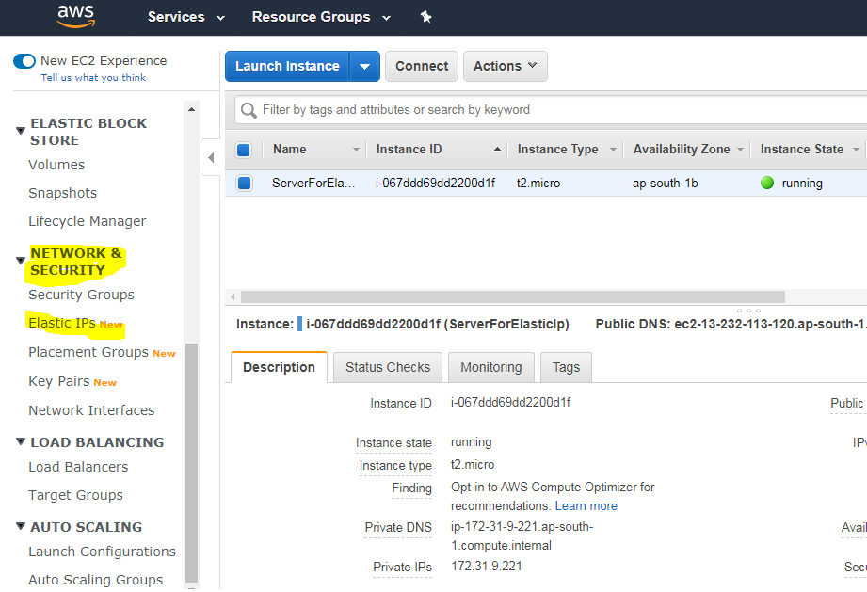

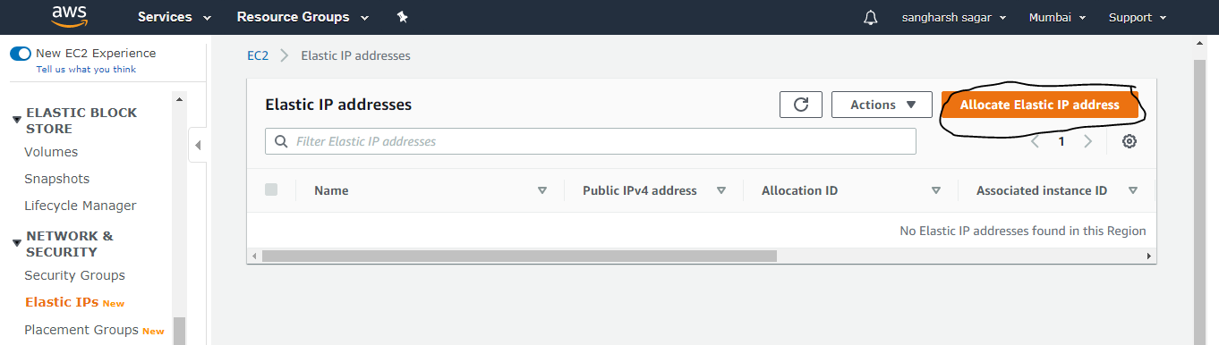

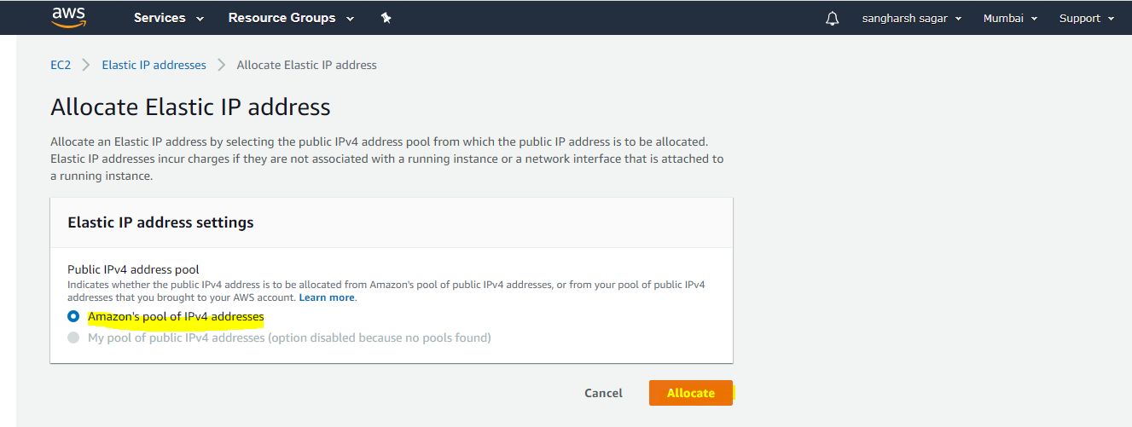

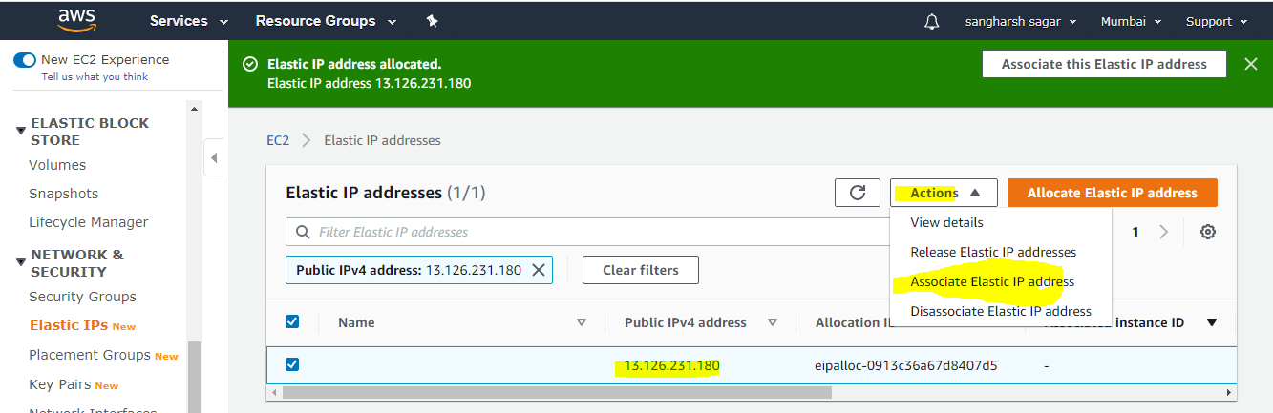

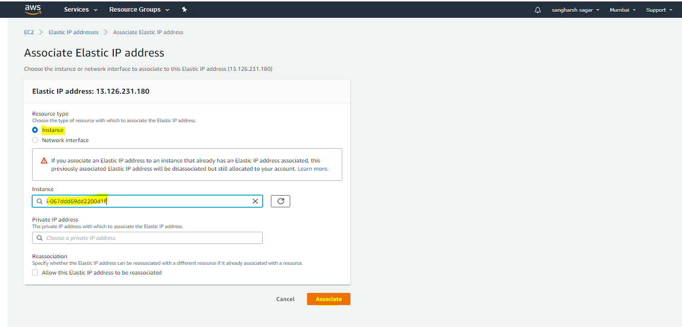

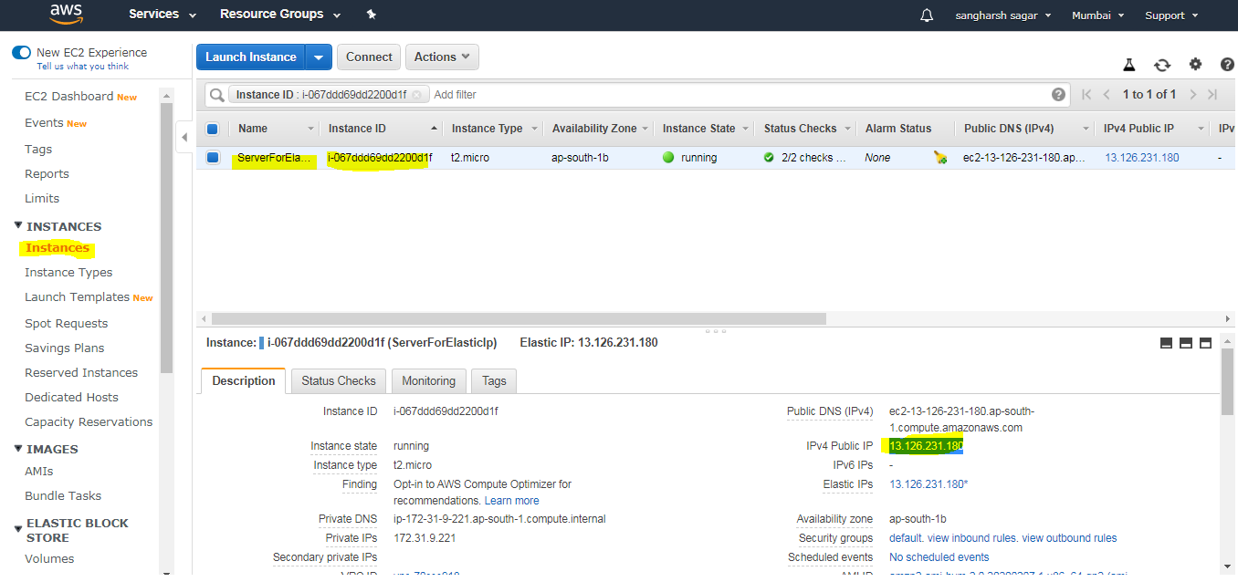

Once you are done with EC2 instance then Release It or else you will be charged if Elastic IP is not associated with any instance.

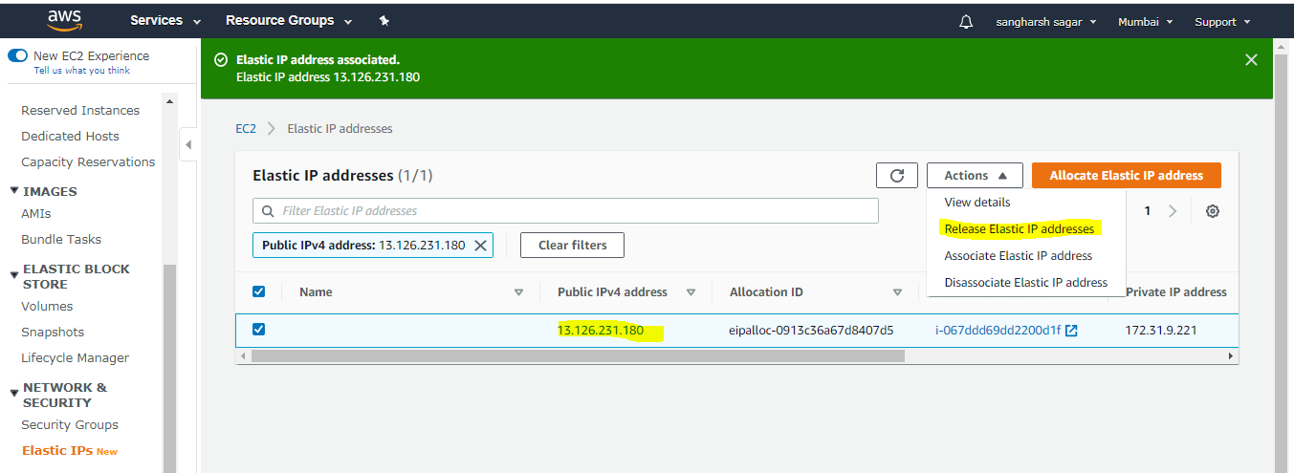

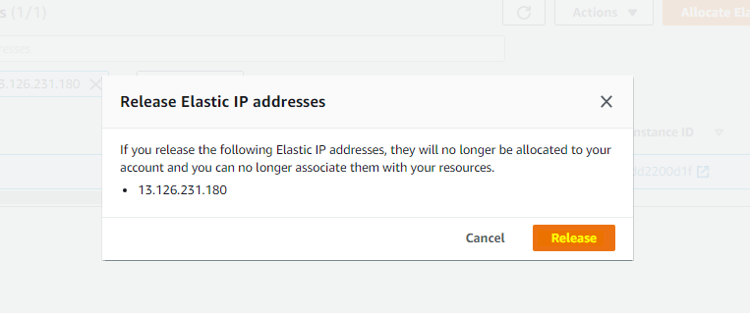

Now you can see in below picture that Elastic IP is released and you get new Public IP address which is dynamic in nature.

