**Auto Scaling:**

* Logical group of **EC2** Instances which can be scaled dynamically.
* Auto Scaling Group needs a **Launch Configuration** to add new instances.
* **Launch Configuration** has details to Add new instances.

**Launch Configuration has following Details:**

1. AMI (Amazon Machine Image)
2. Security Groups
3. EBS Volume Type and Size
4. IAM Role
5. Private Key

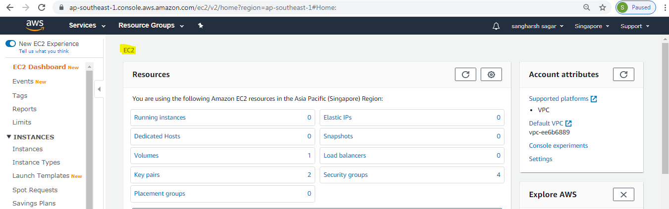

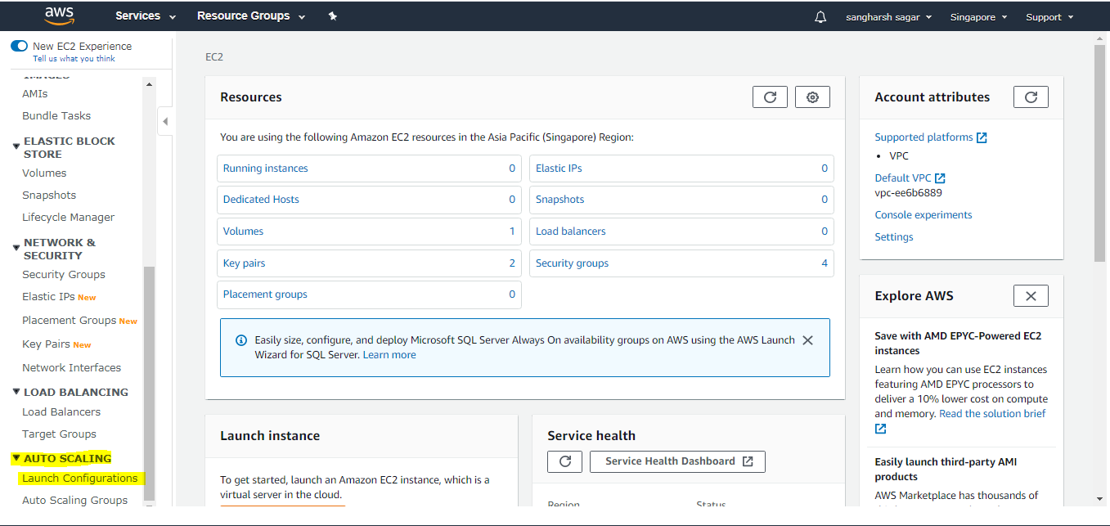

First Step create Launch Configuration:

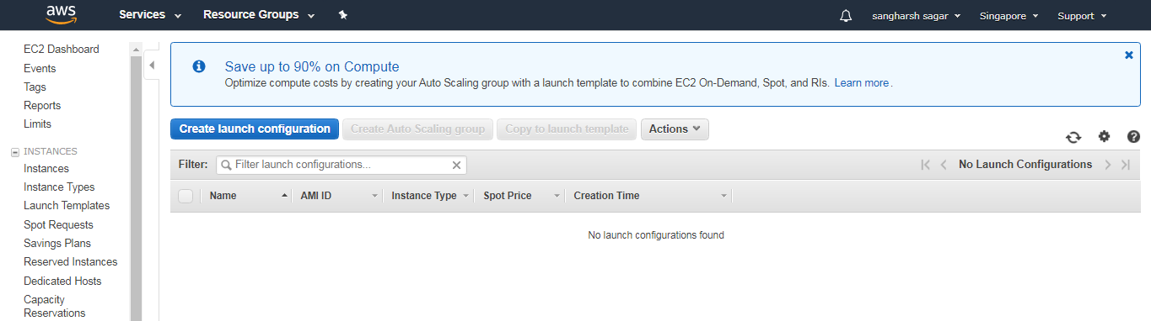

Select AMI

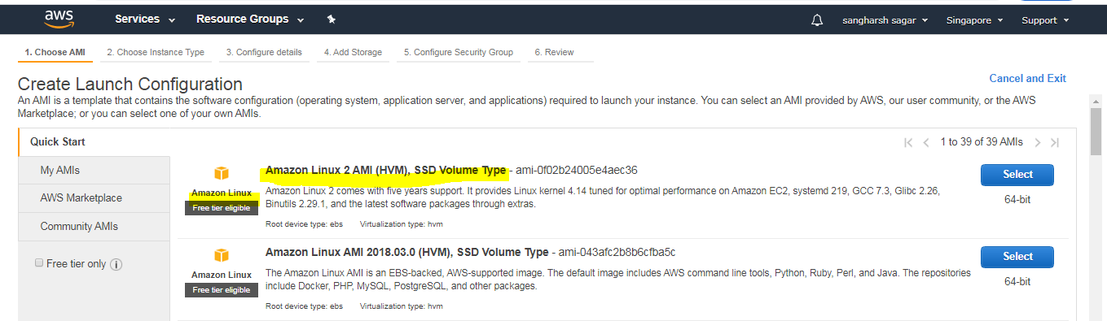

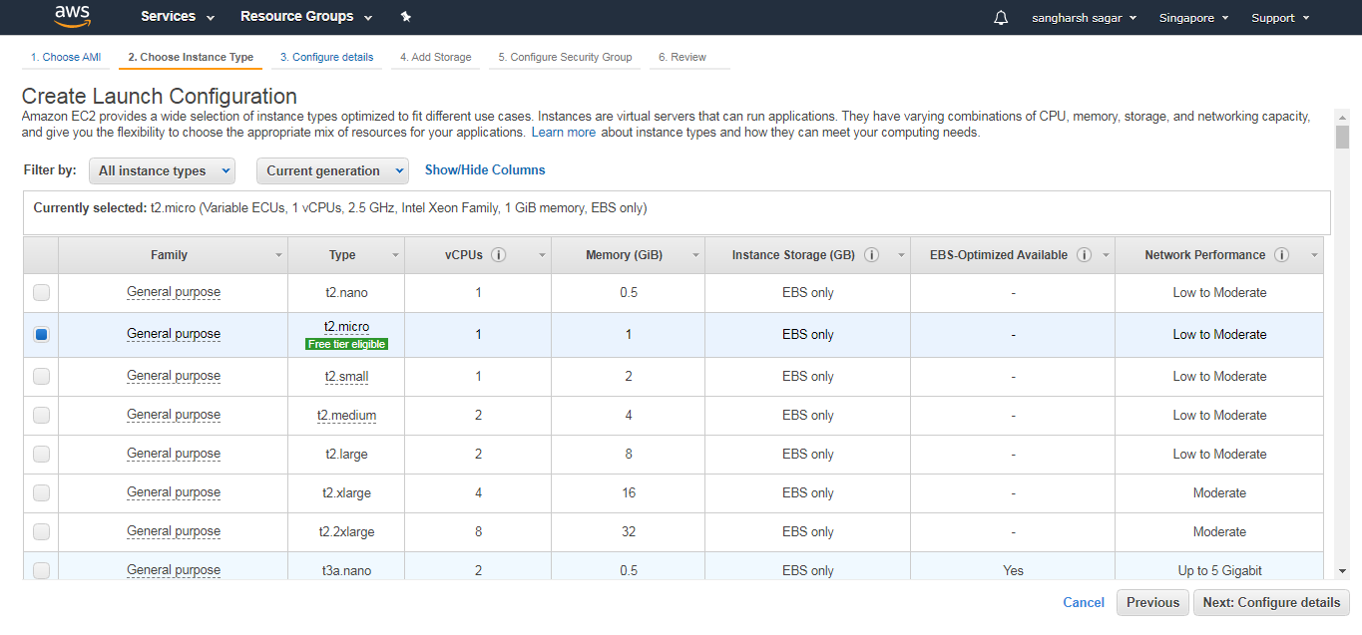

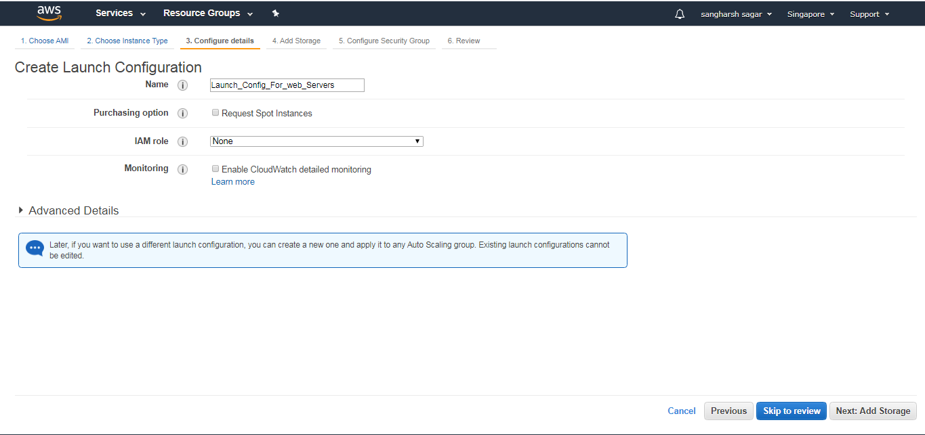

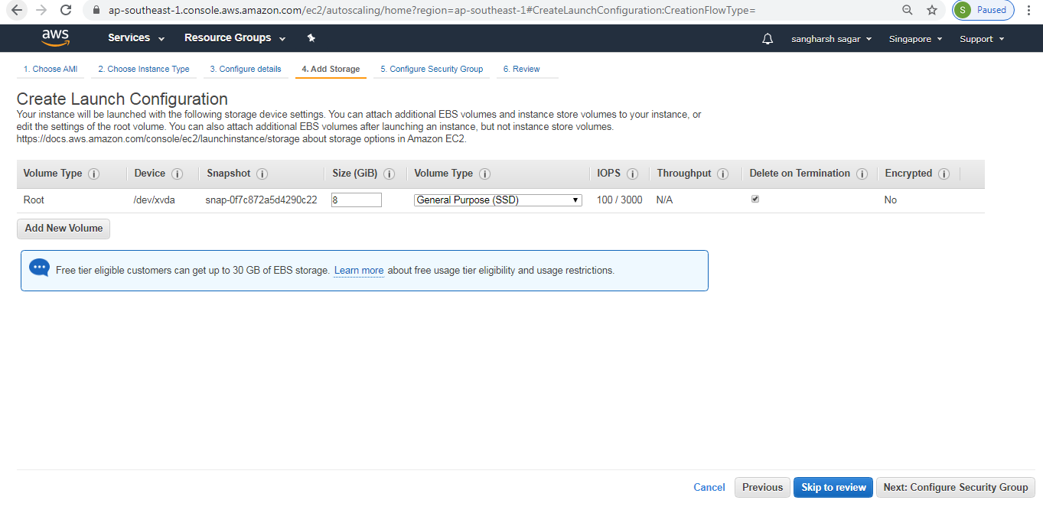

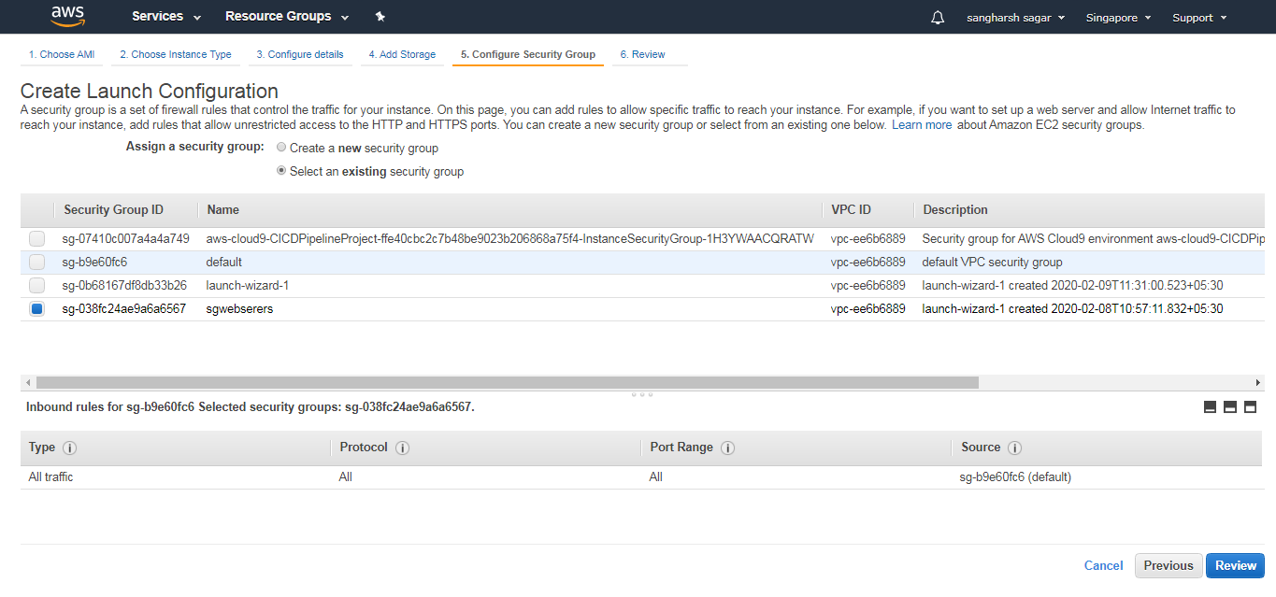

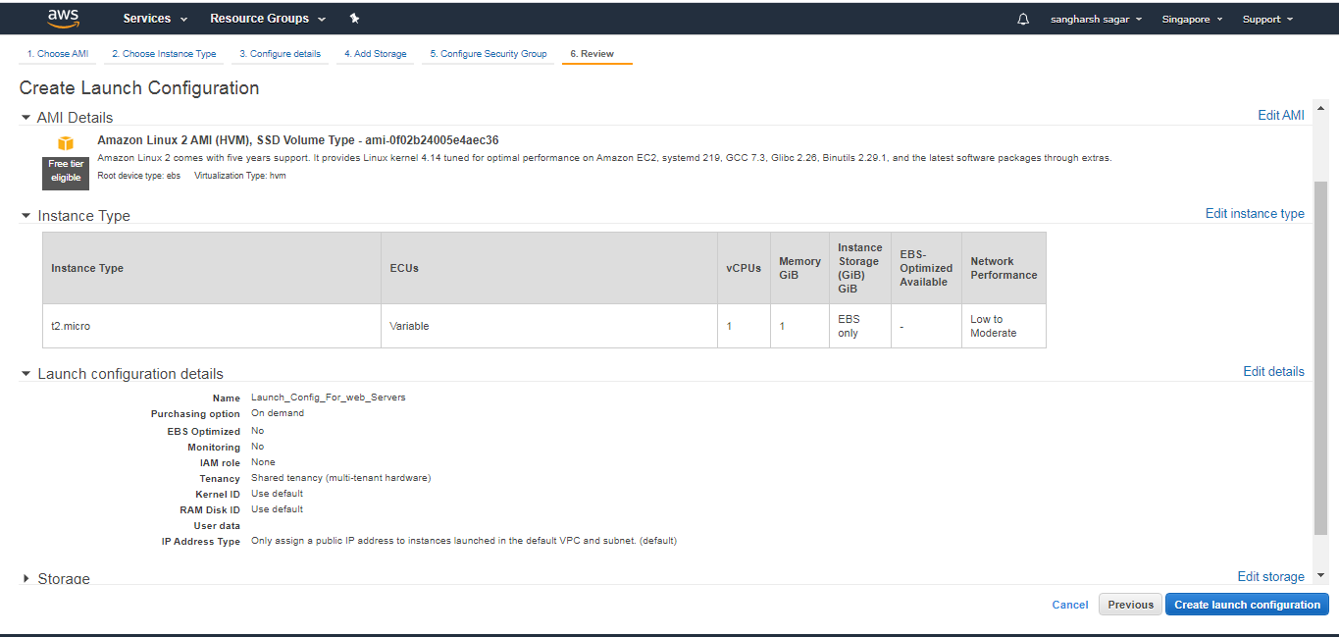

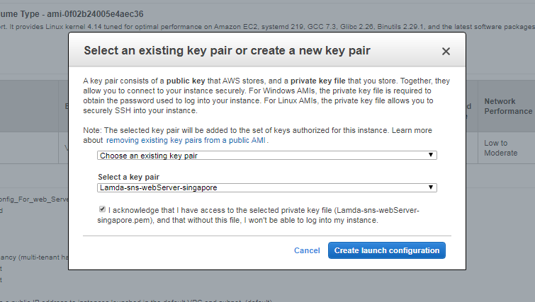

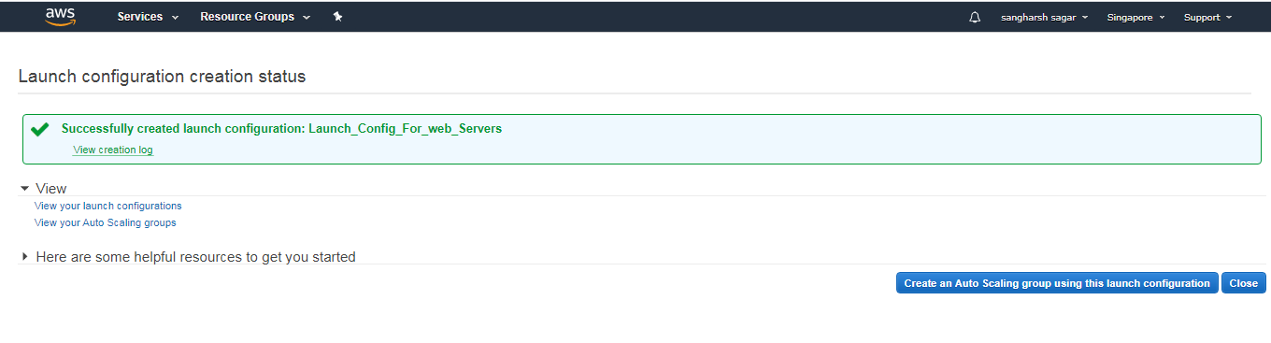

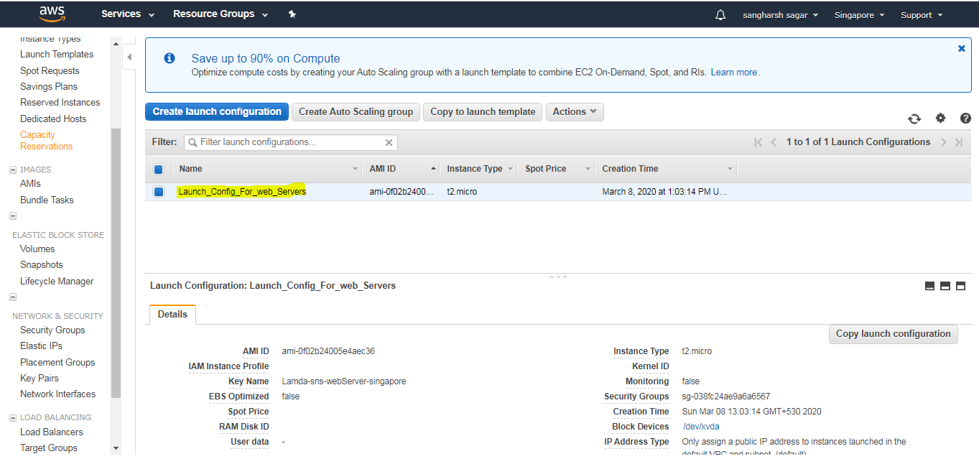

* Launch Configuration created.
* Now using this Launch Configuration, we can create Auto Scaling Group.

**Creating Auto Scaling Group:**

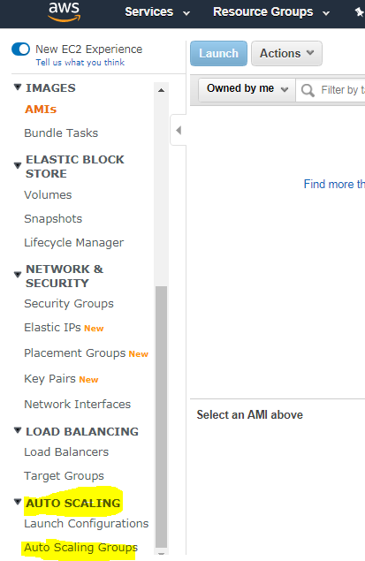

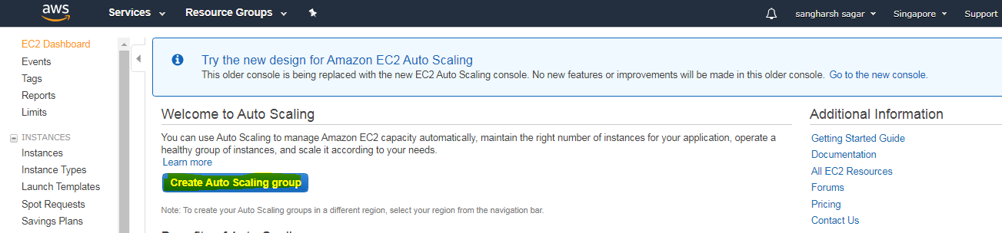

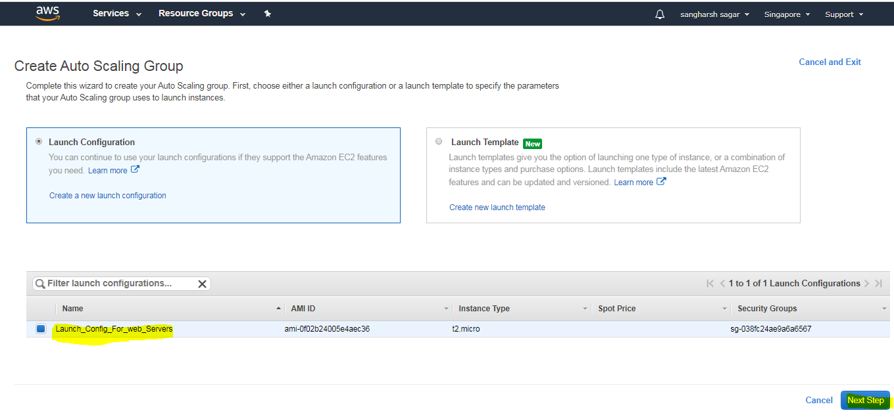

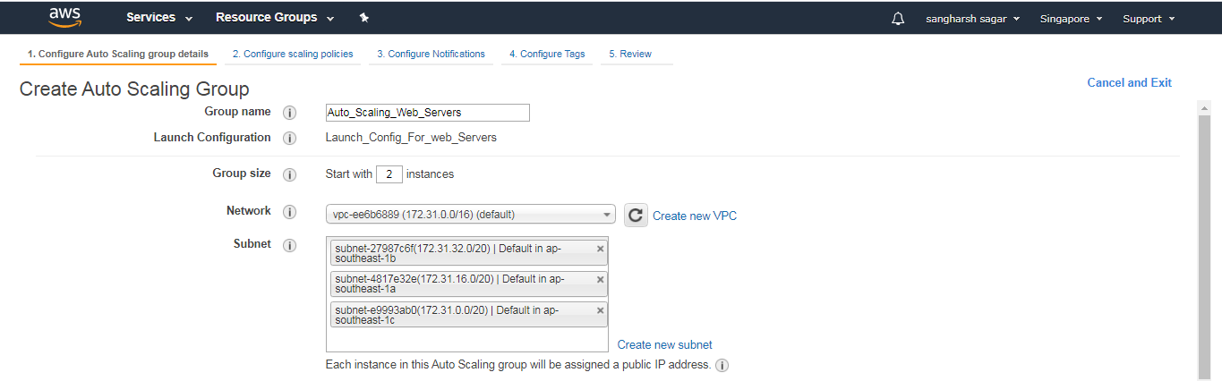

**If you have Load balancers you can add here**

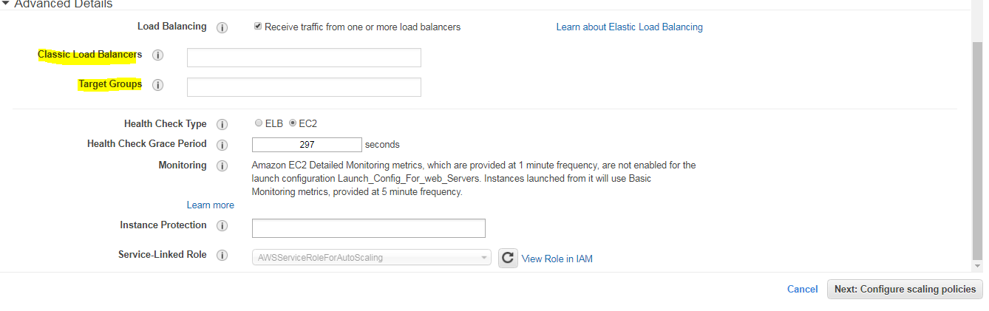

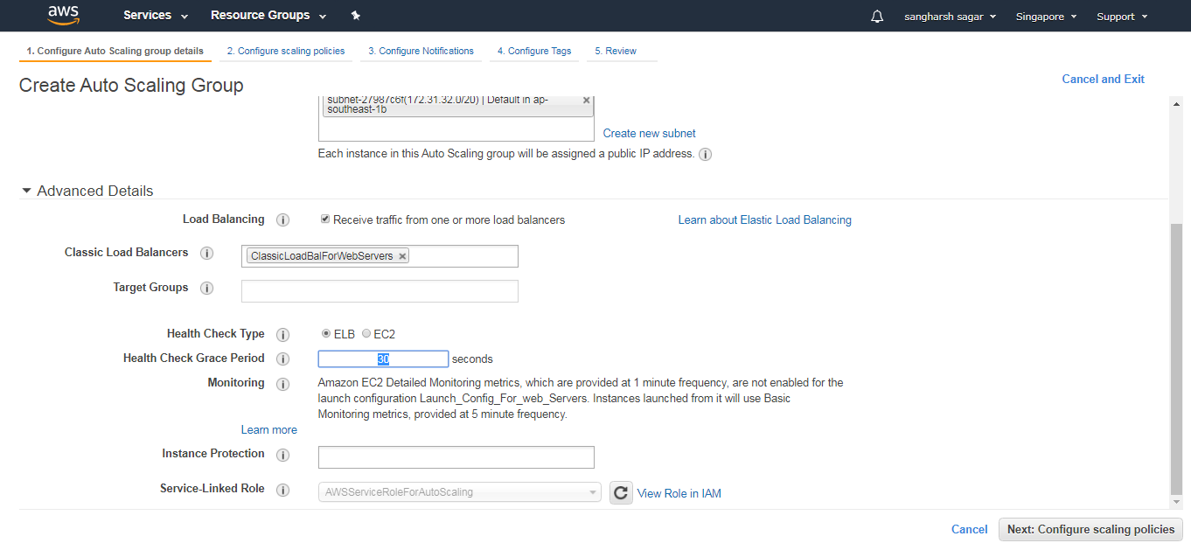



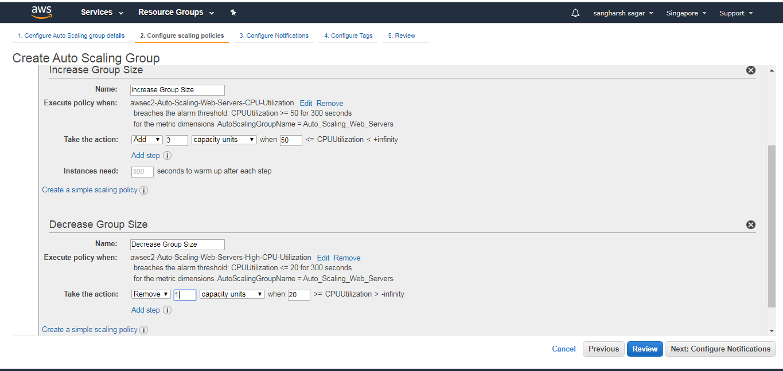

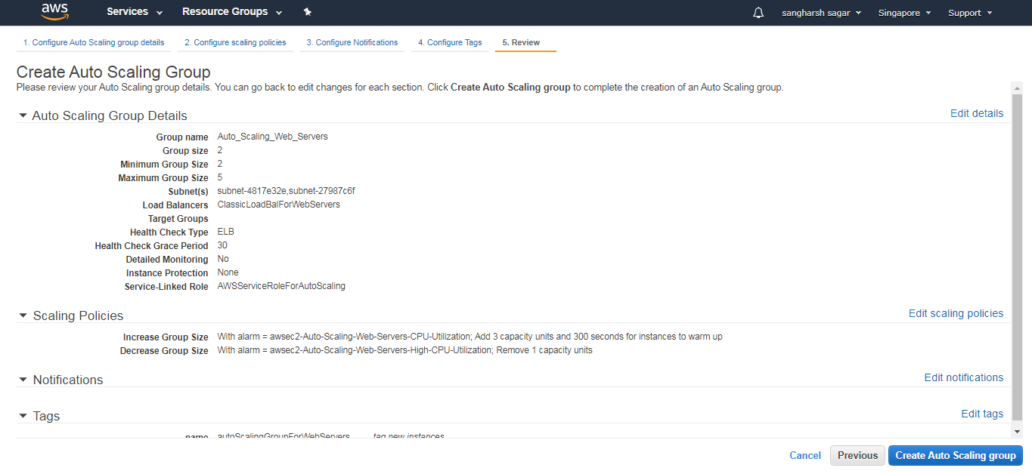

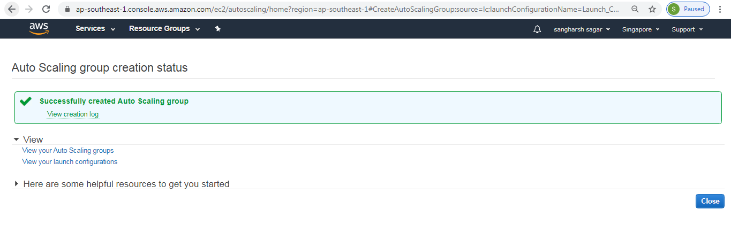

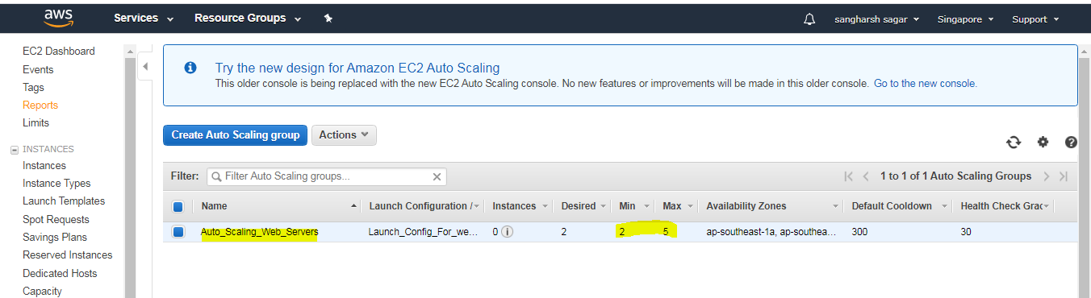

Instances Launched by Auto scaling Group

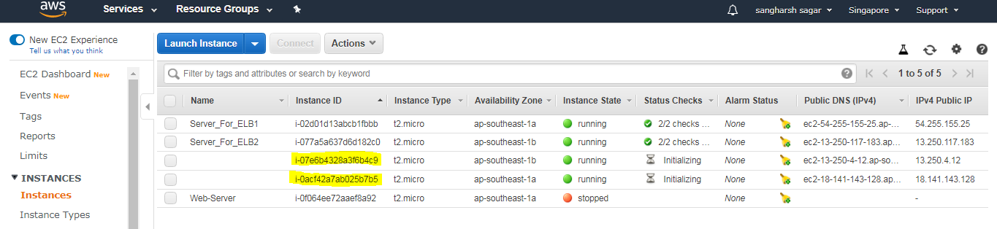

Instances through ELB Works

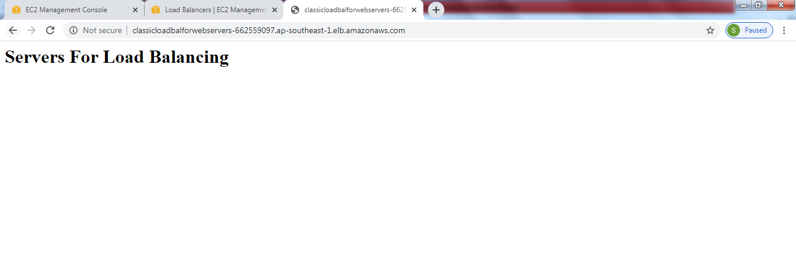

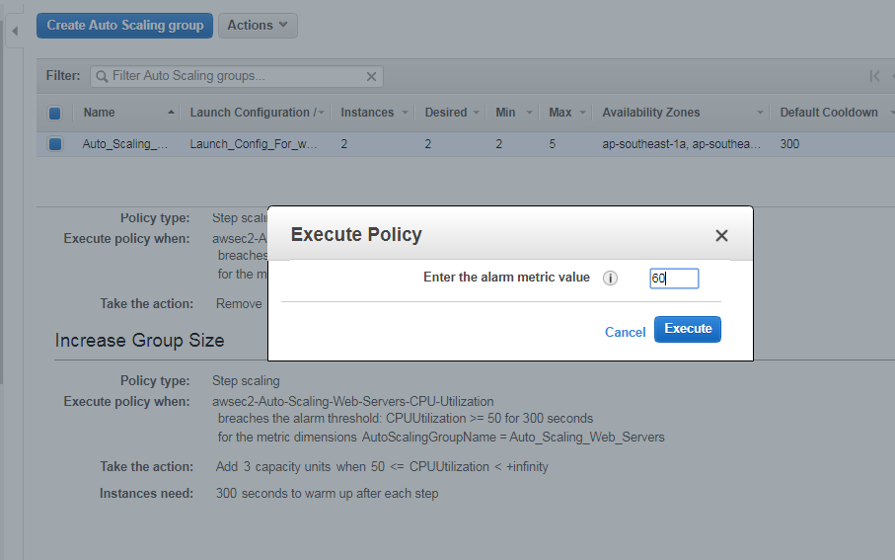

To test scaling policies

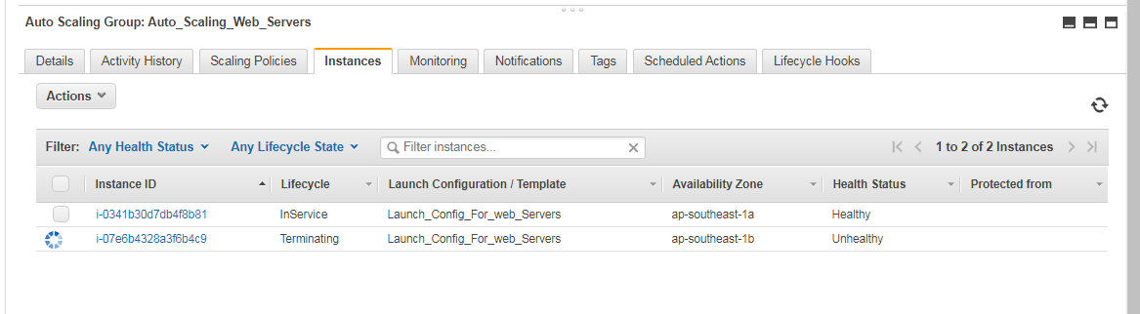

New Instance Added.

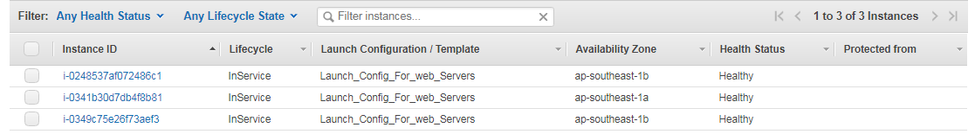

Server still keeps running

