**Putty**

* **GOAL**: We can **connect** to our **EC2 instance** with **AUTHENTICATION KEYS** generate by AWS.

Download Putty Package:

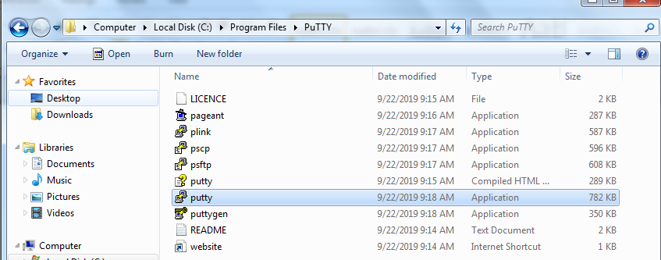

* **Putty** doesn’t accept keys in **.pem** **format** so we need to convert **.pem keys** to **.ppk format**.
* This can be done by **puttygen.exe**

Open **puttygen.exe**

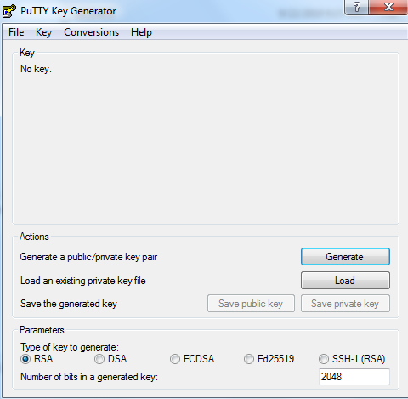

Click on **Load**

* Go to location of .pem file.
* If you get blank select **all files.**

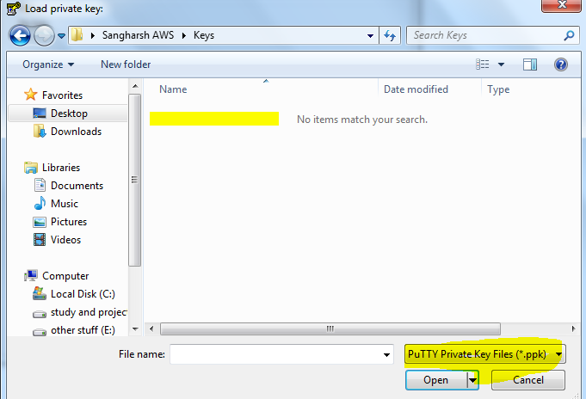

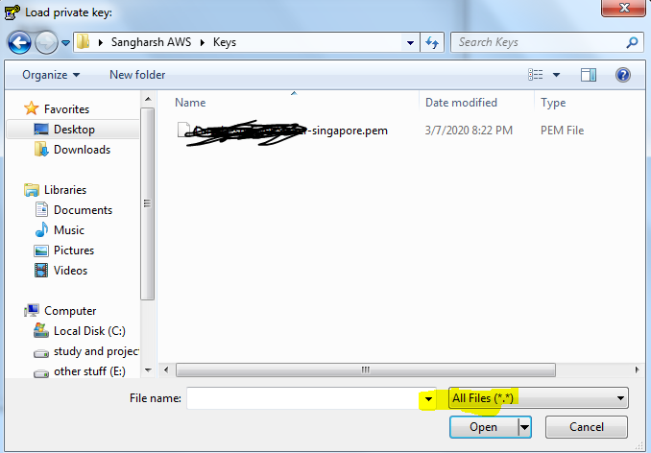

Now **load**

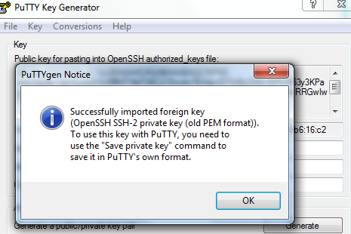

* Now save it as a private key

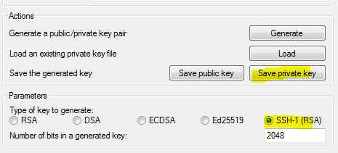

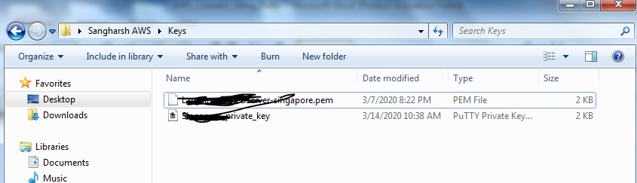

Now Open Putty to connect to an Ec2 instance:

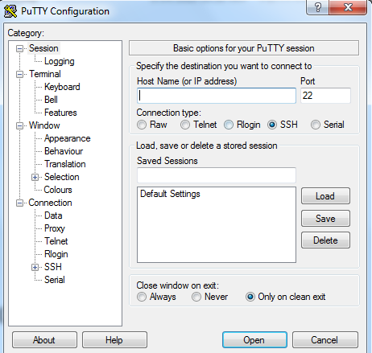

To connect to EC2 we need following things:

* **HostName/IP address**
* **UserName**
* **Authentication File (keys)**

**Go to Ec2 instance get following details:**

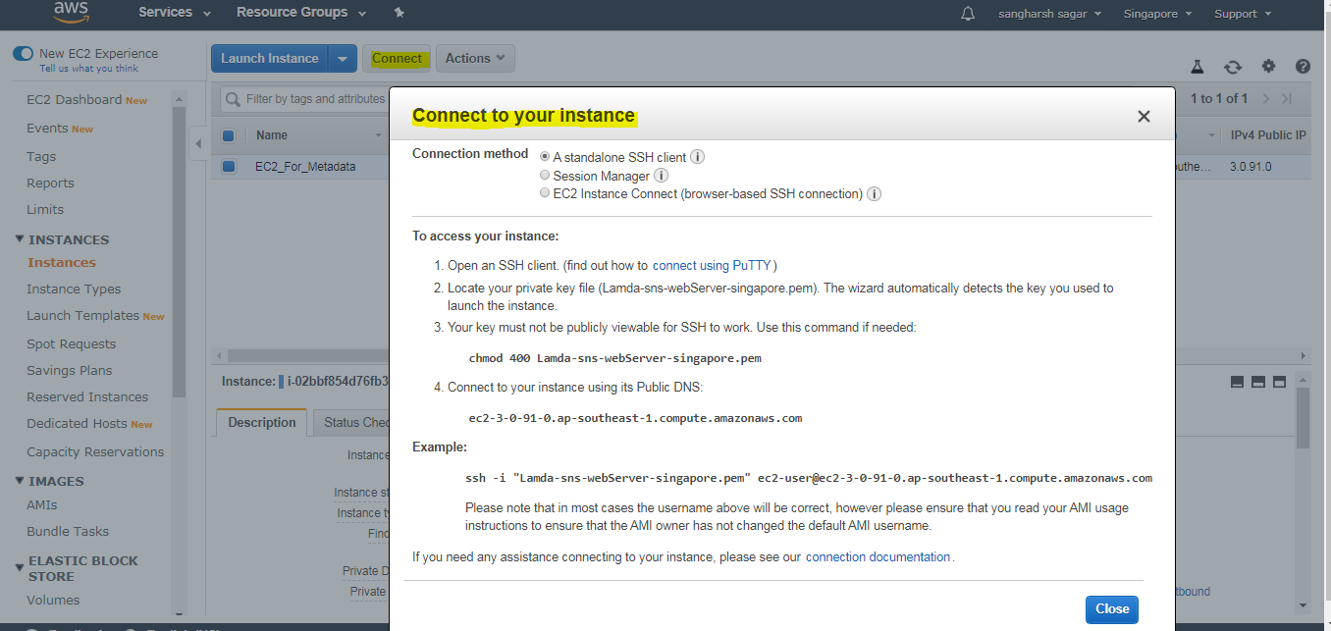

**Click on connect to get the details:**

* Put Hostname/ip address in session section

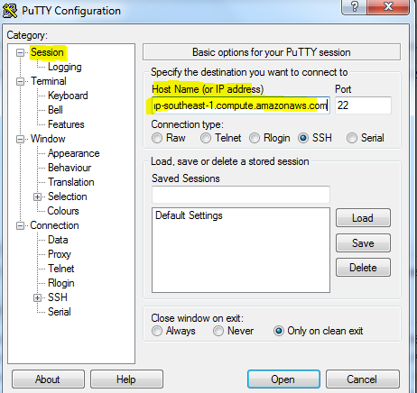

Go to **data** section and put user name

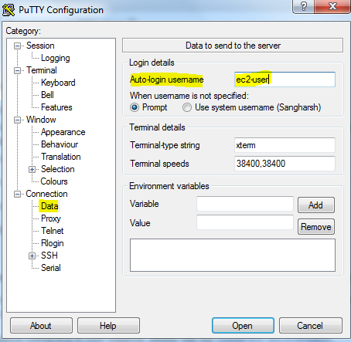

* Go to **SSH**
* Go to **Auth**
* Browse and **select .ppk file.**
* **Select Open**
* If you get **certificate** say yes and move ahead and this will be opened

