**Metadata:**

* Instance Metadata is **data about Instance** one can use to configure or manage **running instance**.
* To View all categories of instance metadata for running instance we use following url

[**http://169.254.169.254/latest/meta-data/**](http://169.254.169.254/latest/meta-data/)

* we can also use **curl**

**curl** [**http://169.254.169.254/latest/meta-data/**](http://169.254.169.254/latest/meta-data/)

**Launch an EC2 Instance:**

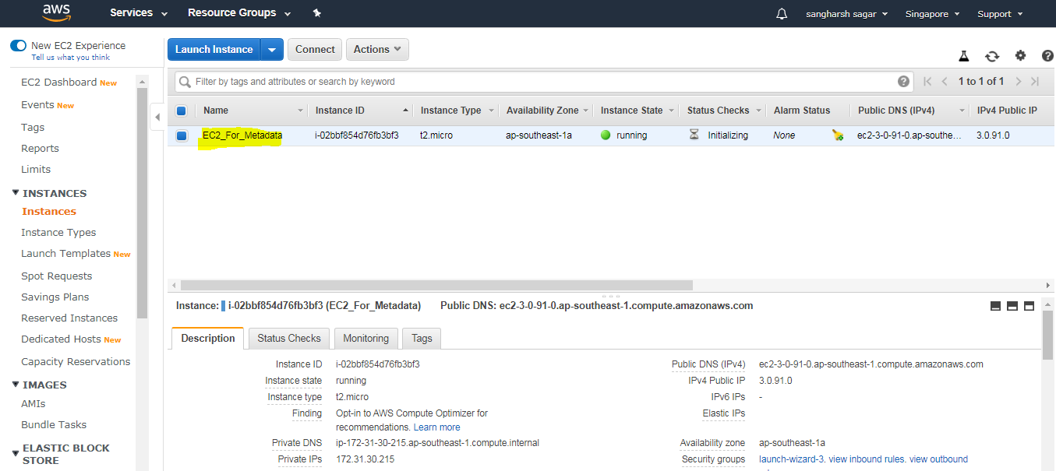

* Using Putty connect to that Instance

c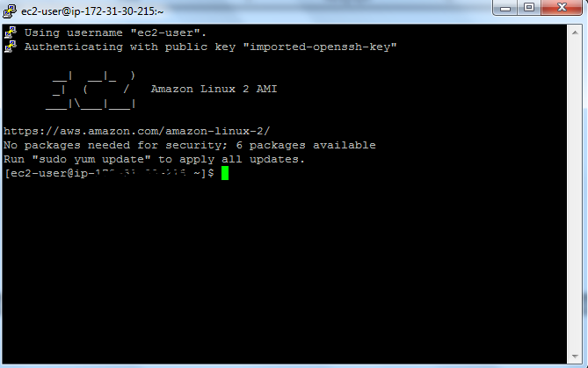

* open instance and type

**curl** [**http://169.254.169.254/latest/meta-data/**](http://169.254.169.254/latest/meta-data/)

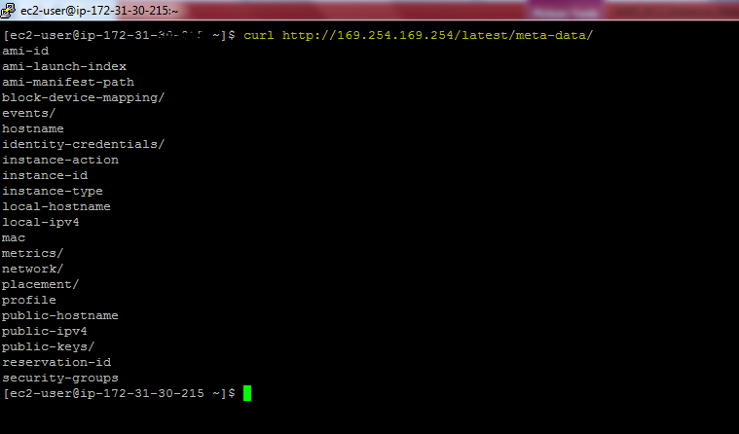

We can get metadata in following way

* **$ curl http://169.254.169.254/latest/meta-data/hostname**
* **$curl http://169.254.169.254/latest/meta-data/ami-id**
* **$ curl http://169.254.169.254/latest/meta-data/instance-id**

