Create Budget:

**PROBLEM STATEMENT**

* Please create a for Mumbai Region in your account.
* Amount - $1
* Notify when
* Alert 1- actual usage crosses 100% utilization
* Alert 2 - forecasted amount 50% of the budget

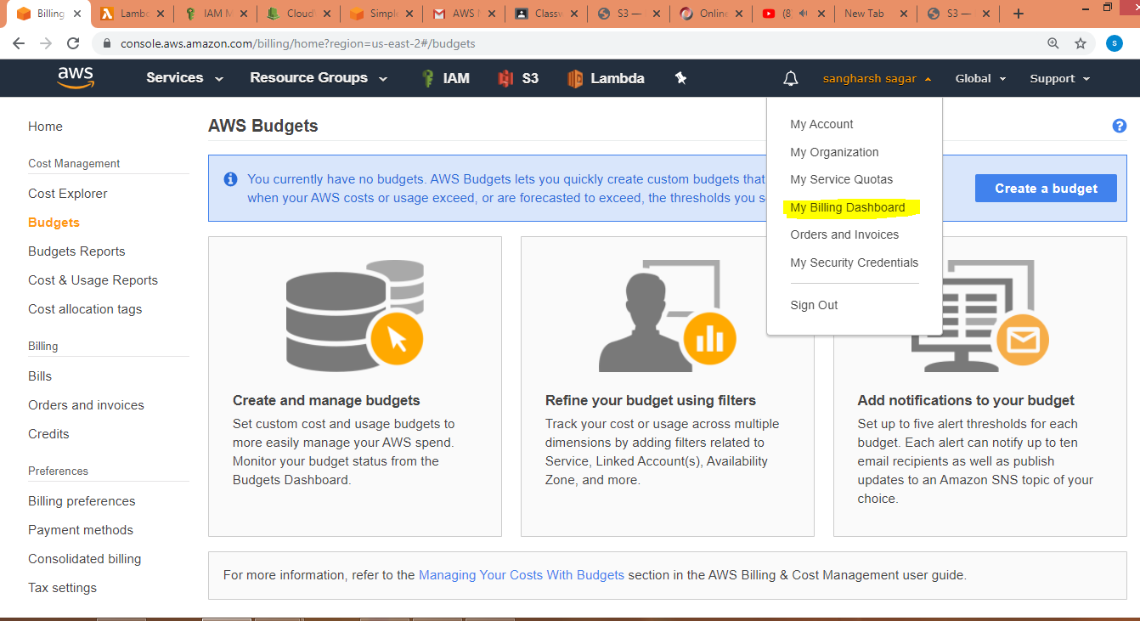

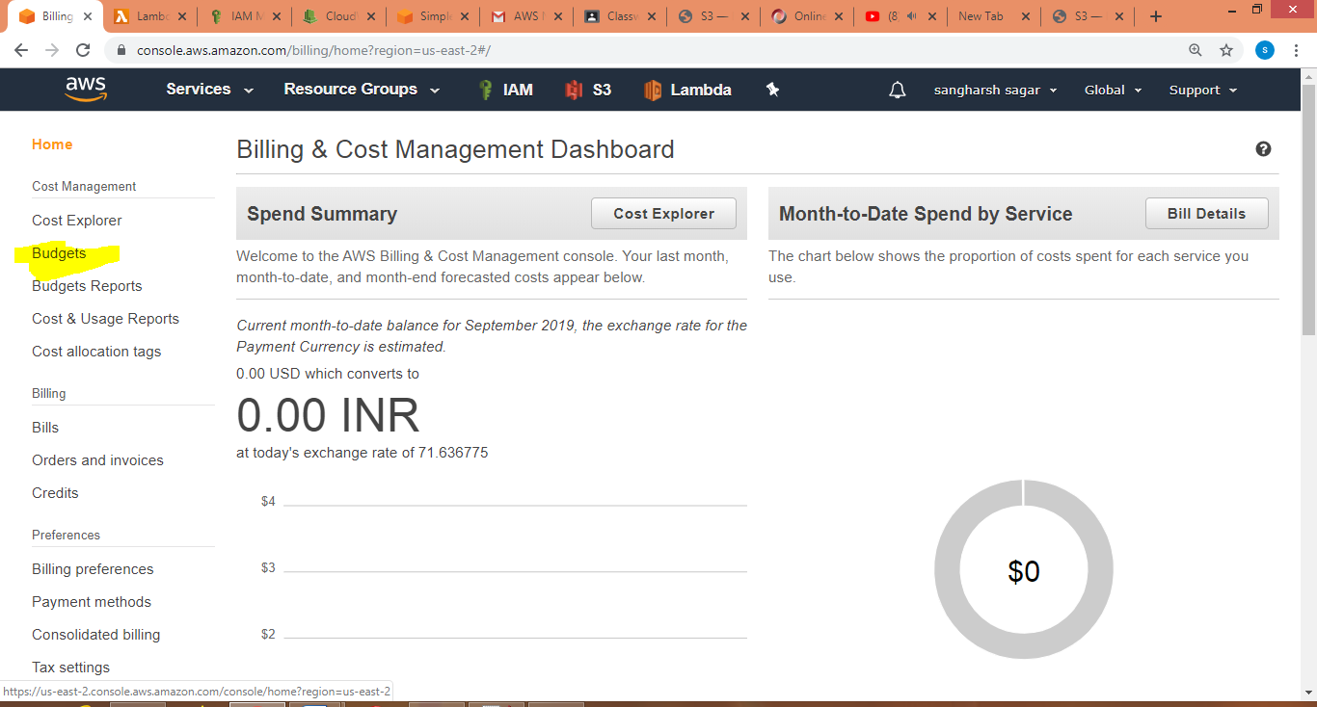

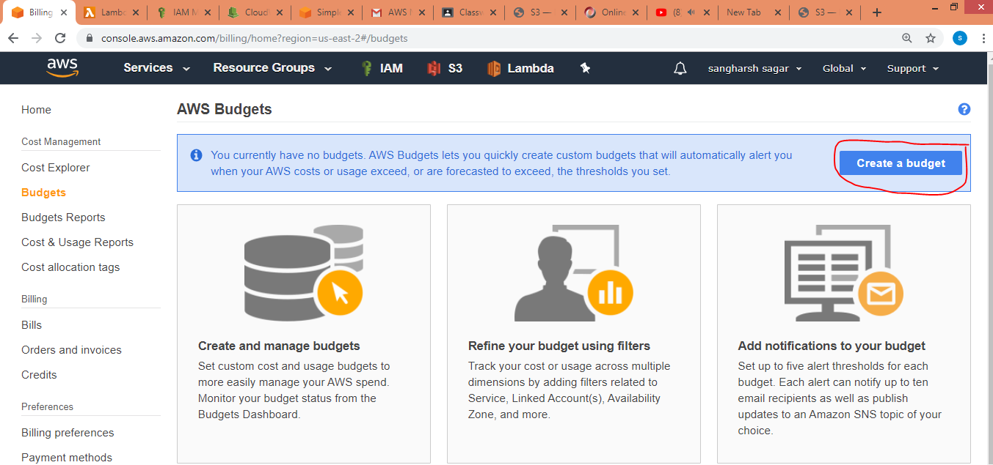

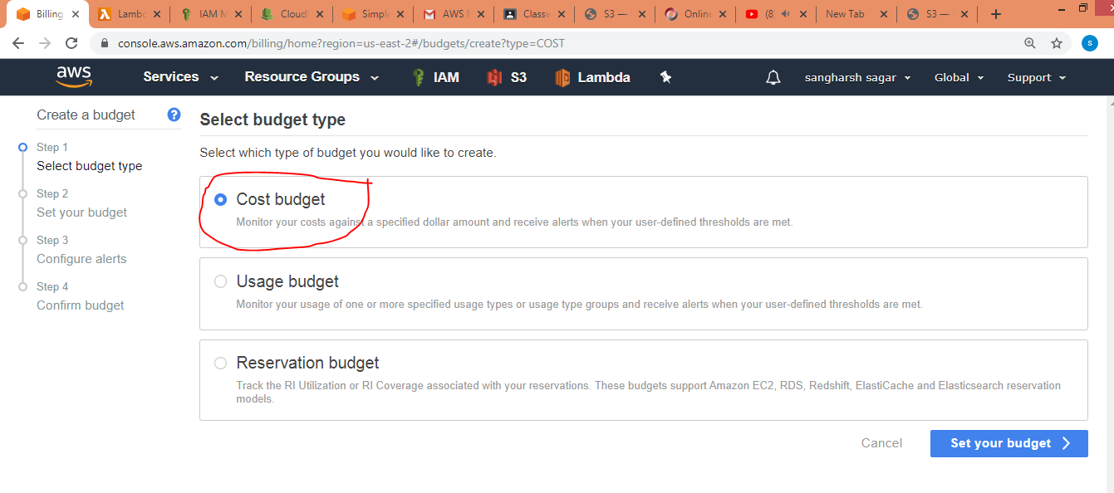

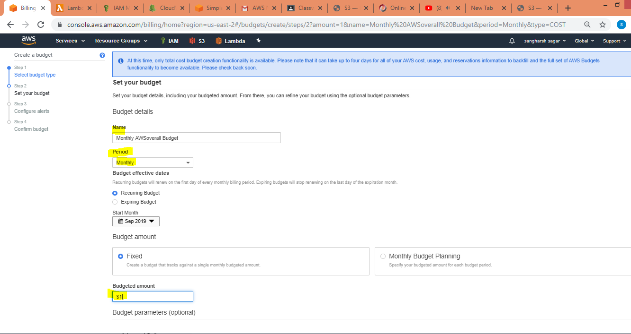

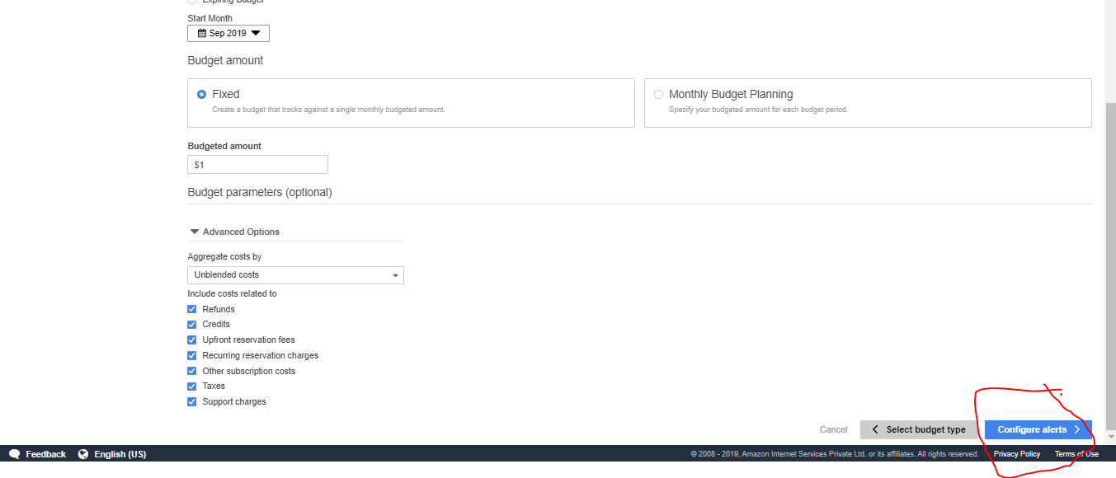

* Alert 1- actual usage crosses 100% utilization
* Alert 2 - forecasted amount 50% of the budget

