**AWS S3**

**Link:** [**https://docs.aws.amazon.com/cli/latest/reference/s3/index.html**](https://docs.aws.amazon.com/cli/latest/reference/s3/index.html)

* **CROSS REGION REPLICATION is done only for buckets in different regions and not same regions.(versioning Required)**
* **Deleted files will always be recovered on basis of latest Version files.**

**PATH:**

* Whenever using command at least one path must be used.
* Path is either **Local** or **s3uri**

**Local Path**: Path of **Local File** or **Directory (absolute or relative path).**

**S3uri**: This path represents **s3 object, prefix** or **bucket**

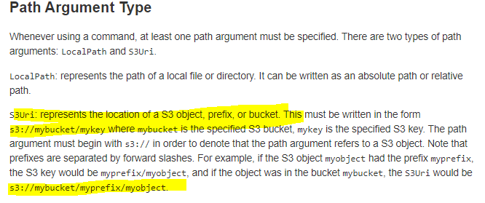

**Order of Path:**

* First Path is **Source Path**
* Second Path is **Destination path**

Some commands perform operations on **single files** and **s3 objects**.

* **cp**
* **rm**
* **mv**

List buckets:

* **ls** is command to create new bucket.
* **aws s3 ls**

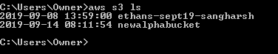

Creating new Bucket:

* **mb** is command to create new bucket.
* **aws s3 mb s3://<BUCKET NAME>**

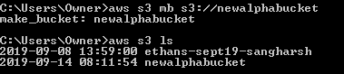

**Remove Bucket:**

