**Create Repository:**

* Click on **+** symbol.
* Click on **New Repository**.
* Fill Data

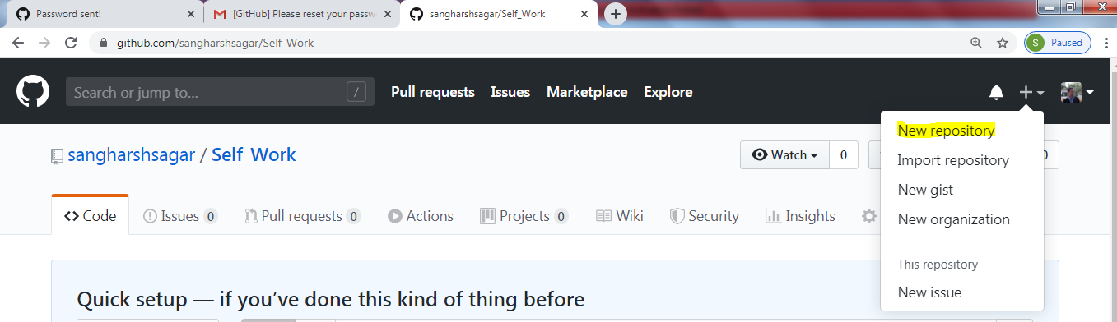

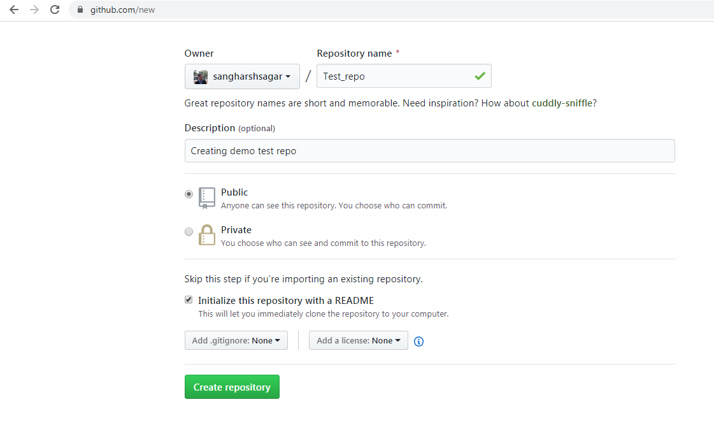

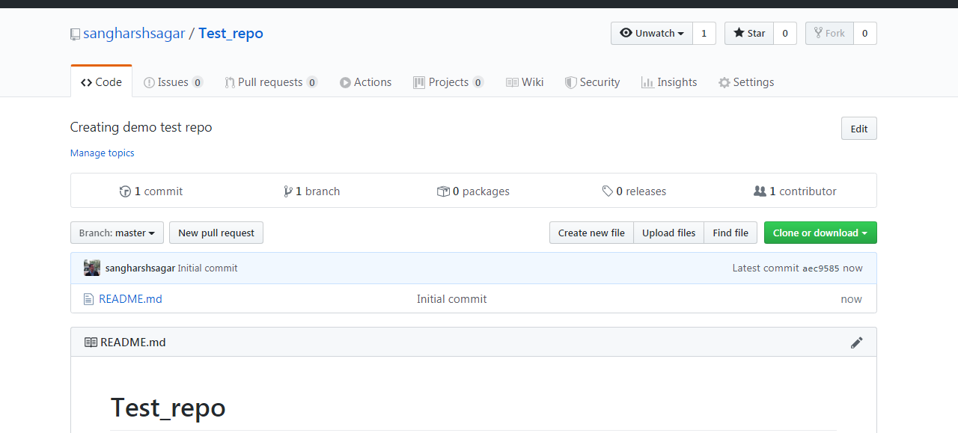

* **New Repository Created**

**Cloning repository on client/local:**

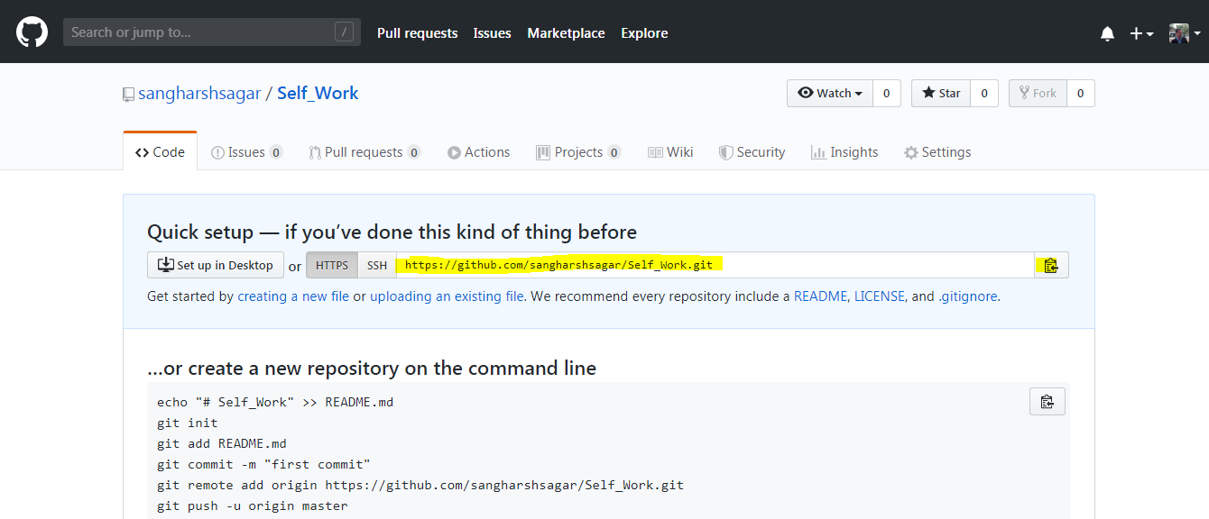

* Copy url **“https://github.com/sangharshsagar/Self_Work.git”**
* **Go to local system**
* Right Click
* **Click on Clone add url**

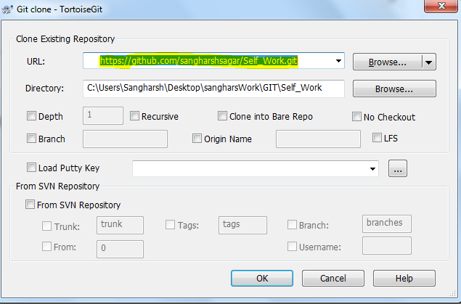

* Paste url and Select ok

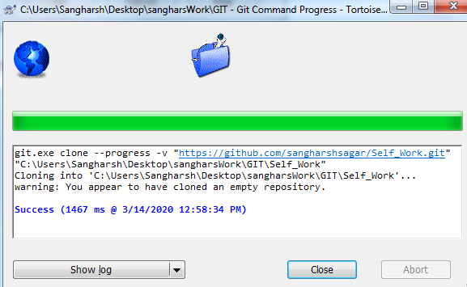

* Click close

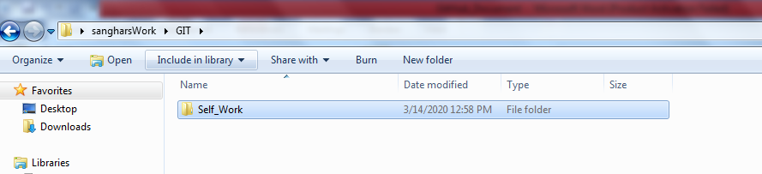

You can see it is cloned.

**Deleting repository:**

* **Go to Repository and select settings**

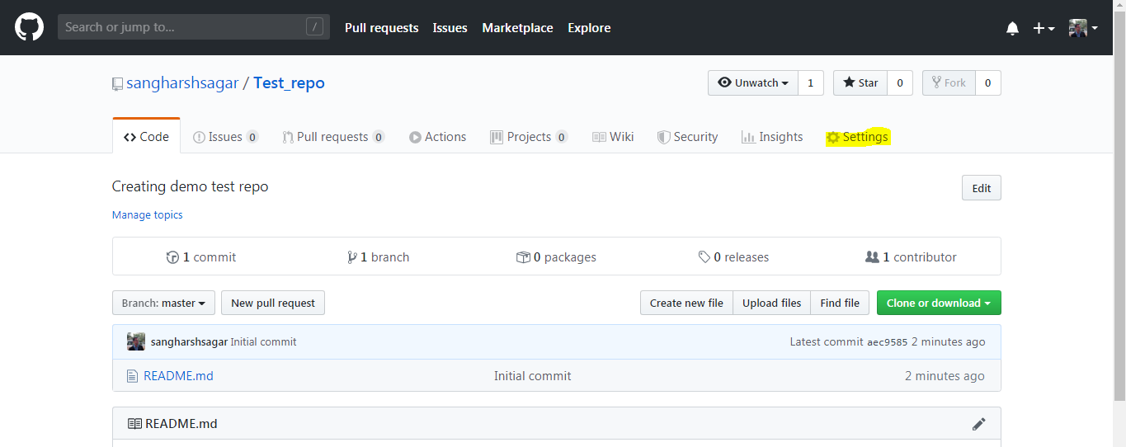

* **This page will be opened**

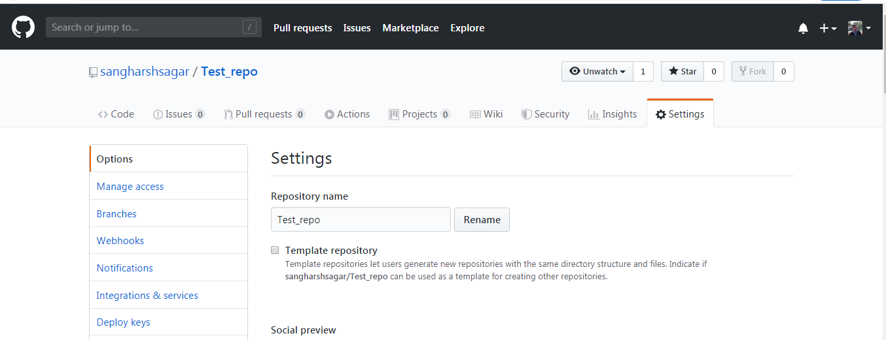

* **Scroll to bottom most part**

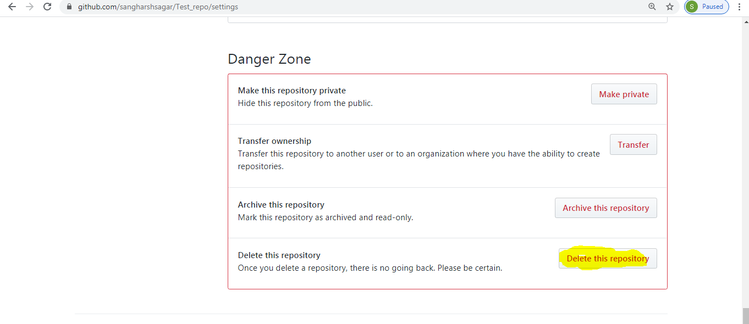

* Click on **delete this Repository**

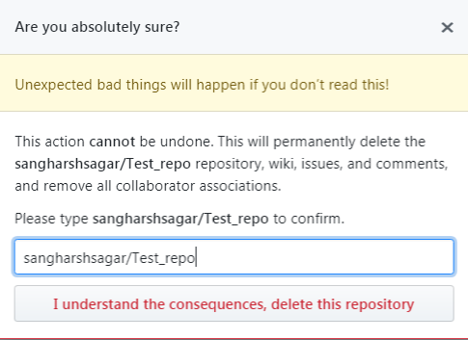

* Type Repo name Click on “**I Understand Consequences……..”**
* Now the Repo **Test_Repo** is deleted