**Create Repository:**

* Click on **+** symbol.
* Click on **New Repository**.
* Fill Data

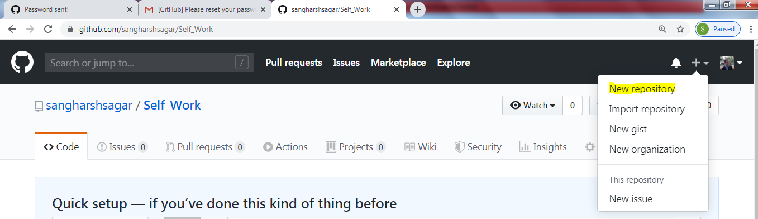

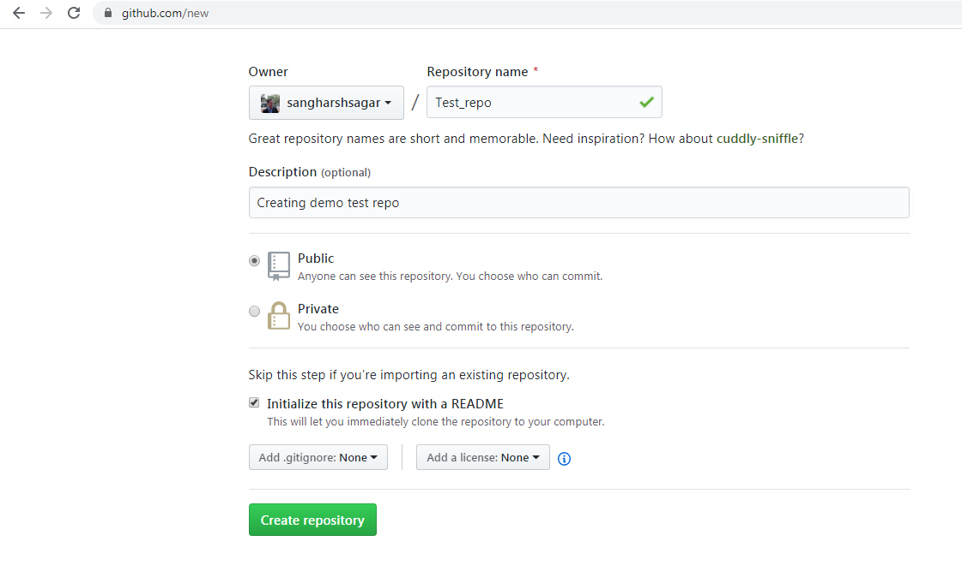

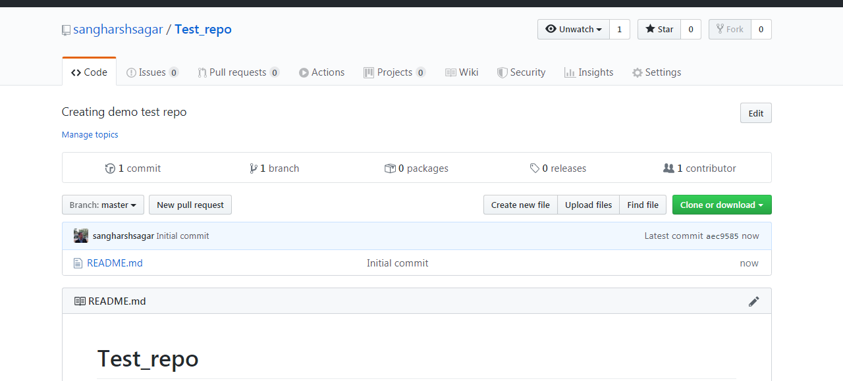

* **New Repository Created**

**Cloning repository on client/local:**

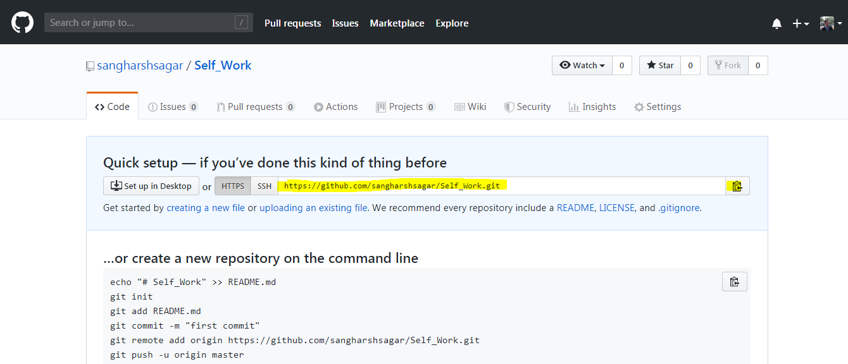

* Copy url **“https://github.com/sangharshsagar/Self_Work.git”**
* **Go to local system**
* Right Click
* **Click on Clone add url**

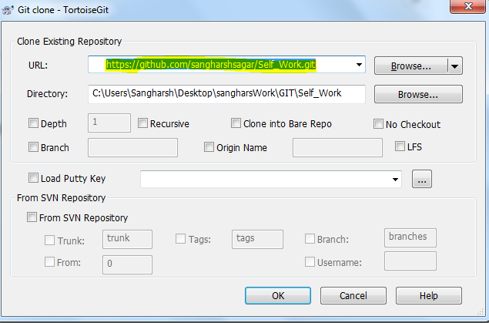

* Paste url and Select ok

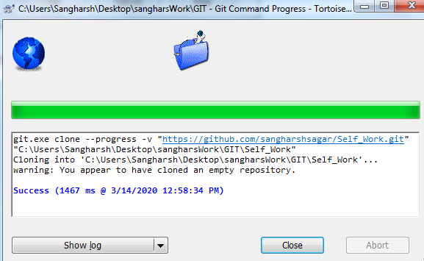

* Click close

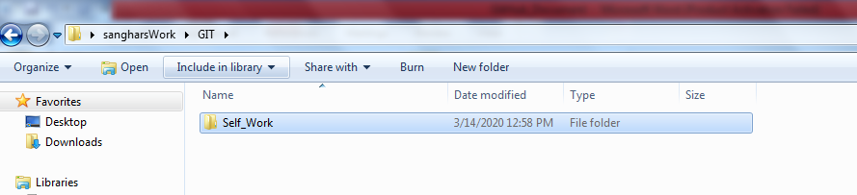

You can see it is cloned.

**Git Switch/Checkout:**

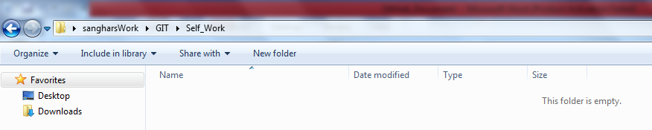

* Right click select **TortoiseGit**
* Select **Switch/Checkout**.

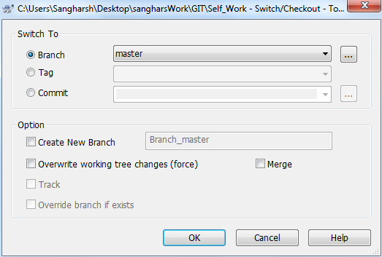

**Git Commit:**

* Add A **File**
* Right click and Select **Git Commit**.

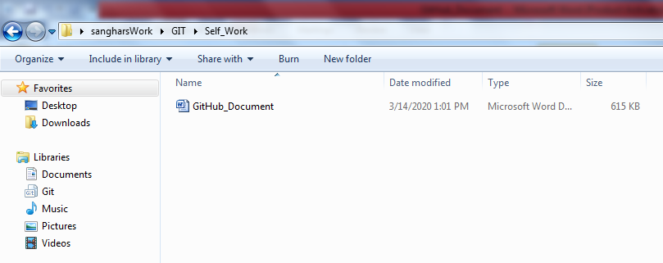

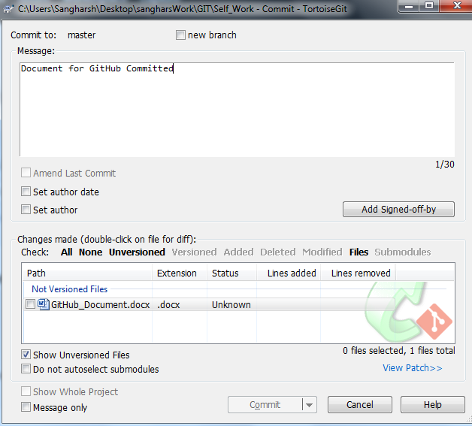

**Git Push:**

* Right click select **TortoiseGit**
* Select **Push**.

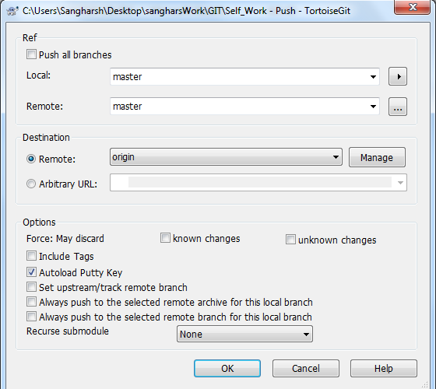

Check details and click **ok**

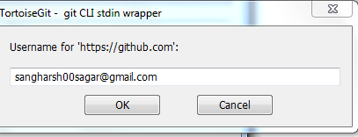

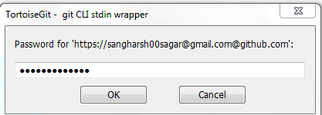

* After putting credentials you will get this

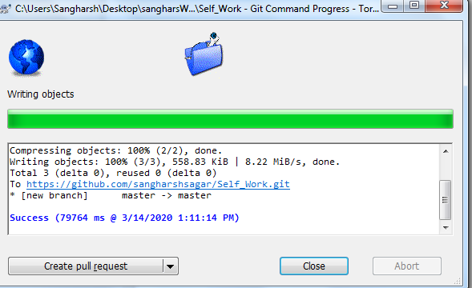

* Now Go to server (Remote Repo) and check if new document is added.

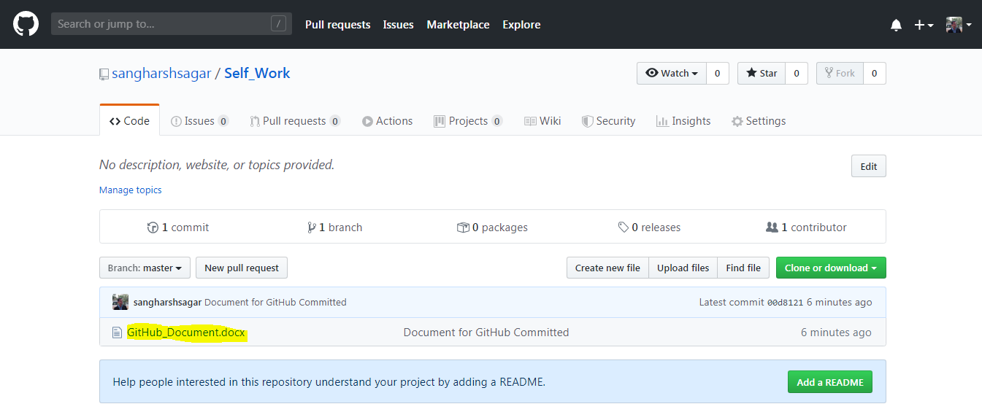

**Git pull:**

* Go to **server(Remote Repo)** click on **create new filed**
* Add a new file

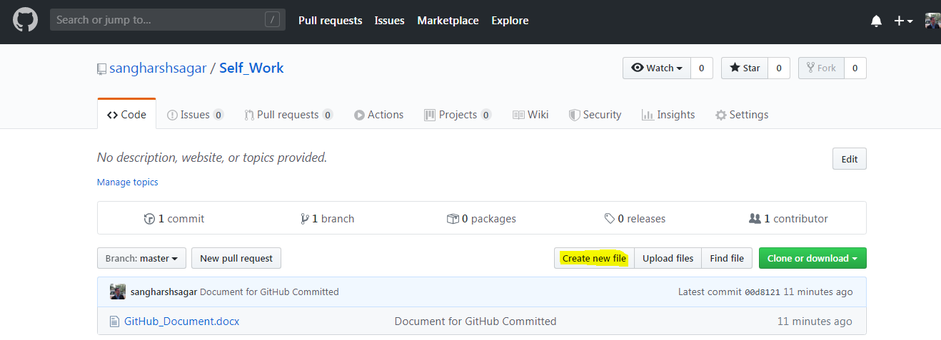

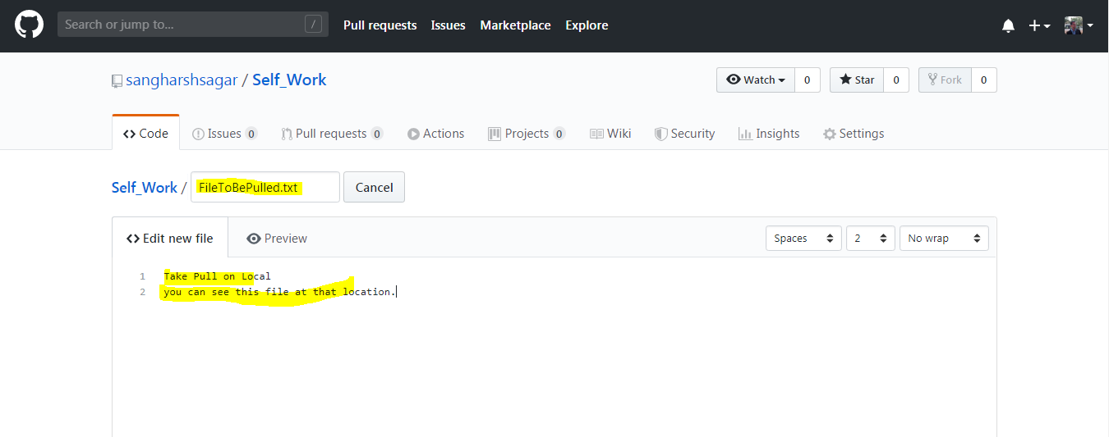

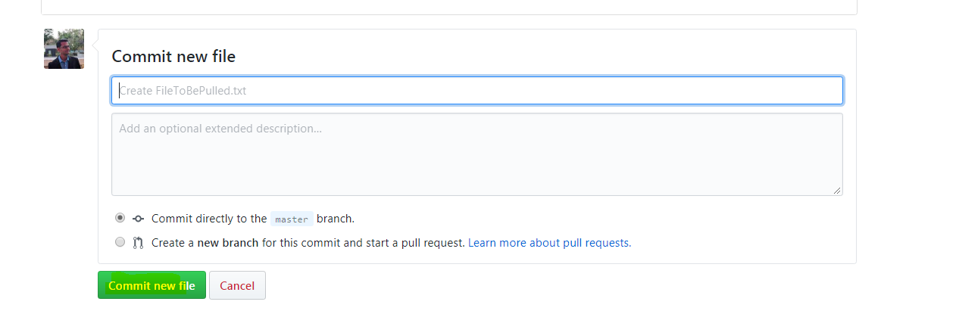

* New File added to master branch(remote repository)

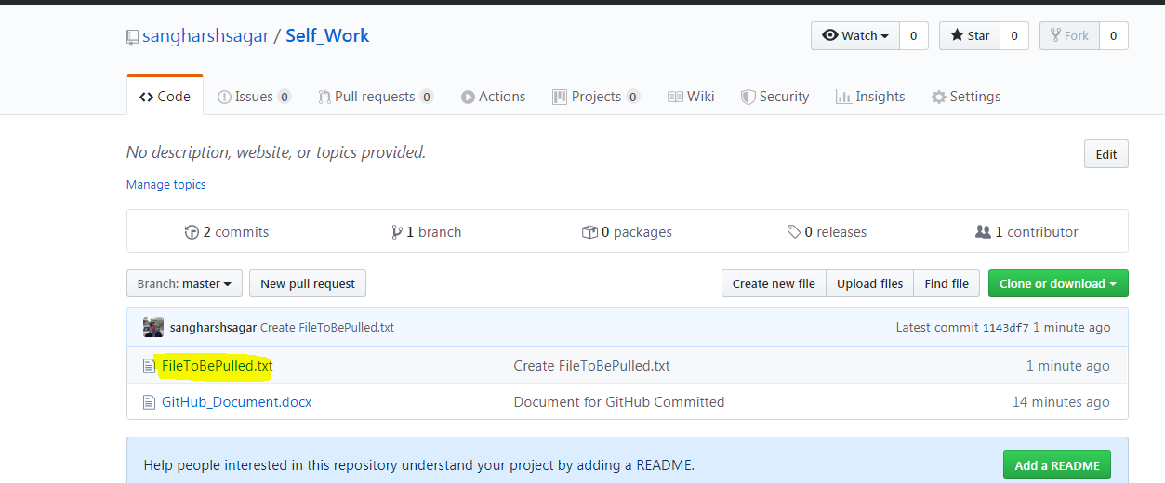

* Do git pull in Local Repository to get this file.
* Go to **Local repository**
* Right click select **TortoiseGit**
* Select **pull**.

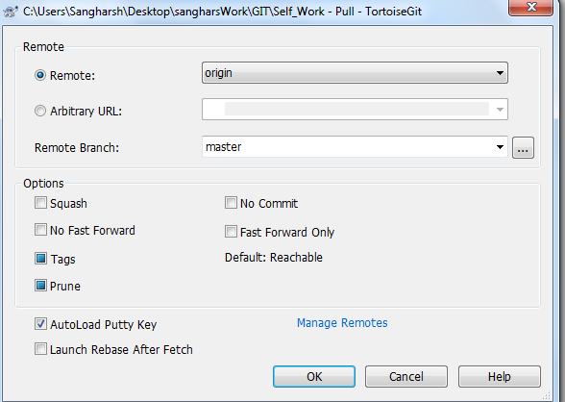

* Select **ok**

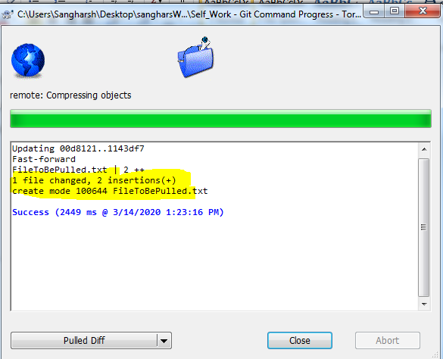

* Now you can see same file in Local Repository

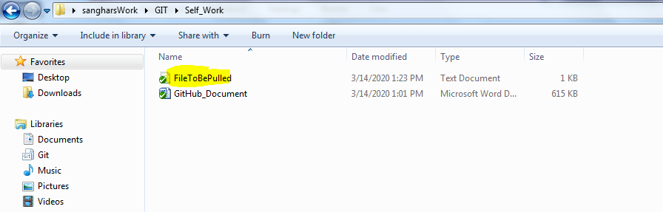

**Deleting repository:**

* **Go to Repository and select settings**

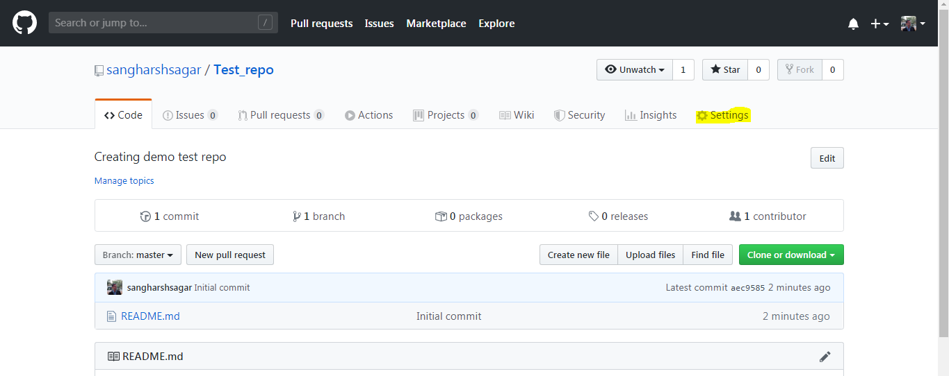

* **This page will be opened**

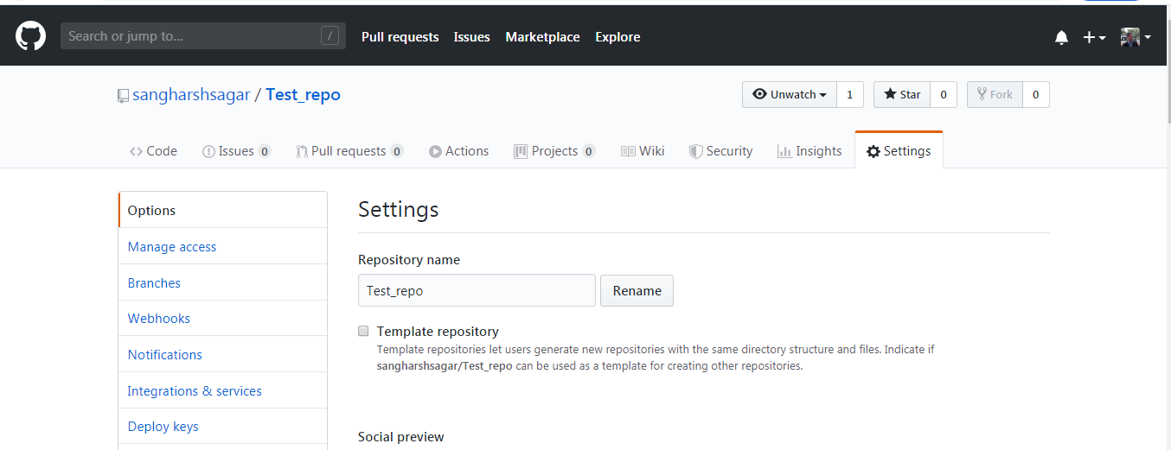

* **Scroll to bottom most part**

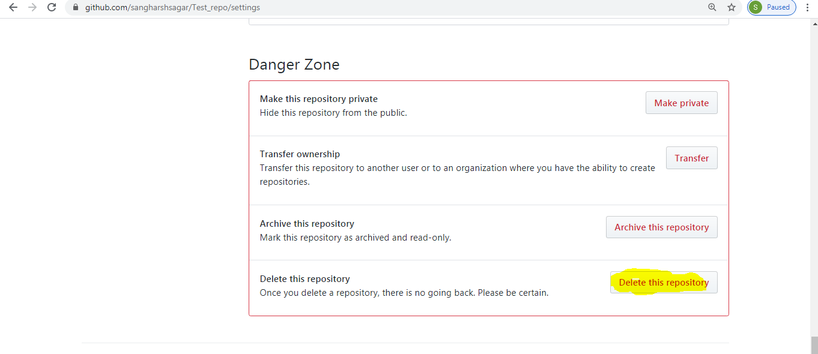

* Click on **delete this Repository**

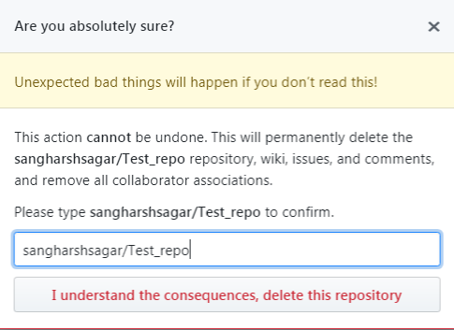

* Type Repo name Click on “**I Understand Consequences……..”**
* Now the Repo **Test_Repo** is deleted