**FileList Project Document**

**Electron:**

* Create Native CrossPlatform, Desktop applications
* with javascript, HTML ,CSS

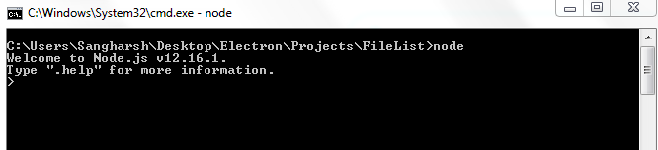

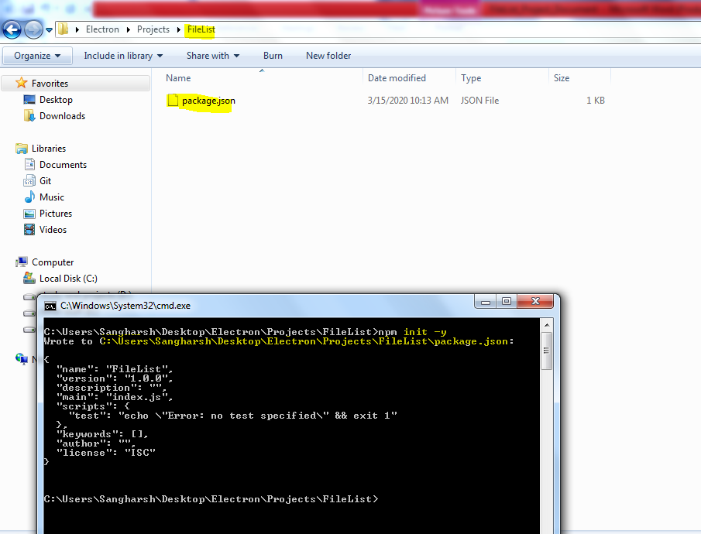

Now install Electron

* npm install electron –save-dev –save-exact

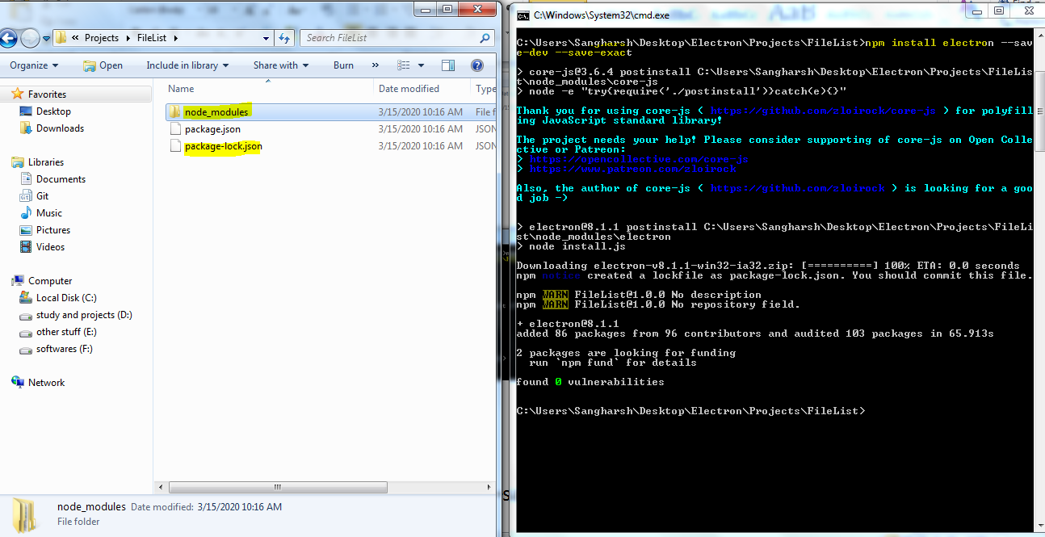

* Create **main.js** File
* Add its entry in **Package.json**

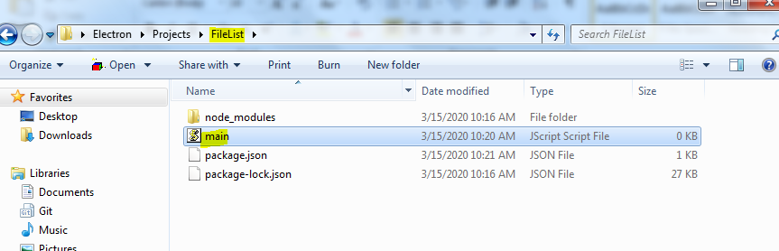

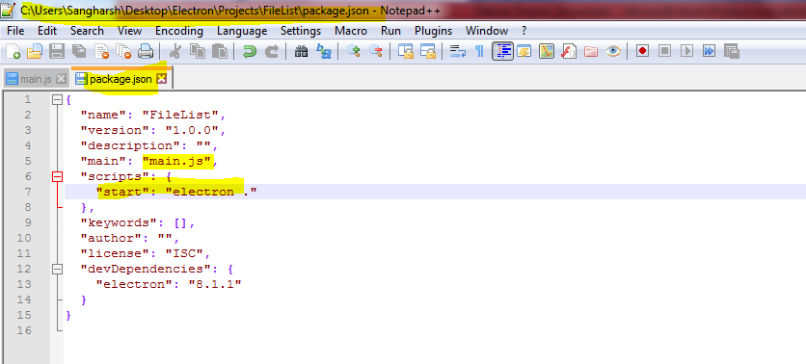

* Defining and getting core and Basic Modules.

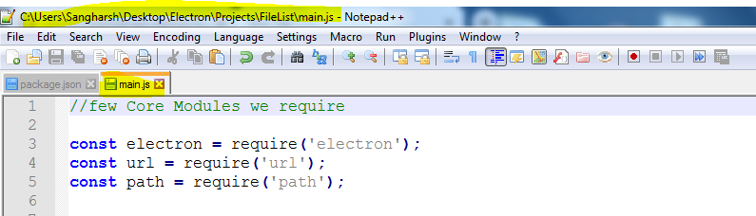

* Creating a new Window

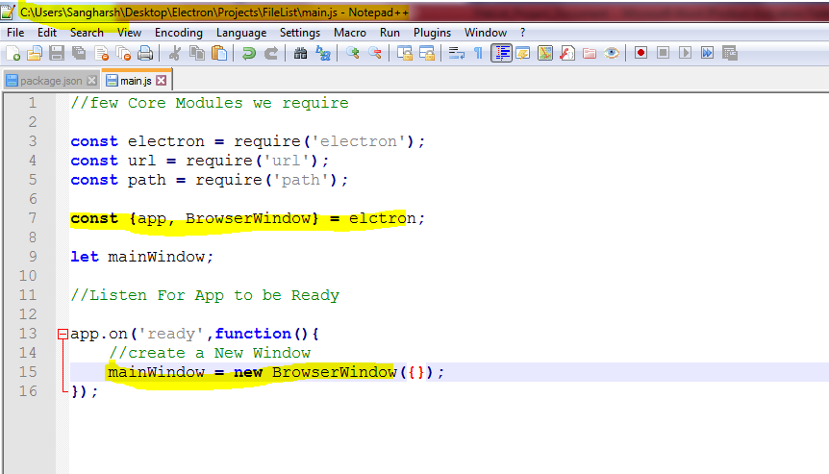

* Create HTML File
* Load HTML File into Window

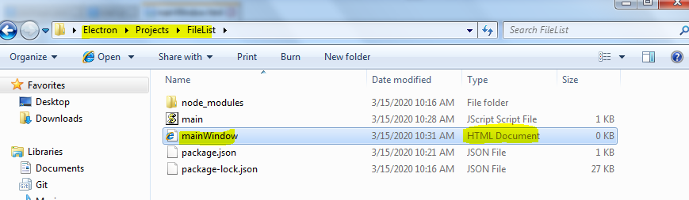

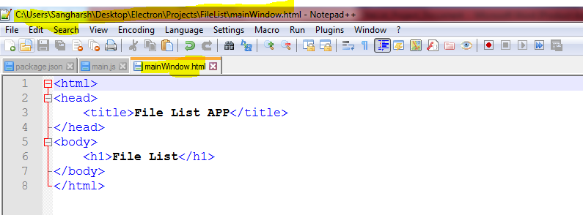

* Loading HTML File to new Window

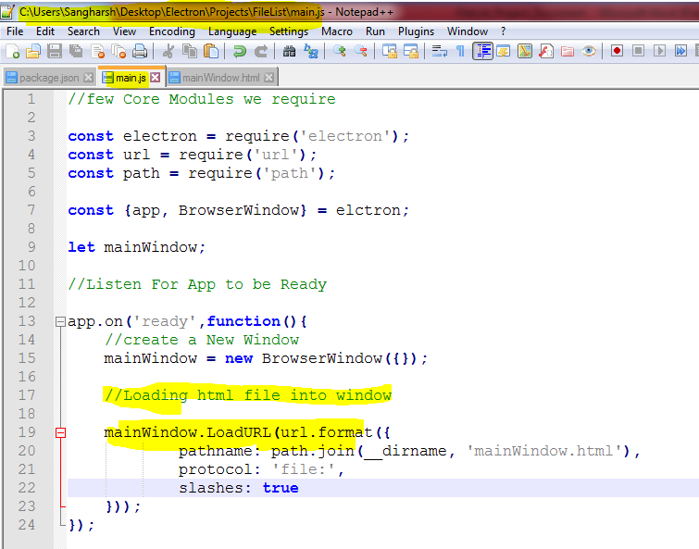

* On running npm new window is opened.

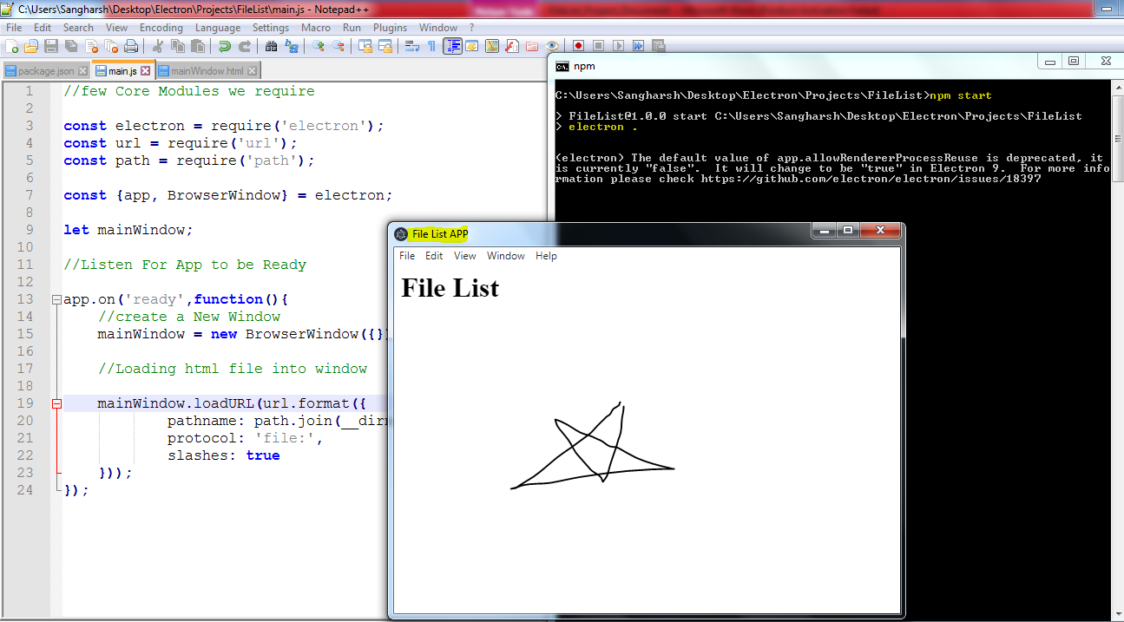

* Creating a Menu Template

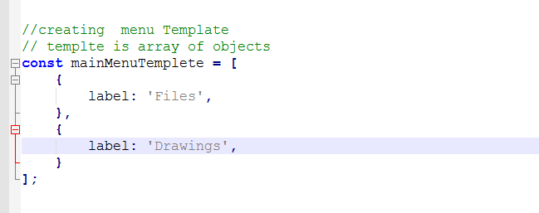

* Now Build Menu From Template.

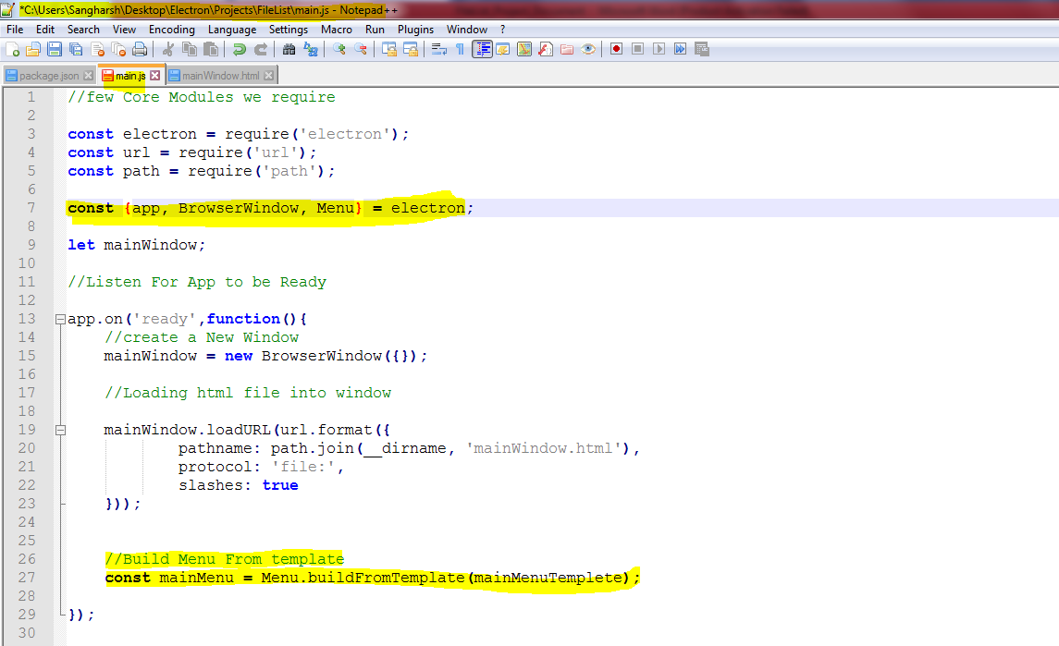

* Now Insert Menu.

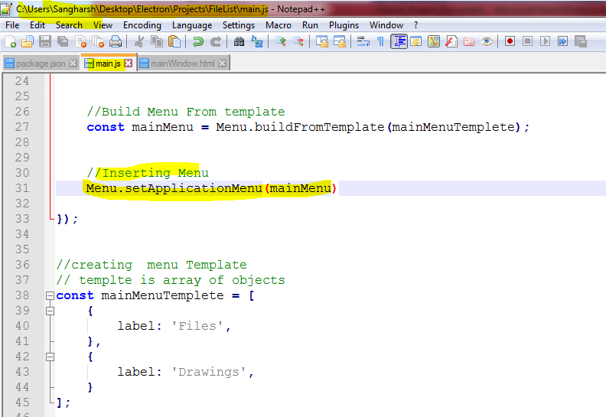

* This is how it looks

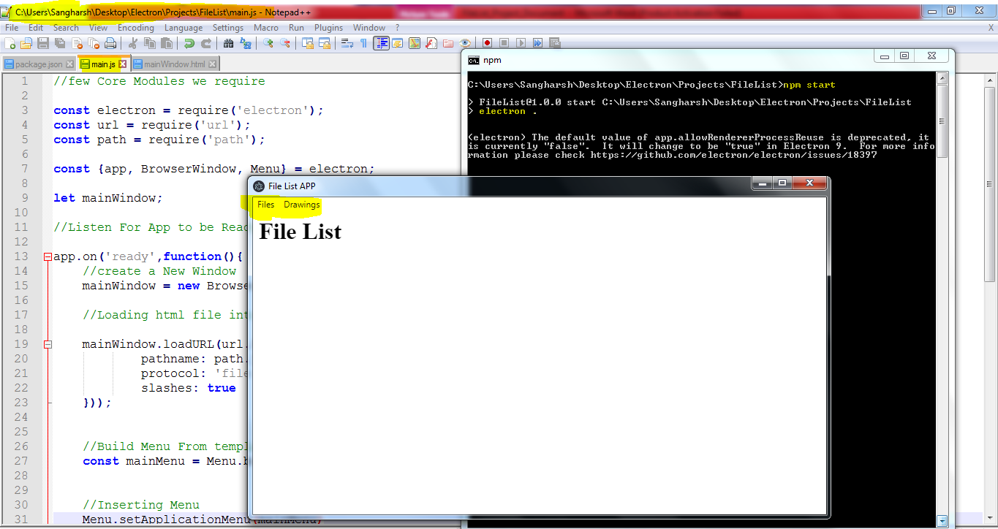

* Adding SubMenu to Menu

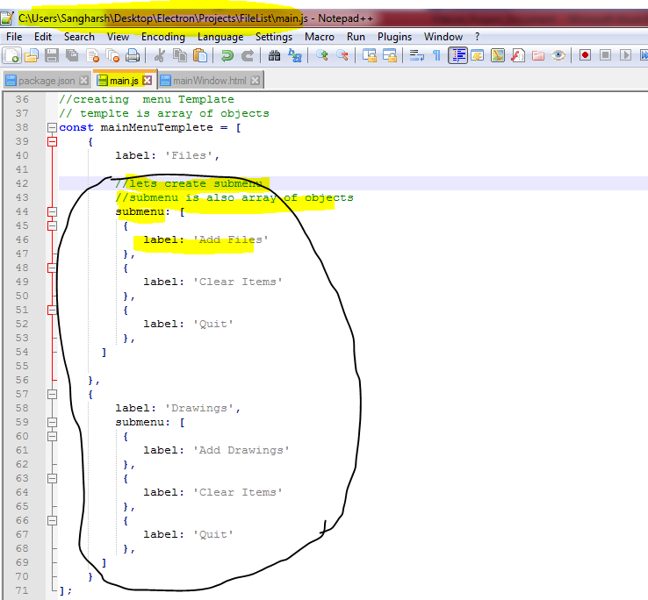

Now you can see sub menus are added.

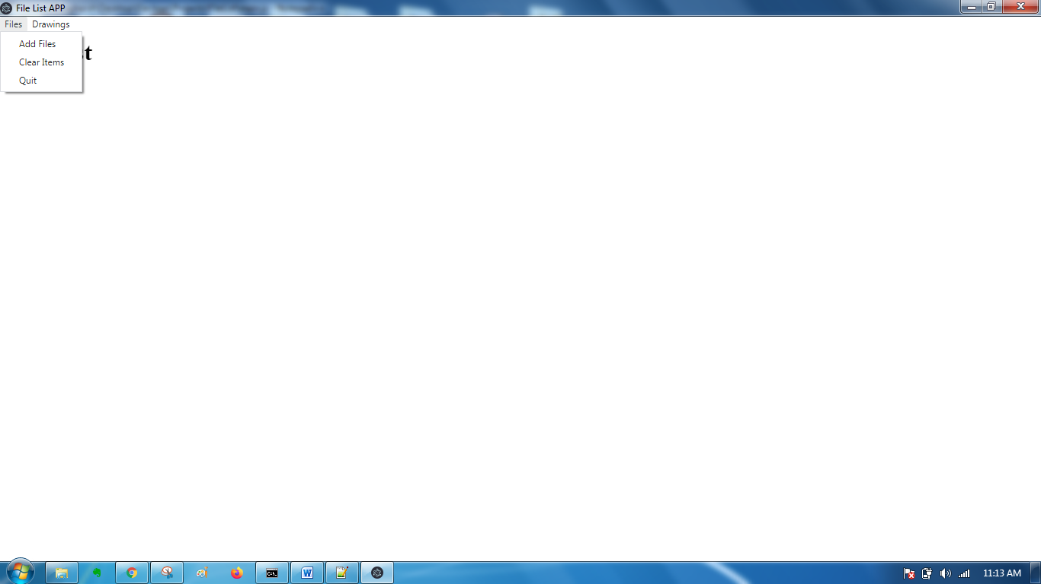

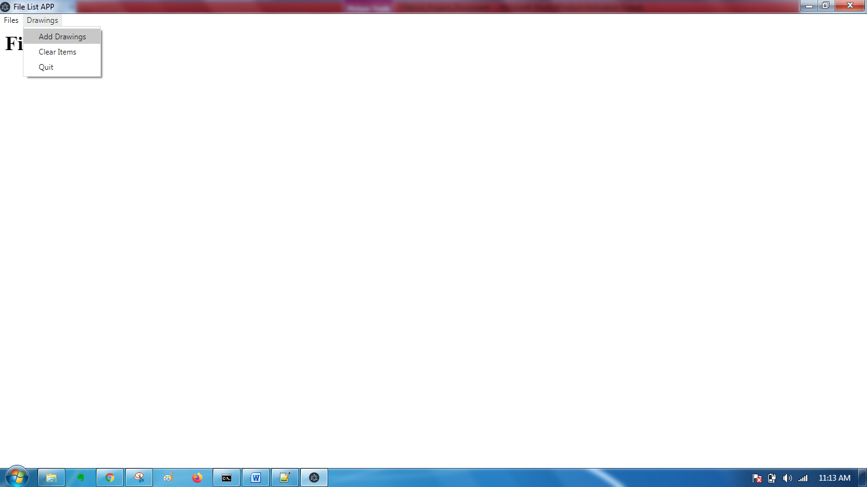

* **Open** a new **window** on clicking “**Add Files**” or “**Add** **Drawings**”
* Add Function to create a new Window

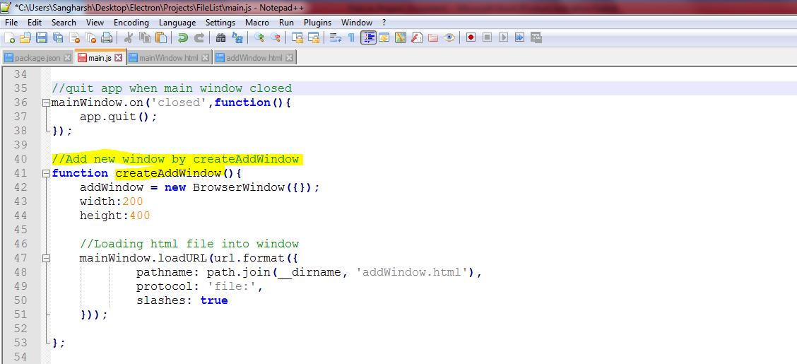

* Quit app when main Window is closed:

