4. Use the function paste to create the following character vectors of length 30:

(a) ("label 1", "label 2", ....., "label 30").

Note that there is a single space between label and the number following

**Answer**

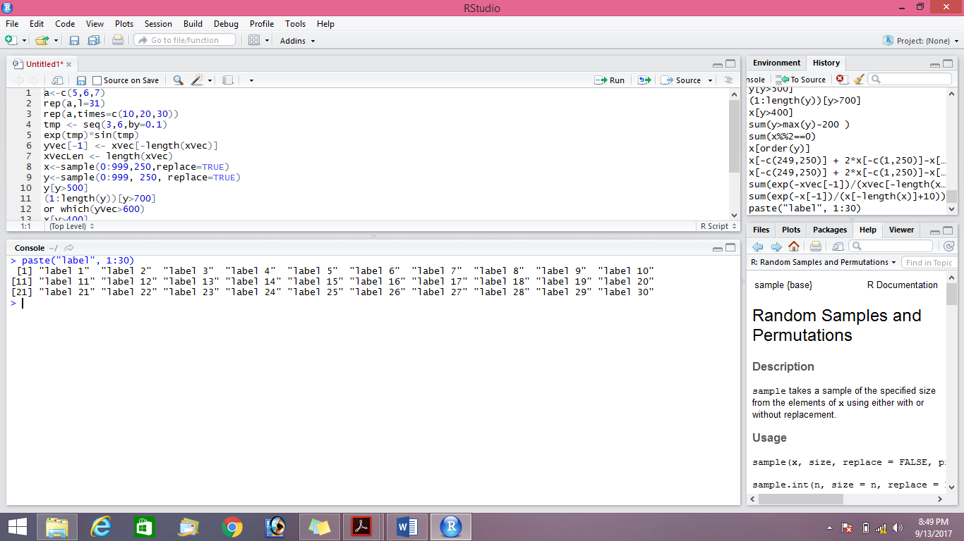

.

(b) ("fn1", "fn2", ..., "fn30").

In this case, there is no space between fn and the number following.

**Answer**

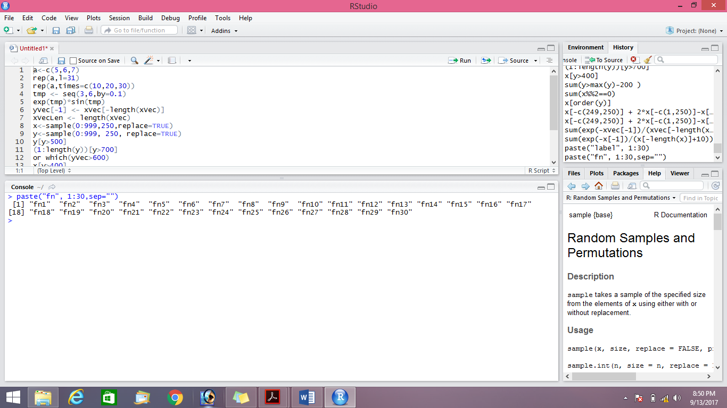



**Answer**

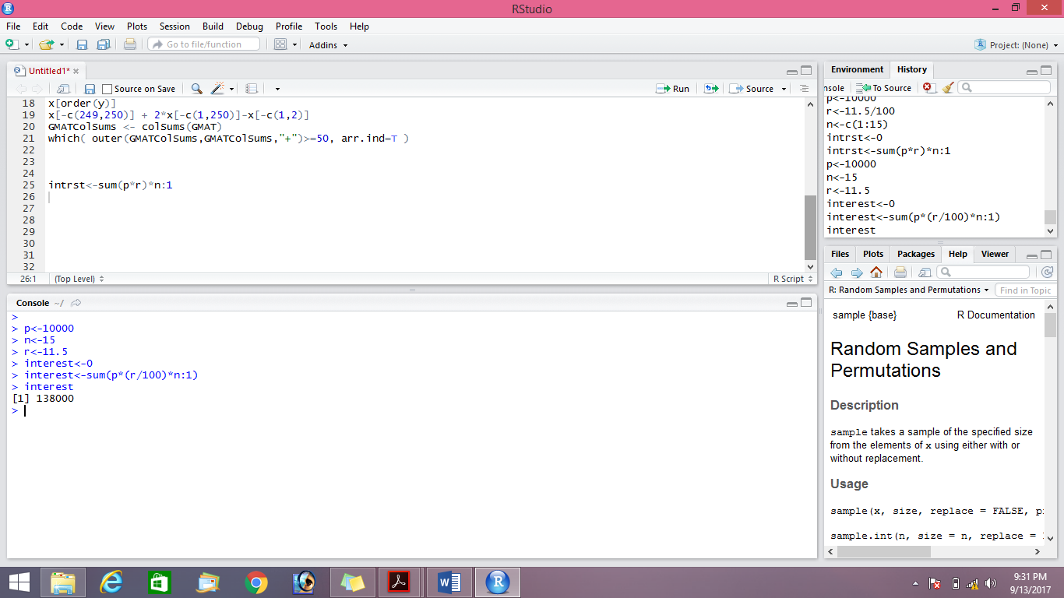



**Answer**

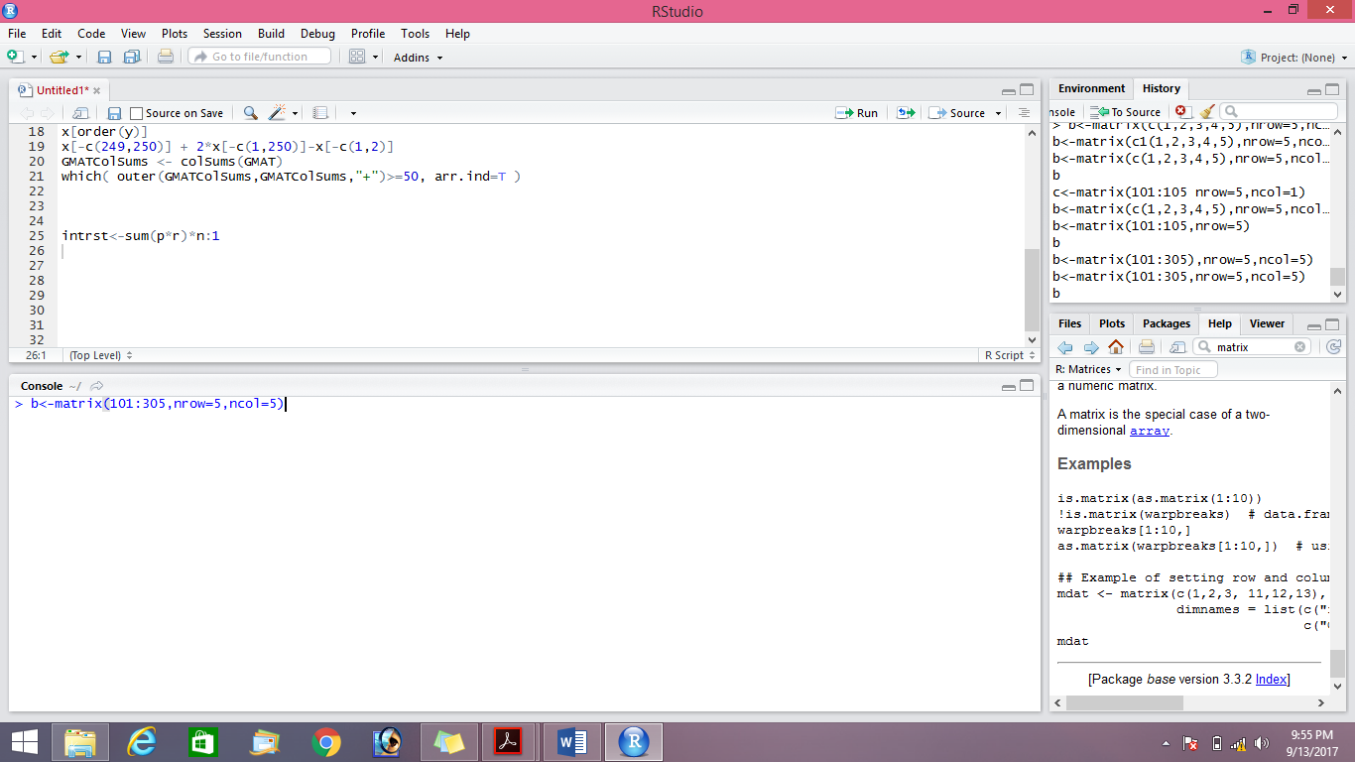



**Answer a**

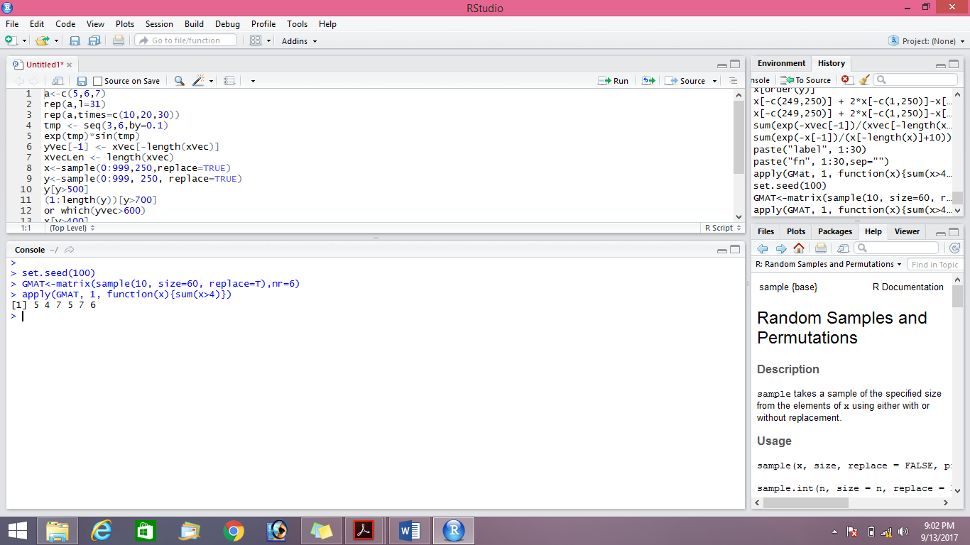

**Answer b**

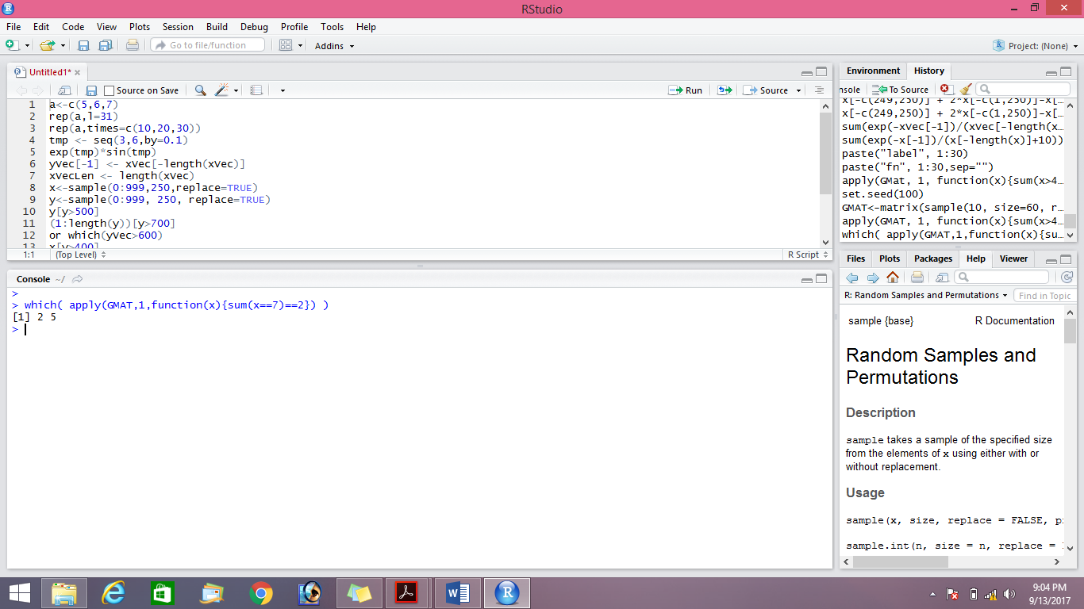

**Answer c**













