**5. Problem Statement**

1. Write a function called sum_of_cubes, that calculates the sum of cubes of the first n natural numbers :

• if we have two numbers : 1, 2 then sum of squares is 9 ( 1^3 + 2^3)

• if we have three numbers : 1, 2, 3 then sum of squares is 36 ( 1^3 + 2^3 + 3^3)

**Answer**

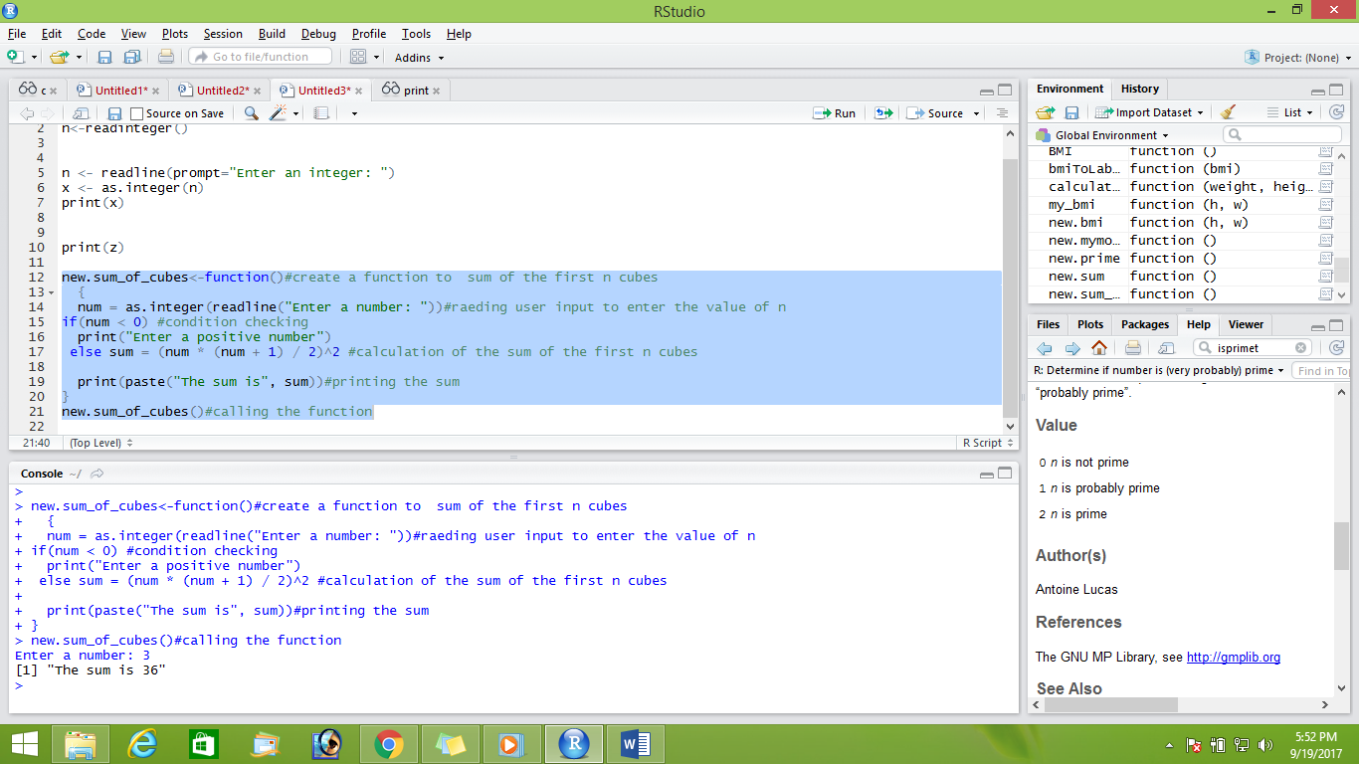

2. Write a function to calculate the mode (highest frequency) of the following vector:

x = c(2,3,3,4,4,5,6,7,9,10)

**Answer**

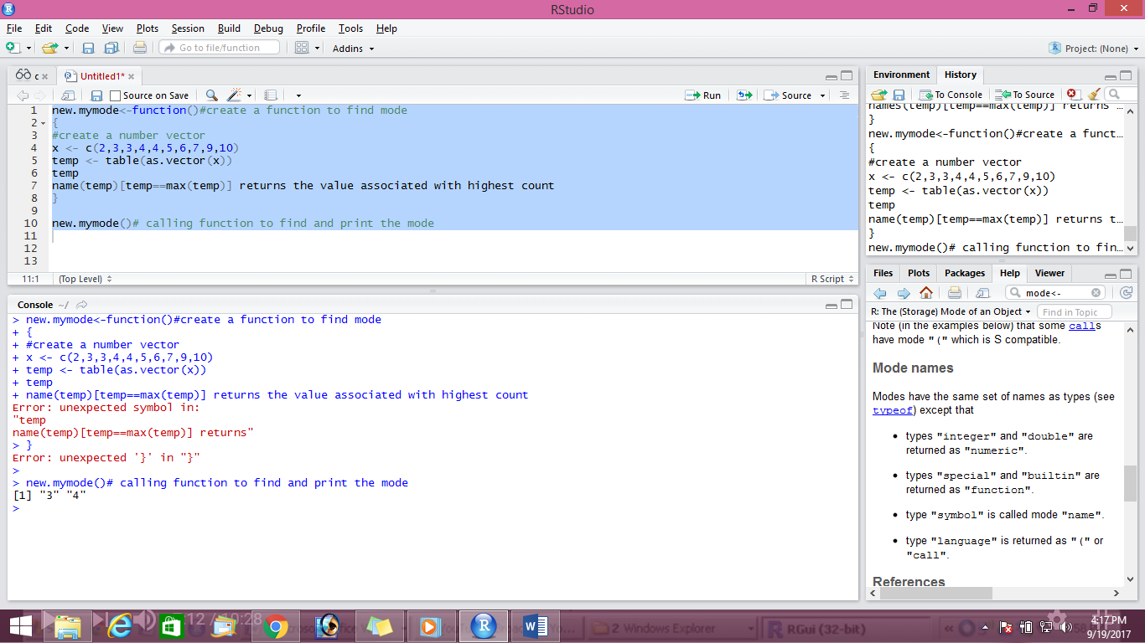



3.Write a function to calculate the no. of prime numbers of the following vector :

x = c(2,2,3,3,4,5,7,11,15,19,24,29)

Answer

