Q1. Use the below data find the relationship between age (in months) and height (Average height in cm)

• age=16:27

• height=c(61.1,61.2,61.8,62.8,63.5,76.1,77,78.1,78.2,78.8,79.7,79.9)

1. check that age and height have the same number of elements

**Answer: age and height do not have same number of elements**

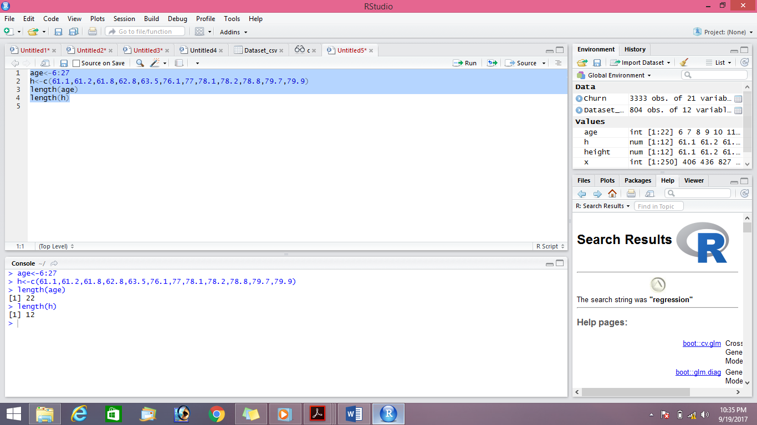

1. Create a scatterplot to determine the relationship between age and height

**Answer**

Since the vectors are not of same size and scatterplot is npt possible with vectors of different size, so the the following steps were done to make it of same size

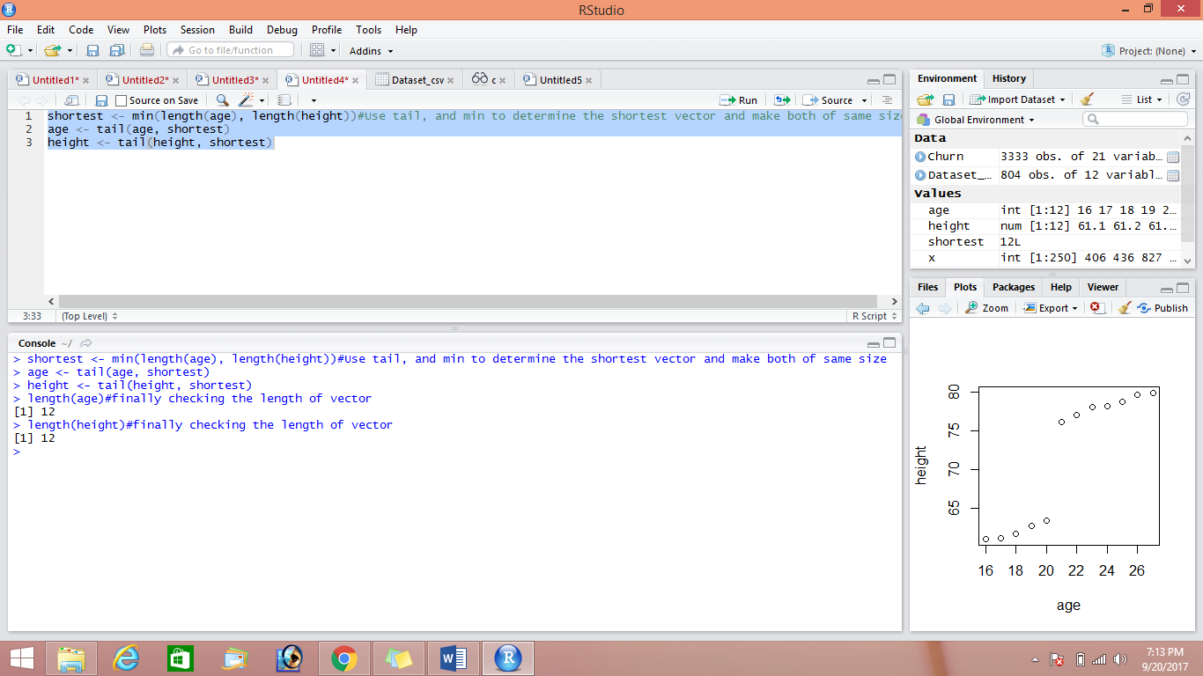

Now scatter plot of age and height was plotted

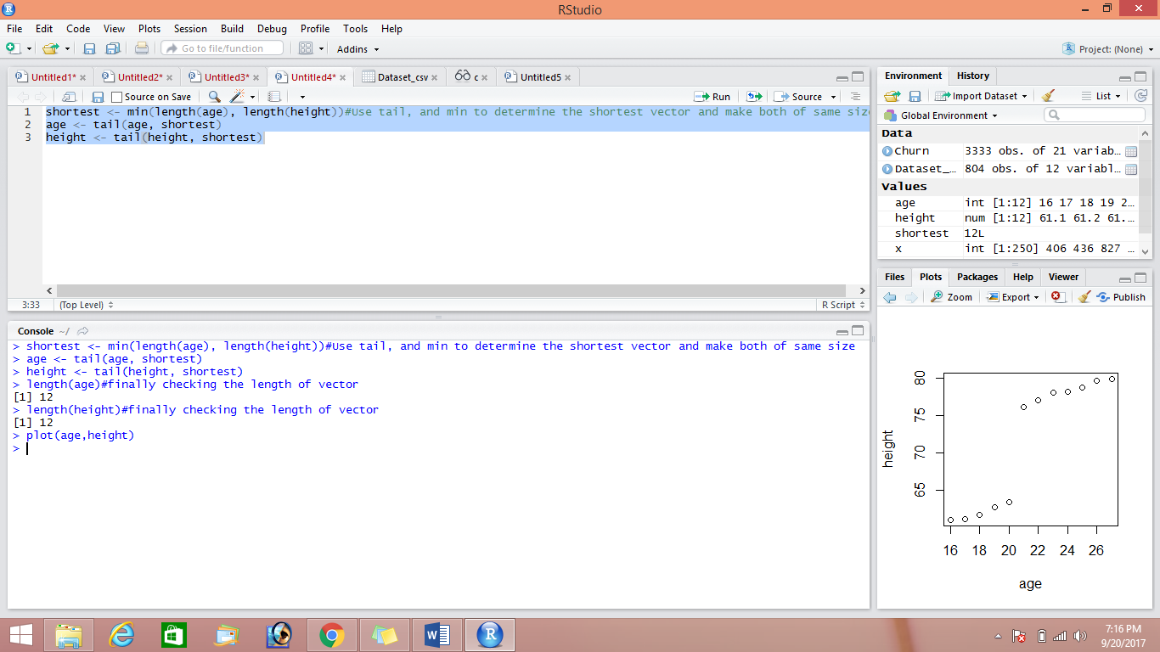

1. Create a "linear model" to fits the data above

**Answer**

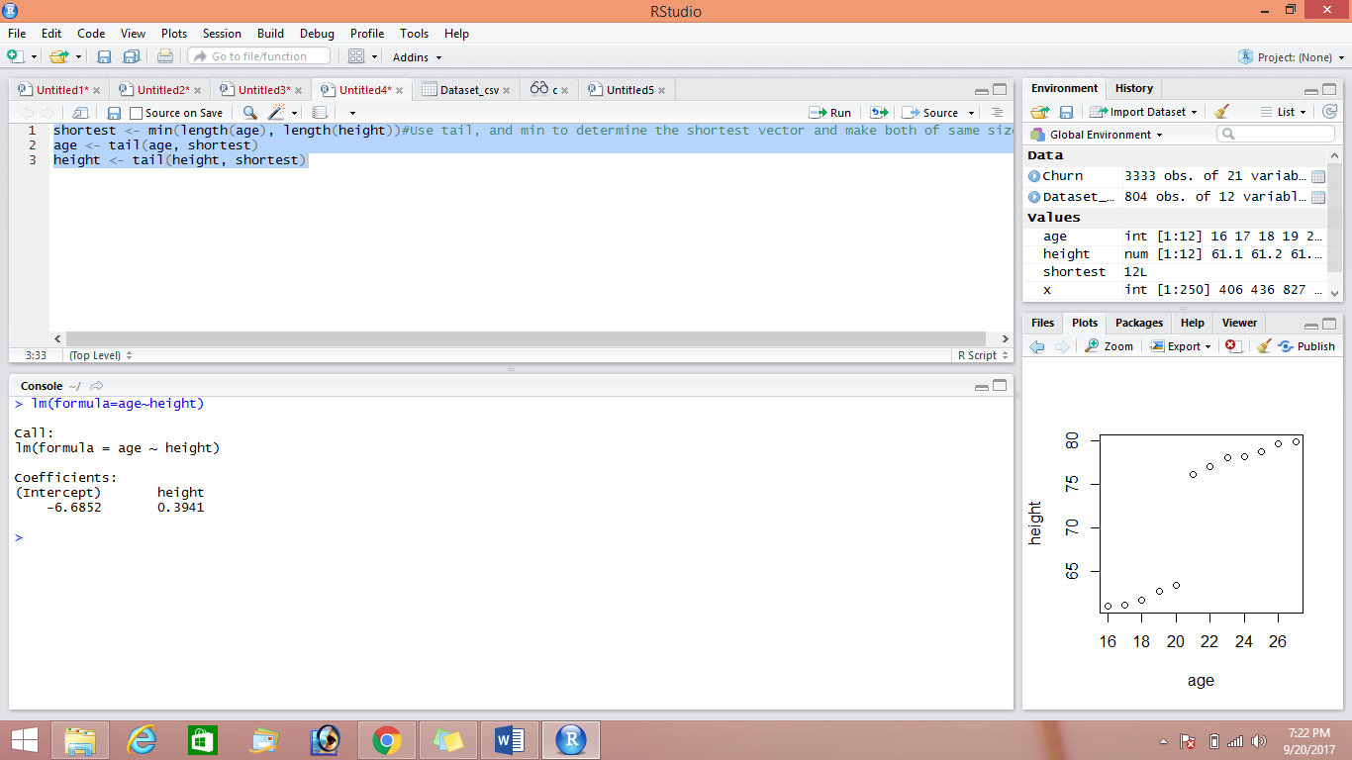

1. Find the equation of the line of best fit

**Answer**

