**1. Create the vectors**

**(a) (2*,* 3*, … ,* 29*,* 30)**

**Answer**

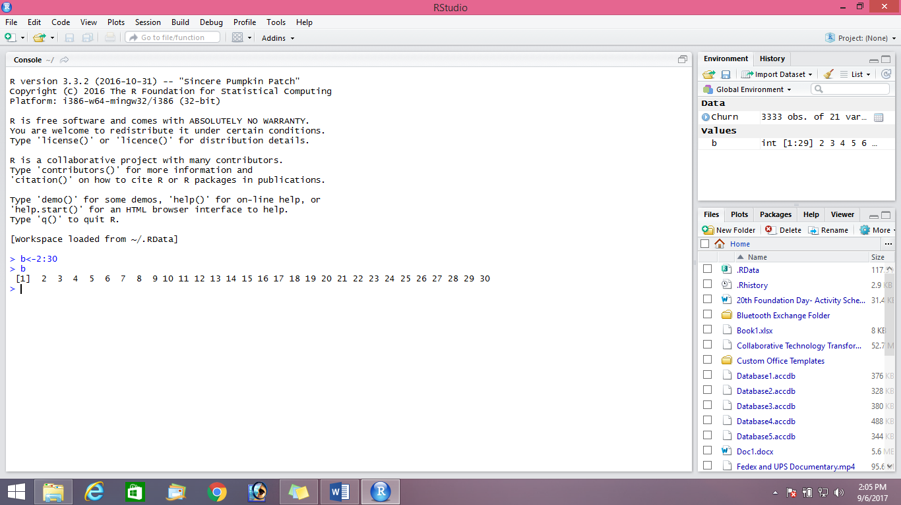

**(b) (30, 29, … , 2)**

**Answer**

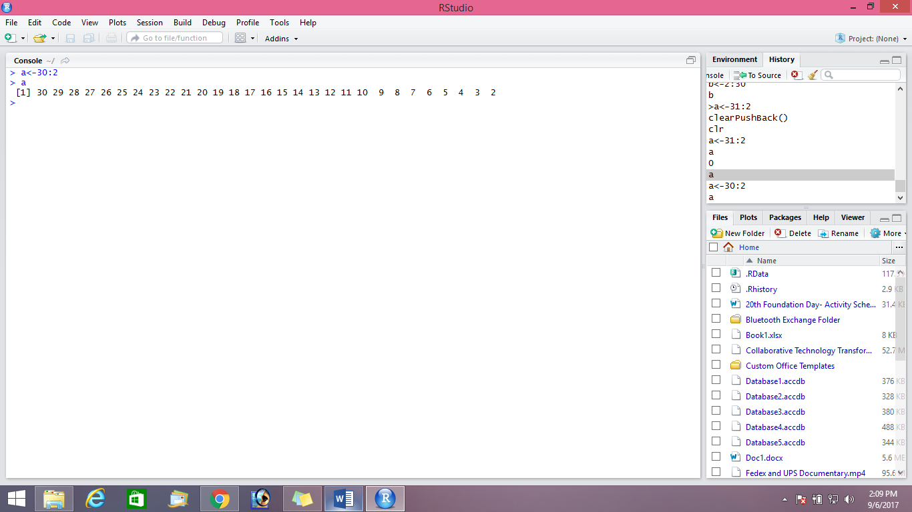

**(c) (1, 2, 3, …. , 29, 30, 29, 28, , 2, 1)**

**Answer**

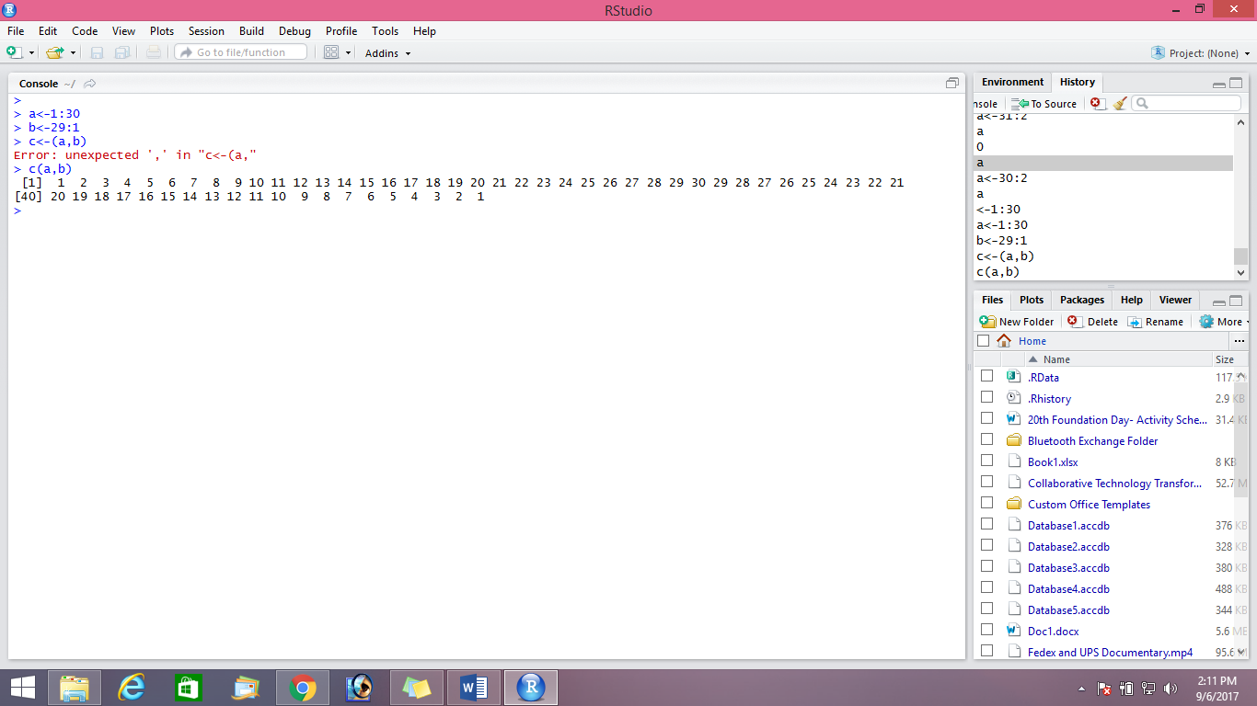

(d) (4*,* 6*,* 3) and assign it to the name dev.

**Answer**

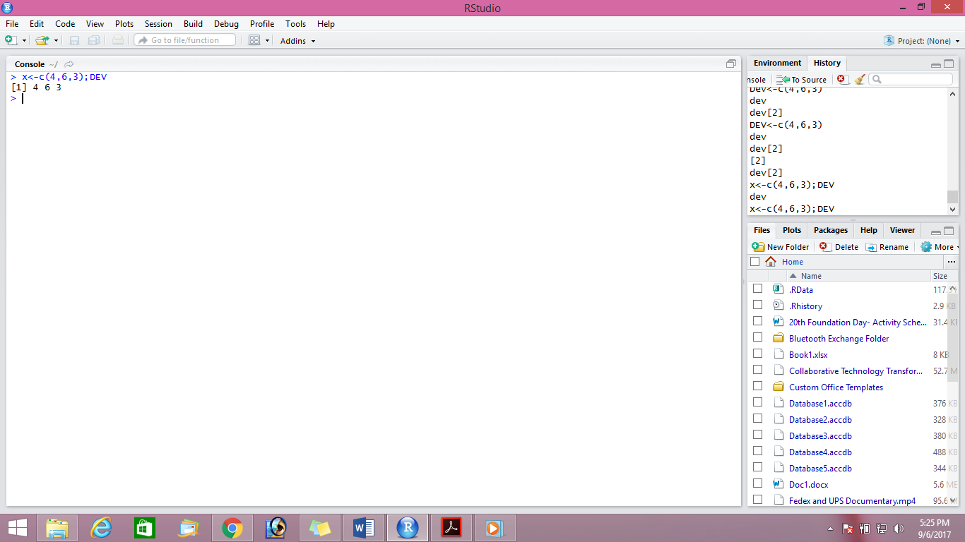

For parts (e), (f) and (g)

e) (5*,* 6*,* 7*,* 5*,* 6*,* 7*, ,* 5*,* 6*,* 7) where there are 10 occurrences of 5.

**Answer**

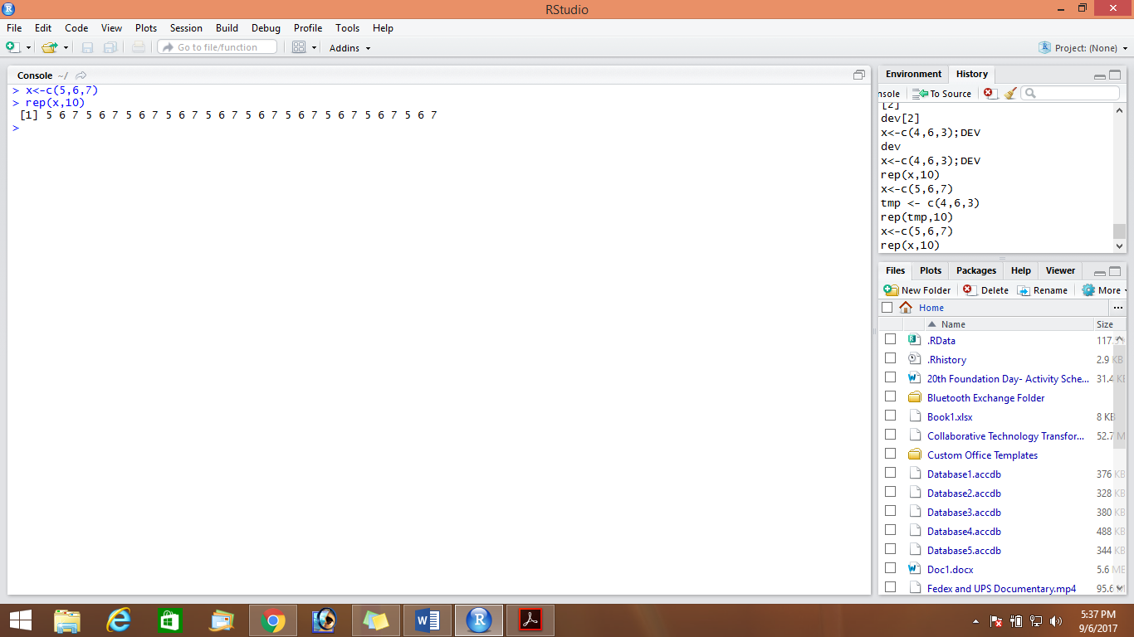

(f) (5*,* 6*,* 7*,* 5*,* 6*,* 7*, ,* 5*,* 6*,* 7*,* 5) where there are 11 occurrences of 5, 10 occurrences of 6 and 10

occurrences of 7.

**Answer**

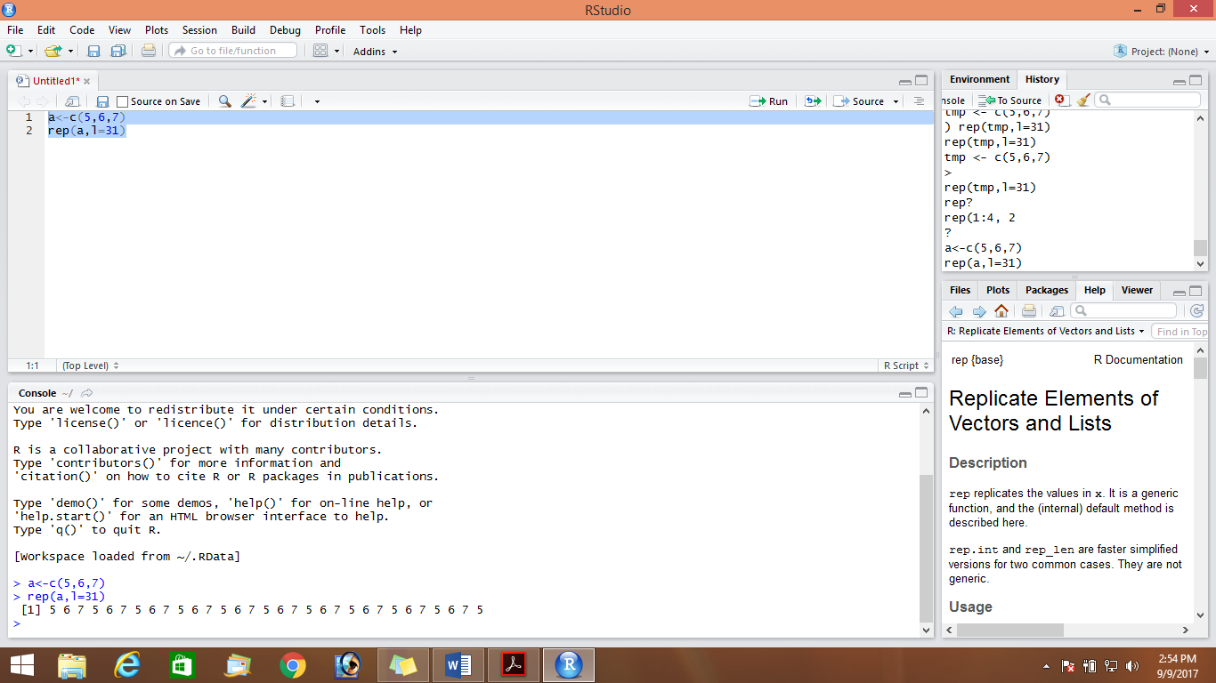

(g) (4*,* 4*, ,* 4*,* 6*,* 6*, ,* 6*,* 3*,* 3*, ,* 3) where there are 10 occurrences of 4, 20 occurrences of 6 and 30 occurrences of 3.

**Answer**

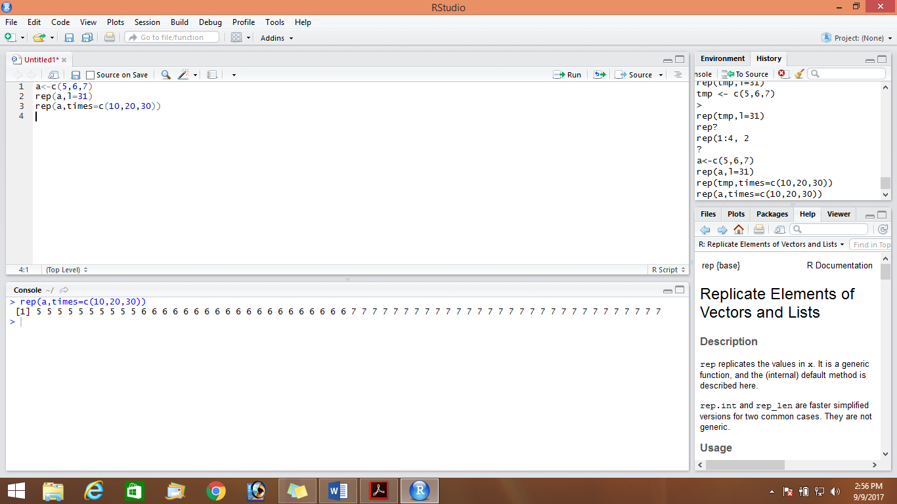

**2.** Create a vector of the values of *eX* sin(*x*) at *x* = 3*,* 3.1*,* 3.2*, ,* 6.

Answer

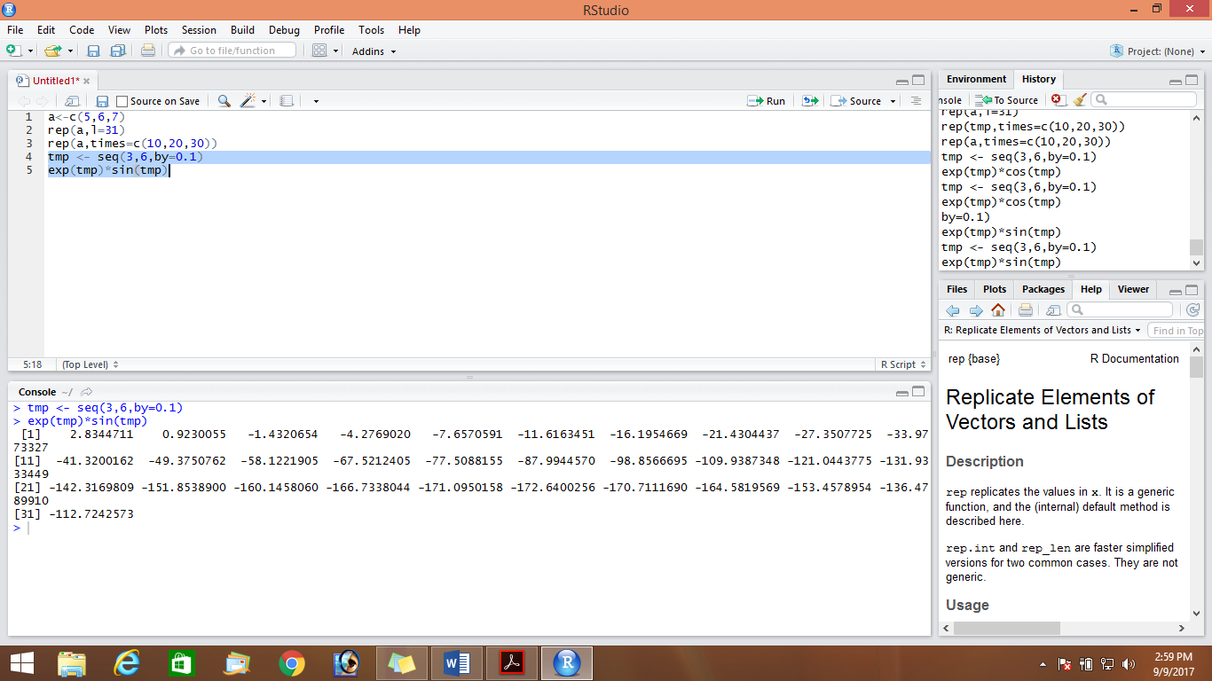

**3.** Execute the following lines which create two vectors of random integers which are chosen with

replacement from the integers 0, 1, : : : , 999. Both vectors have length 250.

set.seed(100)

x <- Sample (0:999, 250, replace=T)

y <- Sample (0:999, 250, replace=T)

1. Identify out the values in y which are > 500.

**Answer**

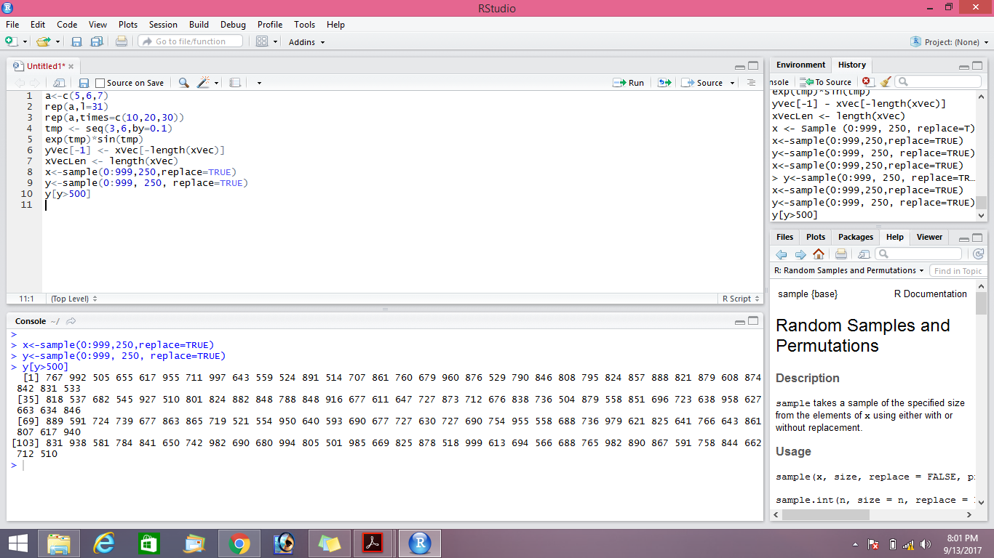

1. Identify the index positions in y of the values which are > 700?

**Answer**

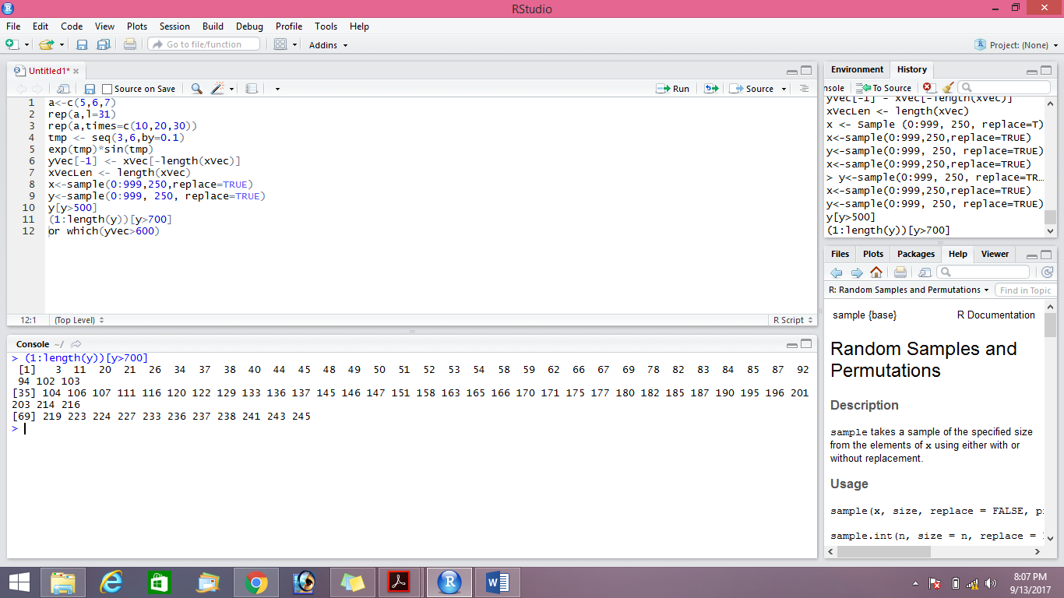

c) What are the values in x which are in Same index position to the values in y which are > 400?

**Answer**

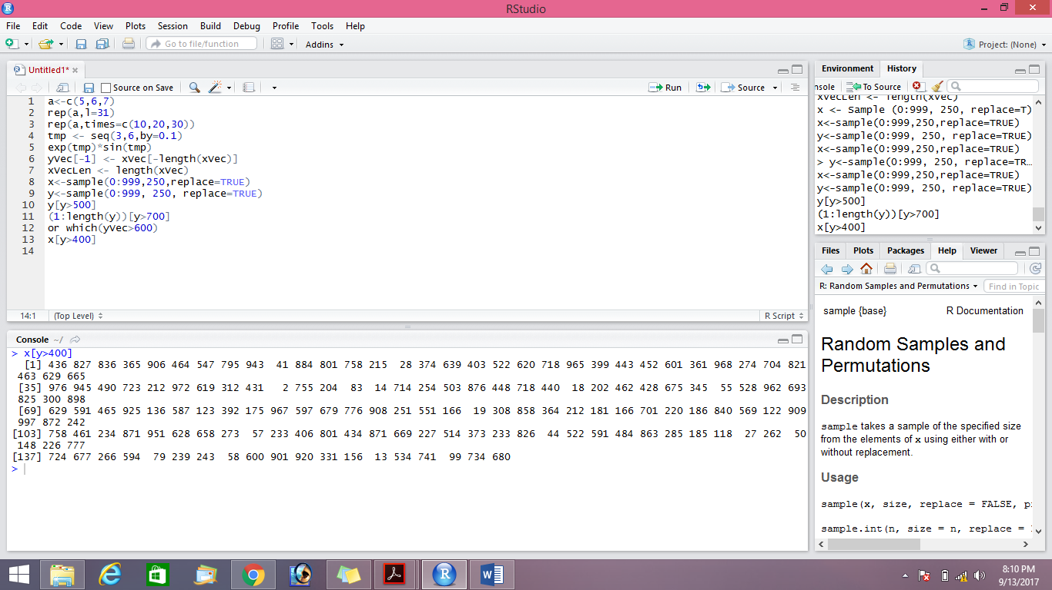

1. How many values in y are within 200 of the maximum value of the terms in y?

**Answer**

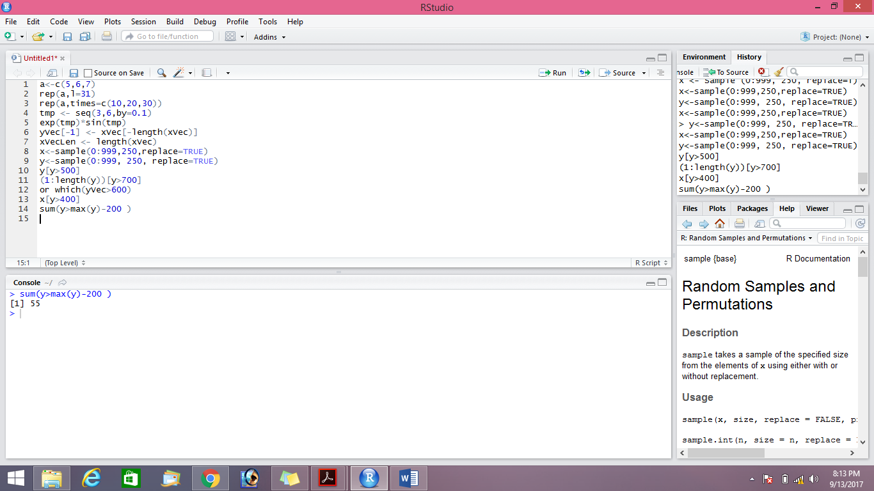

1. How many numbers in x are divisible by 2?

**Answer**

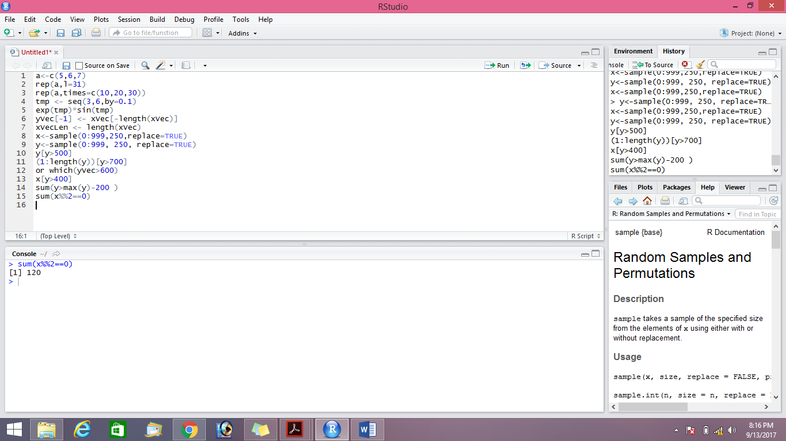

1. Sort the numbers in the vector x in the order of increasing values in y.

**Answer**

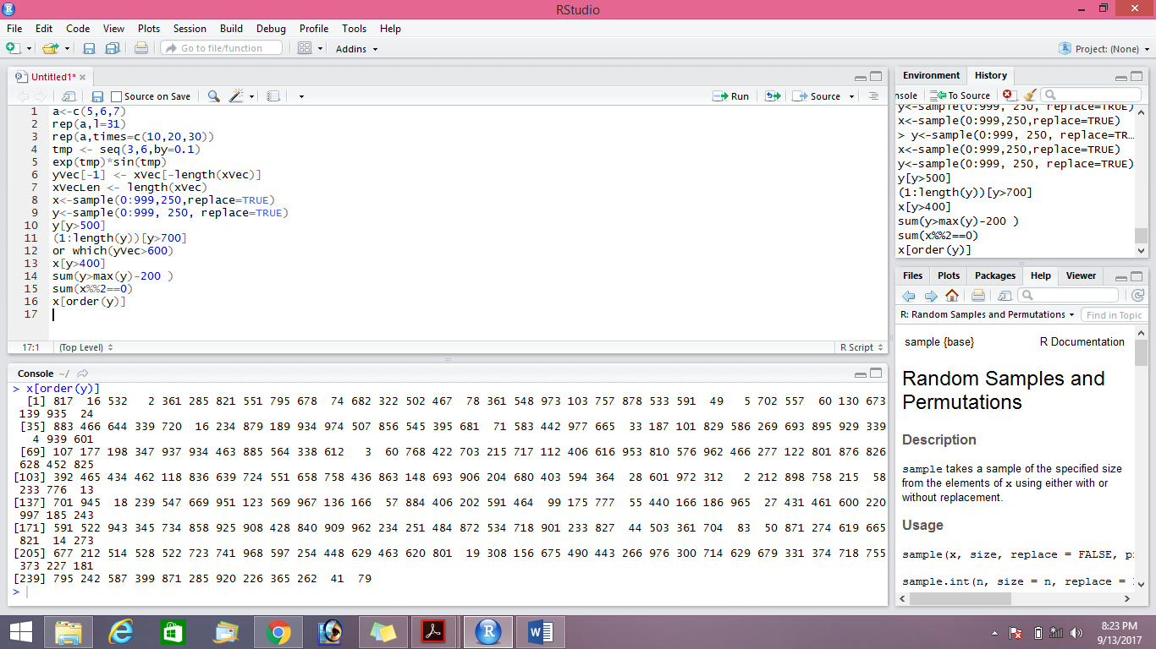

1. Create the vector (x1 + 2x2 - x3; x2 + 2x3 -x4 ,, xn−2 + 2xn−1 - xn).

**Answer**

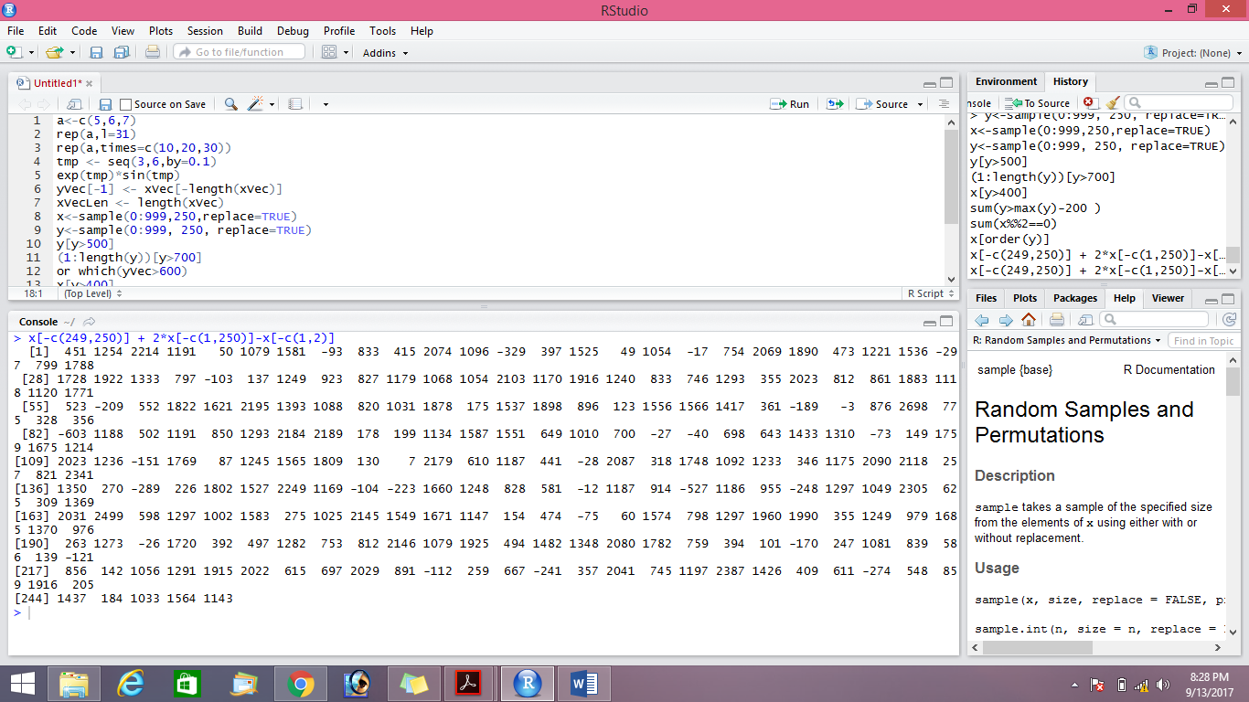

h) Calculate:

n-1

Σ (e−xi+10/ xi + 10)

i=1

