5. Problem Statement

Here is a table with 6 rows and 3 Columns :

X Y Z

910 a1 b1

820 a2 b2

730 a3 b3

640 a4 b4

550 a5 b5

460 a6 b6

Put the data in .xlsx, .txt , .csv and read it using R Code.

Created CSV File

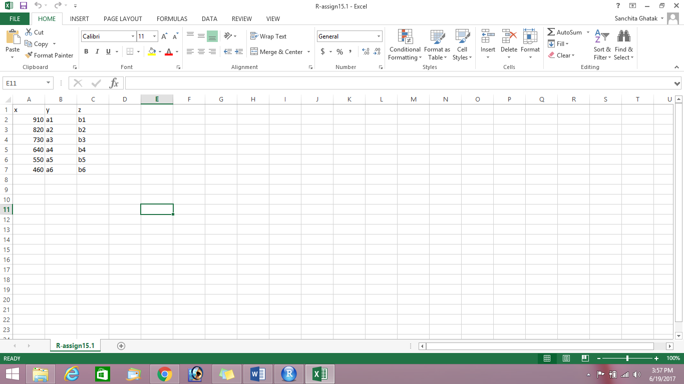

Read it using R code

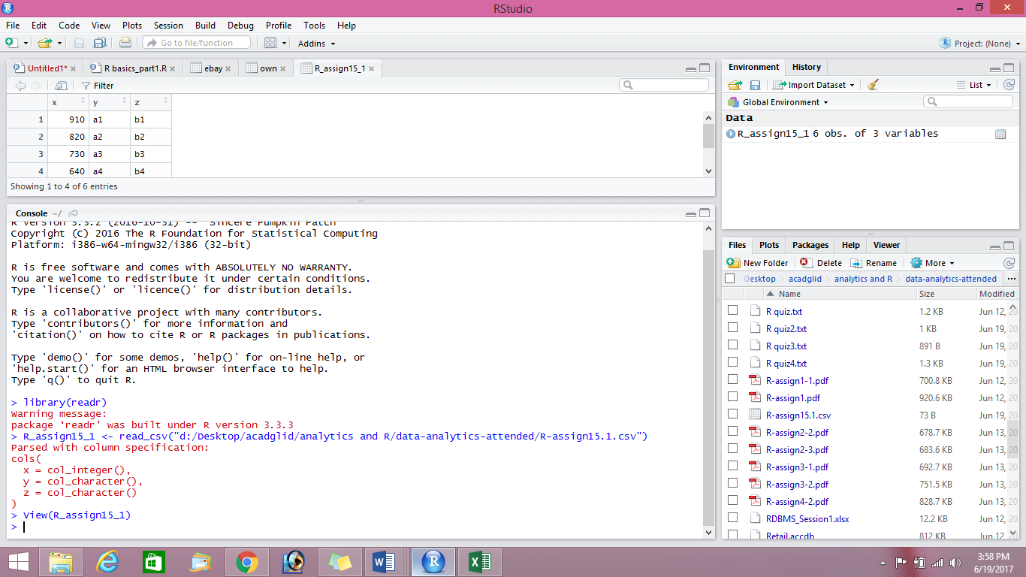

View in R

