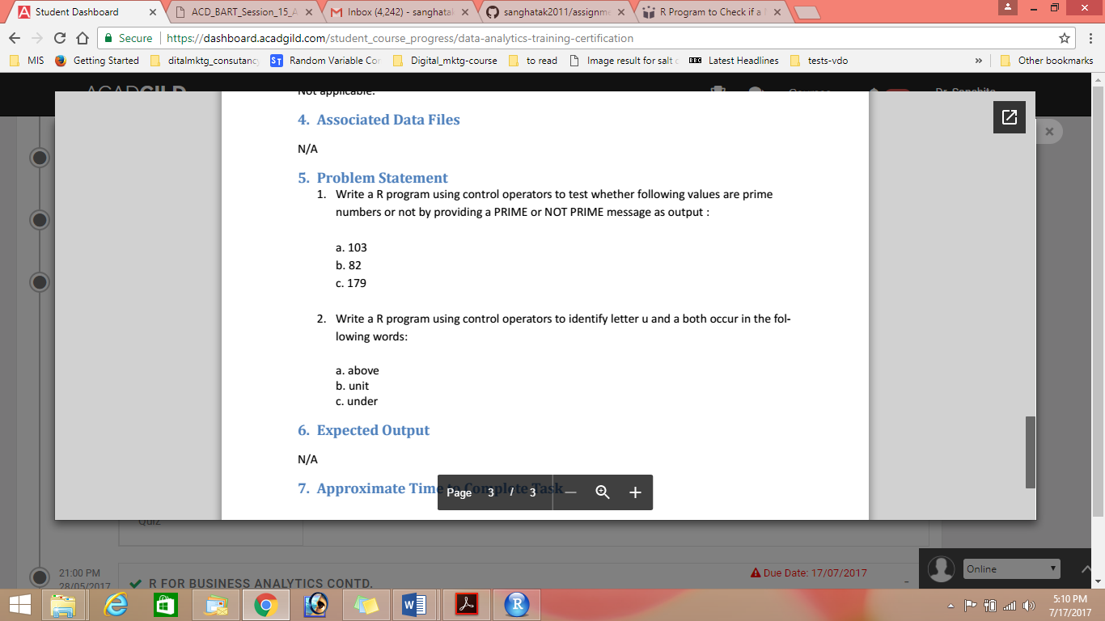

Question 1

num = as.integer(readline(prompt="Enter a number: "))

flag = 0

# prime numbers are greater than 1

if(num > 1) {

# check for factors

flag = 1

for(i in 2:(num-1)) {

if ((num %% i) == 0) {

flag = 0

break

}

}

}

if(num == 2) flag = 1

if(flag == 1) {

print(paste(num,"is a prime number"))

} else {

print(paste(num,"is not a prime number"))

}

Question 2

Pattern<-above

Pattern1<-unit

Pattern3<-under

Grep(pattern,a)

Grep(pattern1,u)

Grep(pattern3,u)