**Create a Filled map by using the Column State. Denote each state with different colors.**

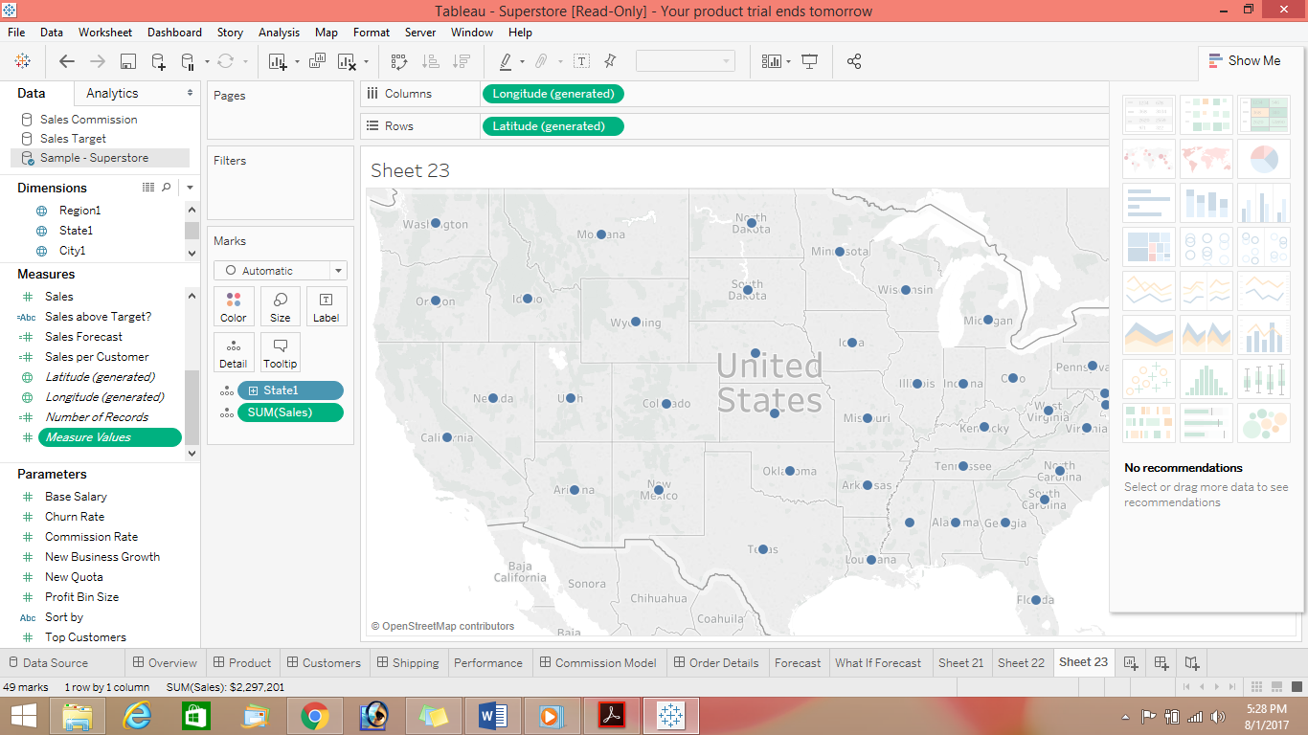

**Show the State Name and Total Sales in the lables**

**Show the tooltip with State Name, Profit and Sales**