**Q1. If I find Covariance between same variable what will be the output? What will be correlation coefficient?**

**Answer:** it will give the variance

Correlation coefficient will be 1

**Q2. Assume I have a set of numbers. The mean, median and mode of the set of numbers are equal. If I draw a Frequency plot of individual distinct numbers, how would the plot look like?**

**Answer:**  If the mean, median, and mode are approximately equal to each other, the distribution symmetry about the center

50% of values less than the mean  and and 50% greater than the mean therefore graph b is the answer

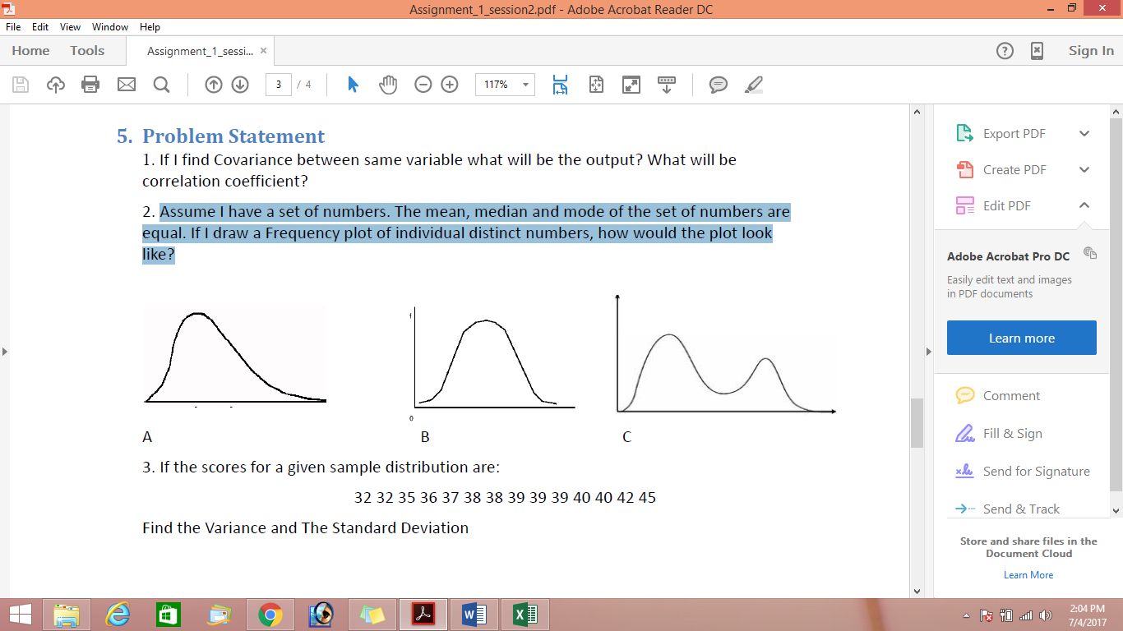

**Q3. If the scores for a given sample distribution are: 32 32 35 36 37 38 38 39 39 39 40 40 42 45**

**Find the Variance and The Standard Deviation**

|  |  |  |  |
| --- | --- | --- | --- |
| Numbers( | x{\displaystyle x_{i}} - x̅ | ( x{\displaystyle x_{i}} - x̅)2 |  |
| 32 | 6 | 36 |  |
| 32 | 6 | 36 |  |
| 35 | 3 | 9 |  |
| 36 | 2 | 4 |  |
| 37 | 1 | 1 |  |
| 38 | 0 | 0 |  |
| 38 | 0 | 0 |  |
| 39 | -1 | 1 |  |
| 39 | -1 | 1 |  |
| 39 | -1 | 1 |  |
| 40 | -2 | 4 |  |
| 40 | -2 | 4 |  |
| 42 | -4 | 16 |  |
| 45 | -7 | 49 |  |
| x̅ = 38 |  | ∑( x{\displaystyle x_{i}} - x̅)2 =162 |  |

Variance = ∑( x{\displaystyle x_{i}} - x̅)2/ n =11.57

Std Dev= = = 3.40

2. The following table shows percent variations of two financial indices, the NYSE (New York Stock Exchange ) and the NASDAQ composite (National Association of Securities Dealers Automated Quotation) in 10 consecutive days:



Use a suitable measure to quantify the dependence between the variations of the two indices and comment on the result.

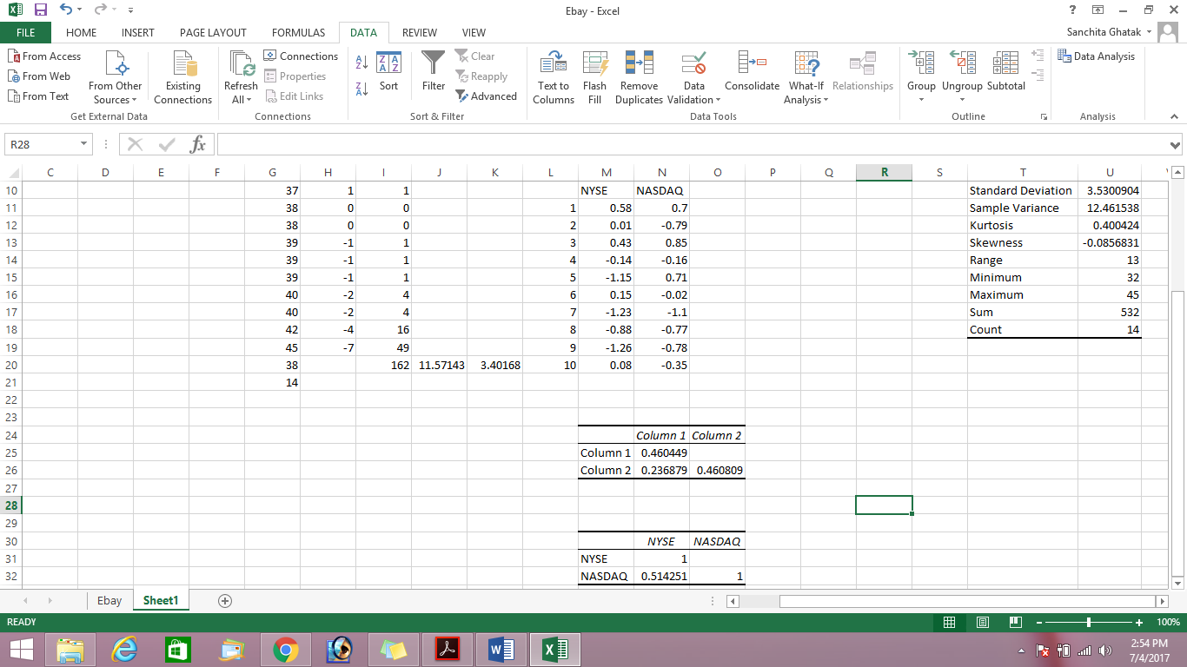

We can use covariance and correlation to find dependencies

Covariance table shows that there is a positive correlation between NYSE and NASDAQ data (.23)

|  |  |  |  |
| --- | --- | --- | --- |
|  | | NSYSE | NASDAQ |
| NSYSE | Pearson Correlation | 1 | .514 |
| Sig. (2-tailed) |  | .128 |
| NASDAQ | Pearson Correlation | .514 | 1 |
| Sig. (2-tailed) | .128 |  |

Correlation table shows there is no significant relationship between the two variables (p>.05) though the correlation strength is moderate (.514)