**Q1. If the scores for a given sample distribution are: 32 32 35 36 37 38 38 39 39 39 40 40 42 45**

**Find the Variance and The Standard Deviation**

|  |  |  |  |
| --- | --- | --- | --- |
| Numbers( | x{\displaystyle x_{i}} - x̅ | ( x{\displaystyle x_{i}} - x̅)2 |  |
| 32 | 6 | 36 |  |
| 32 | 6 | 36 |  |
| 35 | 3 | 9 |  |
| 36 | 2 | 4 |  |
| 37 | 1 | 1 |  |
| 38 | 0 | 0 |  |
| 38 | 0 | 0 |  |
| 39 | -1 | 1 |  |
| 39 | -1 | 1 |  |
| 39 | -1 | 1 |  |
| 40 | -2 | 4 |  |
| 40 | -2 | 4 |  |
| 42 | -4 | 16 |  |
| 45 | -7 | 49 |  |
| x̅ = 38 |  | ∑( x{\displaystyle x_{i}} - x̅)2 =162 |  |

Variance = ∑( x{\displaystyle x_{i}} - x̅)2/ n =11.57

Std Dev= = = 3.40

2. The following table shows percent variations of two financial indices, the NYSE (New York Stock Exchange ) and the NASDAQ composite (National Association of Securities Dealers Automated Quotation) in 10 consecutive days:



Use a suitable measure to quantify the dependence between the variations of the two indices and comment on the result.

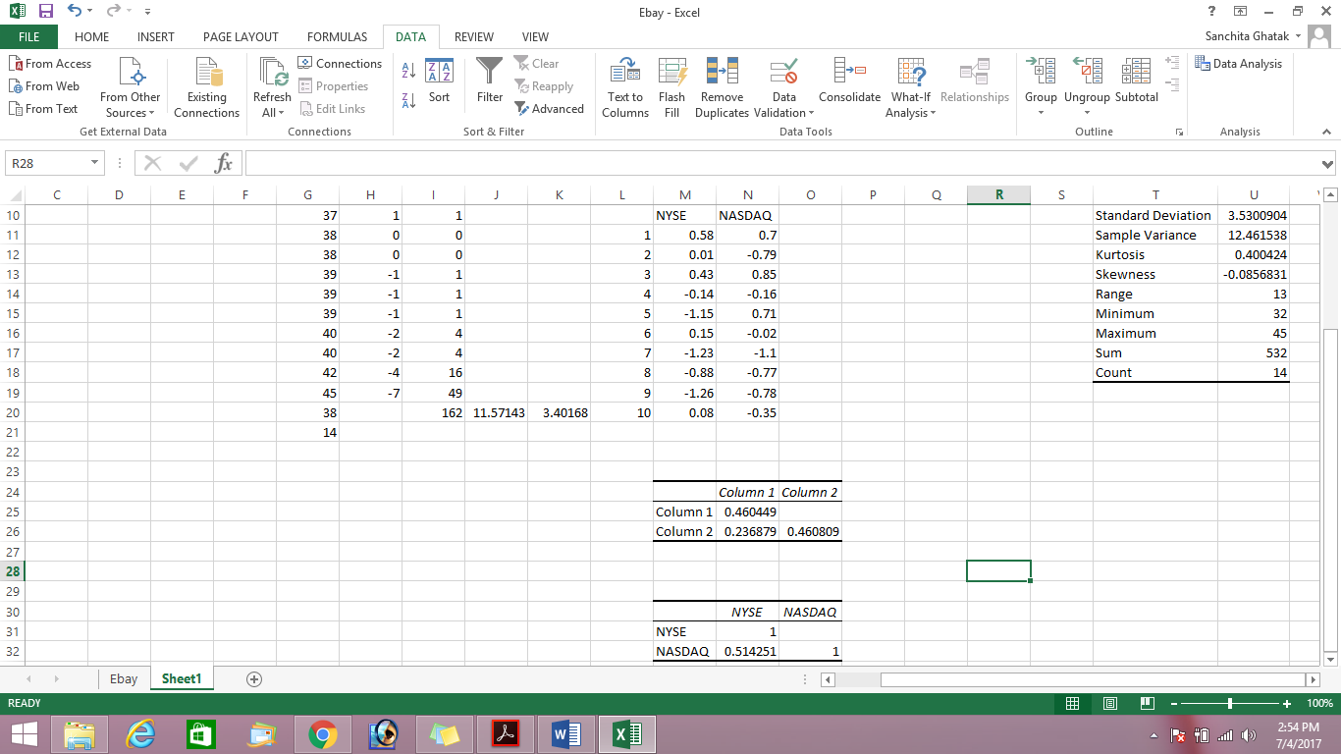

We can use covariance and correlation to find dependencies

Covariance table shows that there is a positive correlation between NYSE and NASDAQ data (.23)

|  |  |  |  |
| --- | --- | --- | --- |
|  | | NSYSE | NASDAQ |
| NSYSE | Pearson Correlation | 1 | .514 |
| Sig. (2-tailed) |  | .128 |
| NASDAQ | Pearson Correlation | .514 | 1 |
| Sig. (2-tailed) | .128 |  |

Correlation table shows there is no significant relationship between the two variables (p>.05) though the correlation strength is moderate (.514)