Using the excel spreadsheet “Data.xlsx”, create a series of Pivot Tables (or Pivot Charts) to answer the following questions.

• What are the averages for purchases in each region?

• What form of payment is most common? • Do our customers shop at work (most likely between 8:00 and 17:00) or at home?

• Turn in a printout of the pivot tables you used to answer each question.

Note: To answer number 3, a new column is created in the spreadsheet labeled "Hour of Day" and set it to just the hour instead of hour and minutes. In other words =hour(G8). The students who are excel power users should use an "if" formula to create a value of either day (time between 8:00 and 17:00) or night (not between 8:00 and 17:00).

Answer1

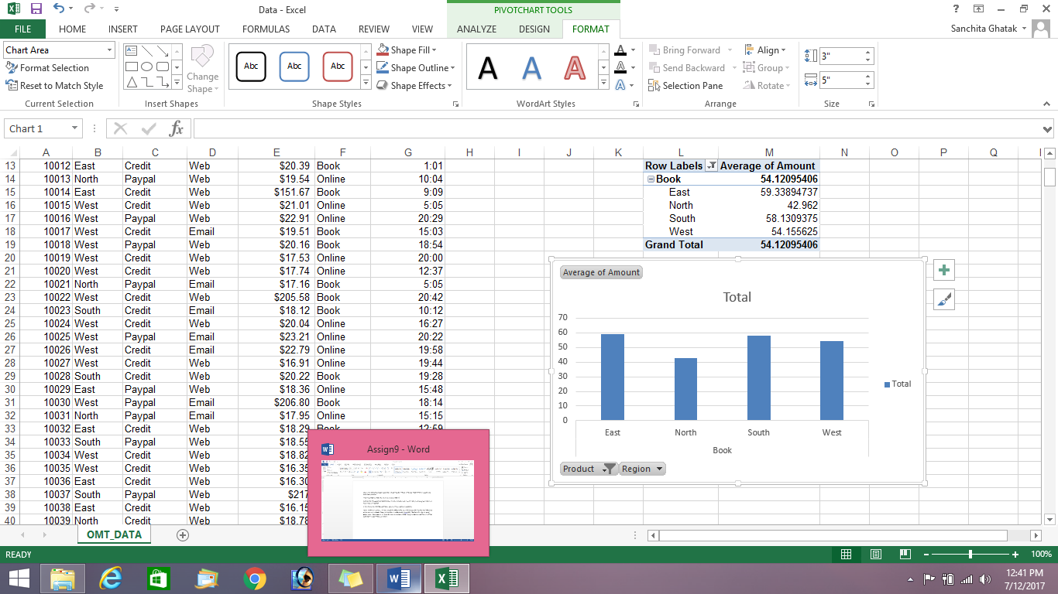

Answer 2 : The pivot chart /graph shows that credit is mostly used

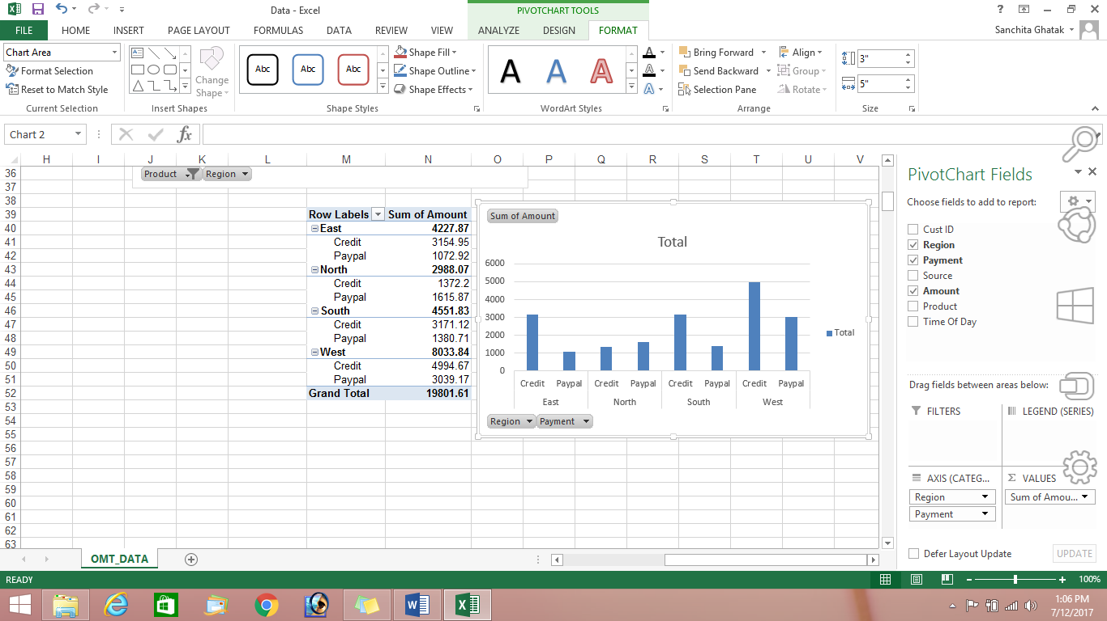

Answer 3

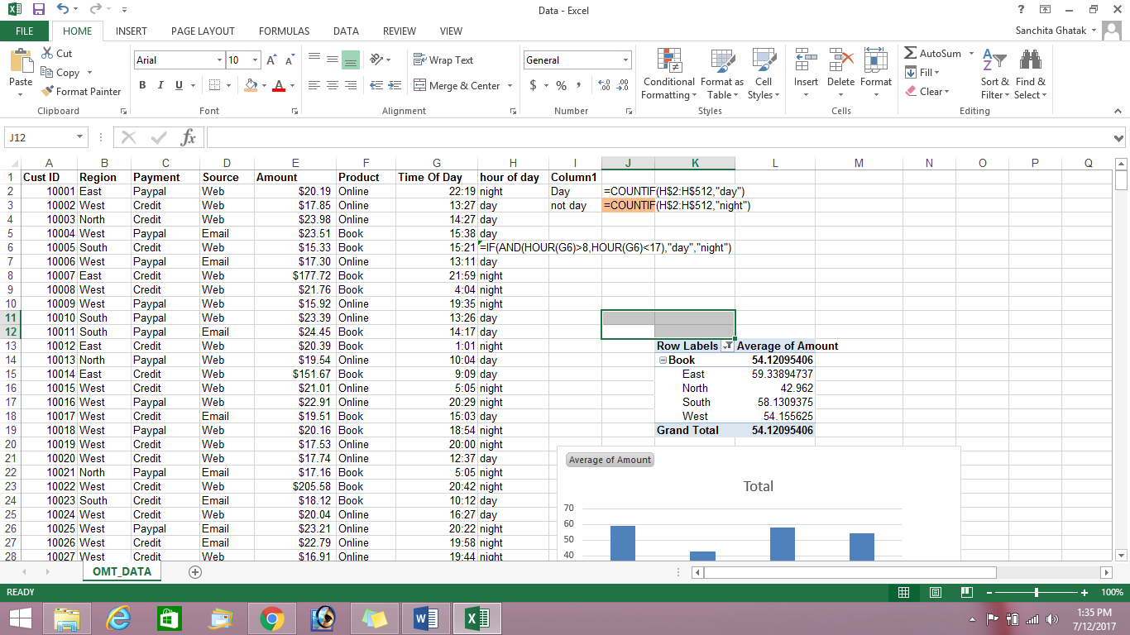

Using if found whether shopping time is day or night

Using countif found whether day is predominant or night is predominant, and it was found that people mostly shop during night

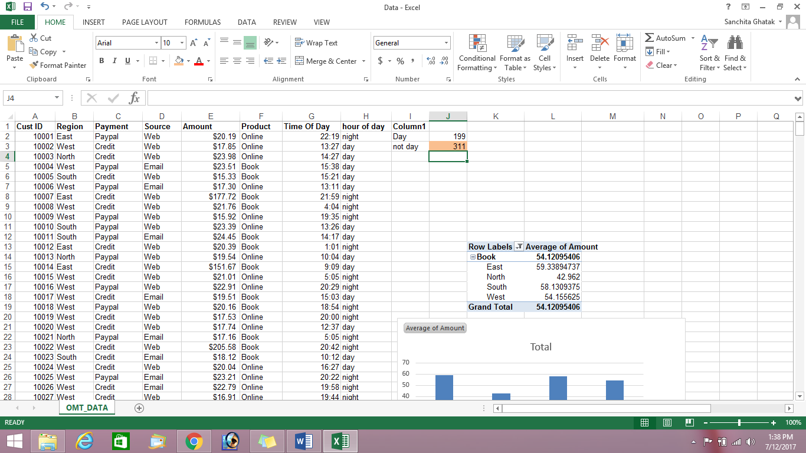

Answer4 :Printout

