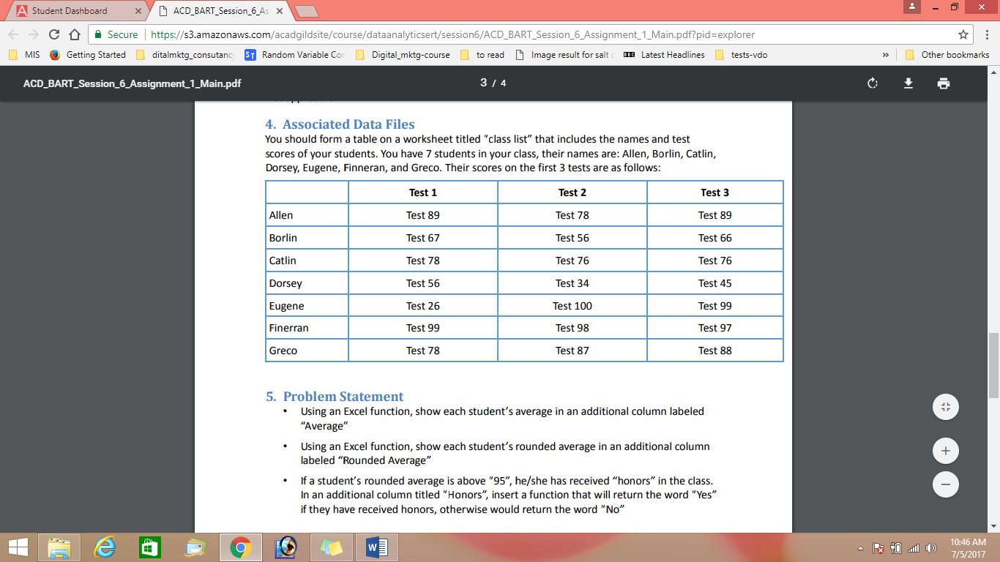



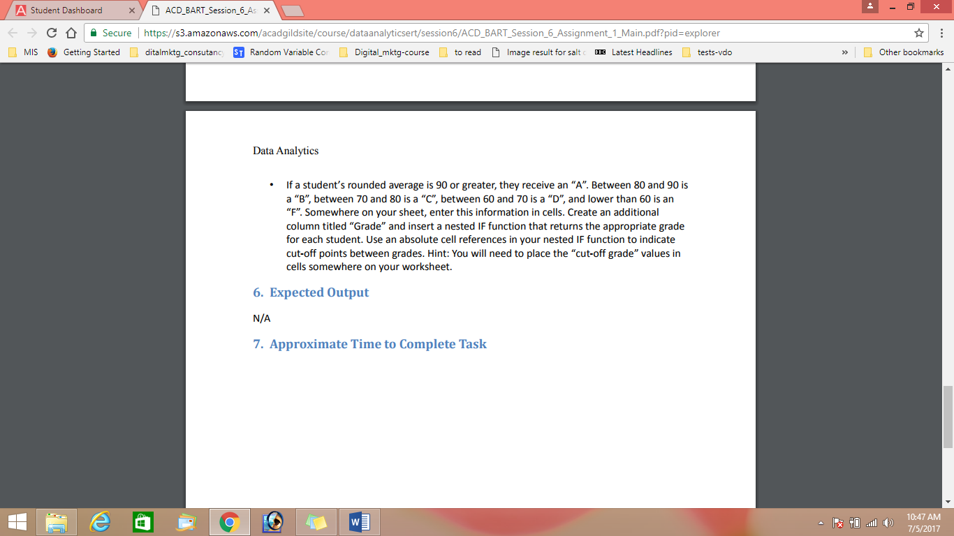

Sheet created in excel

Average calculated in a separate column and average rounded off in a separate column( upto 2 decimal places)

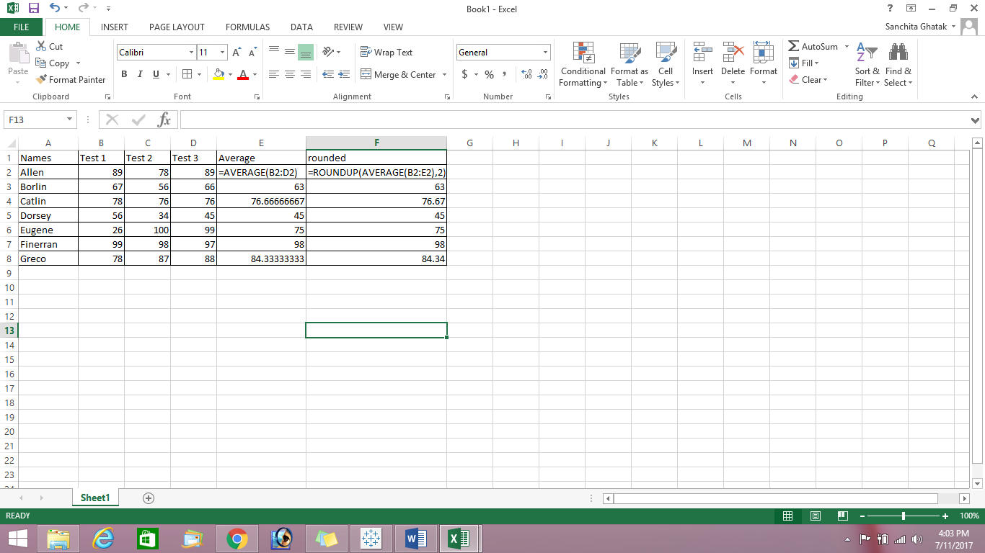

Grade of individual student calculated

**Formula used :**

**=IF(AND(F2>0,F2<60),"F",IF(AND(F2>=60,F2<=70),"D",IF(AND(F2>70,F2<=80),"C",IF(AND(F2>80,F2<=90),"B","A"))))**

