**Data Analysis Report : Probability Density Function Of Salaries**

**Data overview:**

The dataset consists of salary information with no specified column headers.

**Probability Distribution :**

PDF is a function that describes the likelihood of a continuous random variable falling within a particular range of values. From, the graph we can observe the values are equally distributed on both sides of mean.

**Mean :**

The mean is the measure of central tendency that represents the average of a set of values. It is calculated by summing up all the values in a dataset and then dividing the sum by the number of values. The mean value here is 50320.26.

$$\frac{mean=\sum_{i=1}^{n}{arr[i]}}{n}$$

**X value:**

X value represents the salary value below 33% of people fall. Here the x value is 36562.68.

X = percentile (data, 33)

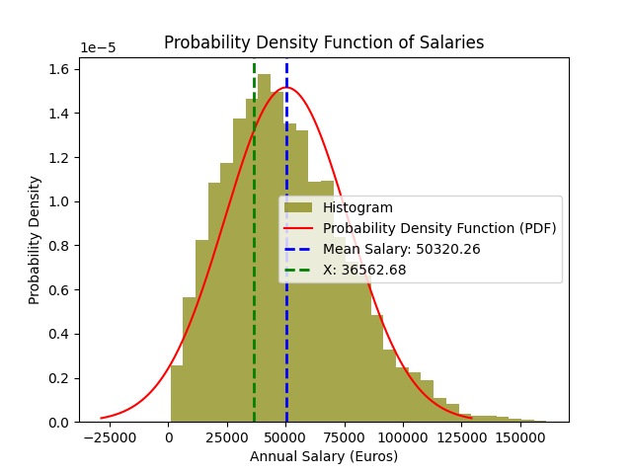

**Name : Sanghavi Rangineni**

**Student Id : 22086311**