<Additional Fractals>

1. 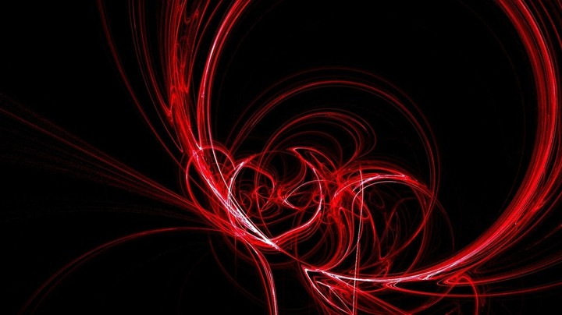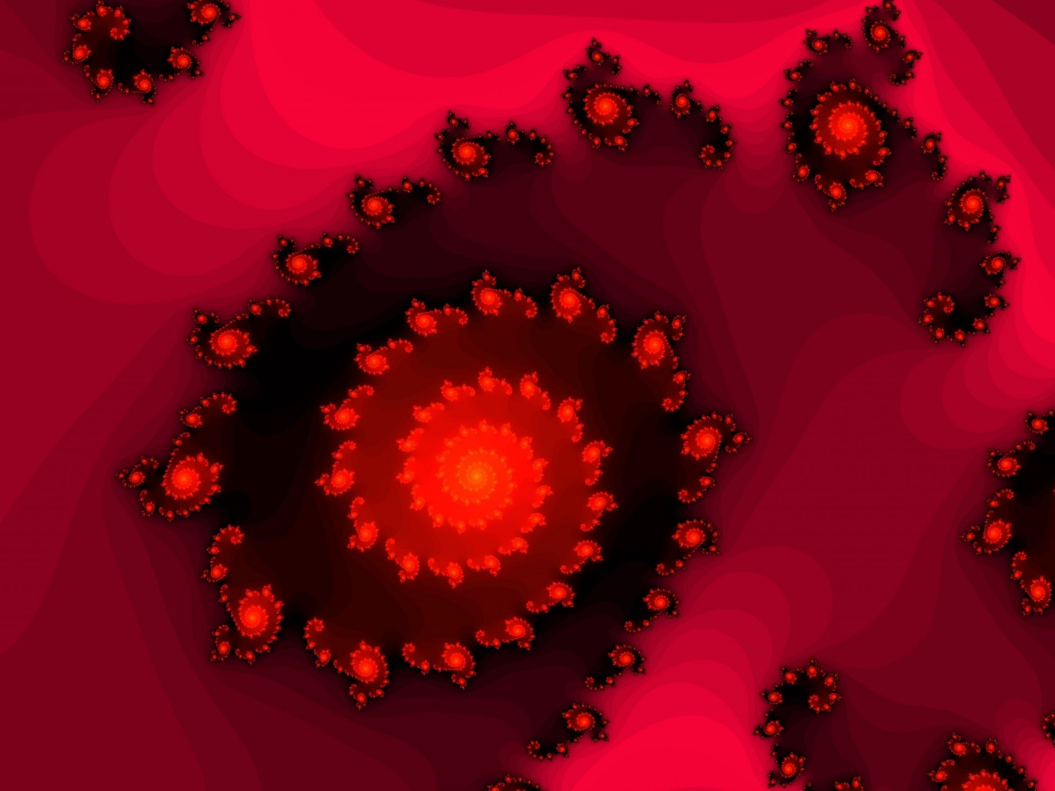Red

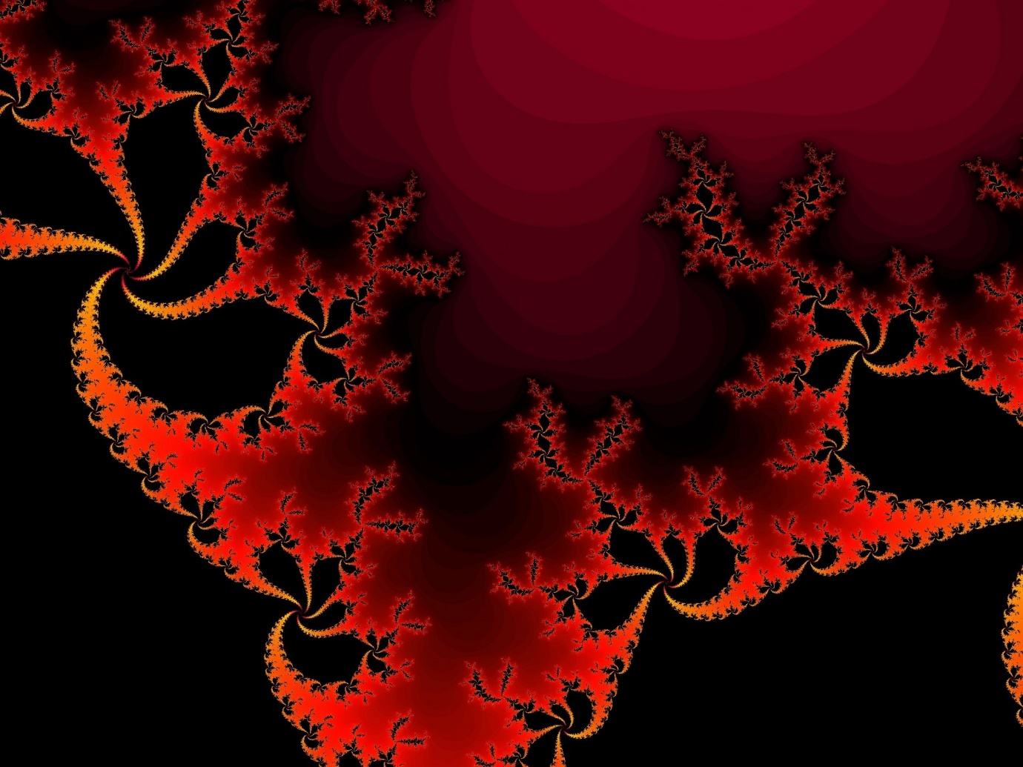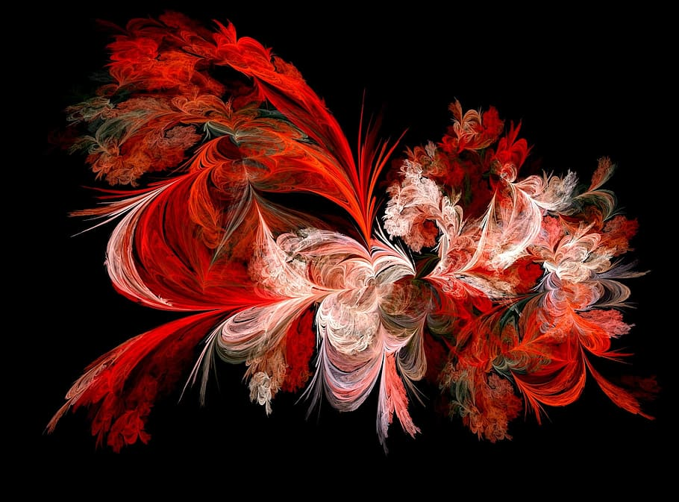

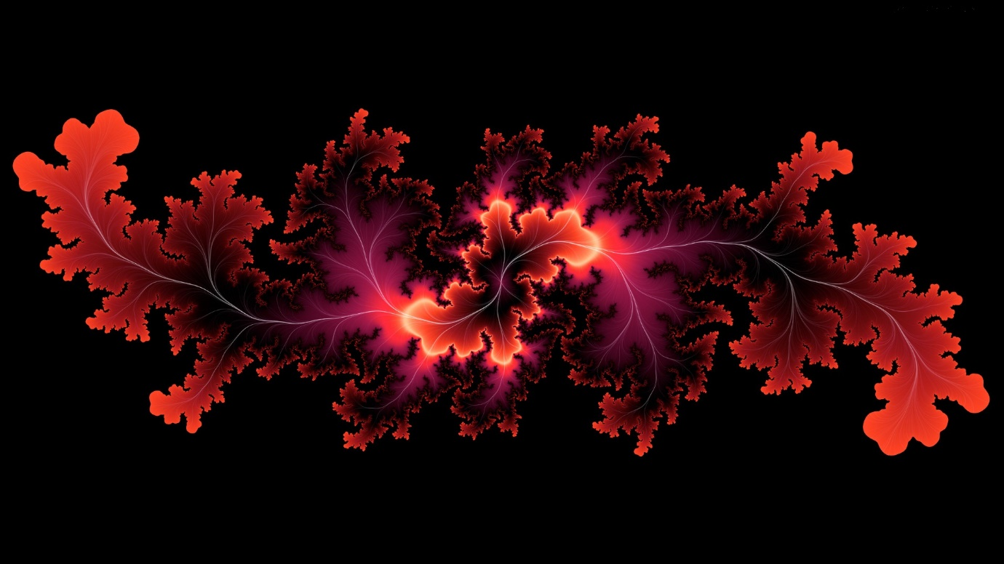

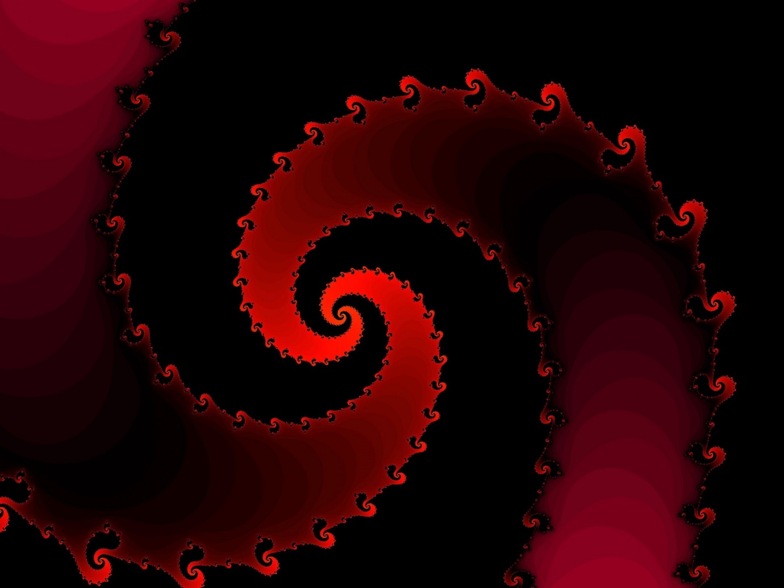

1)<https://www.publicdomainpictures.net/en/view-image.php?image=51048&picture=red-fractal-galaxy>

2)<https://revelwallpapers.net/w/EieV2F6FSXD5AjRvVgnFYf/abstract-backgrounds-colors-digital-art-red-1366x768-76351-wallpapers.html>

3)<https://www.pxfuel.com/en/free-photo-ombem>

4) <https://www.publicdomainpictures.net/en/view-image.php?image=98104&picture=red-fractal-background>

5) <https://imgur.com/gallery/aquJH4n>

6) <https://www.needpix.com/photo/1381243/art-spiral-fractal-astronira-pattern-graphic-design-decorative-abstract>

1. 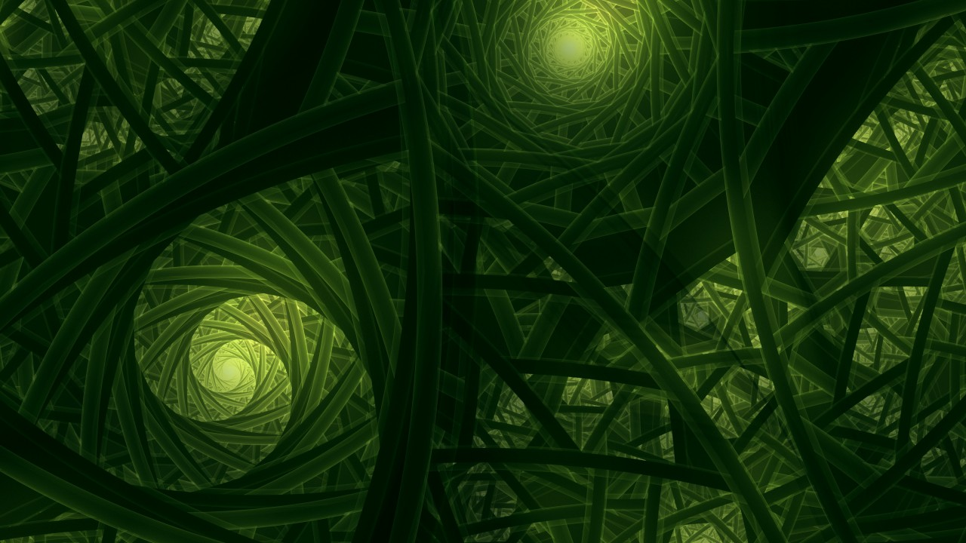Green
2. <https://wallpapersite.com/abstract/fractals-green-4k-7419.html>
3. Blue