**GAM536-DPS936**

**Labs 7&8**

**Due Date: July 31**

**So far, you have built a mini-golf field with holes, ball, lights and camera. In previous lab, you have also, created animation for the ball.**

**In this lab, you are requested to apply physics into your simulation in order to make the motions more professional. To accomplish this, follow these steps:**

**1 - Remove the animation that you built for the ball**

**2 – Apply the appropriate “Rigid-Body” to the ball. (Dynamic, Kinematic or Static)**

**3 – Add a putter to the scene and close to the ball and animate it to simulate the effect of shooting**

**3 – Create and apply the appropriate force that can simulate the effect of shooting a ball with the putter**

**4 – Fine tune the force to shoot the ball into, or close to any of these holes**

**“Character Rigging”**

**Not included in this course ☹**

**If you are excited and enjoyed working with 3DSMAX, you may want to look at this topic 😊**

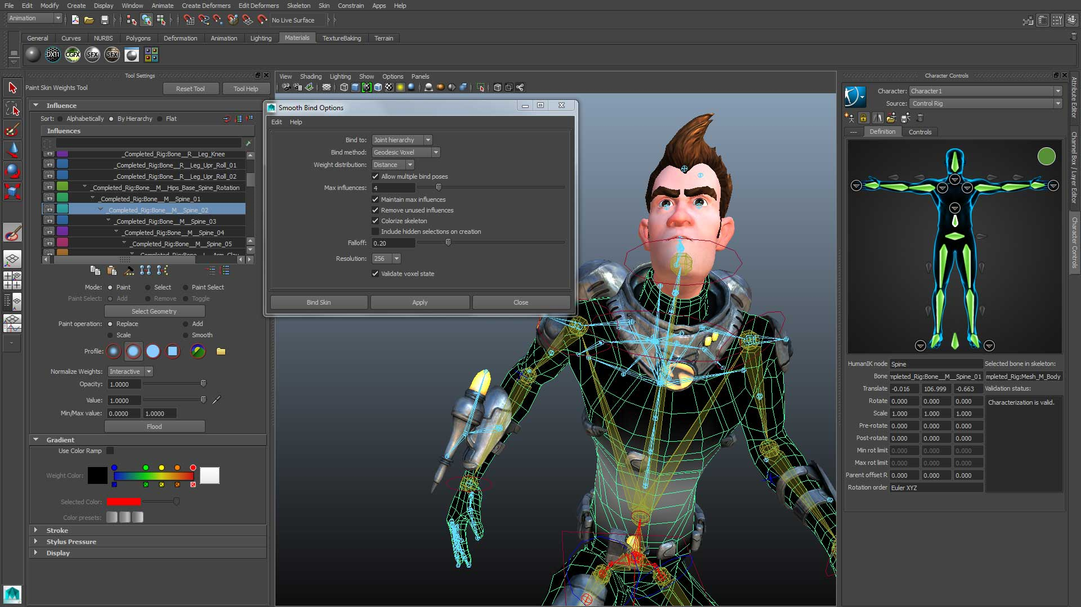

**https://area.autodesk.com/tutorials/series/character-rigging-in-3ds-max/**

**https://www.youtube.com/watch?v=a32NCbmaeqI**