**UNX510 – Act1**

**Sanghyuk Lee(129405171)**

1. Create a new folder in your HOME folder, name it May19-Act1
2. Create another folder inside May19-Act1, name it “invoice” and “report”



1. Using touch command, create three files inside invoice folder: Jan.txt, Feb.txt, Mar.txt



1. Using vi, create a new file in report directory, name is summary.txt and add your name, courses in this semester inside the file

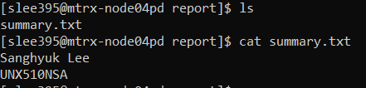

1. Show list of all files/directories in “May19-Act1: (all details)

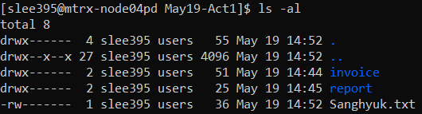

1. Show the tree view of “May19-Act1”

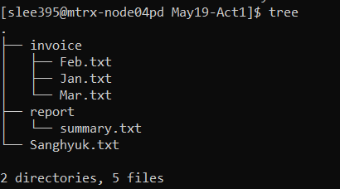

1. Using vi, create a txt file and add your name and today date as its content.

