**UNX510 – Act10**

**Sanghyuk Lee(129405171)**

**p.14**

This is the function I made:

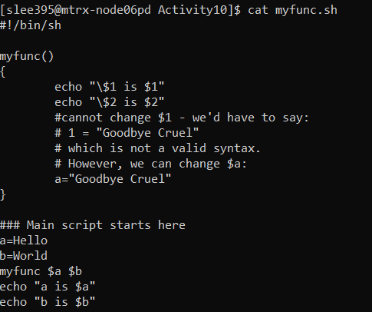

Output:

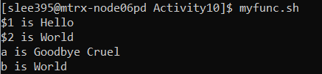

**Demonstration)** To demonstrate the code I will demonstrate with numbering

1. Variable a, b is assigned values, Hello and World respectively
2. Call the function, myfunc with initialized values, a and b
3. Inside the function it echoes two lines with escape character “\” to indicate $1, $2
4. It outputs the first two line of output of myfunc.sh; $1 is Hello $2 is World
5. Before the function is ended, it initializes variable a with the new value “Goodbye Cruel”
6. When it echoes variables a and b, variable a echo with the newly initialized value “Goodbye Cruel” and b echoes with World which is initialized at the very first

In this code, we can notice that there is no scope of variable

**p.15**

This is the function I made:

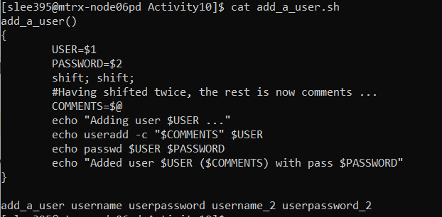

Output:

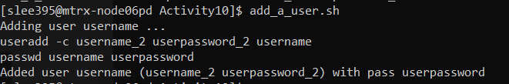

**Demonstration)** I will do numbering to demonstrate the code

1. Call the function add_a_user() with 4 argument; username, userpassword, username_2, userpassword_2
2. Variables in the function, USER and PASSWORD, initialize the value of the first two arguments, username , userpassword
3. It shifts twice so that the remained arguments are username_2, userpassword_2
4. Variable COMMENTS initialize the value to remaining arguments, username_2, userpassword_2
5. It echoes the value of variable USER, username, which is first argument before it shifts
6. It echoes the value of variable COMMENTS username_2, userpassword_2
7. It echoes the value of variable PASSWORD, userpassword, which is second argument before it shifts

What I notice on this code is although there is a shift statement, if the variables are initialized before shift statement inside the function, those variables won’t be changed inside the function unless user initialize those variables with new values inside the function.