**UNX510 – Act10**

**Sanghyuk Lee(129405171)**

**p.10**

code:

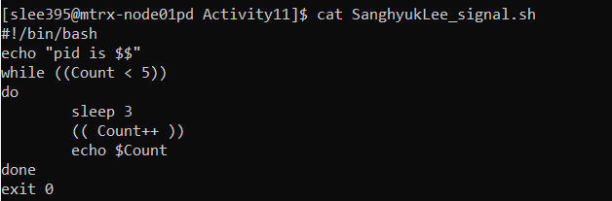

Output:

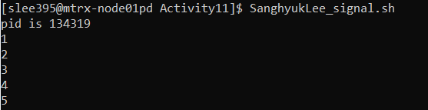

Firstly, it shows the pid and it starts to loop 5 times from the value of variable Count 1 to 5.

With the sleep statement, it delays 3 seconds every time and increase 1 to Count and display the “echo “$Count”” statement.

As the output it shows 1 to 5 with the 3 seconds delay.

**p.11**

**code:**

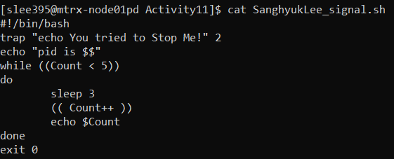

**output:**

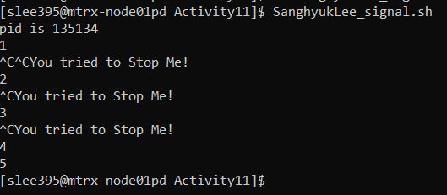

I added one line “trap “echo You tried to Stop Me!” 2”. In this line, the 2 stands for Signal Number, which name is SIGINT. The Signal name SIGINT means that if the user sends an interrupt signal (Ctrl + C). Therefore, whenever the user sends a signal by Ctrl + C, instead of quit the implementation, it echoes “You tried to Stop Me!”

**p.12**

Press Ctrl+Z and run ps

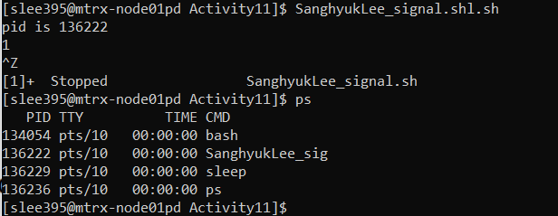

On the process, when we press Ctrl+z, the pid 136222 is still exist.

Run kill -9 PID



Run ps

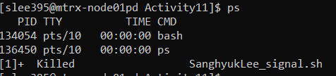

It kills the process which was there before.

What I notice is although Ctrl+z seems the process stop, it is still existing on the process and once we kill the process with pid then it would gone.