**UNX510 – Act12**

**Sanghyuk Lee(129405171)**

**p.16**

Create a script which ask user to enter 6 city names and store them into array

And display array element in reverse order in the output

**Code:**

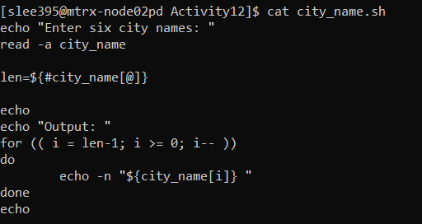

**Output:**

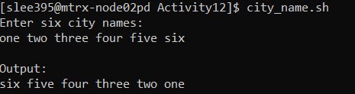

Used read command with option -a to create an array with user input and used for loop to display the array in reverse order

**p.18**

Create an array with the following data

*I spring like spring on spring in spring*

Replace the spring with something else (whatever you want)

Display the array in the output

**Code:**

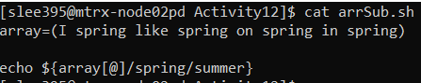

**Output:**



Replace spring to summer using the syntax of ‘{parameter/pattern/string}’

**p.19**

Create a text file on the matrix, name it “mydata.txt”

Enter 15 people name in the file (in each line)

Develop a new script which read the file and store it into array

read –a people <<<$(cat mydata.txt)

Or : people=$(cat mydata.txt)

Add a loop to display array in reverse order

**Code of mydata.txt:**

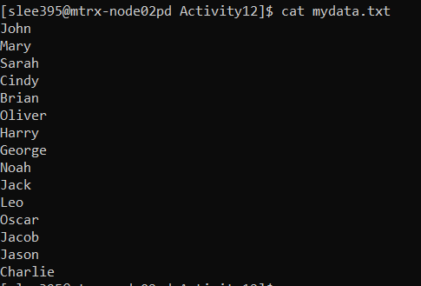

**Code of people.sh:**

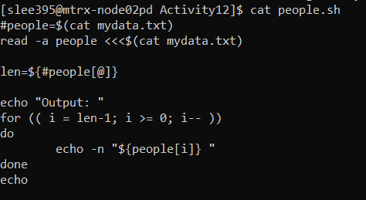

**Output:**



I’ve chosen to use ‘read –a people <<<$(cat mydata.txt)’ instead of using people=$(cat mydata.txt) because the former one stores the file in each index so that I could reverse the order of file by reversing the order of element but the latter one stores the whole mydata.txt in one element, index 0, so was not able to reverse the order.

**p.23**

Create a script which:

– Create an associative array and add 5 different pairs of username/password

– Display all array elements (usernames+passwords) on the output

**Code:**

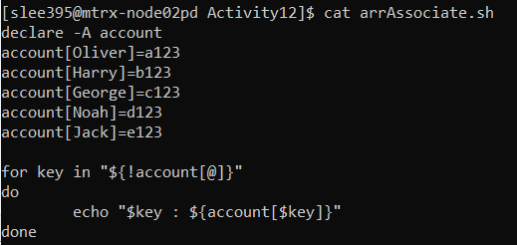

**Output:**

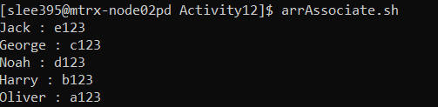

After declaring associative array, I used for loop to trace all the elements of an array.

By using ${!account[@]}” which stands for the index of the array, I could display each username and with ${account[$key]} I could display the password.