**UNX510 – Act13**

**Sanghyuk Lee(129405171)**

**p.4**

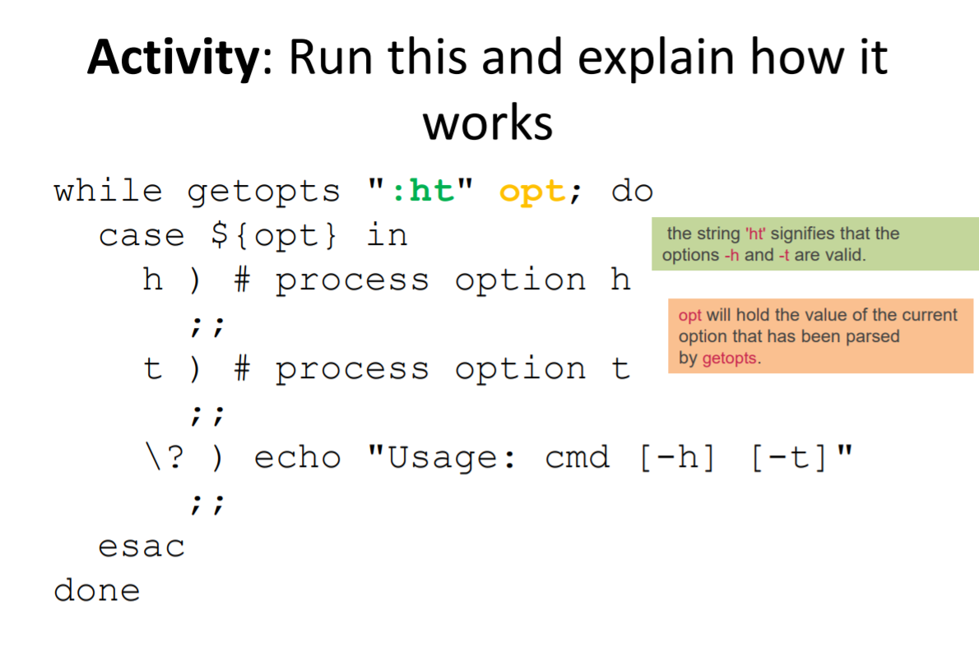

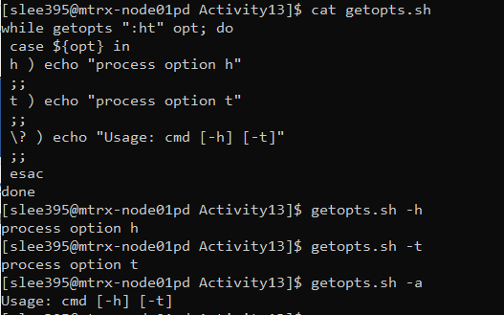

When user provide an argument which is listed on the case option, it displays proper echo statement. However when user provide an argument which is not on the case statement, it displays “Usage: 층 [-h] [-t]”. The colon at the beginning of the optstring stands for “silent error checking mode”

**p.8**

**Code:**

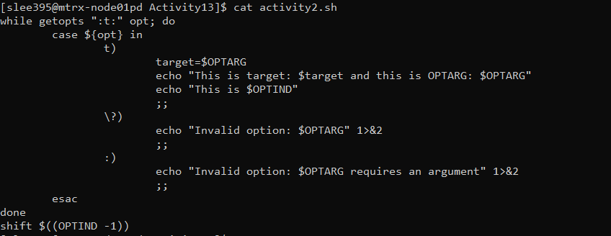

: after optstring is for missing option arguments



When user provide an option -t with third argument, it triggers the first case option which stores the value of OPTARG variable which is *Value* in this case.



If user does not provide any argument following the option -t, then as the variable OPTARG expects an argument but the user didn’t provide, It will unset OPTARG so that it will go to the last case option.



If user provide any other option other than option -t, it will display the second case option.

**p.12**



It displays “Hi” as the variable *NAME* is still empty as the while loop has been triggered because there is no following option after script name on the command line.



As -n option is used, the *UNIX* which is used as the value of the option is stored in variable NAME and displays the name after Hi

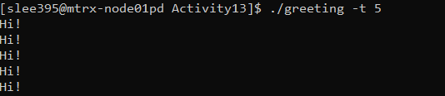

5 is sent as a value of a option -t and stored in a variable *TIMES*. And as the variable *NAME* is empty because there is no -n option use case, within the while loop it echoes only HI! for five times.

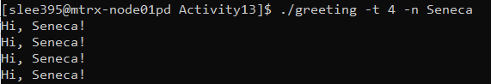

Unlike the previous case It stores the Seneca as the value of variable *NAME* and stores 4 as the value of variable *TIMES,* It echoes Hi, Seneca! four times.



0 meets the case of if statement condition inside the t option case, it echoes Error message first and by going through exit_abnormal function and usage function it displays "Usage: $0 [ -n NAME ] [ -t TIMES ]".