**UNX510 – Act2**

**Sanghyuk Lee(129405171)**

1. Develop a new script : Name : Script1.sh



1. The script will calculate the area of a rectangle, width is 100 and height is 250.

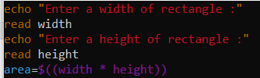

1. When you execute the script, it displays the following:

* The area of rectangle with size (100 by 250) is 25000.

1. Modify the script in order to ask user to enter “width” and “height”

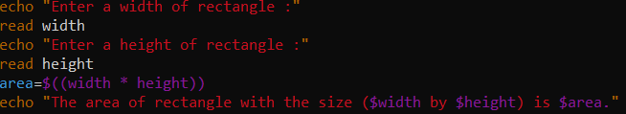

1. Before we execute the file, we need to assign the permission to execute the script file.





1. Then execute the file

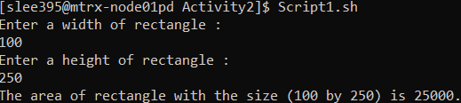

Following is the tree of where the file saved in case you want:

