**UNX510 – Act1**

**Sanghyuk Lee(129405171)**

**All the following script is run after I gave the permission by using chmod command.**

1. Develop a script which ask user to enter a password and check whether the password is equal to “admin123”. Also allows user to enter the following as well; ADMIN123, aDmin123, aDmin123, ADmin123, adMIN123.

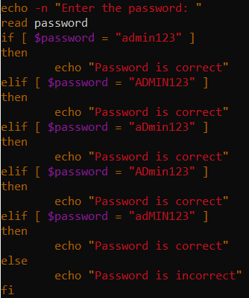

All the passwords inside the condition results in ‘Password is correct’



If the user types the password that is not under the list of the condition, then it shows ‘Password is incorrect’



1. Try following code in command prompt

x=9

test $x –eq 9

echo $?

Q. What is the output?

A. 0

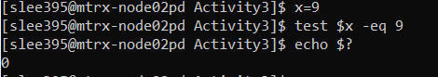

Q. Change x=10, and try the above code again. What is the output?

A.

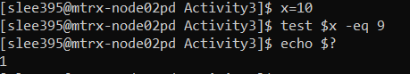

$? – it is one of the special parameters which can be used to represent positional parameter information and other useful information and stands for ‘Exit Status of previous command’

Therefore, if the command is true then it returns 0, otherwise it returns 1.

1. Change the previous script to read a number from input, and displays whether it is an even number or odd number

Changed to read the user input

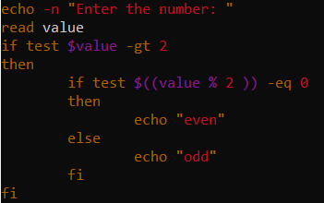

Depends on the user input it identifies whether it is even or odd number

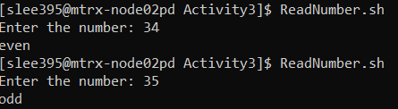

1. Change the previous script to accept a number as argument, and displays whether it is an even number or odd number

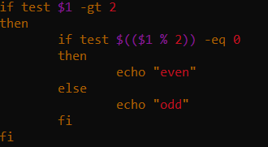

Depends on the accepted number, it shows whether it is even or odd number

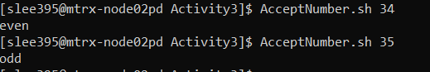

1. What does the following program do?

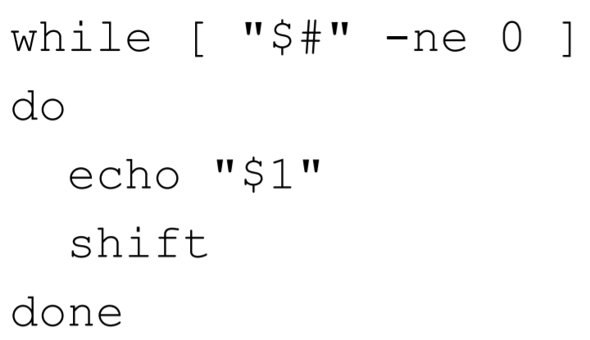

1. Until there is no argument, it shows the very first argument. ($# stands for the number of positional parameters)
2. Explain what does the following scripts do?

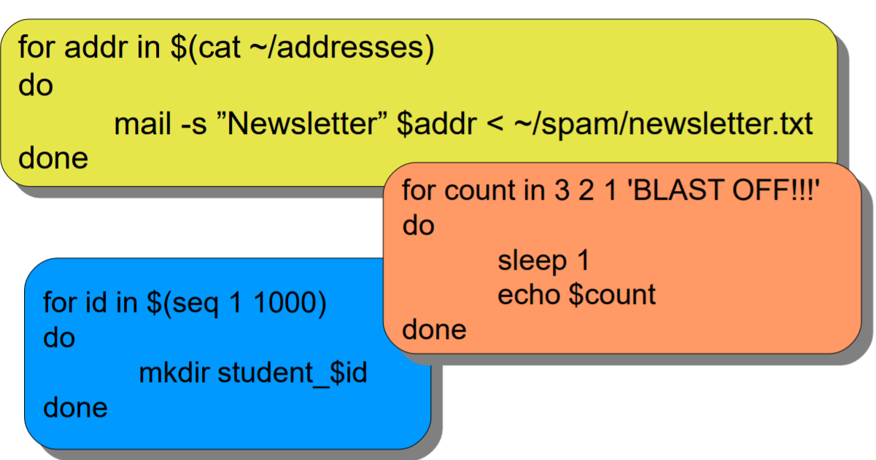

The script inside the yellow box is trying to send the email to someone.

Script in the orange box is trying to suspends the calling process for a specified time by showing the arguments.

The last one is trying to make the directory by using the seq commands which is used to generate numbers from first to last in steps of increment. So, It will make the directory from student_1 to student_1000.