**UNX510 – Act4**

**Sanghyuk Lee(129405171)**

**p.16**

1. Create a file using vi and add 10 friends name, their phone no and their email as follow

* John, 6471112222,joan@abc.com

I made the script file called FriendInfo.sh which includes 10 friends’ information including name, phone no and their email

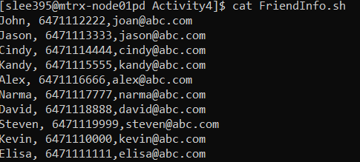

1. List the file content sorted by phone no

* I’ve used the command sort with the option -k2 which is sorting on 2nd Field (default field delimiter is white-space)

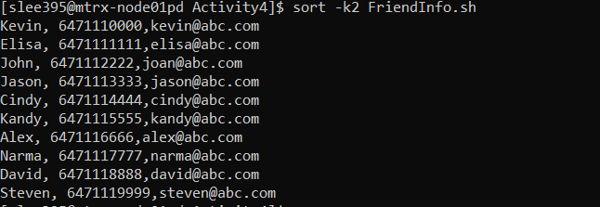

1. List the first 3 person in the file

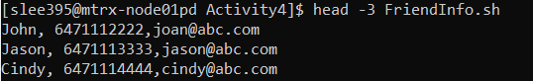

1. List the last two persons in the file

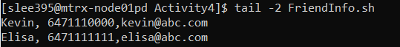

1. List the person 3,4 only

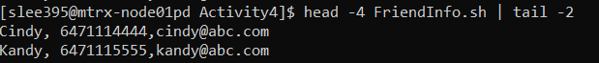

**P.19**

Try the following and explain how it works

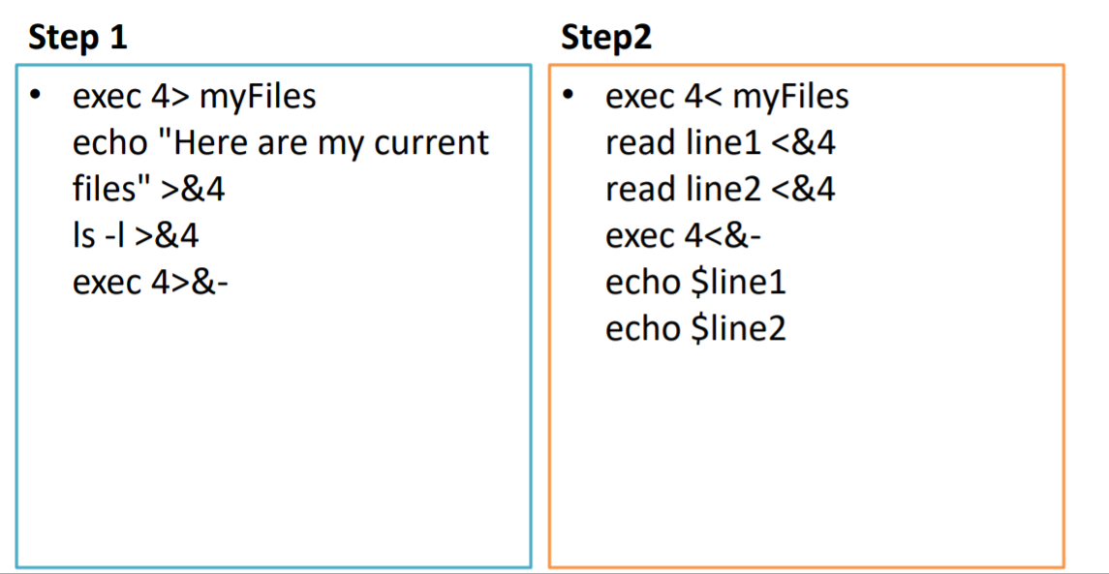

**Step1**

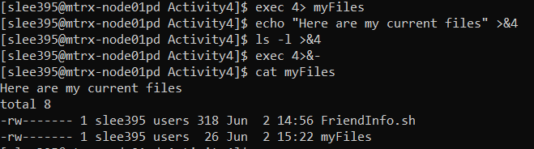

exec 4> myFiles : output or errors redirected to file descriptor 4 will be written to myFiles

echo “Here are my current files” >&4 : appending the sentence into the file description so that the myFiles will have the content of echo command

ls -l >&4 : appending the list of files with the more information about files into the file description so that the myFiles will have the content of the command

exec 4>&- : closed the command

**Step2**

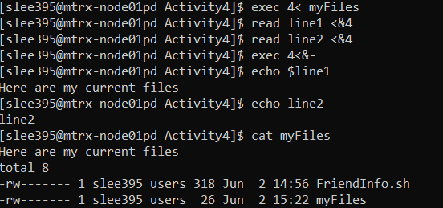

exec 4< myFiles : input redirected from file descriptor 4 will be read from myFiles

read line1 <&4 : input the first line of the myFiles into the variable line1

read line2 <&4 : input the second line of the myFiles into the variable line2

exec 4<&- : closed the command